Table of Contents

# Sensitivity Analysis

## Sensitivity Analysis for Raltegravir 10 mg (lactose formulation)

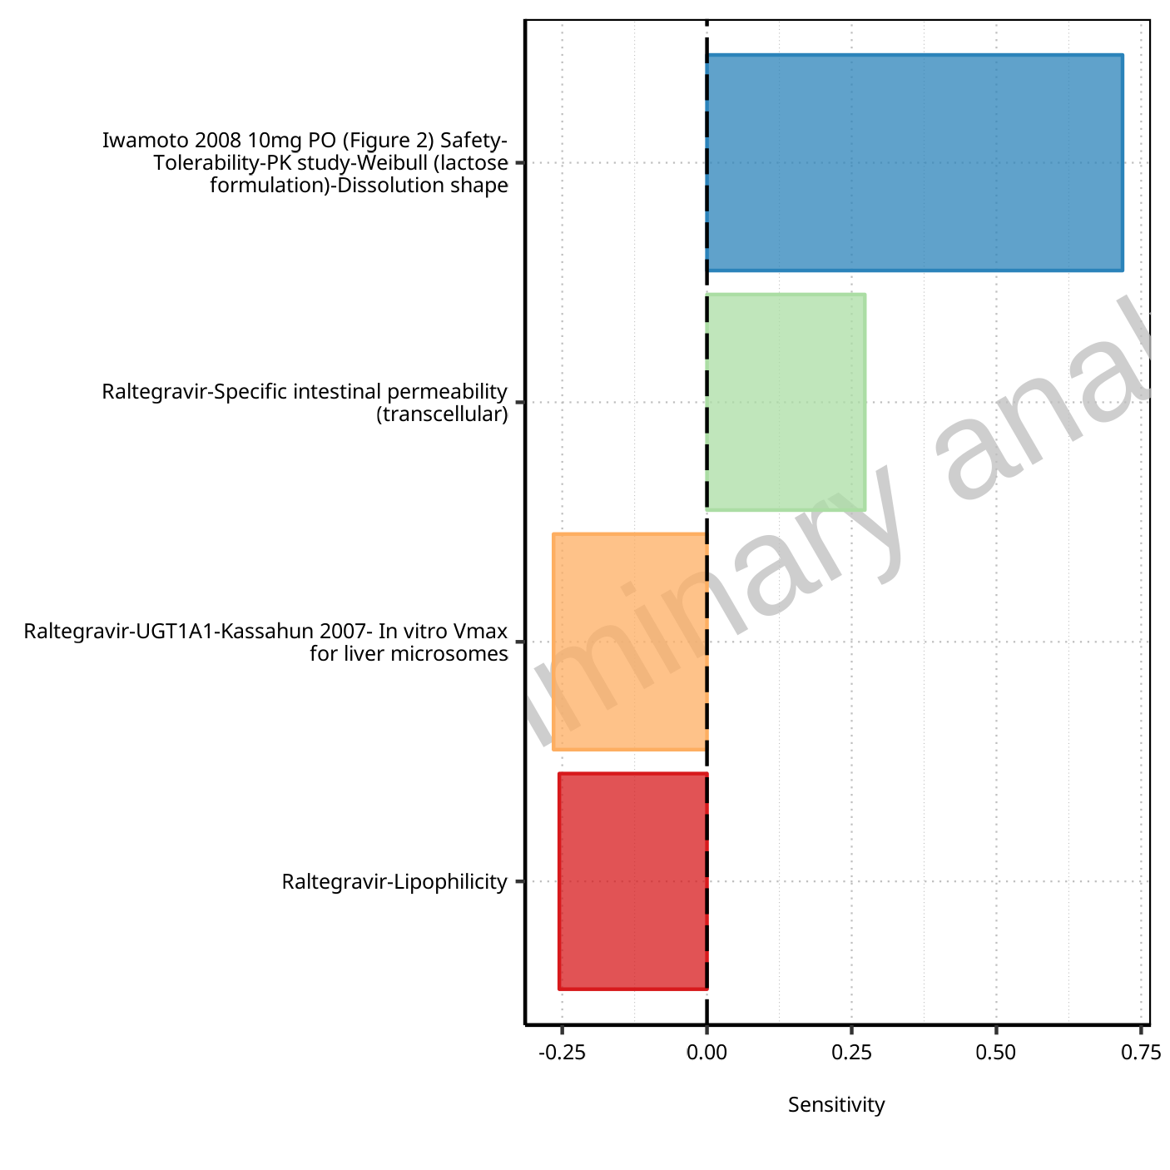

**Figure 1-1: Most sensitive parameters for C_max of Raltegravir.**

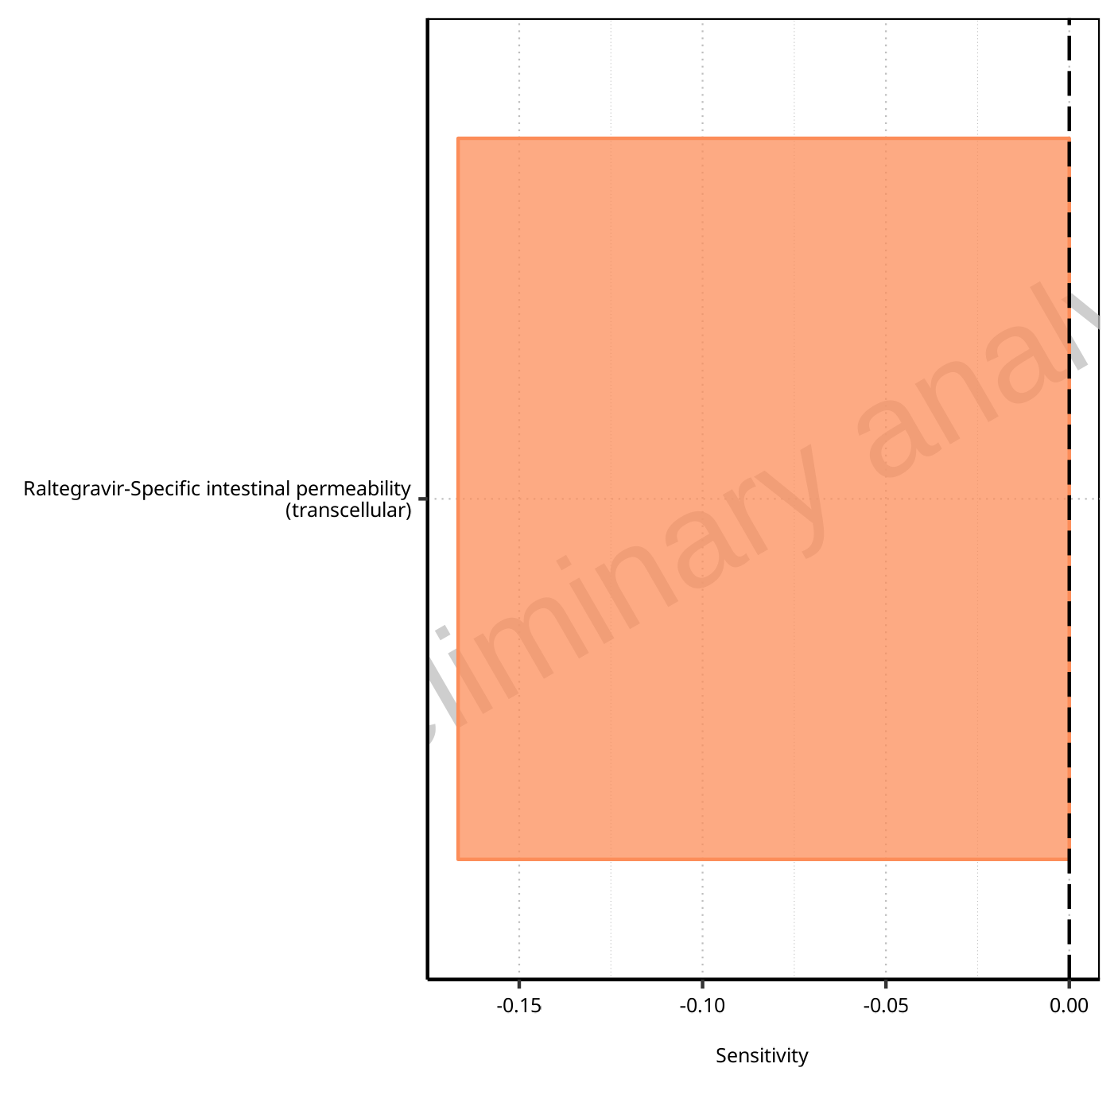

**Figure 1-2: Most sensitive parameters for t_max of Raltegravir.**

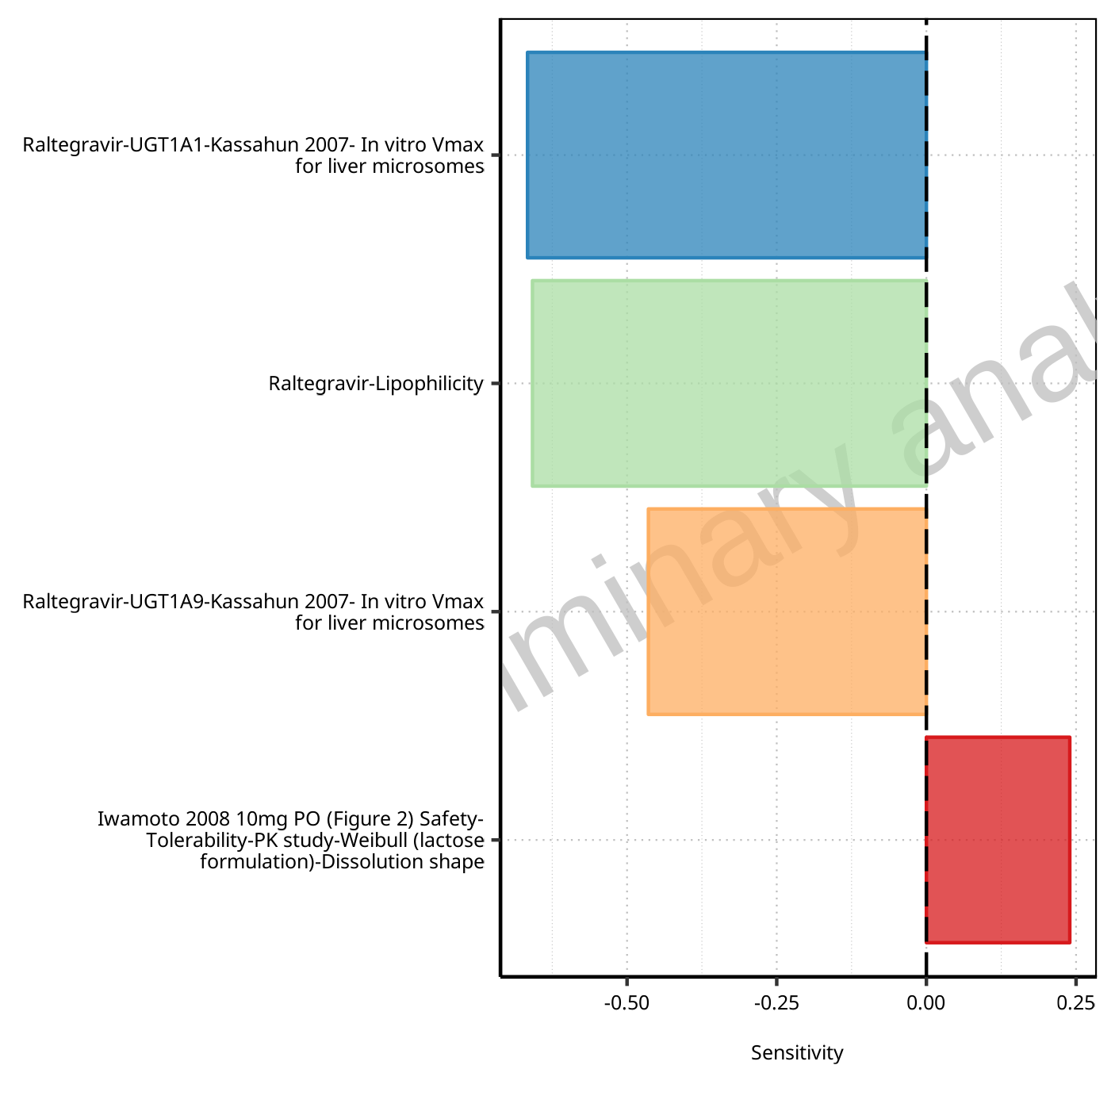

**Figure 1-3: Most sensitive parameters for C_tEnd of Raltegravir.**

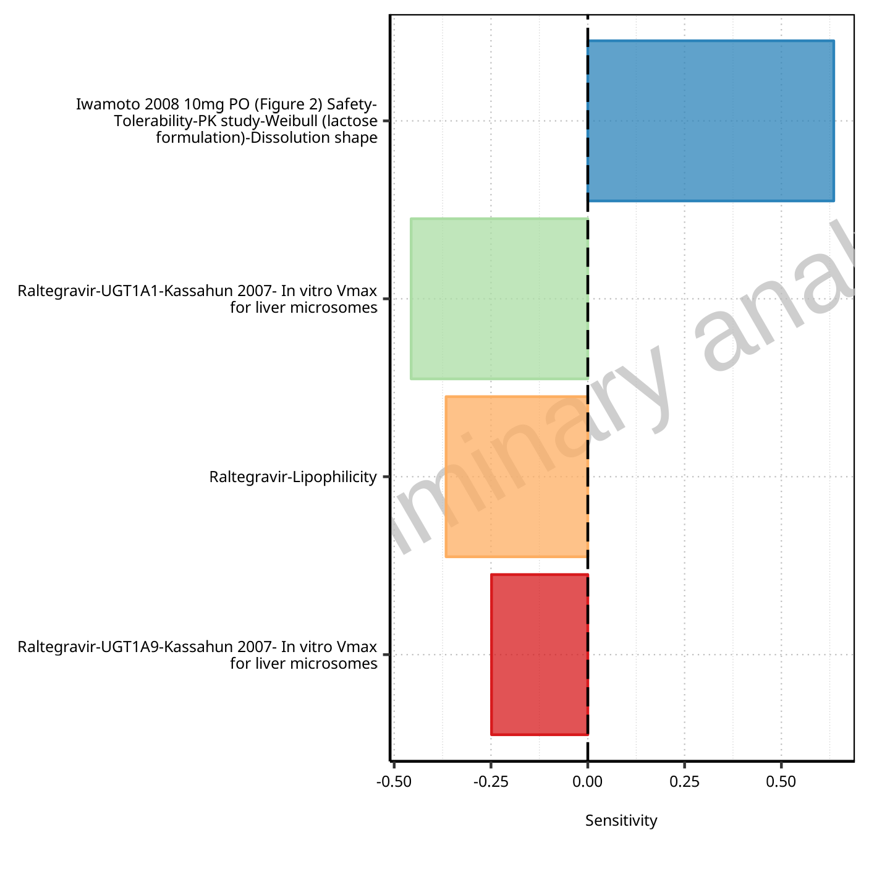

**Figure 1-4: Most sensitive parameters for AUC of Raltegravir.**

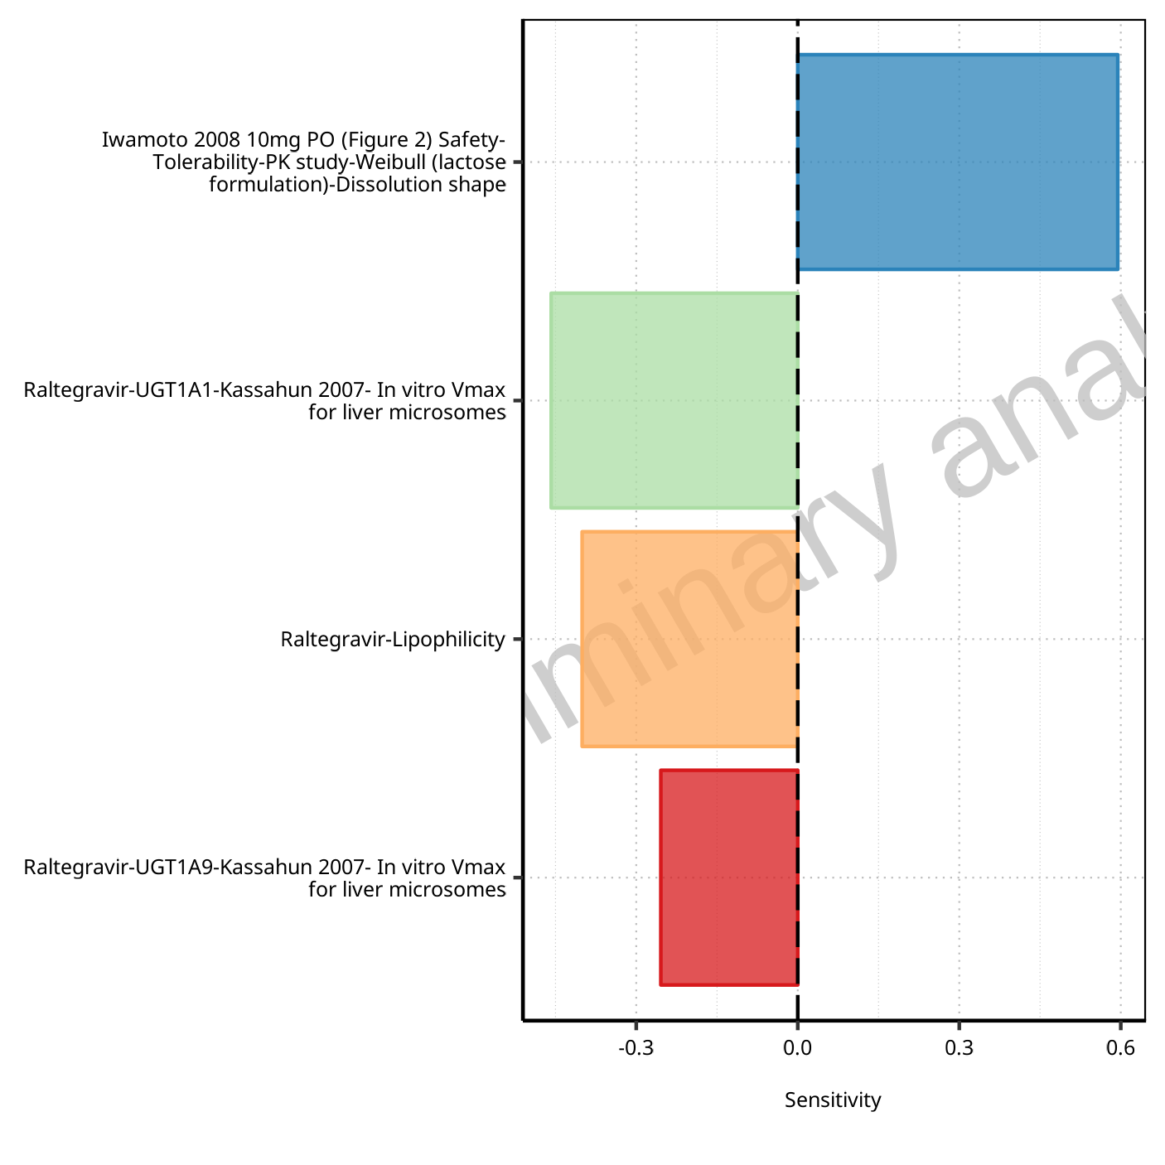

**Figure 1-5: Most sensitive parameters for AUC_inf of Raltegravir.**

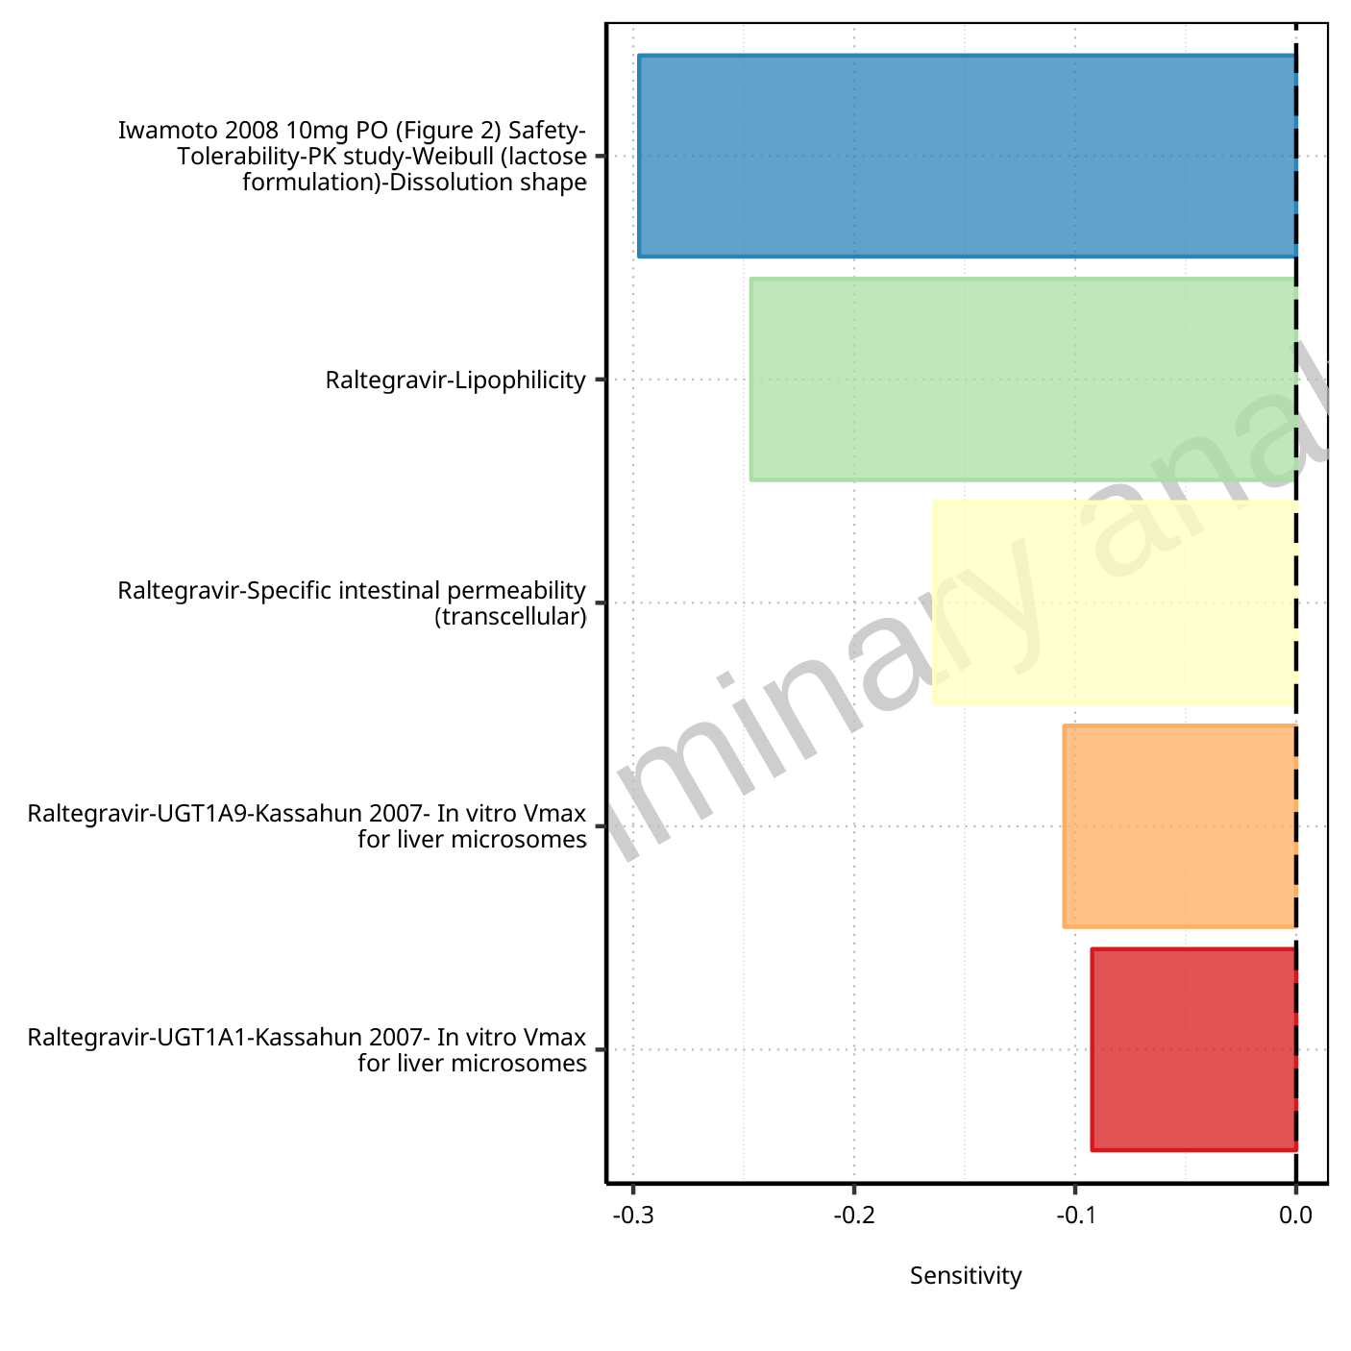

**Figure 1-6: Most sensitive parameters for MRT of Raltegravir.**

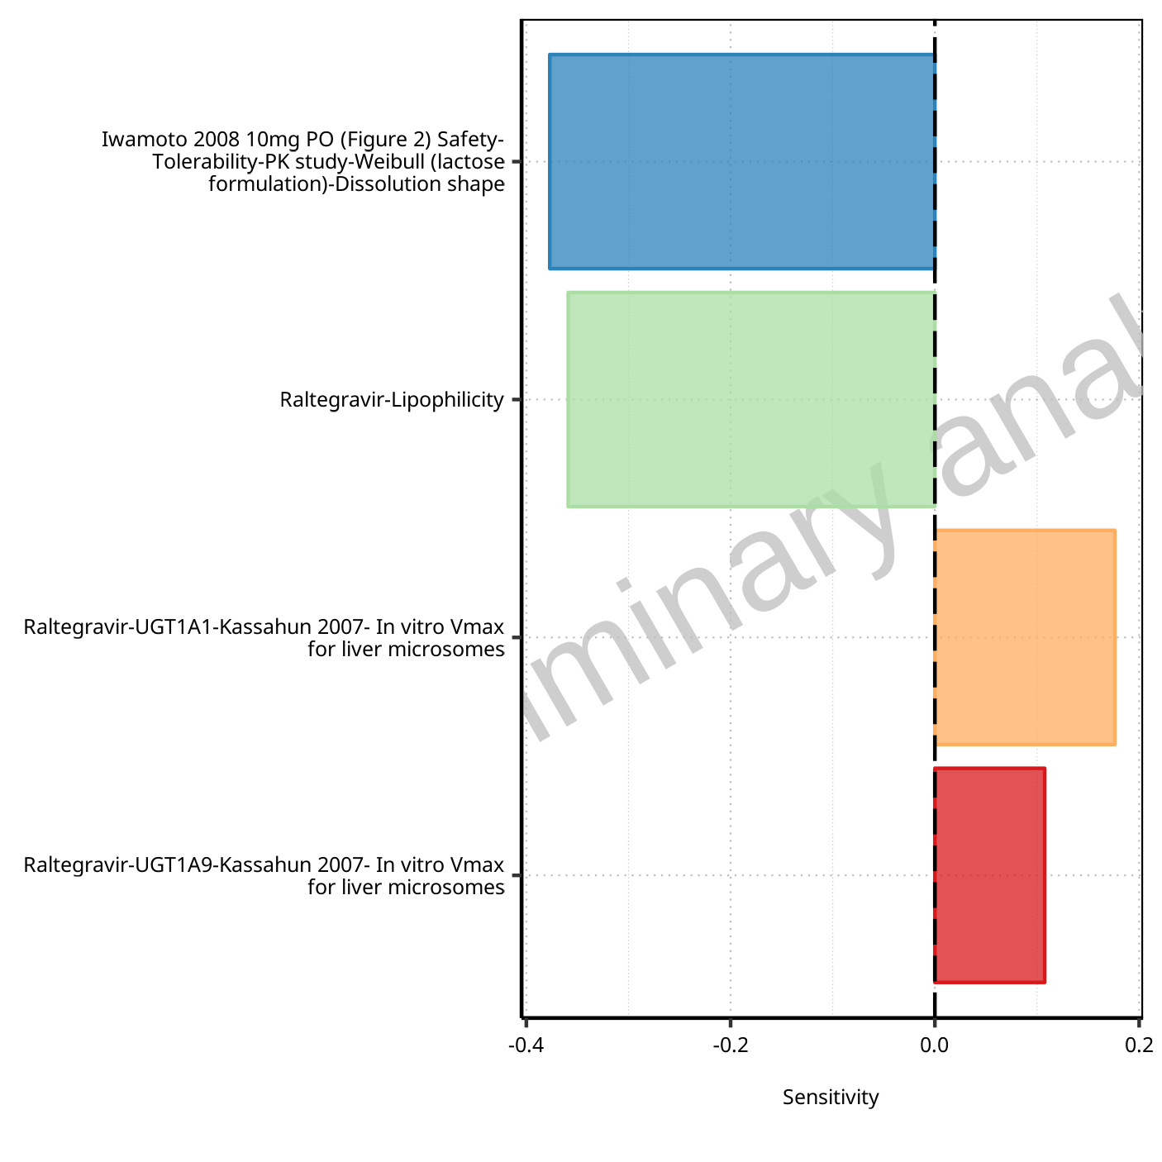

**Figure 1-7: Most sensitive parameters for Thalf of Raltegravir.**

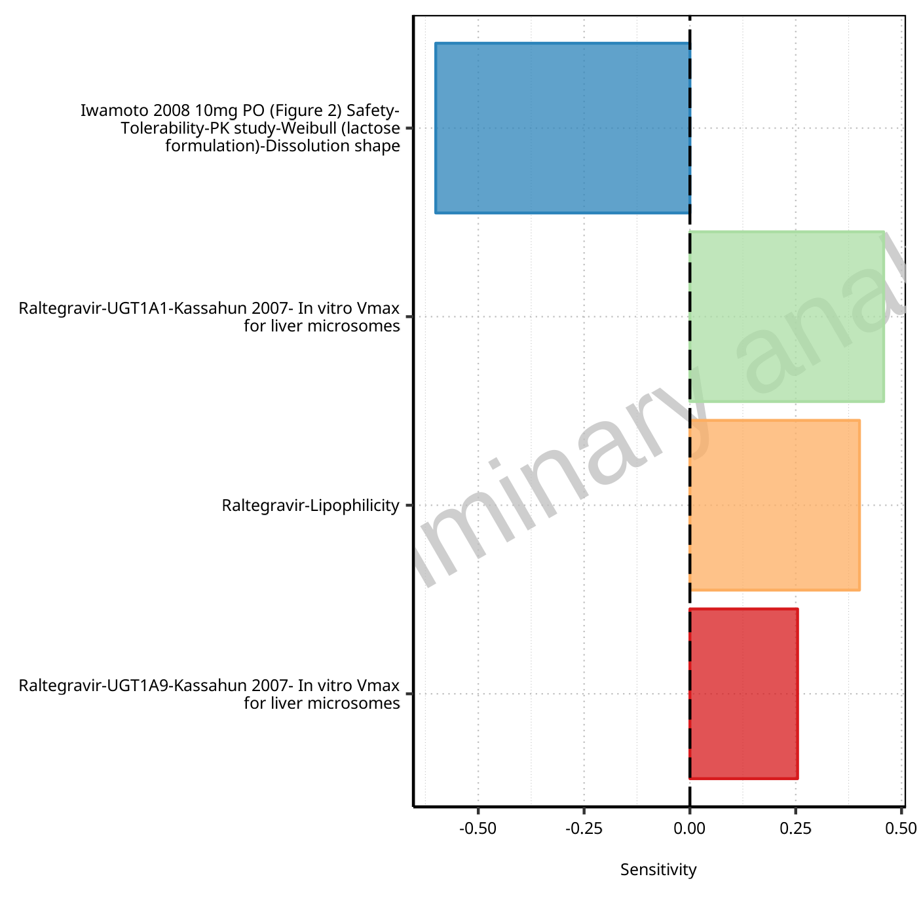

**Figure 1-8: Most sensitive parameters for CL of Raltegravir.**

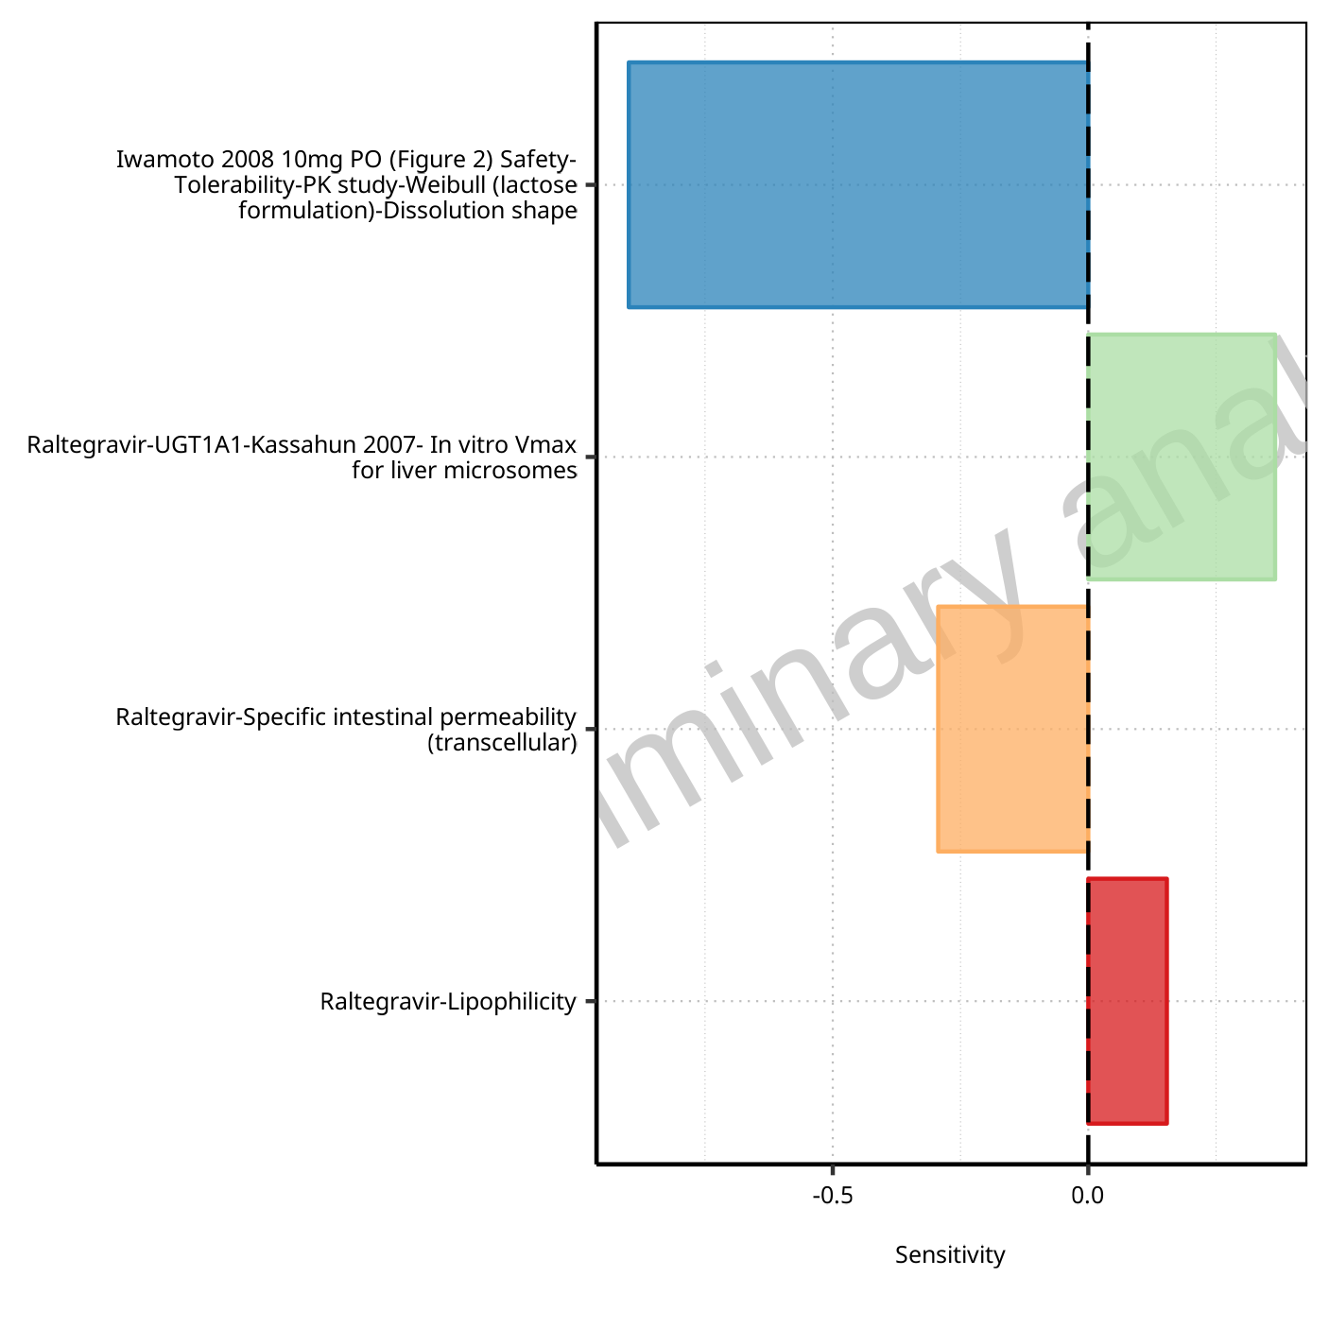

**Figure 1-9: Most sensitive parameters for Vss of Raltegravir.**

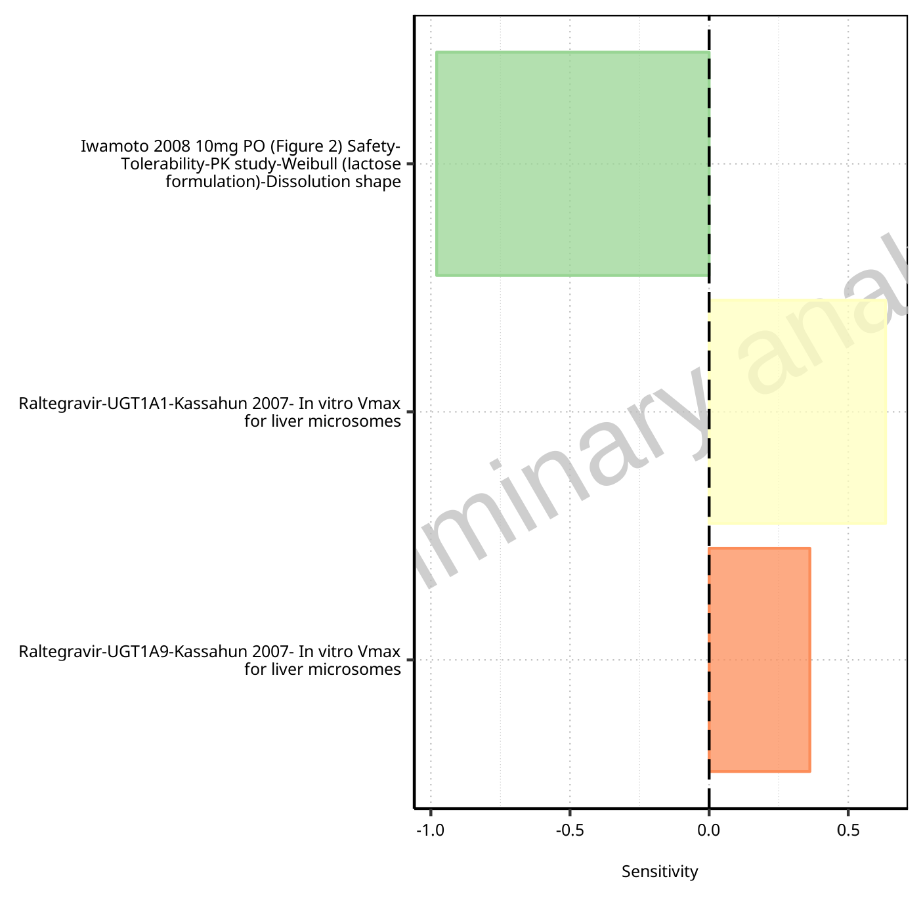

**Figure 1-10: Most sensitive parameters for Vd of Raltegravir.**

## Sensitivity Analysis for Raltegravir 100 mg filmcoated tablet md

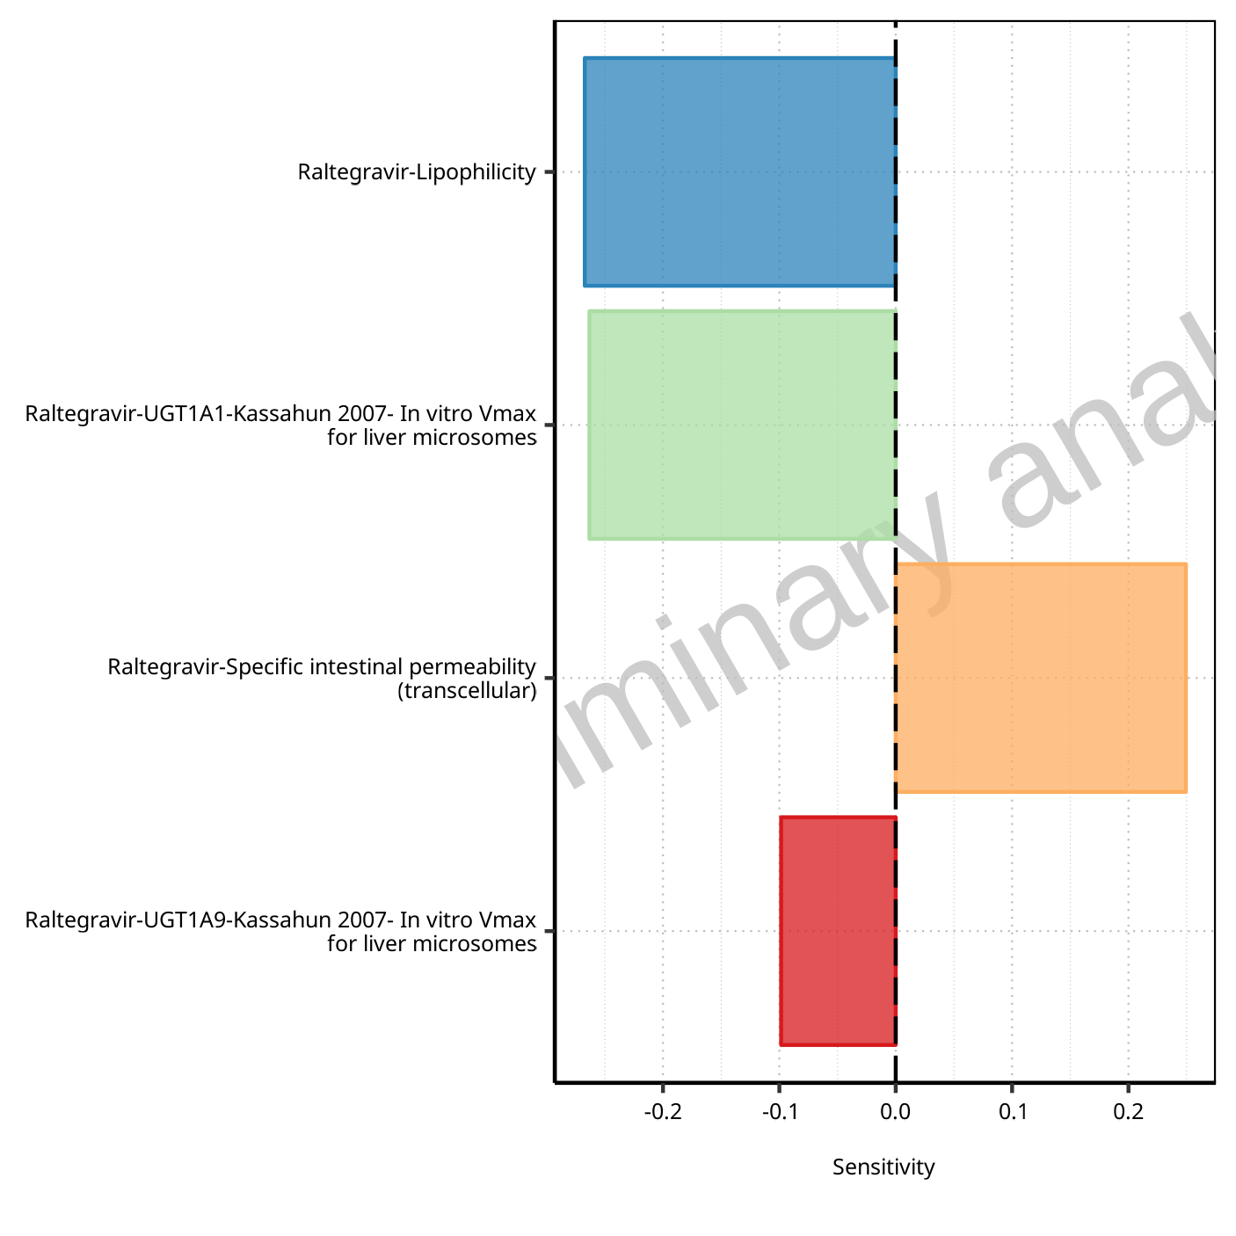

**Figure 1-11: Most sensitive parameters for C_max of Raltegravir.**

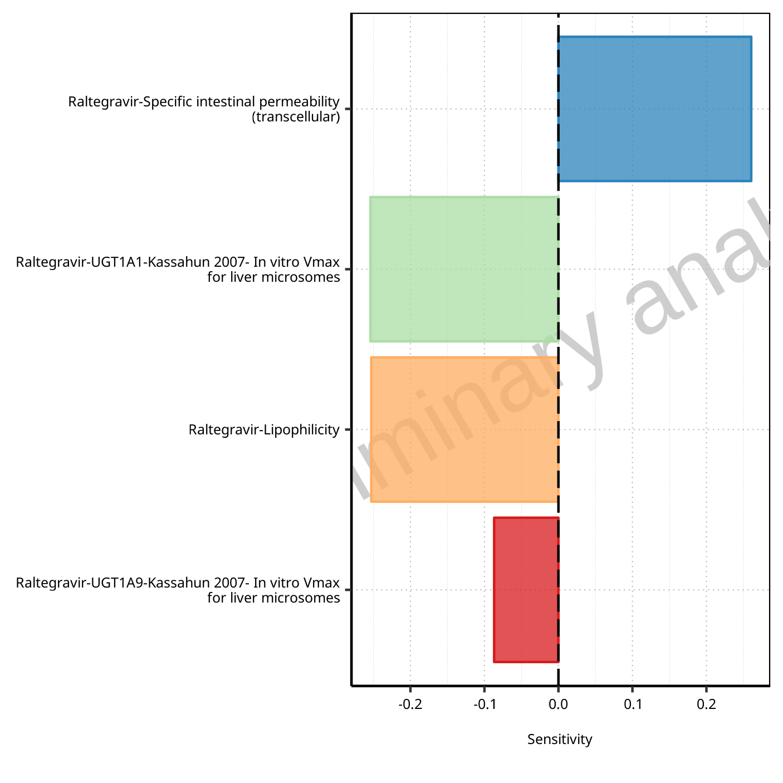

**Figure 1-12: Most sensitive parameters for C_max_t1_t2 of Raltegravir.**

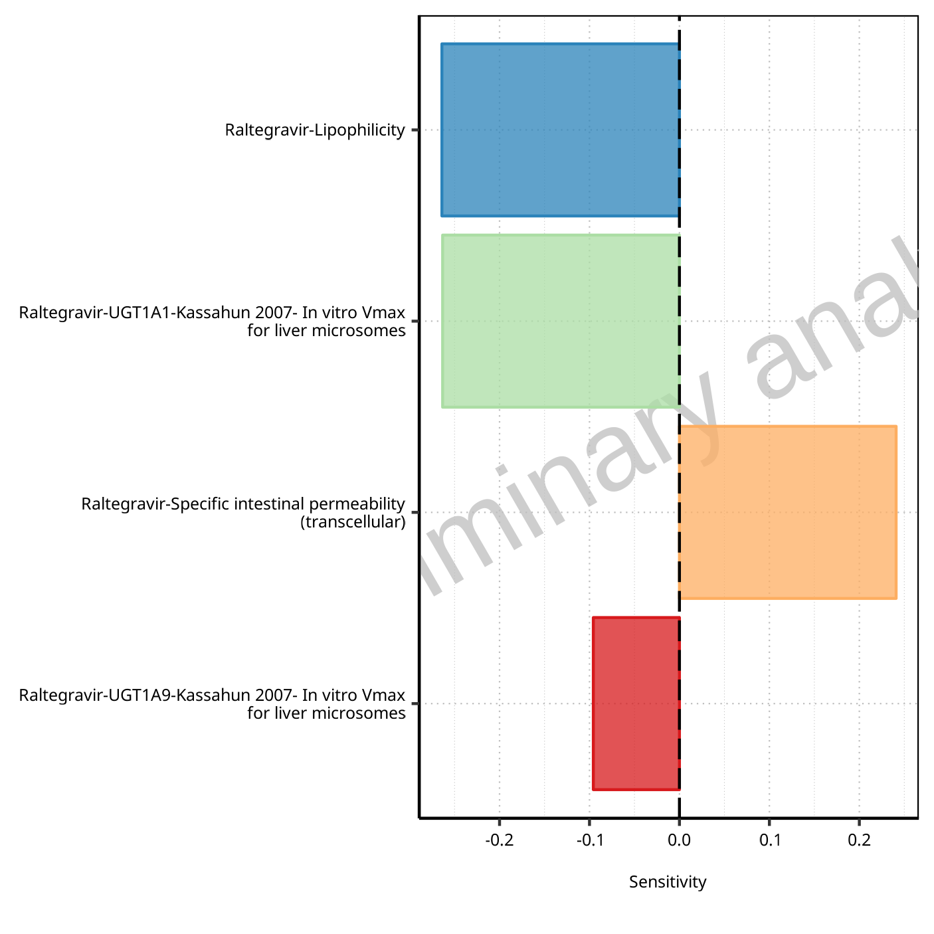

**Figure 1-13: Most sensitive parameters for C_max_tLast_tEnd of Raltegravir.**

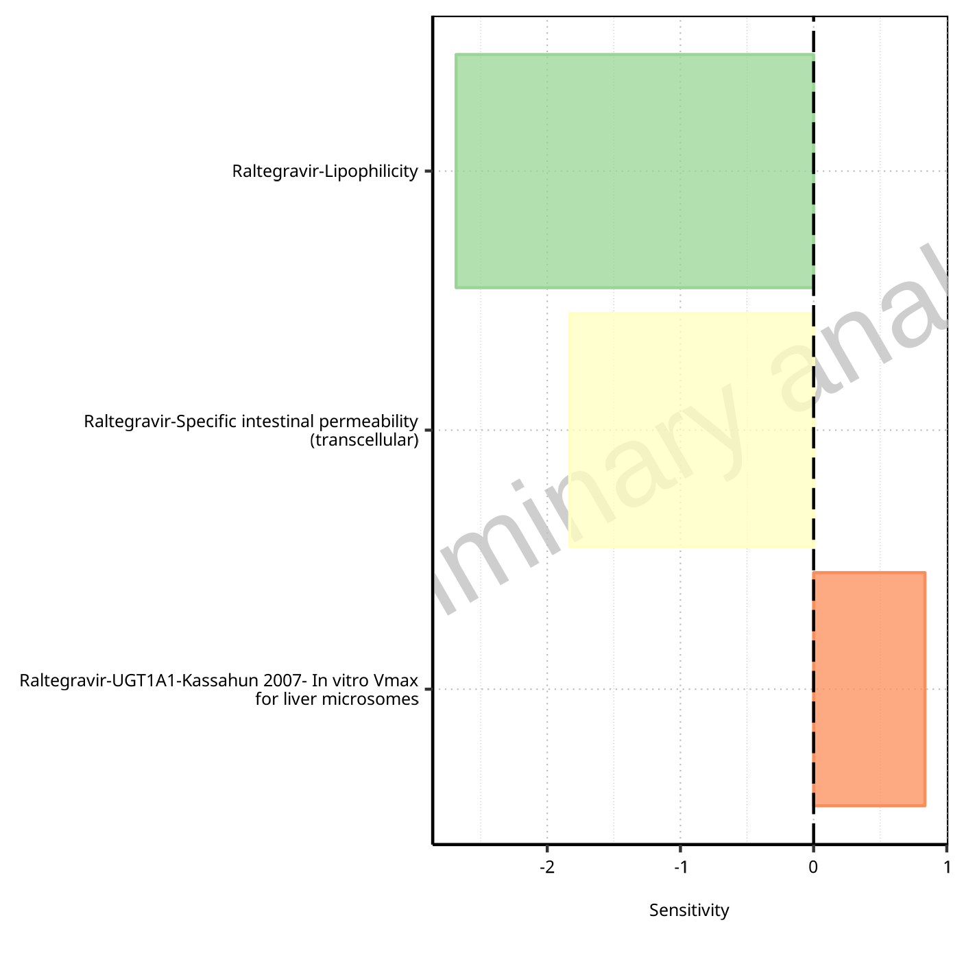

**Figure 1-14: Most sensitive parameters for t_max of Raltegravir.**

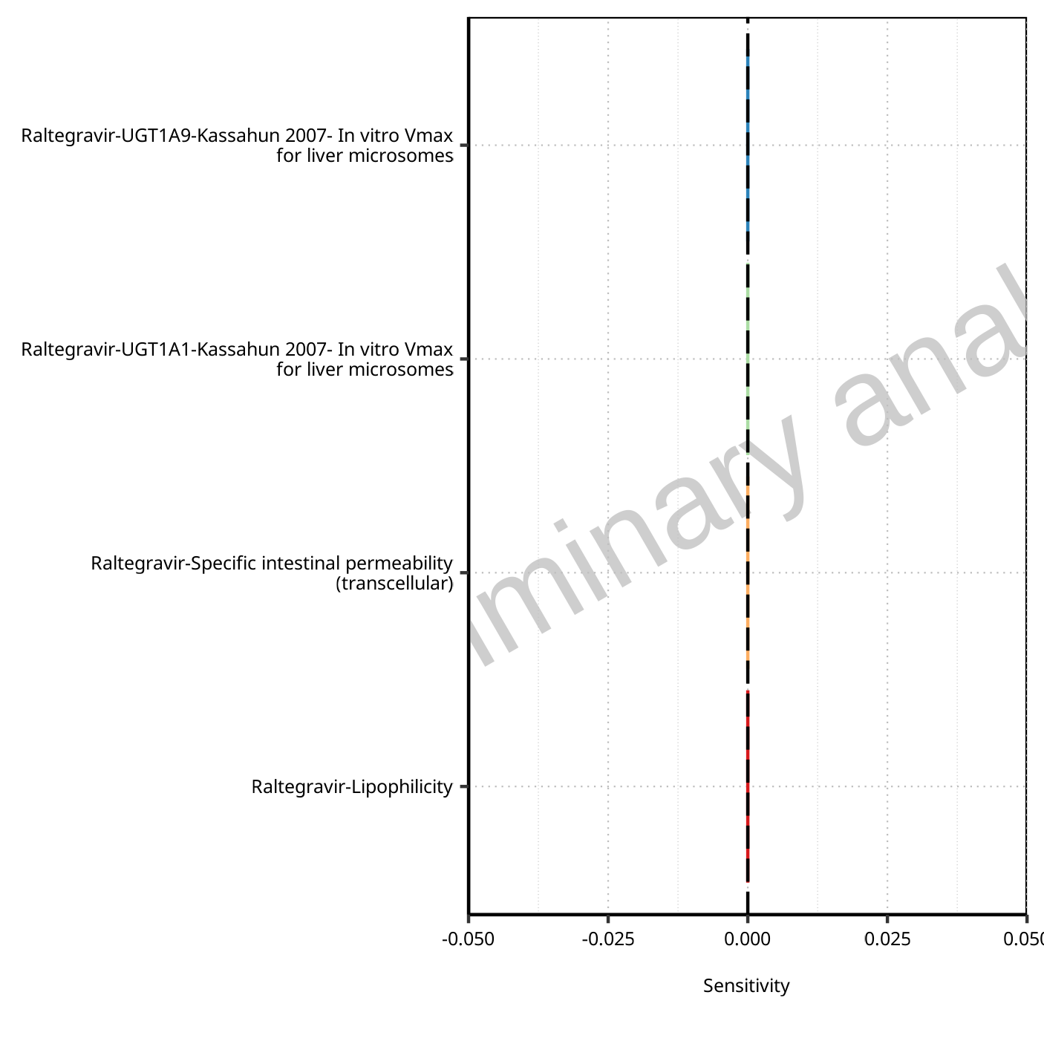

**Figure 1-15: Most sensitive parameters for t_max_t1_t2 of Raltegravir.**



**Figure 1-16: Most sensitive parameters for t_max_tLast_tEnd of Raltegravir.**

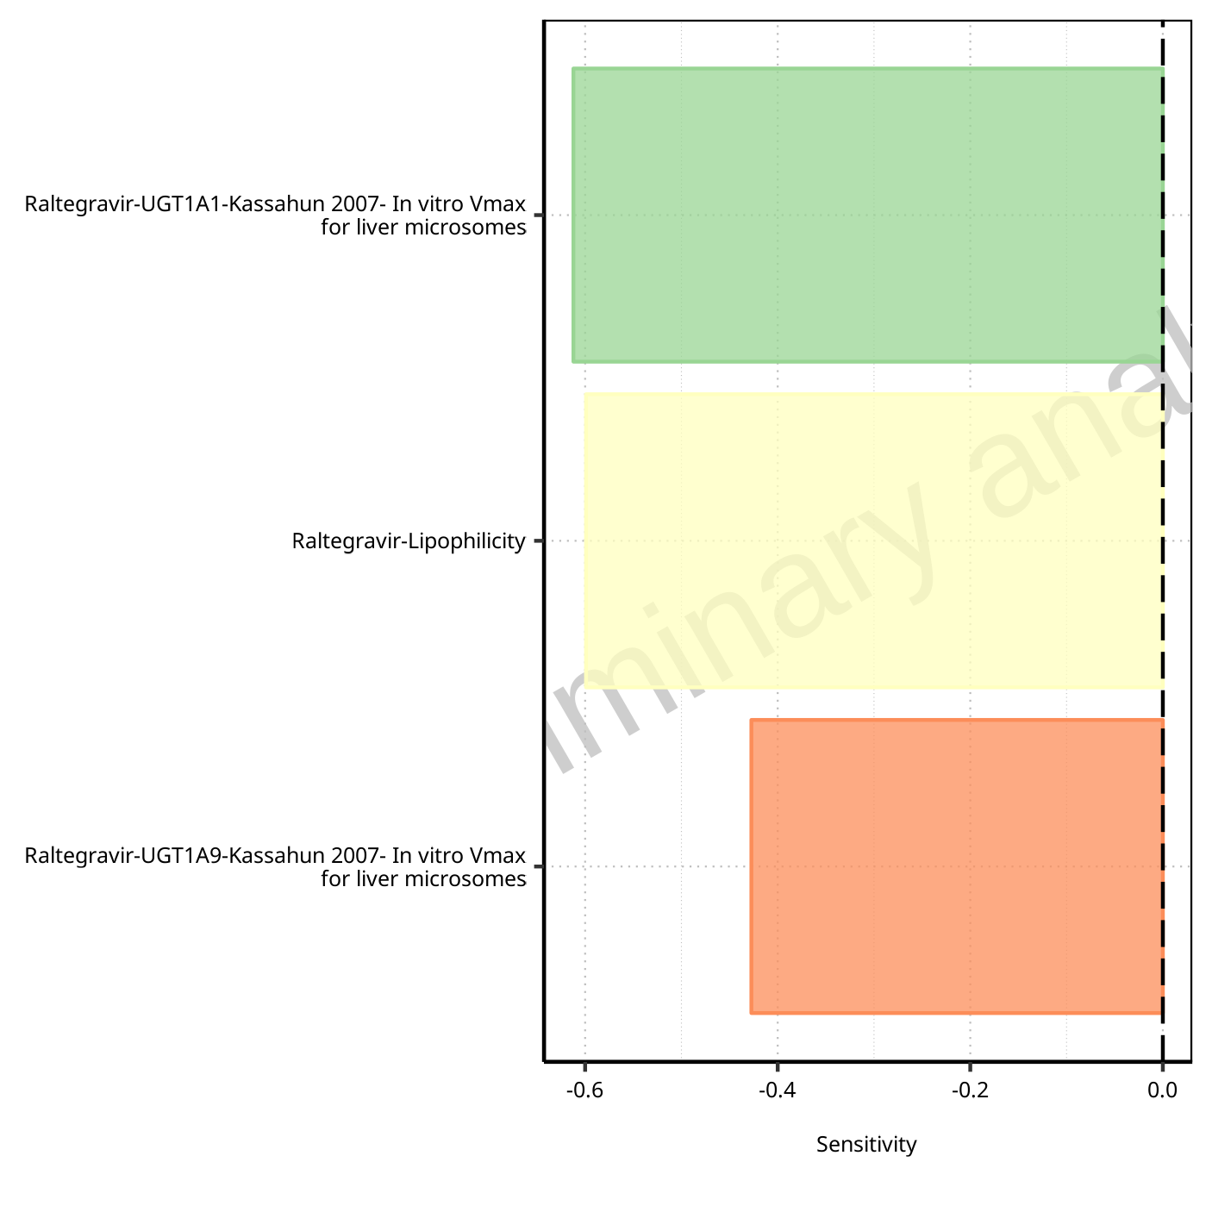

**Figure 1-17: Most sensitive parameters for C_trough_t2 of Raltegravir.**

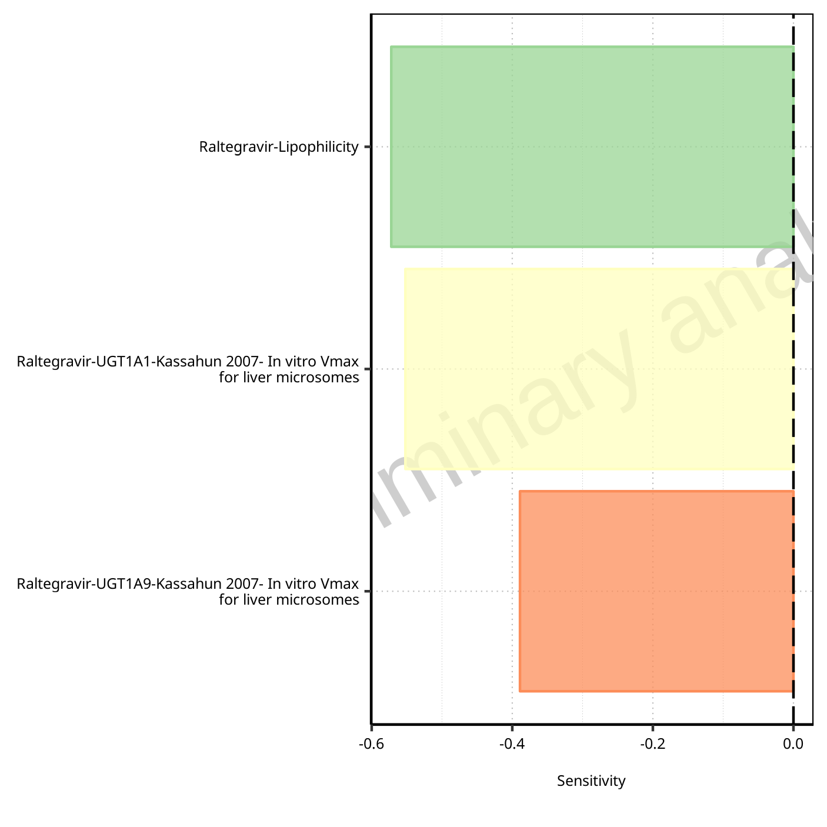

**Figure 1-18: Most sensitive parameters for C_trough_tLast of Raltegravir.**

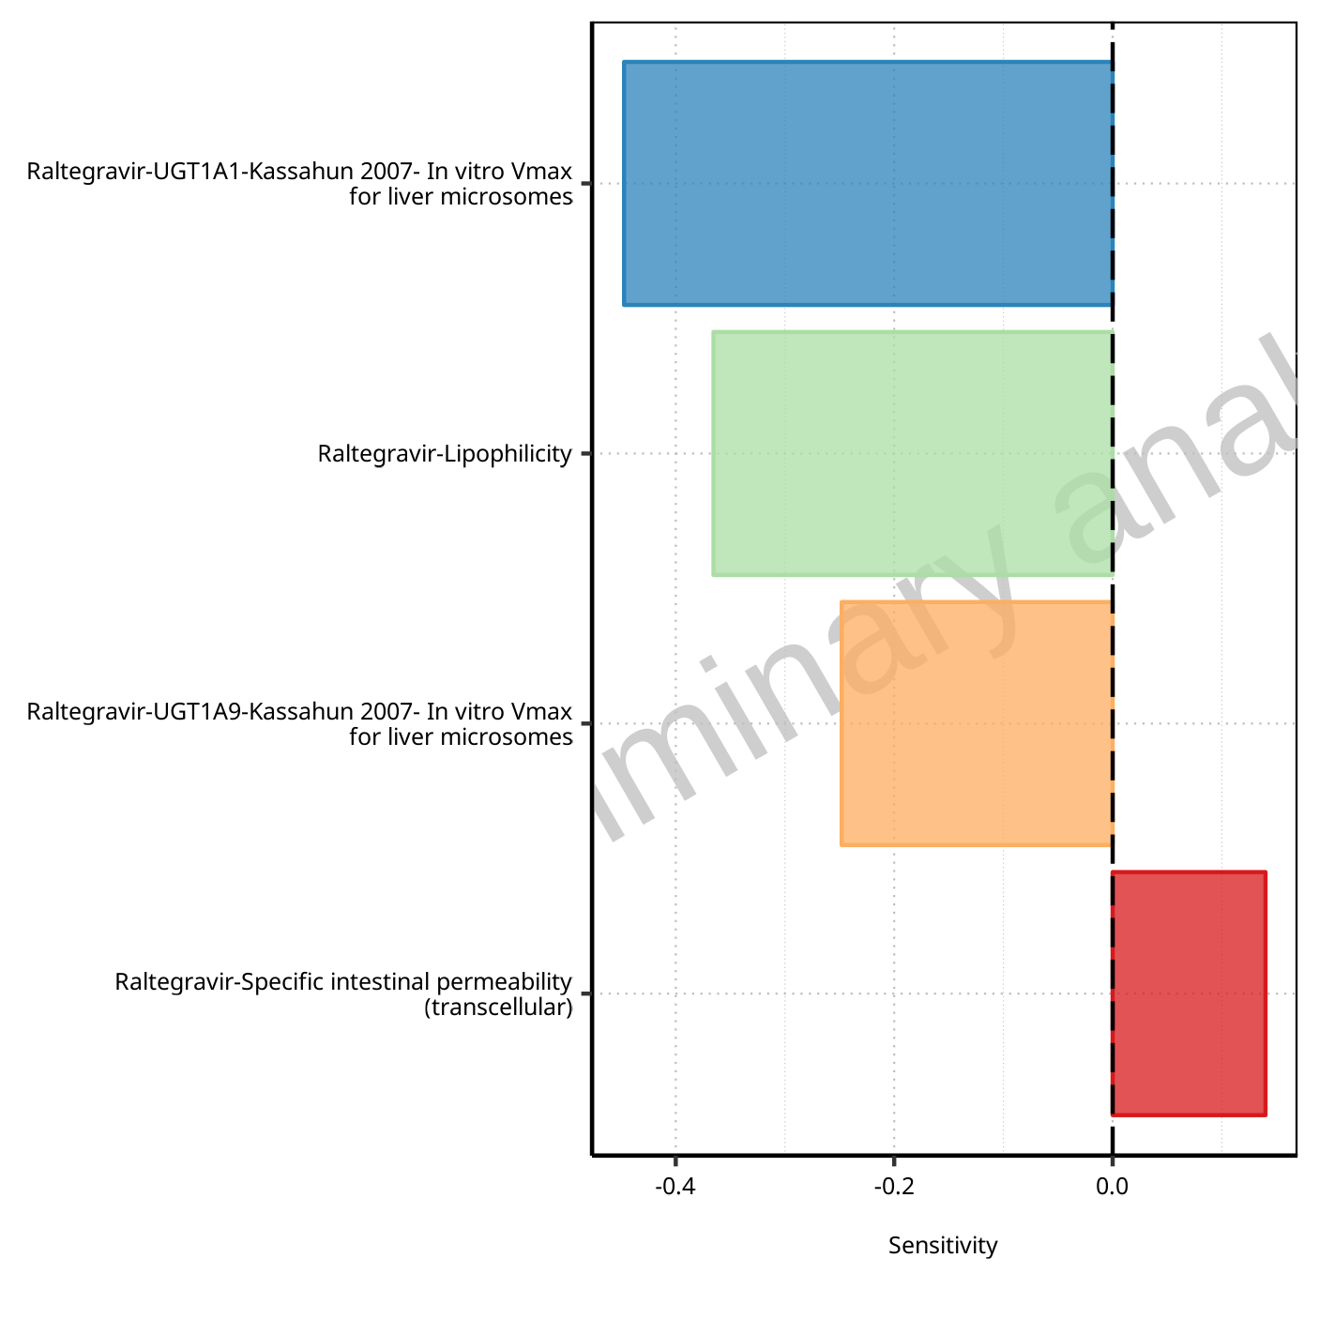

**Figure 1-19: Most sensitive parameters for AUC_t1_t2 of Raltegravir.**

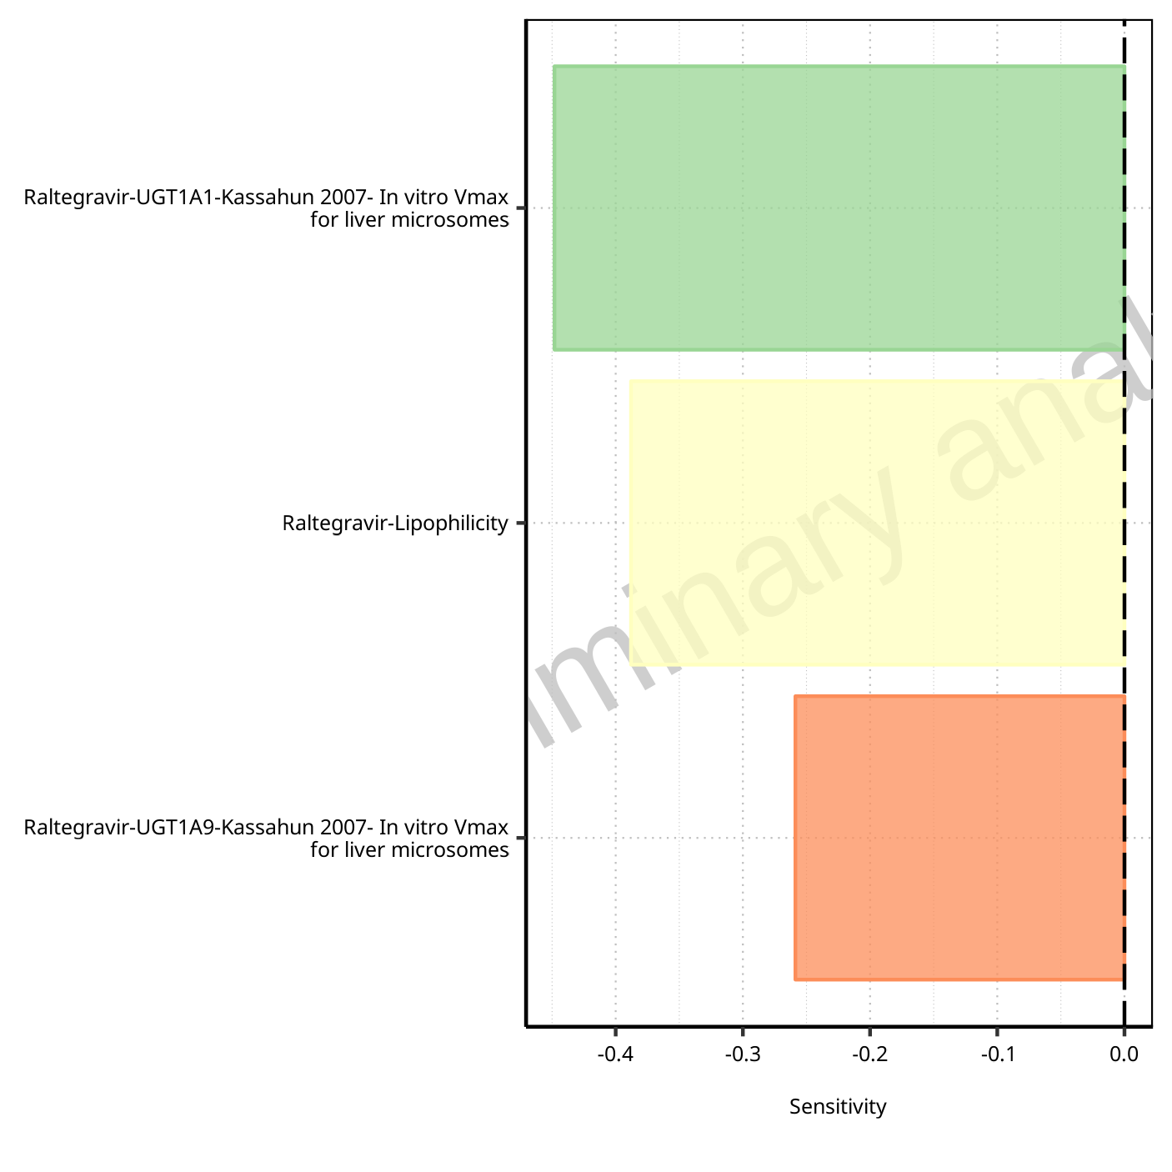

**Figure 1-20: Most sensitive parameters for AUC_tLast_minus_1_tLast of Raltegravir.**

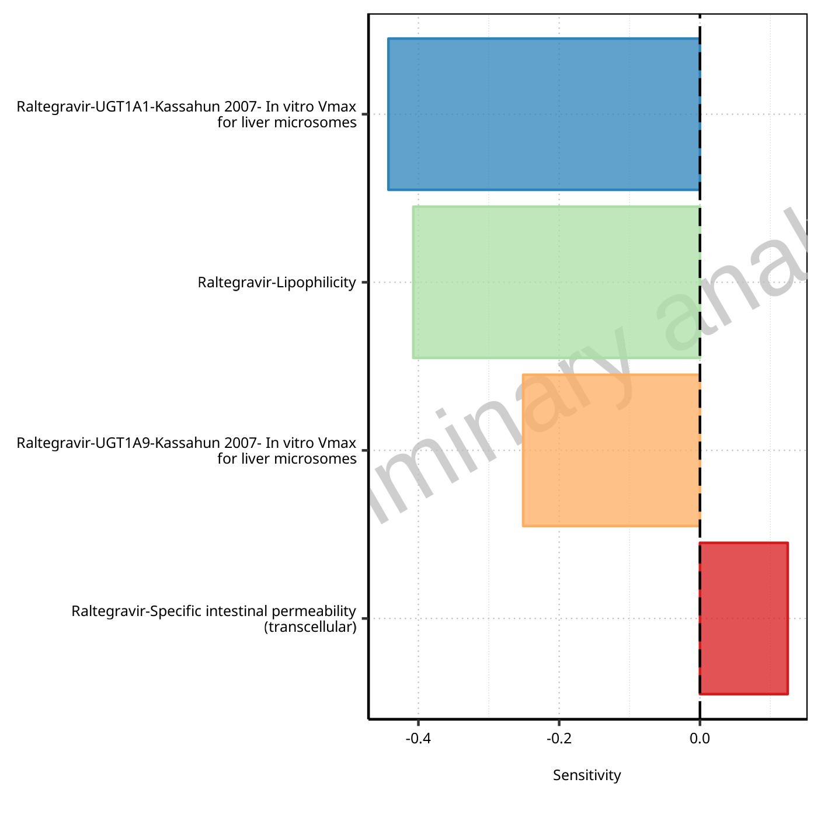

**Figure 1-21: Most sensitive parameters for AUC_inf_t1 of Raltegravir.**

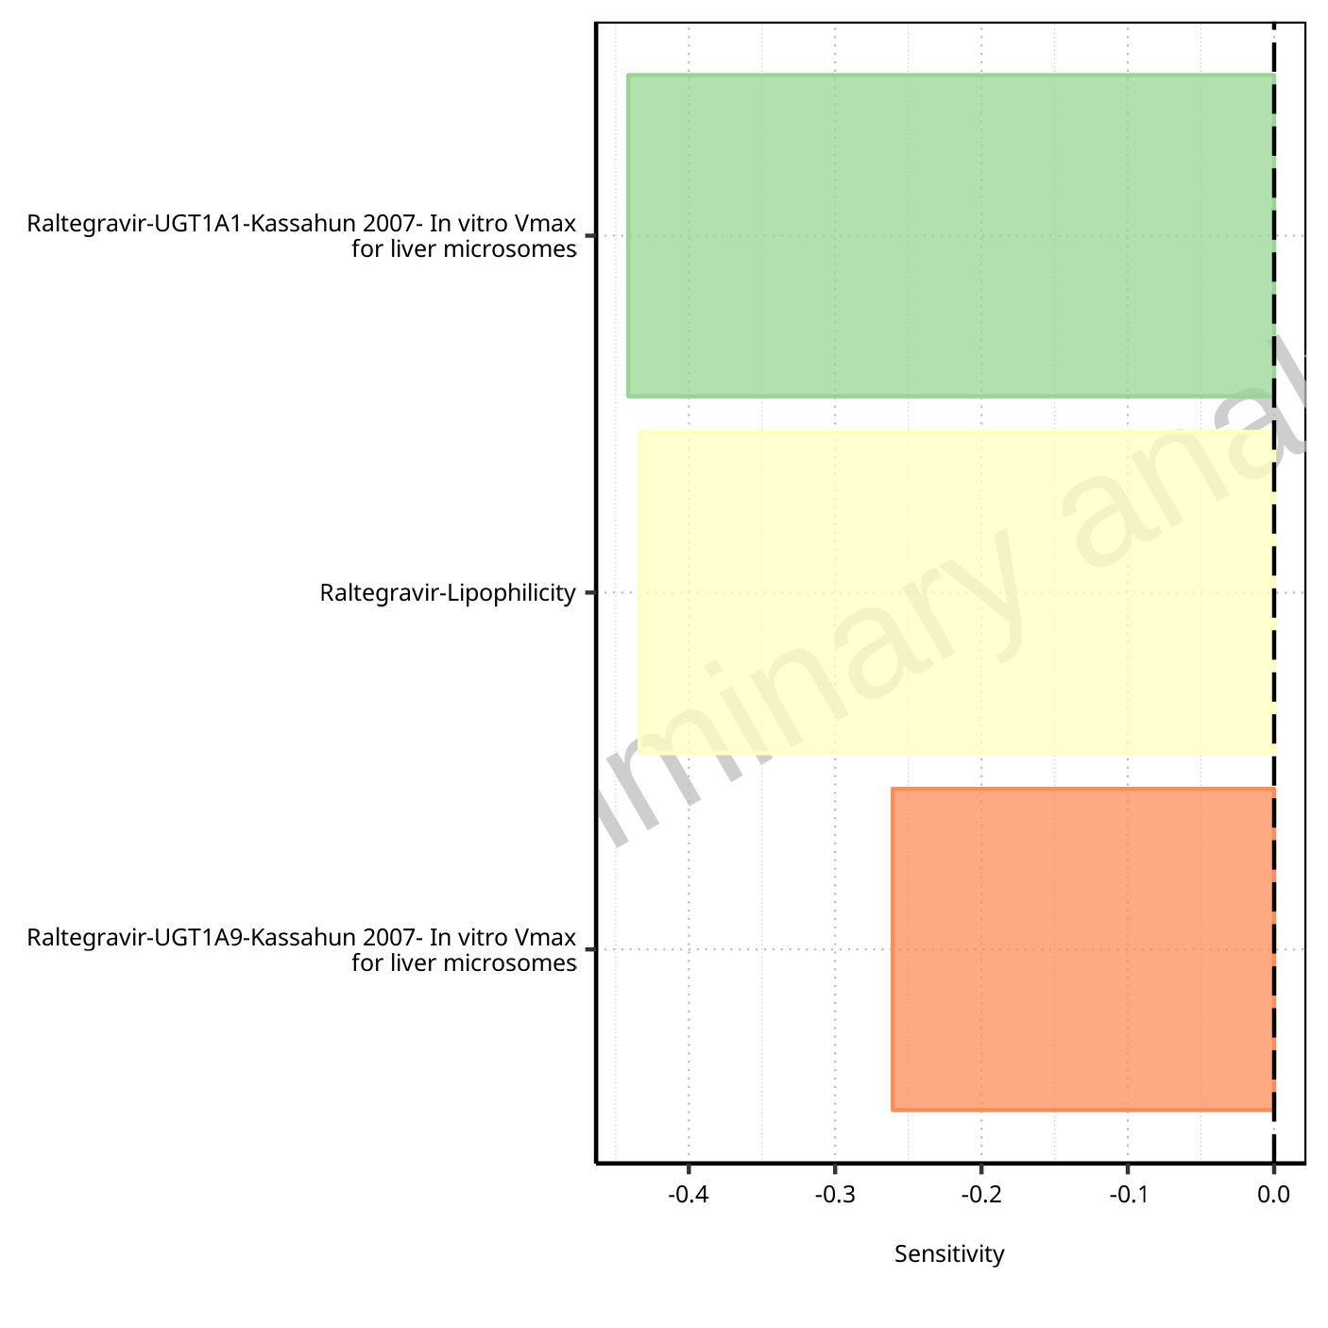

**Figure 1-22: Most sensitive parameters for AUC_inf_tLast of Raltegravir.**

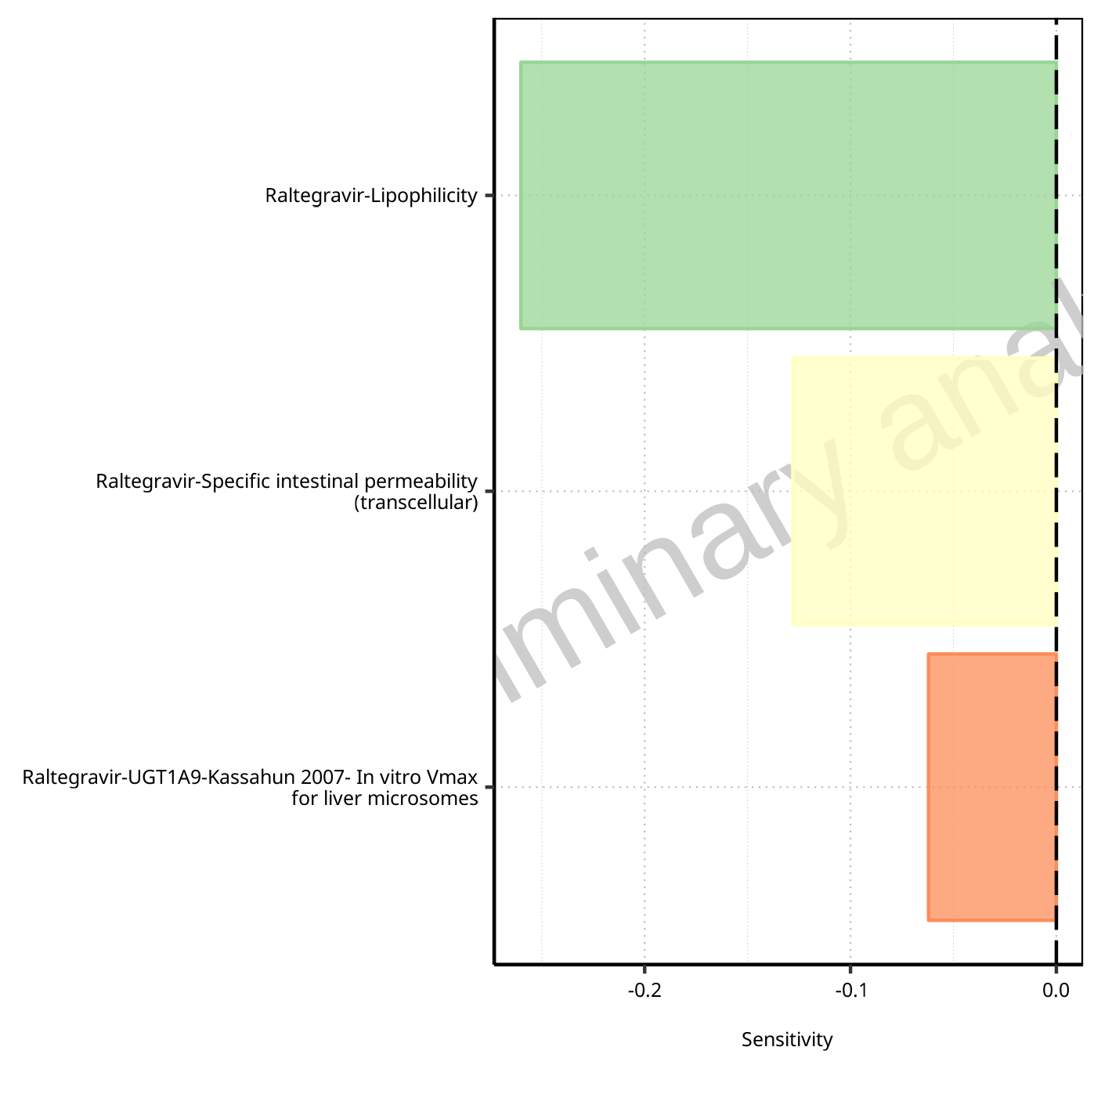

**Figure 1-23: Most sensitive parameters for MRT of Raltegravir.**

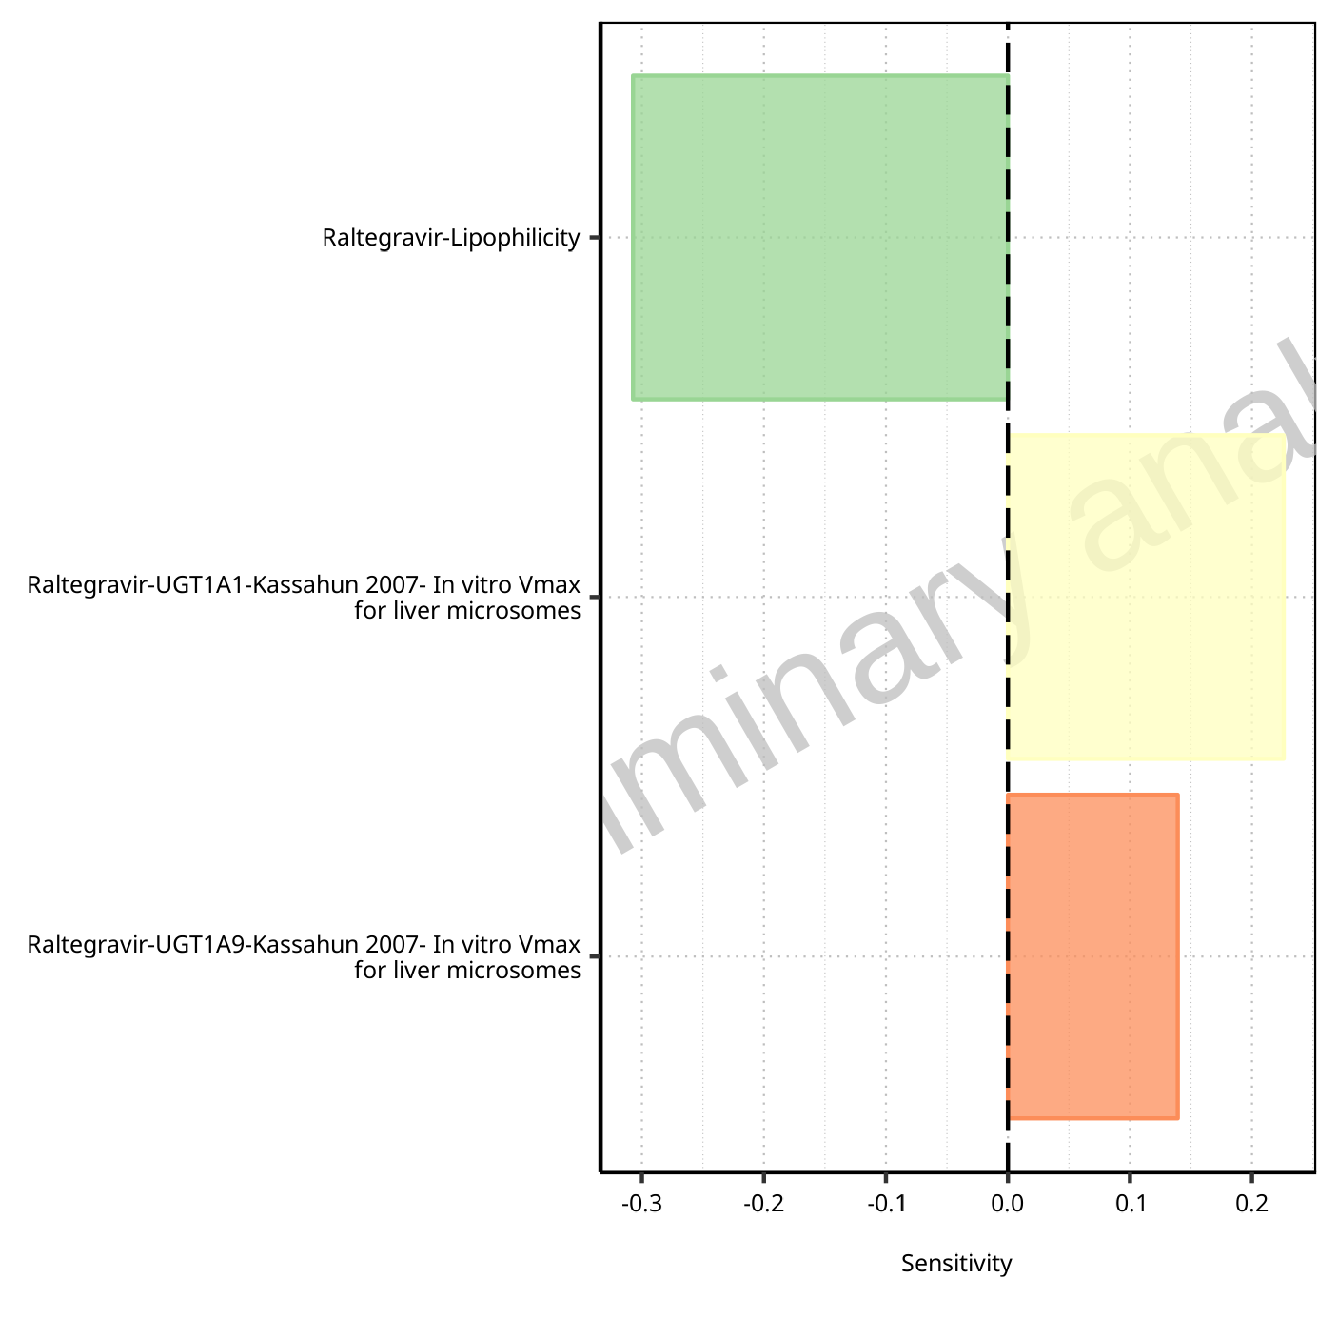

**Figure 1-24: Most sensitive parameters for Thalf of Raltegravir.**

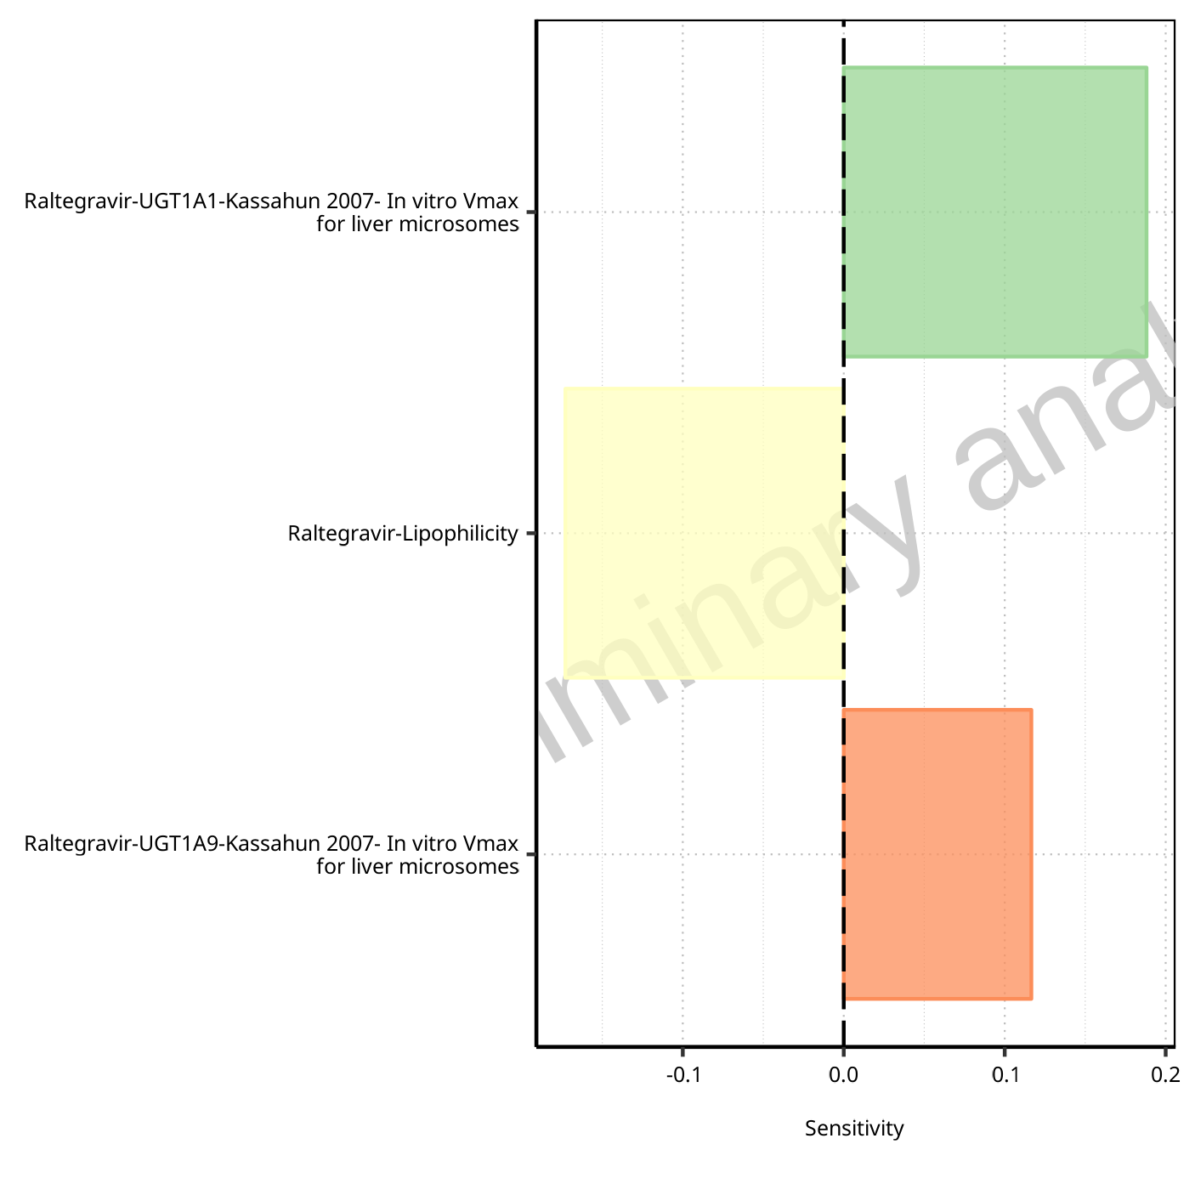

**Figure 1-25: Most sensitive parameters for Thalf_tLast_tEnd of Raltegravir.**

## Sensitivity Analysis for Raltegravir 200 mg filmcoated tablet md

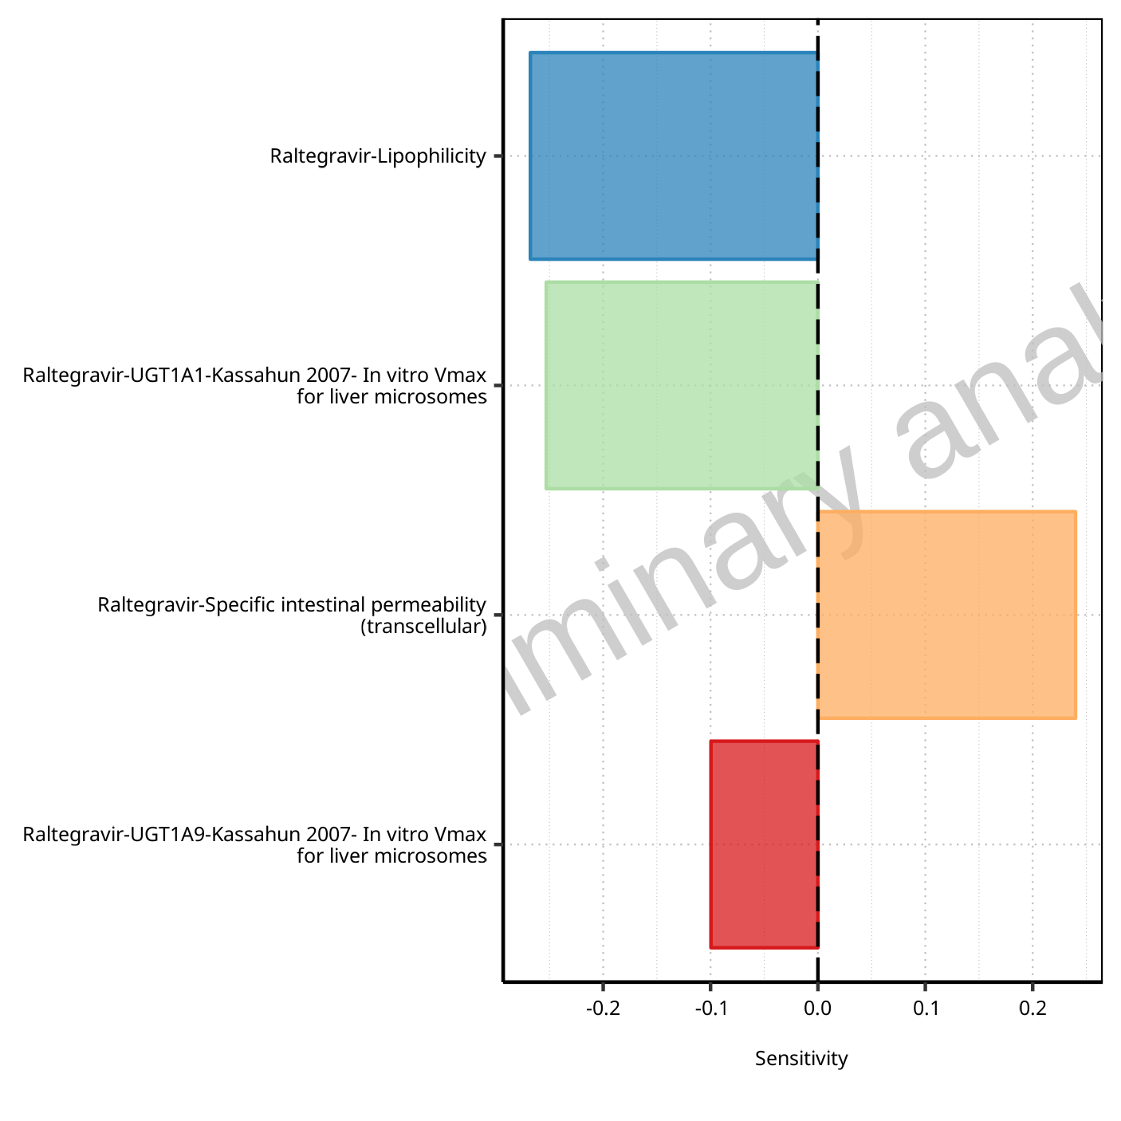

**Figure 1-26: Most sensitive parameters for C_max of Raltegravir.**

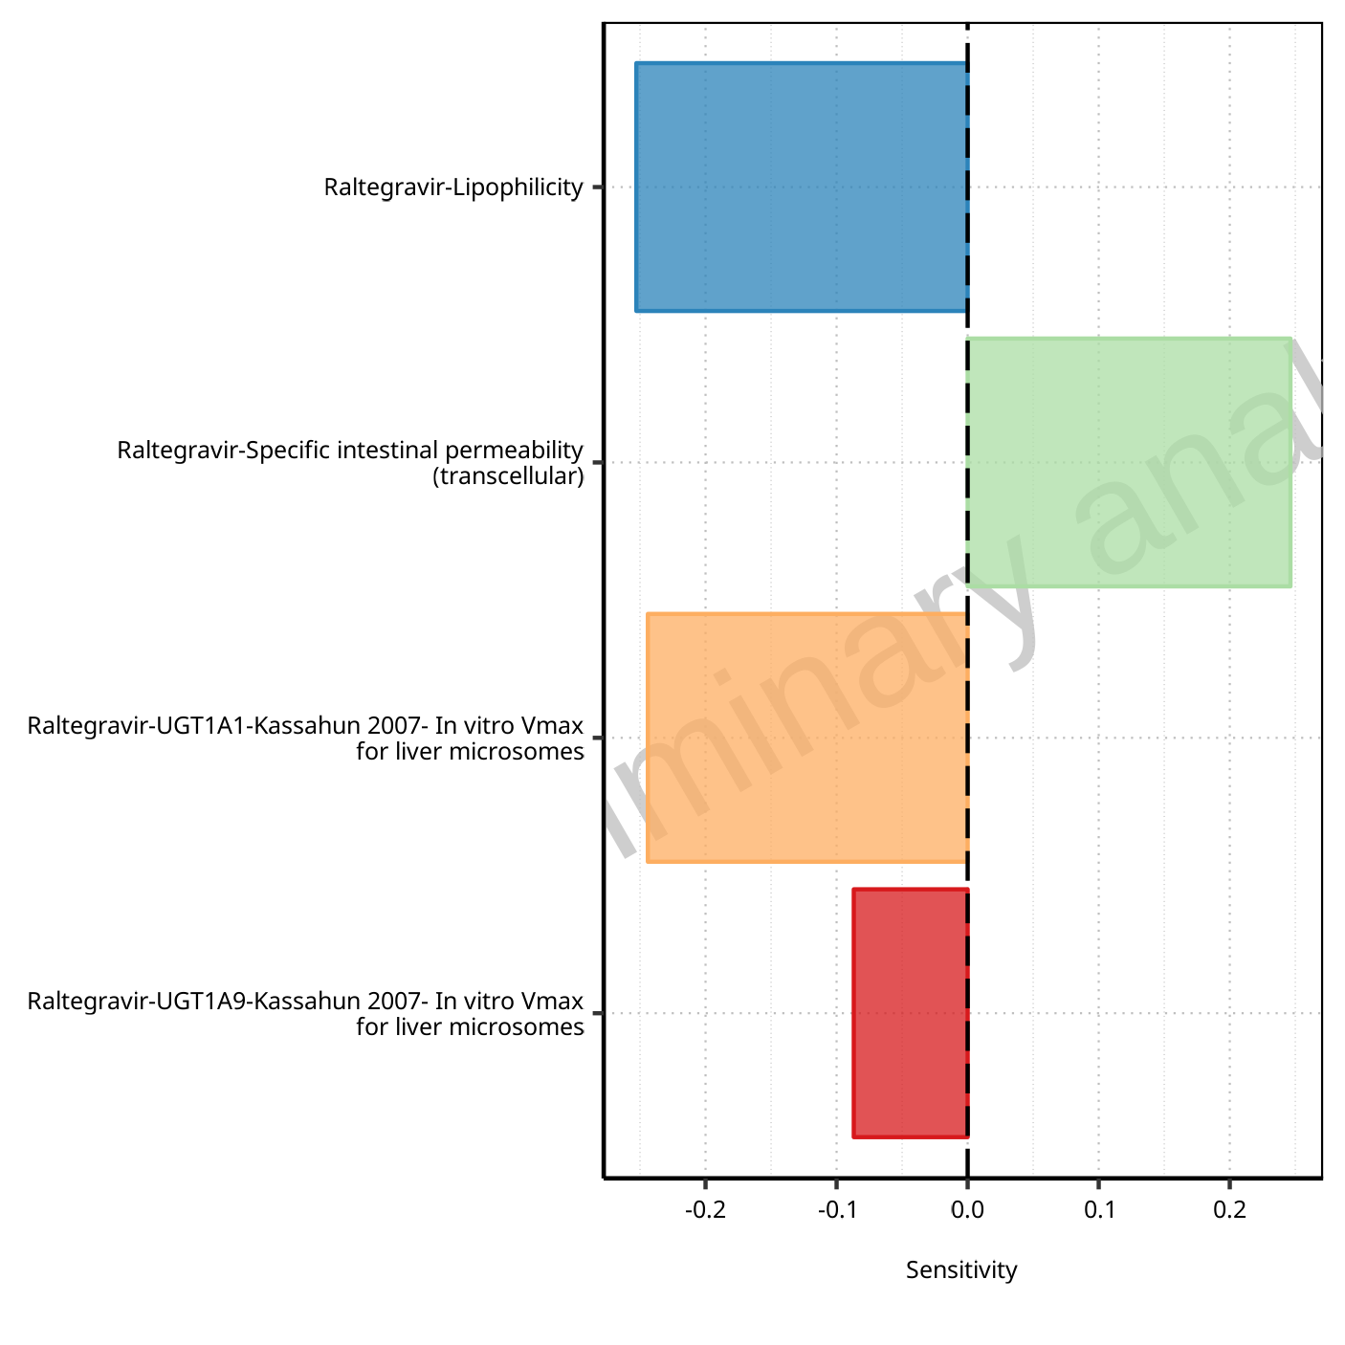

**Figure 1-27: Most sensitive parameters for C_max_t1_t2 of Raltegravir.**

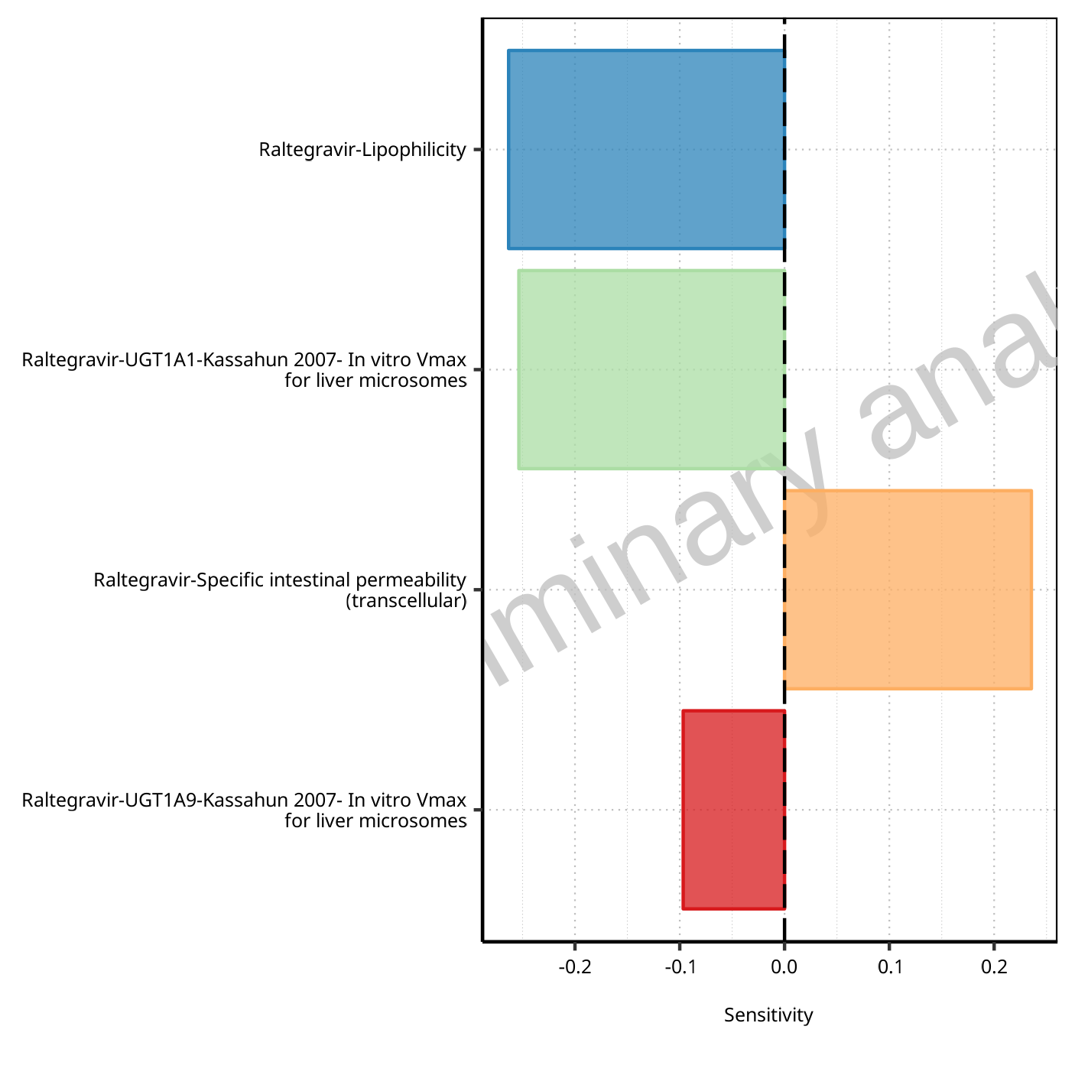

**Figure 1-28: Most sensitive parameters for C_max_tLast_tEnd of Raltegravir.**

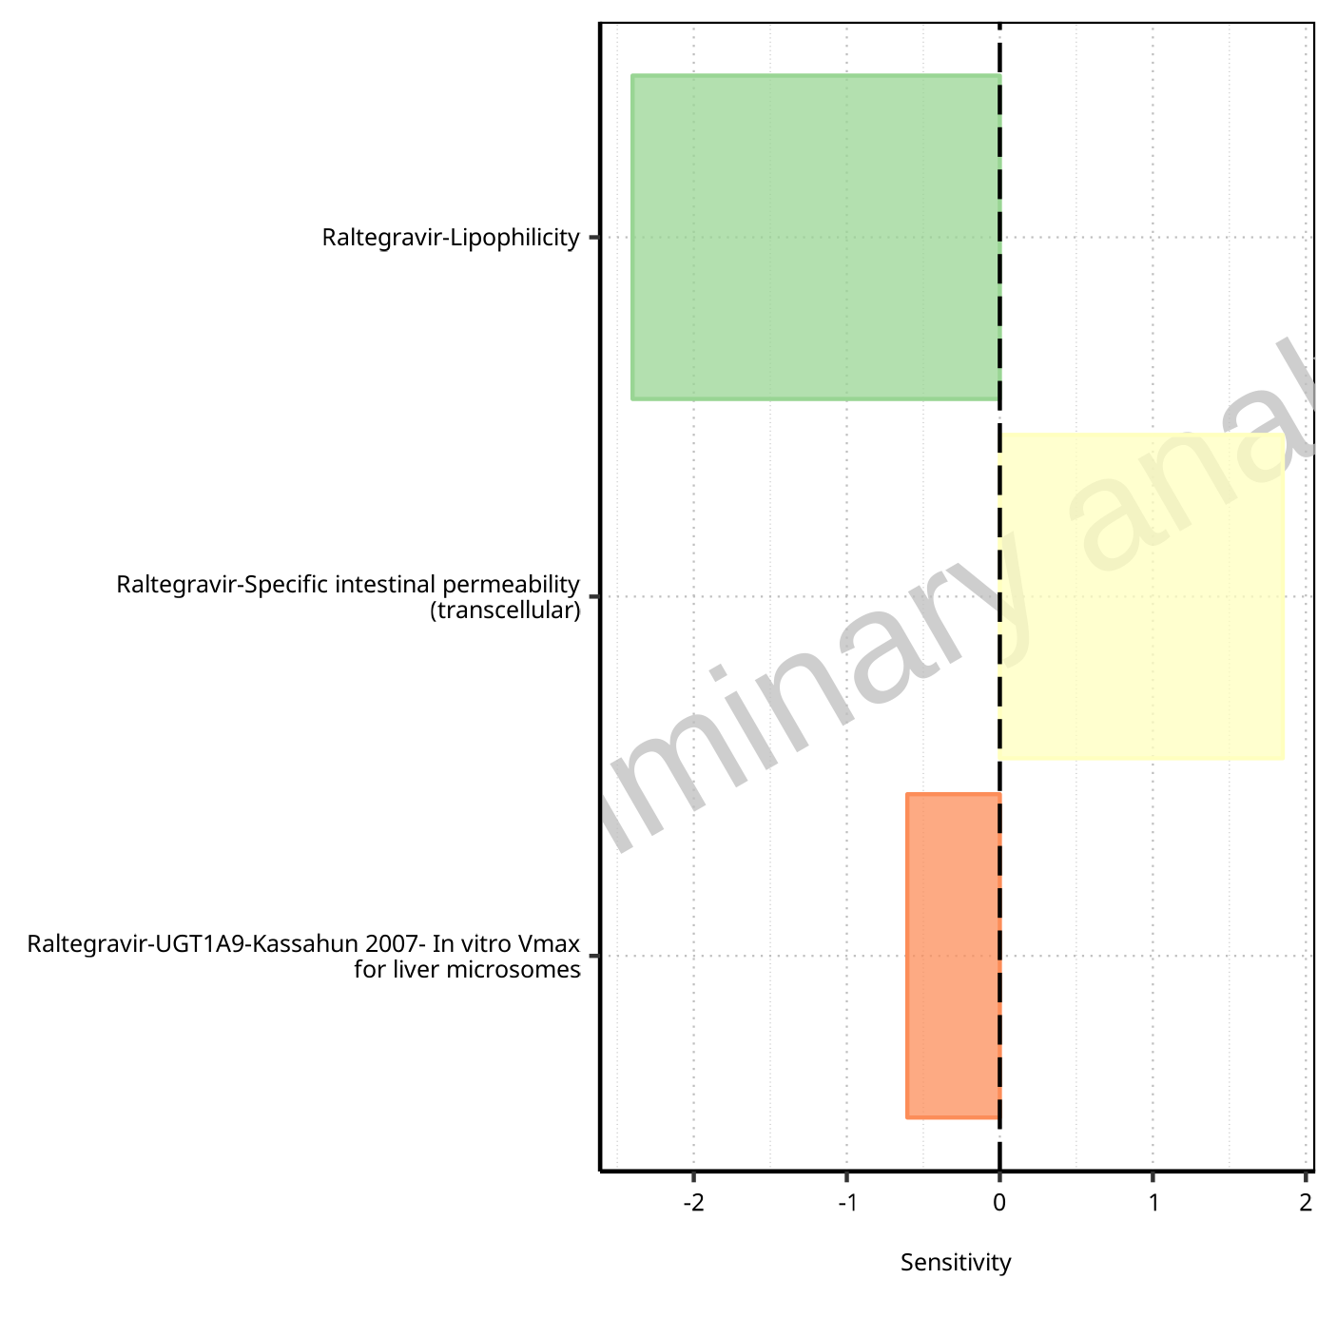

**Figure 1-29: Most sensitive parameters for t_max of Raltegravir.**



**Figure 1-30: Most sensitive parameters for t_max_t1_t2 of Raltegravir.**



**Figure 1-31: Most sensitive parameters for t_max_tLast_tEnd of Raltegravir.**

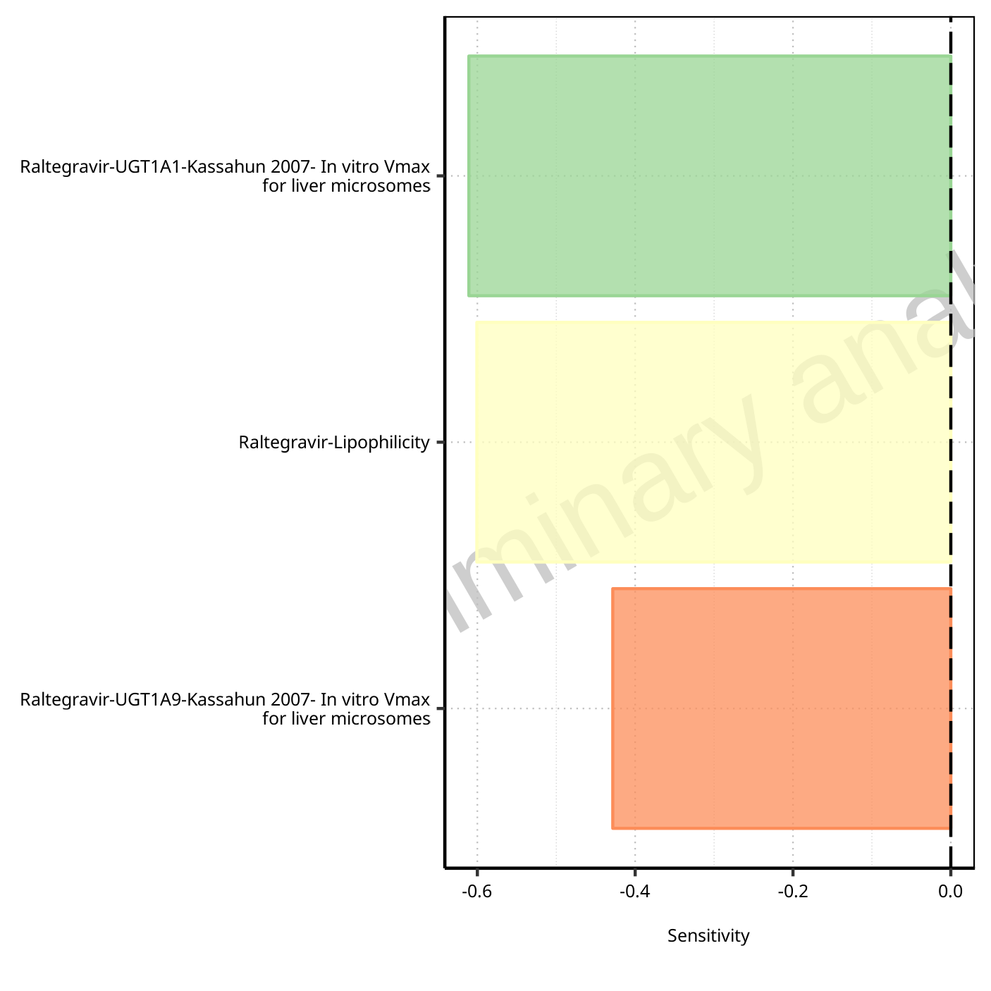

**Figure 1-32: Most sensitive parameters for C_trough_t2 of Raltegravir.**

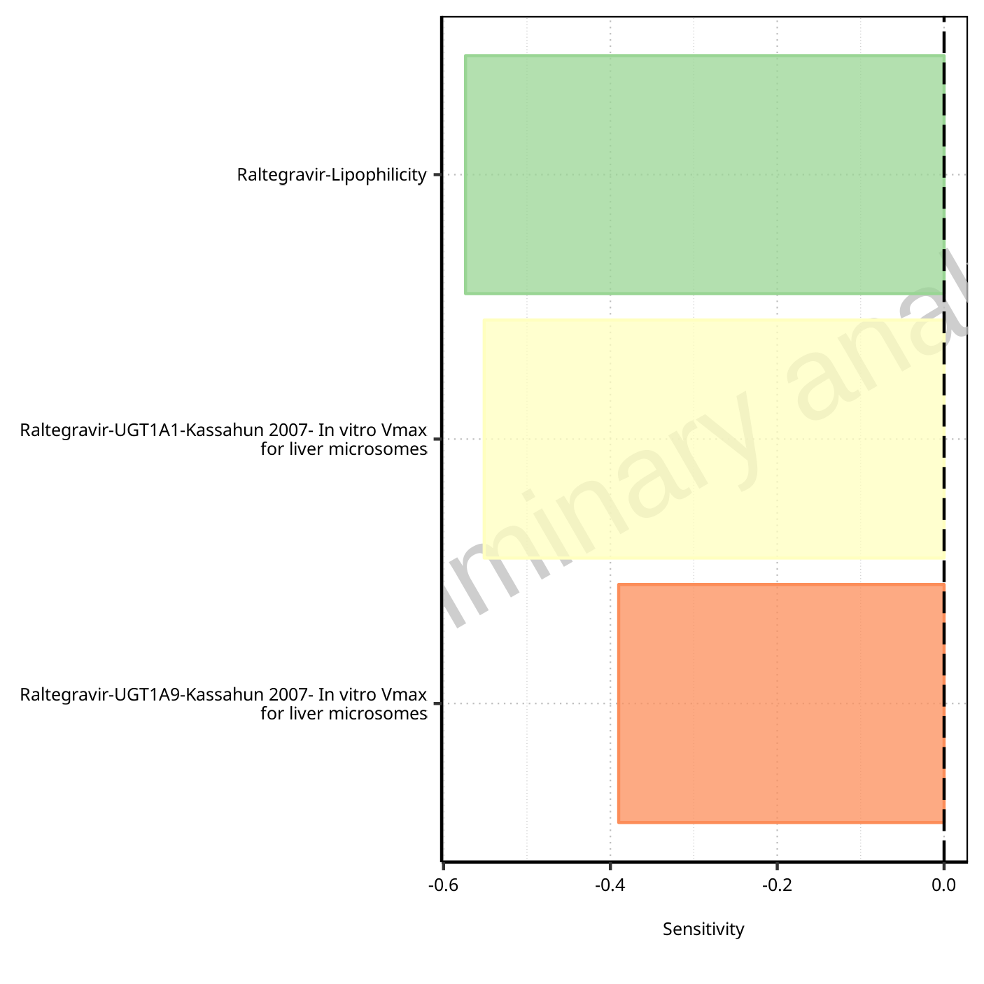

**Figure 1-33: Most sensitive parameters for C_trough_tLast of Raltegravir.**

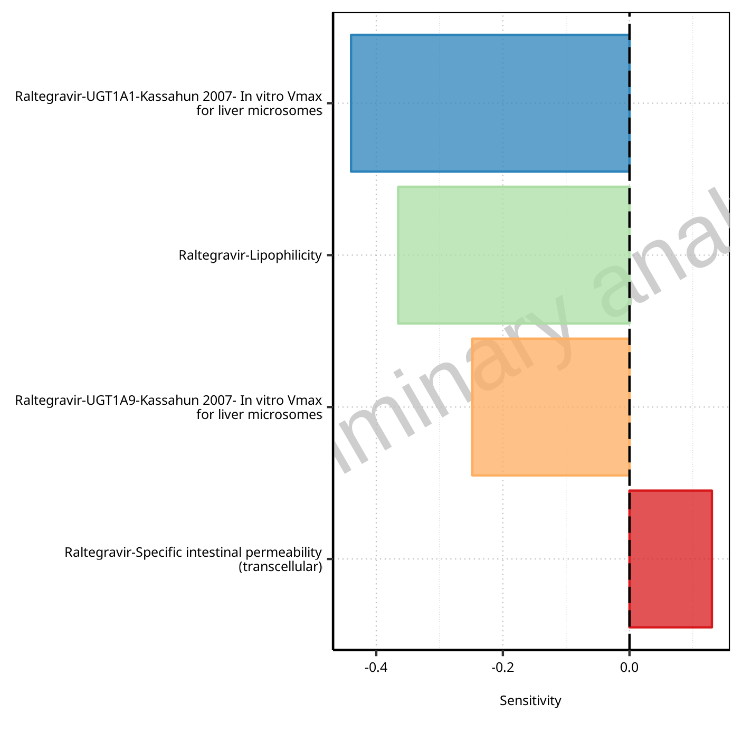

**Figure 1-34: Most sensitive parameters for AUC_t1_t2 of Raltegravir.**

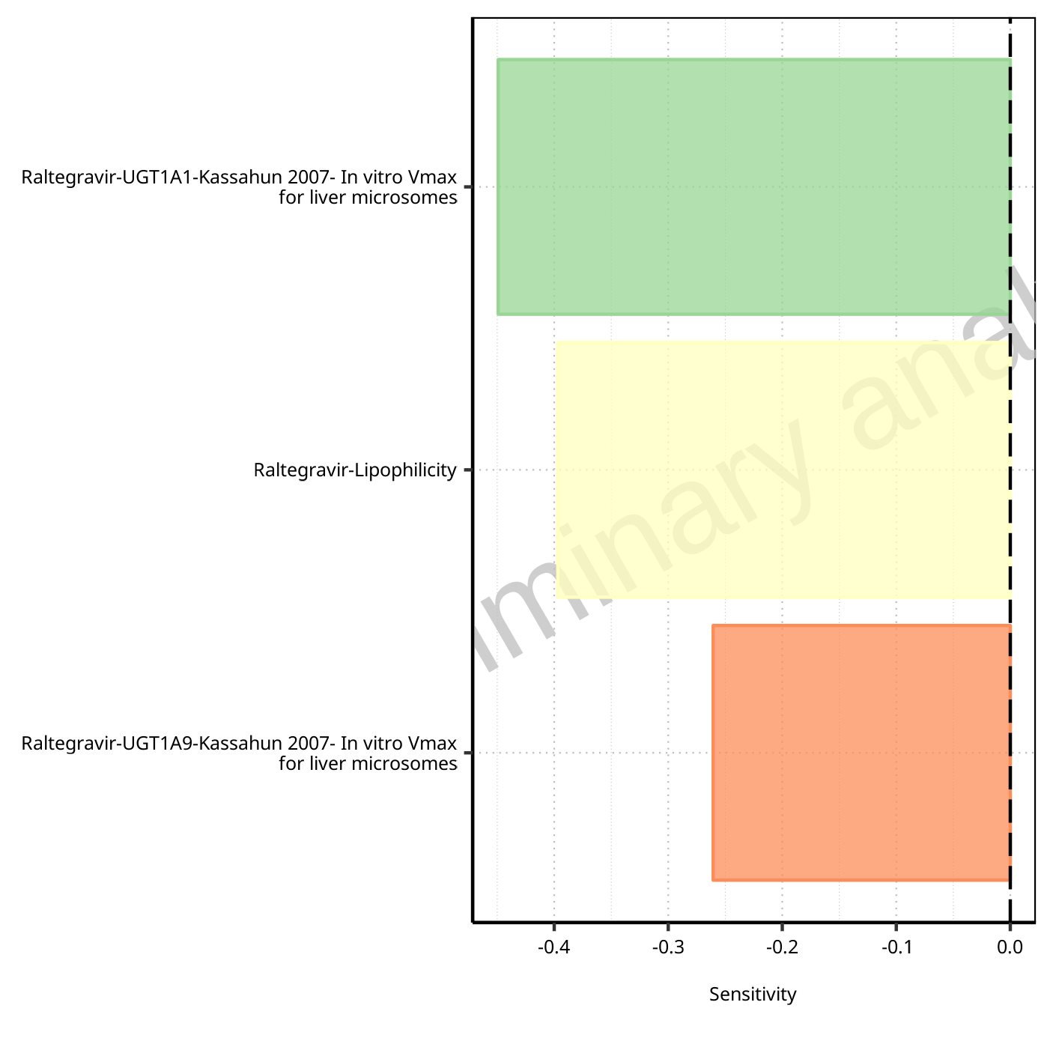

**Figure 1-35: Most sensitive parameters for AUC_tLast_minus_1_tLast of Raltegravir.**

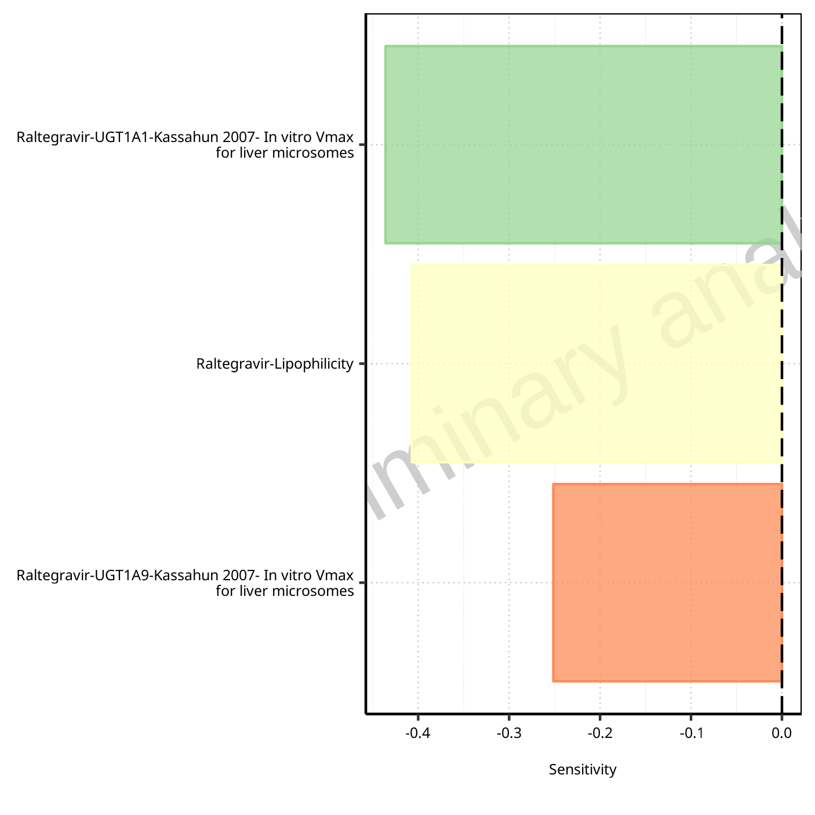

**Figure 1-36: Most sensitive parameters for AUC_inf_t1 of Raltegravir.**

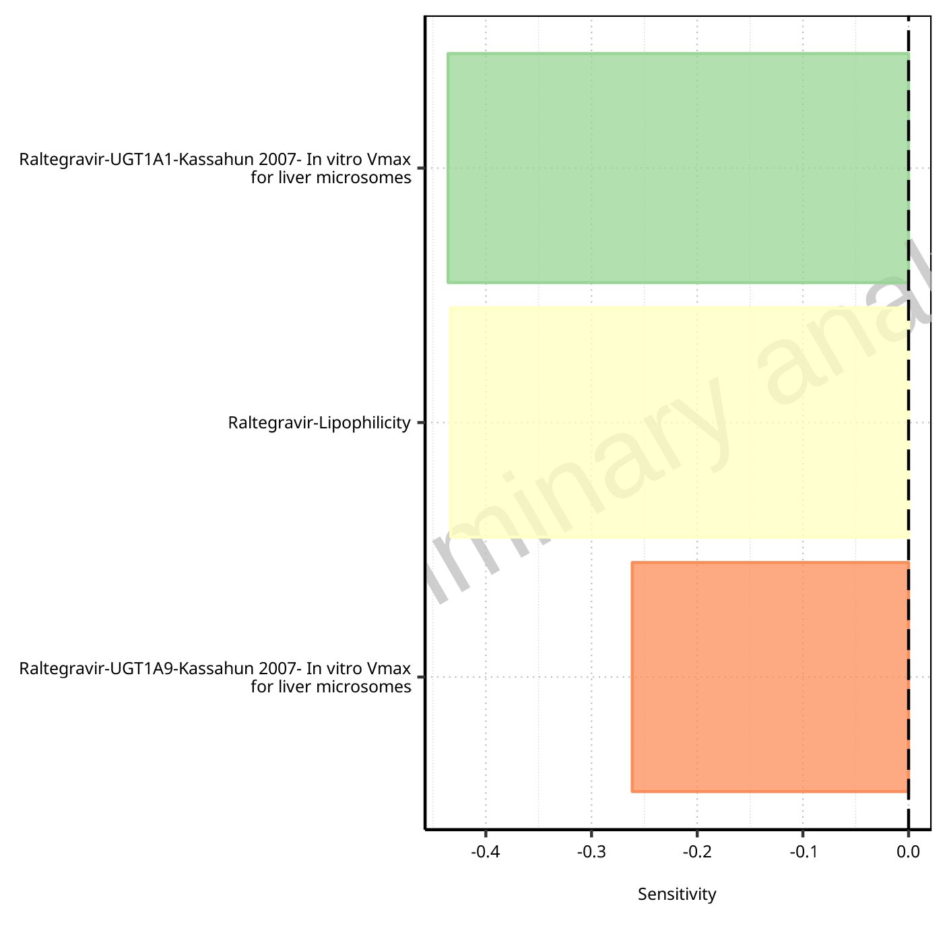

**Figure 1-37: Most sensitive parameters for AUC_inf_tLast of Raltegravir.**

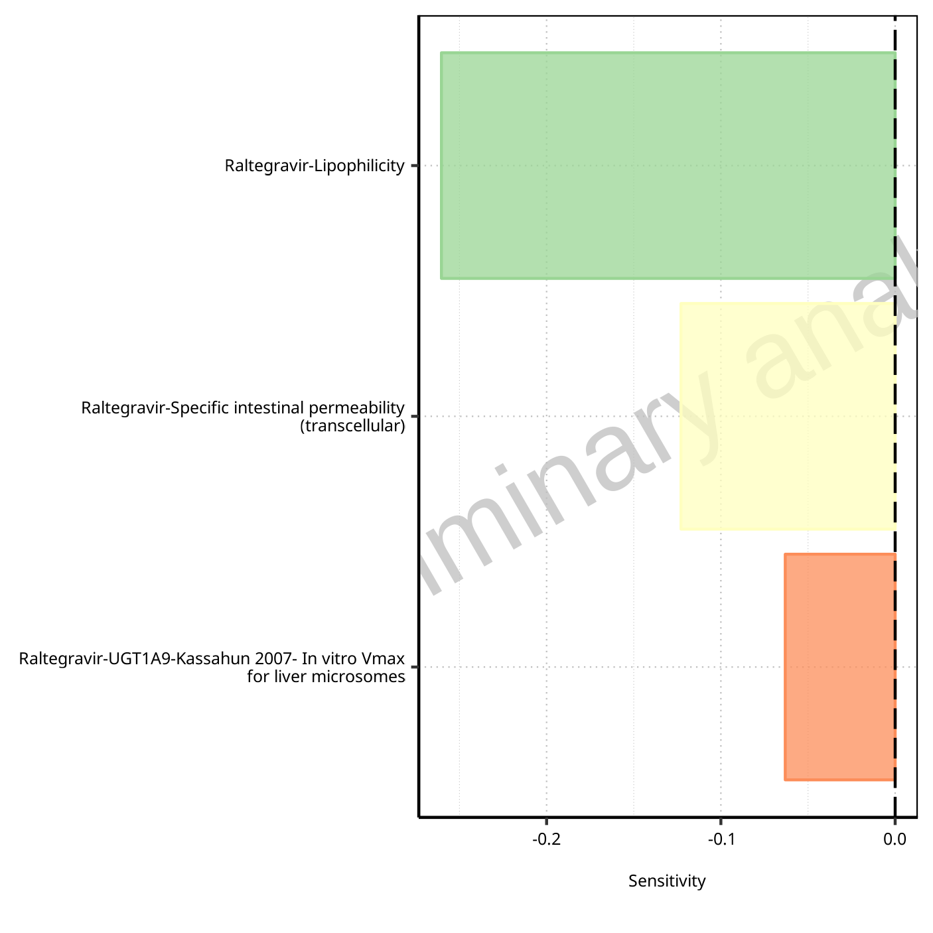

**Figure 1-38: Most sensitive parameters for MRT of Raltegravir.**

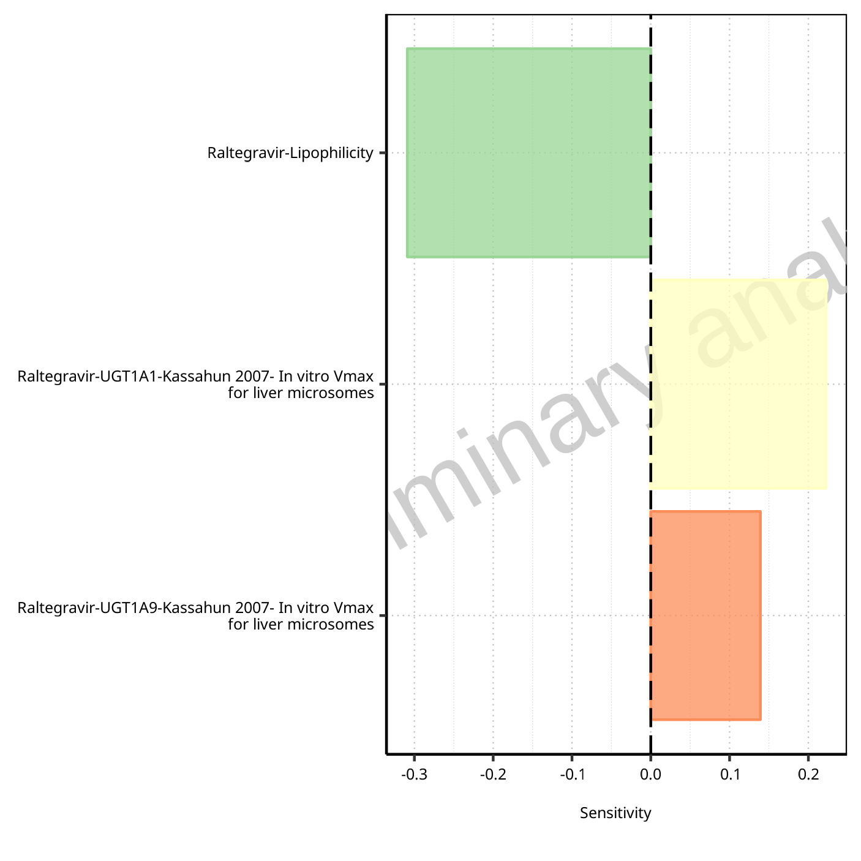

**Figure 1-39: Most sensitive parameters for Thalf of Raltegravir.**

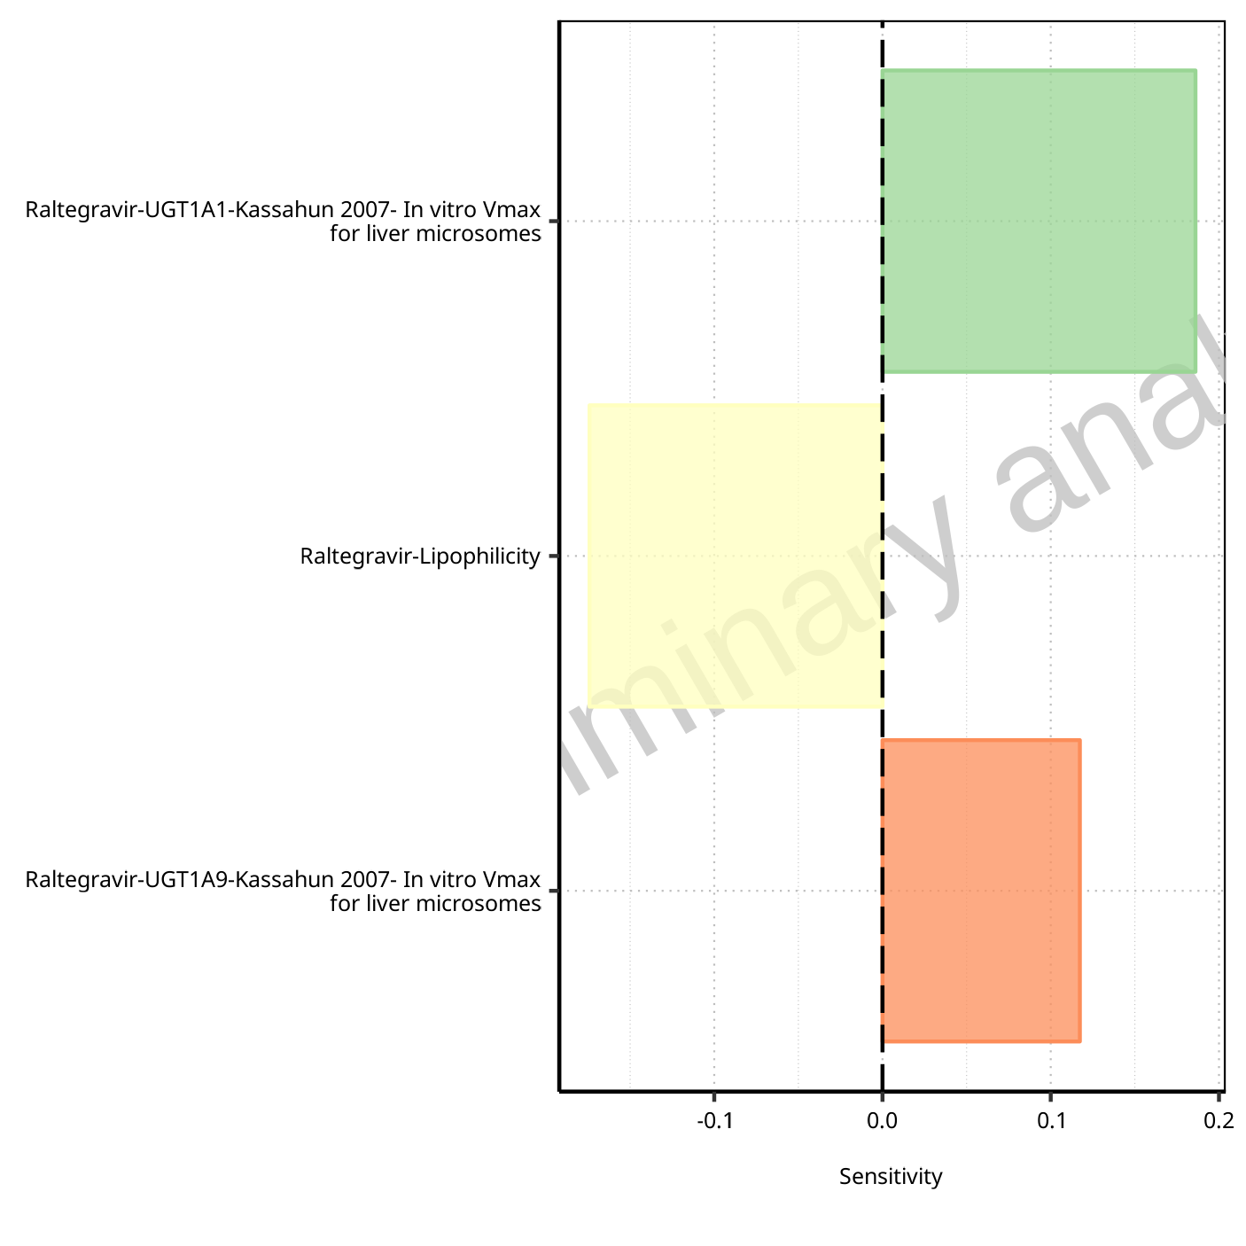

**Figure 1-40: Most sensitive parameters for Thalf_tLast_tEnd of Raltegravir.**

## Sensitivity Analysis for Filmcoated_tablet_400mg_sd

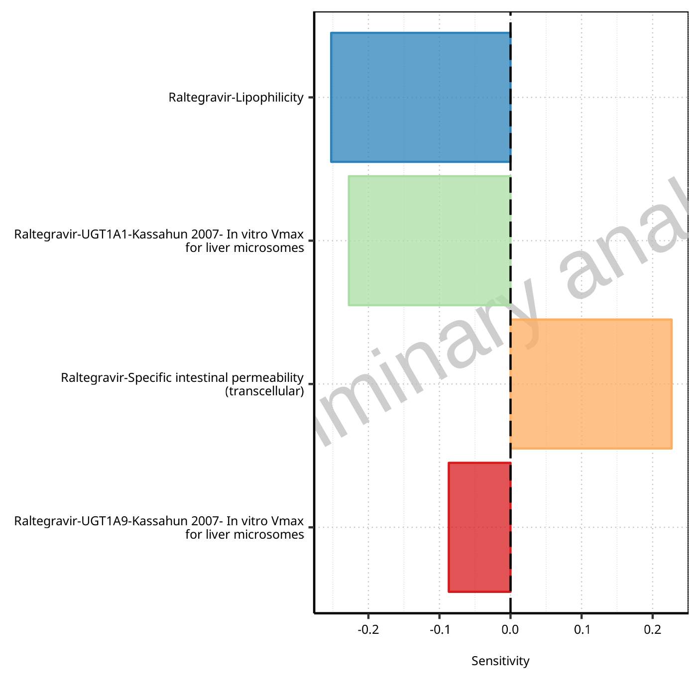

**Figure 1-41: Most sensitive parameters for C_max of Raltegravir.**



**Figure 1-42: Most sensitive parameters for t_max of Raltegravir.**

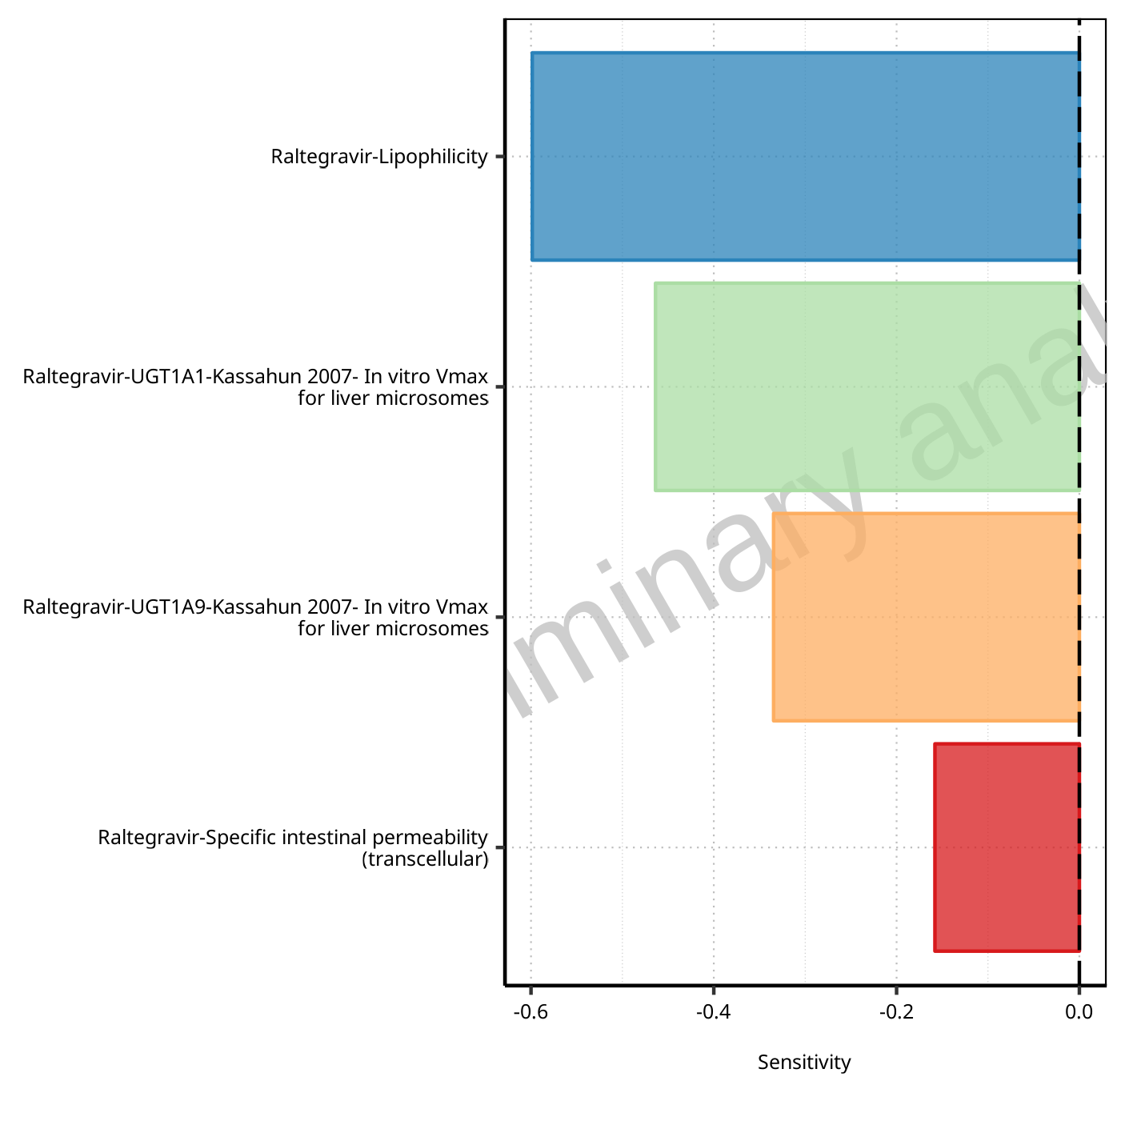

**Figure 1-43: Most sensitive parameters for C_tEnd of Raltegravir.**

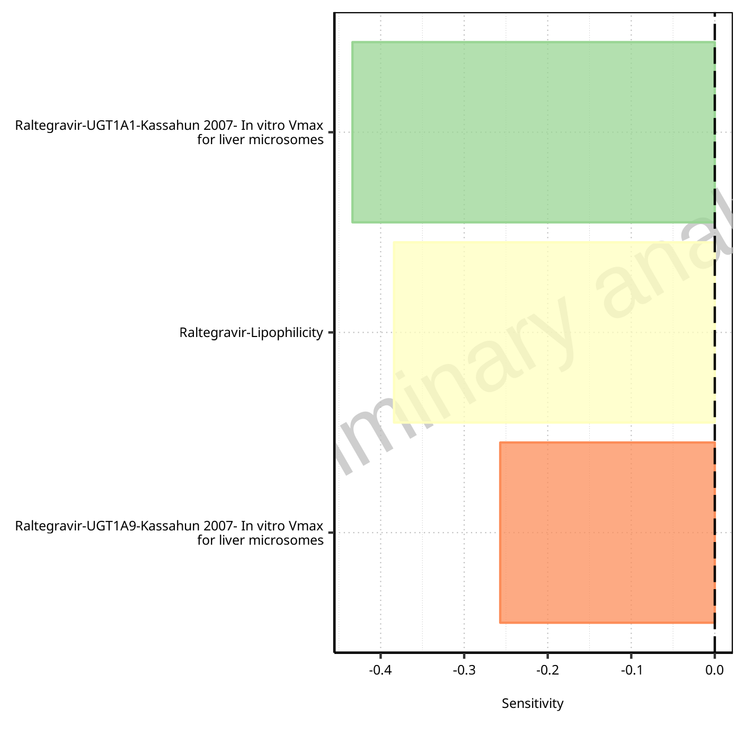

**Figure 1-44: Most sensitive parameters for AUC of Raltegravir.**

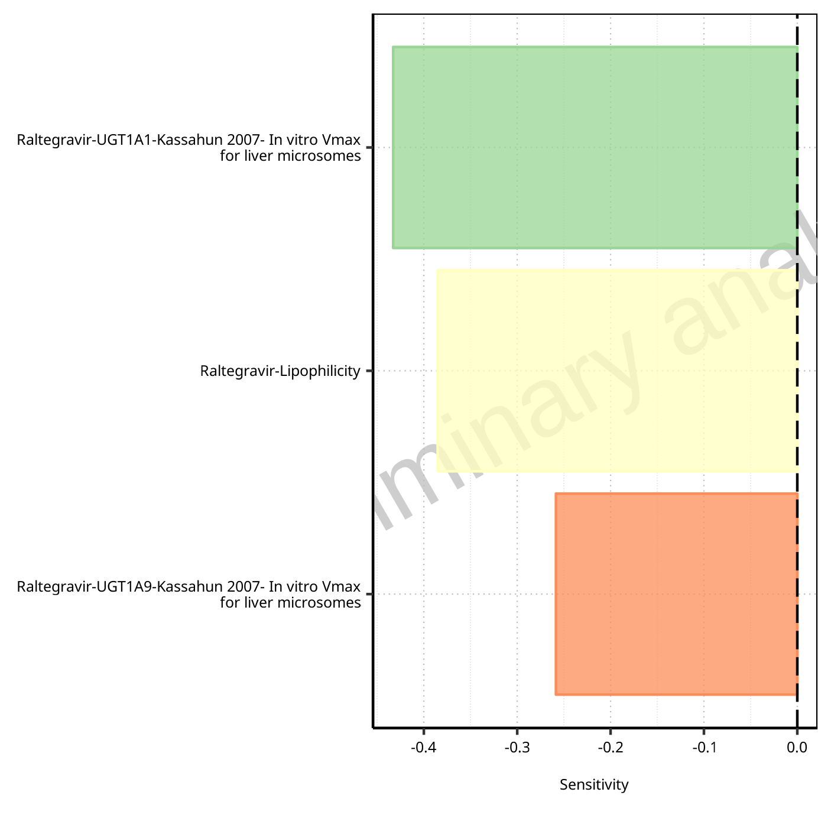

**Figure 1-45: Most sensitive parameters for AUC_inf of Raltegravir.**

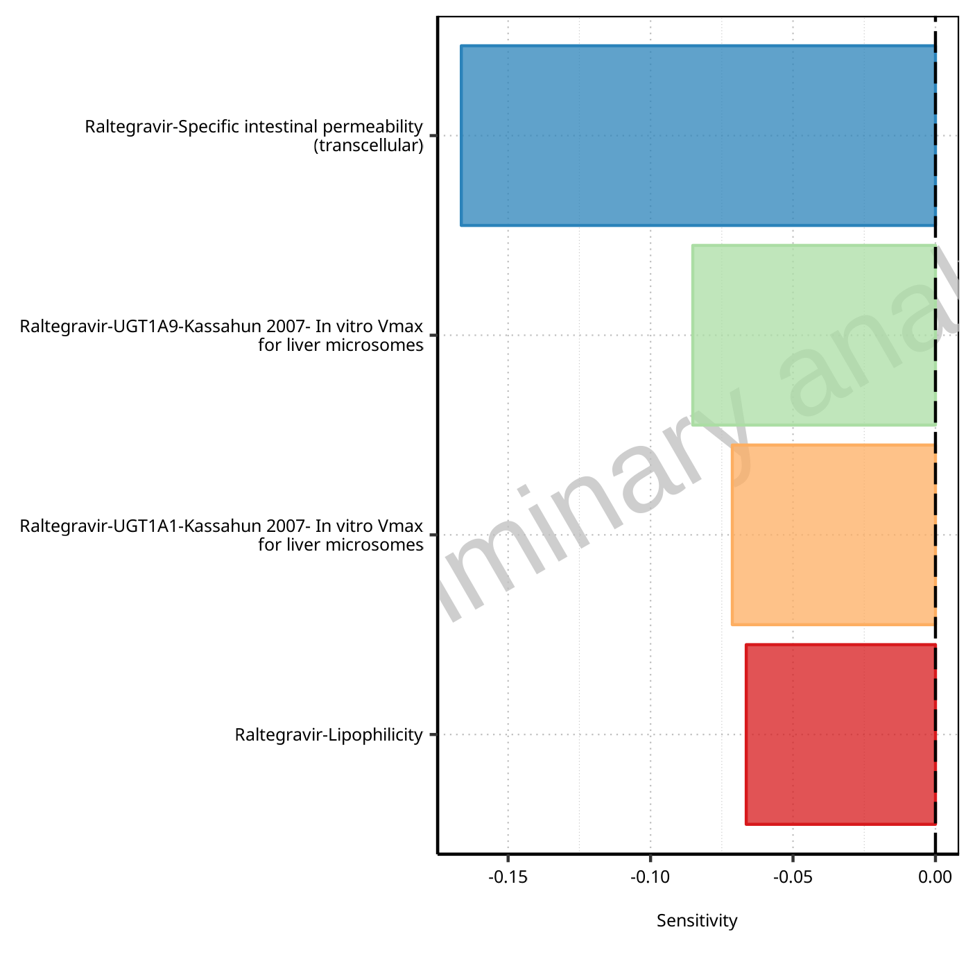

**Figure 1-46: Most sensitive parameters for MRT of Raltegravir.**

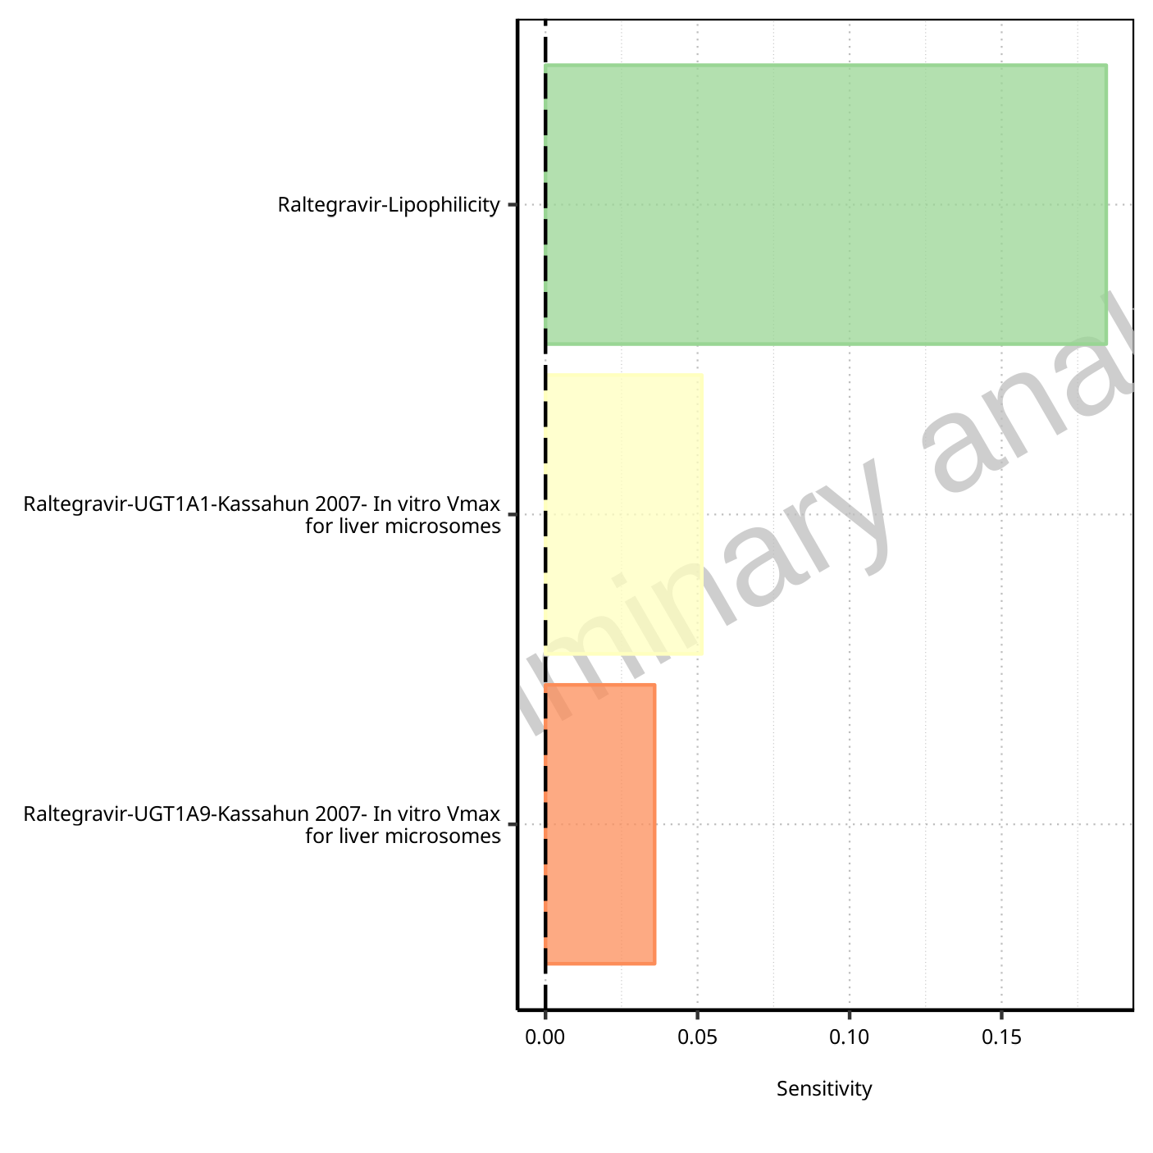

**Figure 1-47: Most sensitive parameters for Thalf of Raltegravir.**

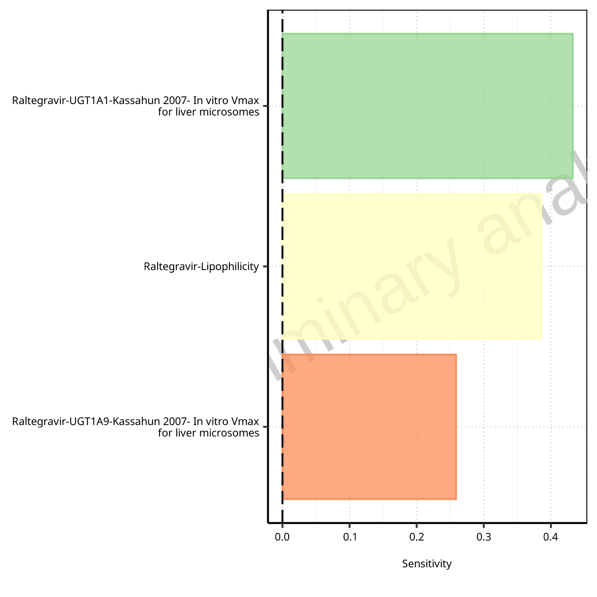

**Figure 1-48: Most sensitive parameters for CL of Raltegravir.**

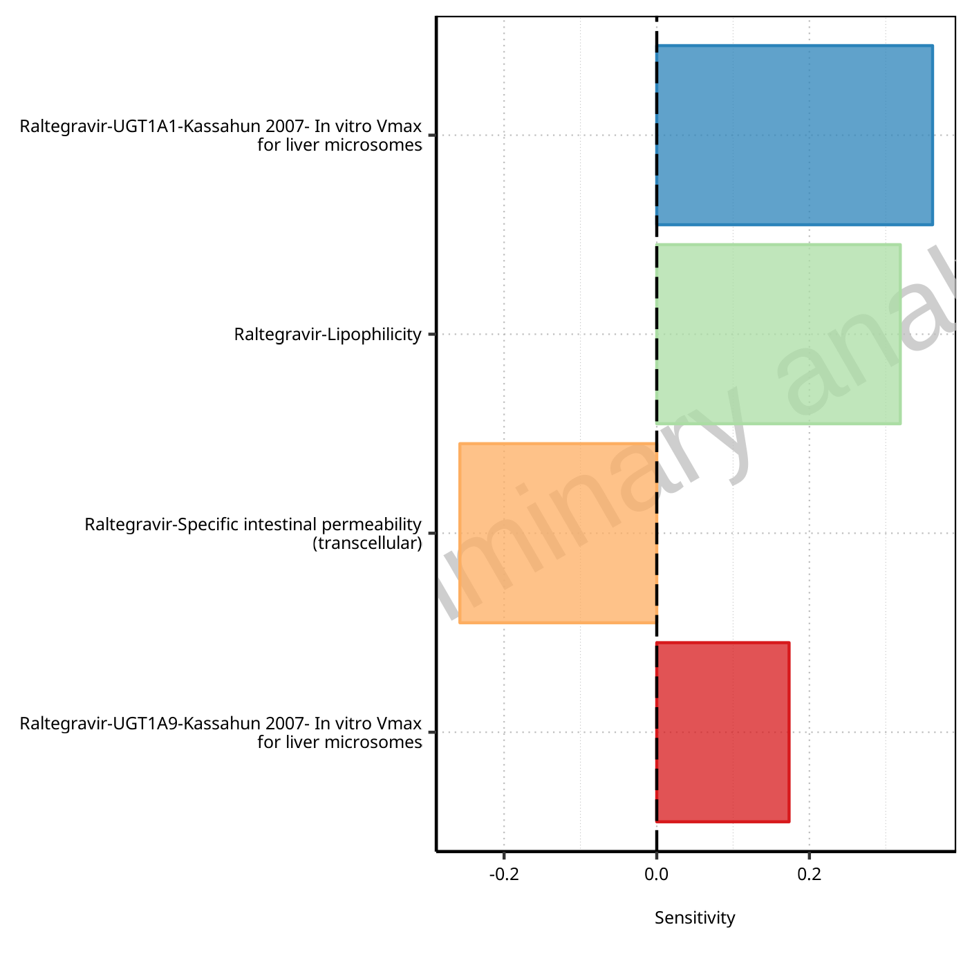

**Figure 1-49: Most sensitive parameters for Vss of Raltegravir.**

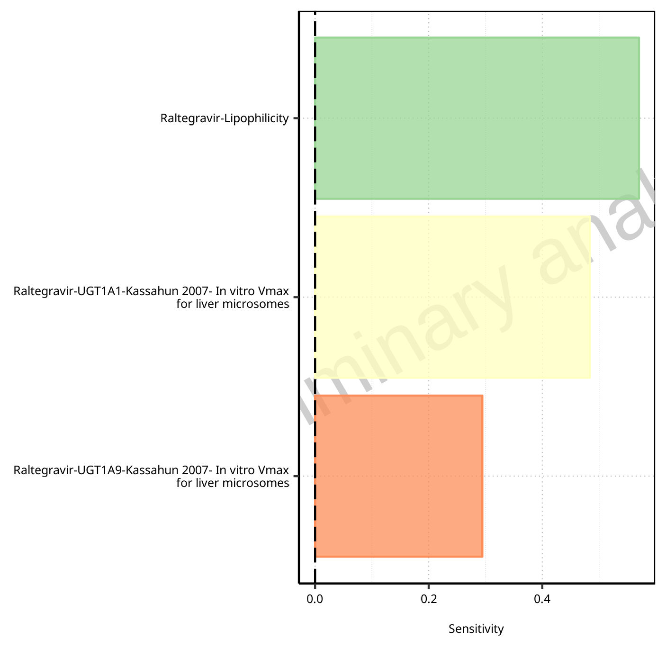

**Figure 1-50: Most sensitive parameters for Vd of Raltegravir.**

## Sensitivity Analysis for Raltegravir 400 mg filmcoated tablet md

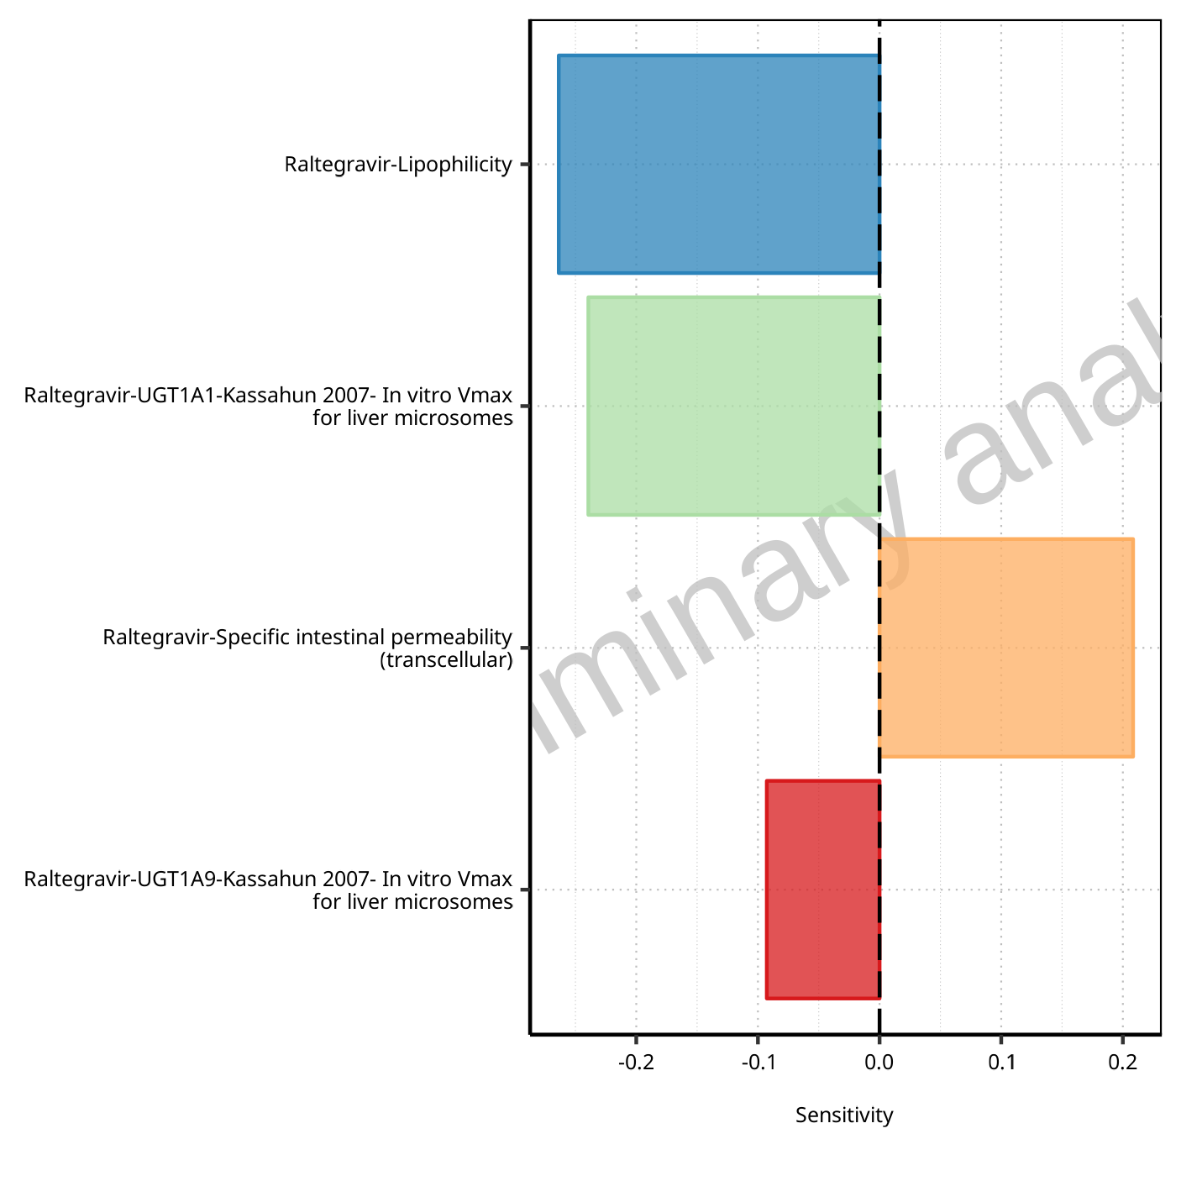

**Figure 1-51: Most sensitive parameters for C_max of Raltegravir.**

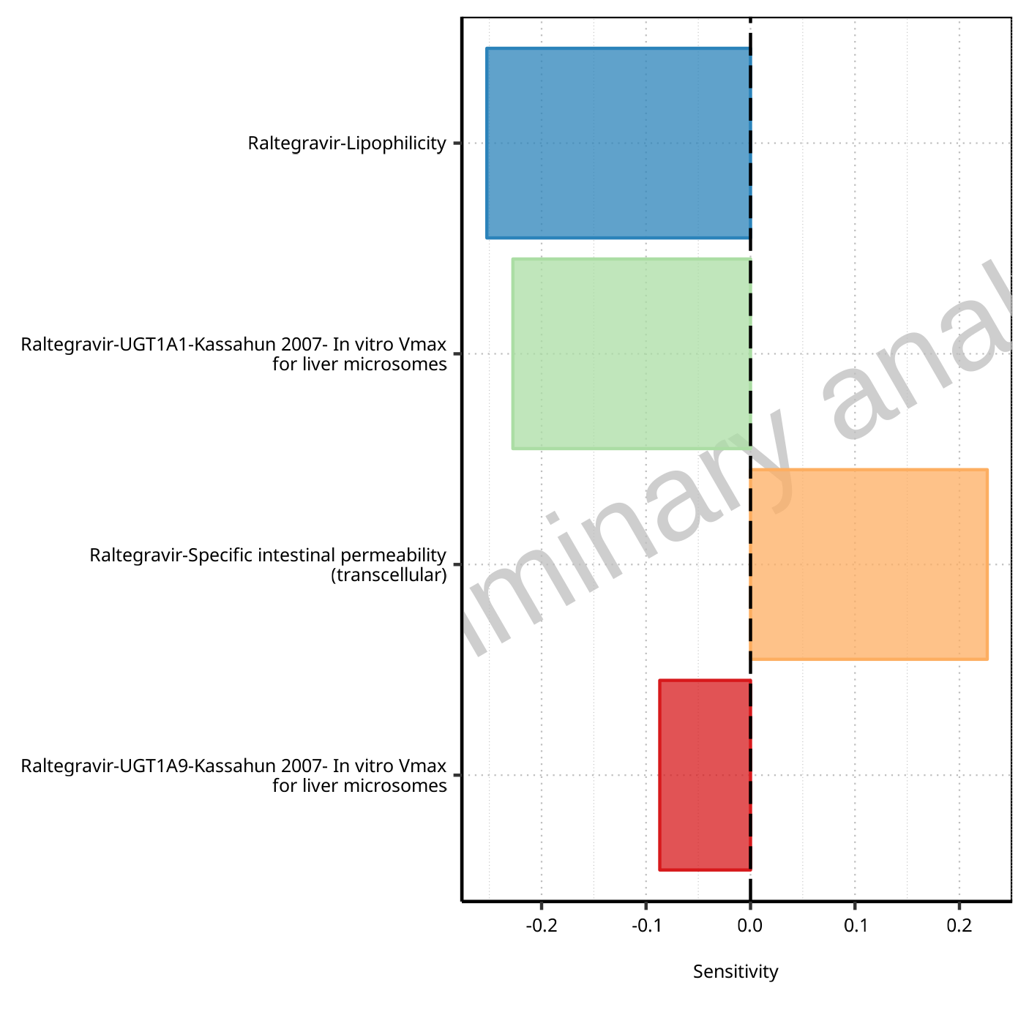

**Figure 1-52: Most sensitive parameters for C_max_t1_t2 of Raltegravir.**

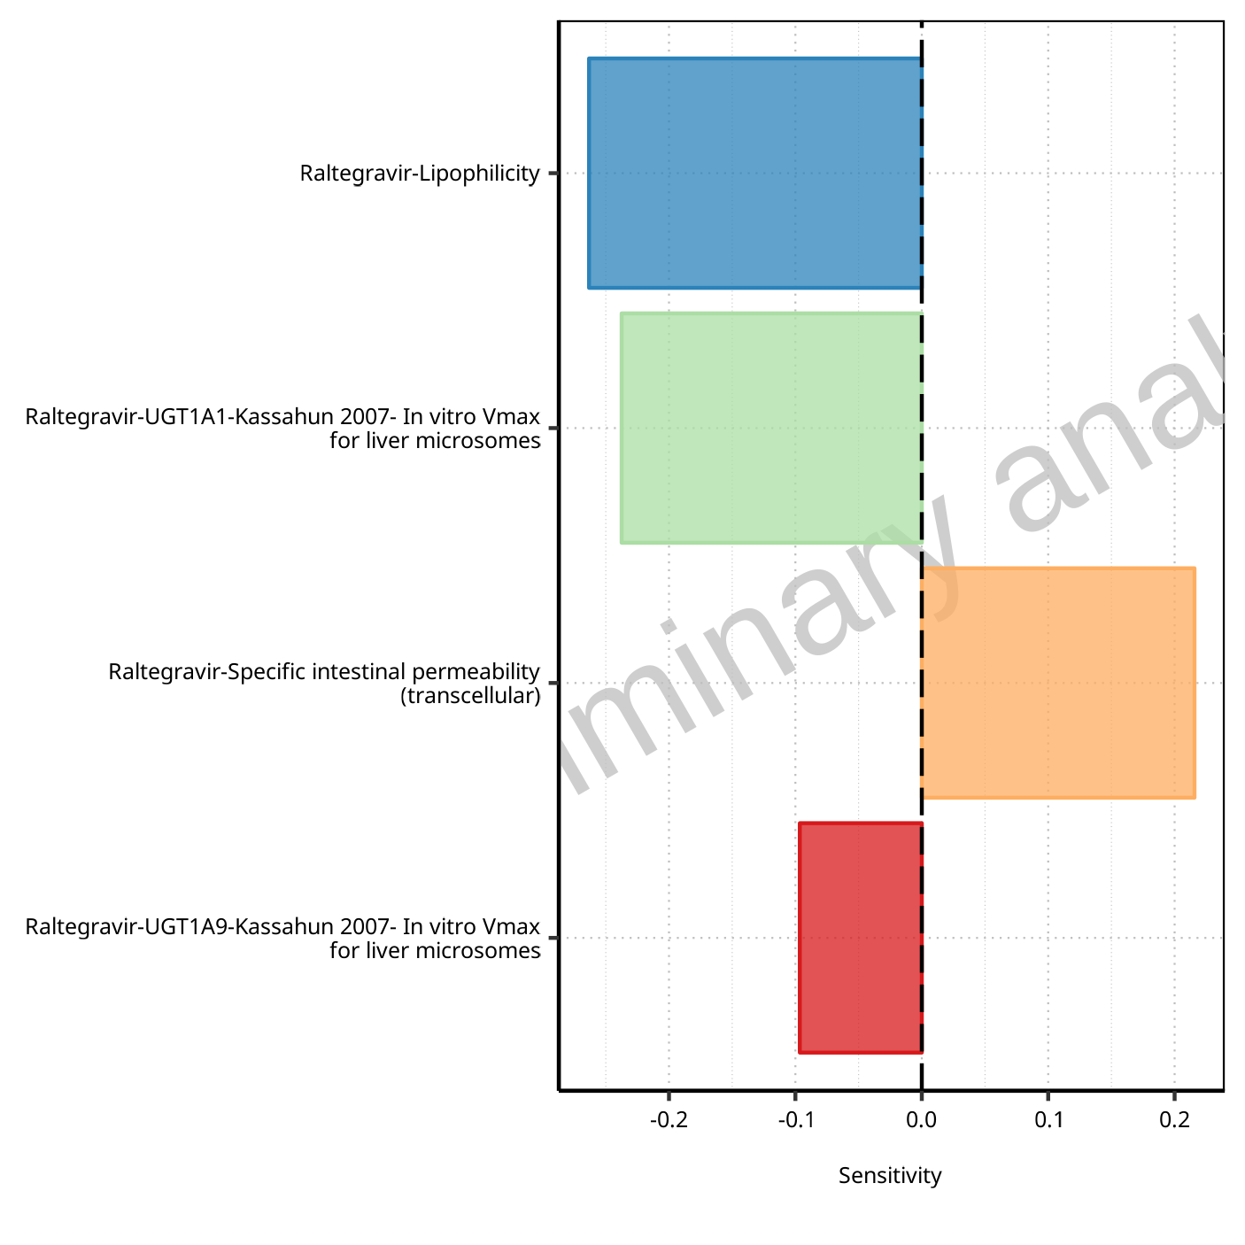

**Figure 1-53: Most sensitive parameters for C_max_tLast_tEnd of Raltegravir.**

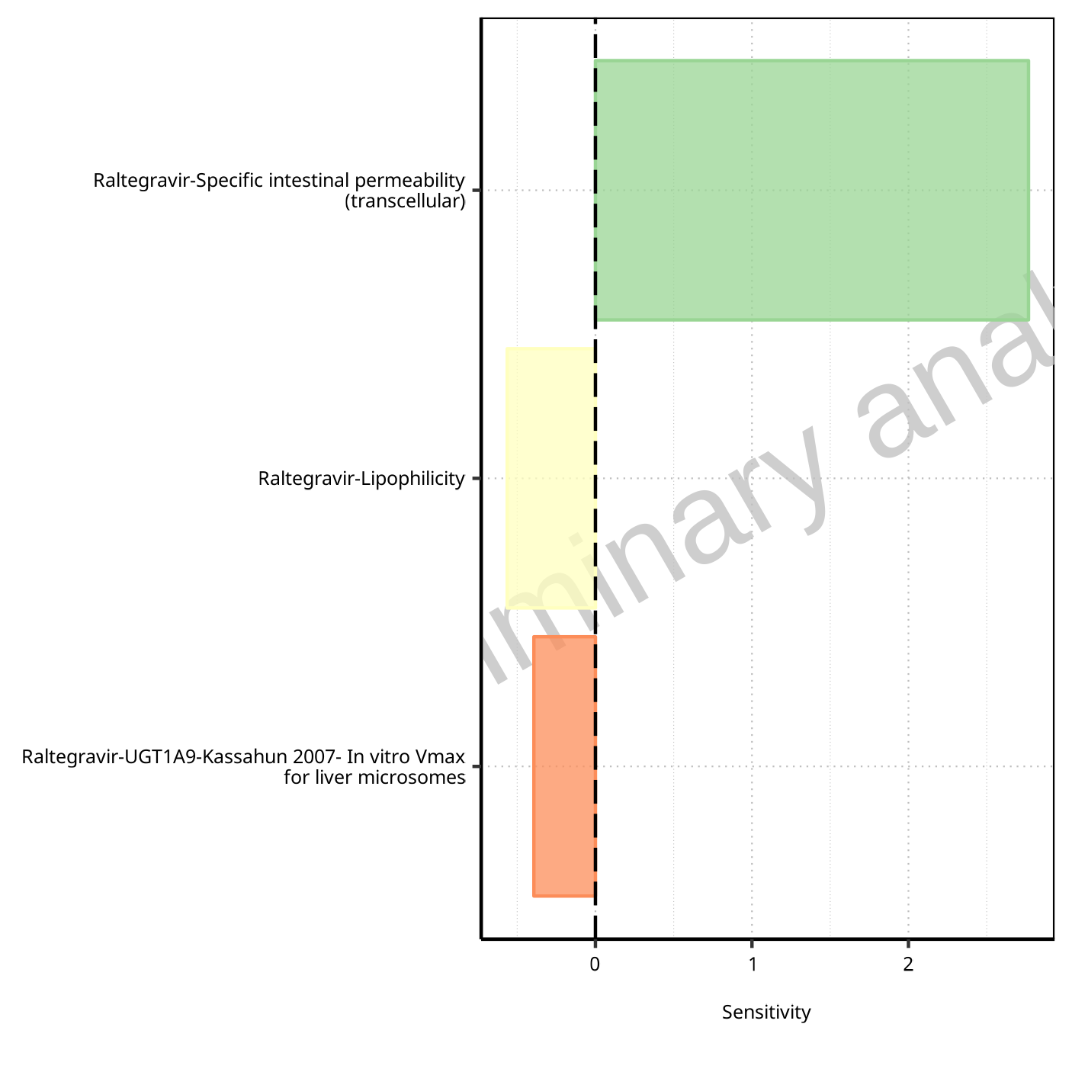

**Figure 1-54: Most sensitive parameters for t_max of Raltegravir.**



**Figure 1-55: Most sensitive parameters for t_max_t1_t2 of Raltegravir.**



**Figure 1-56: Most sensitive parameters for t_max_tLast_tEnd of Raltegravir.**

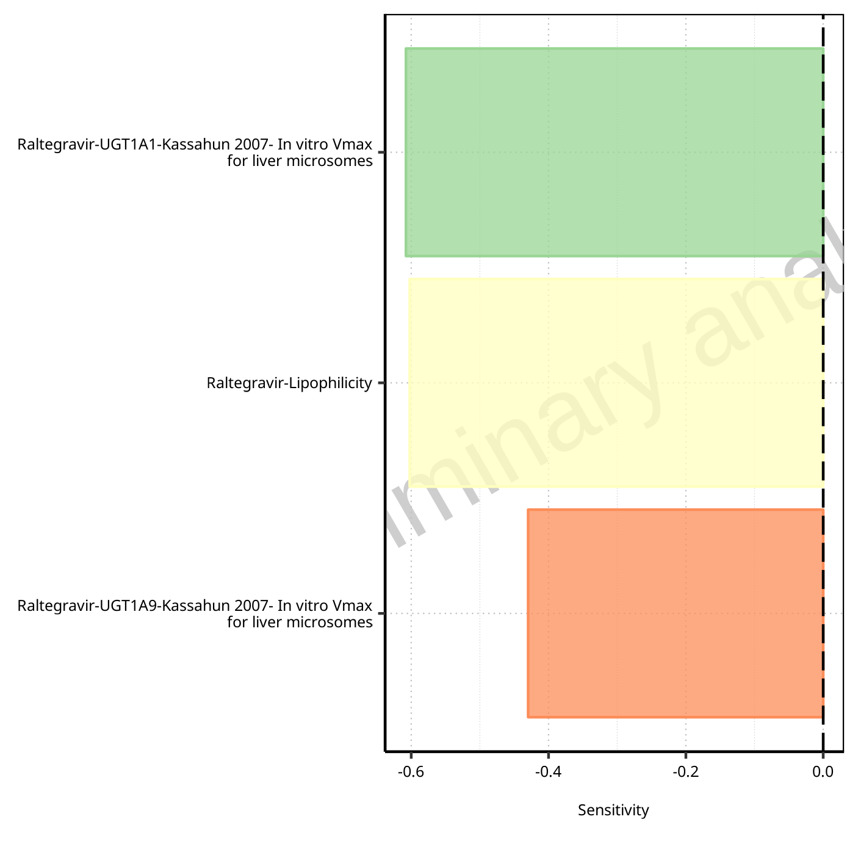

**Figure 1-57: Most sensitive parameters for C_trough_t2 of Raltegravir.**

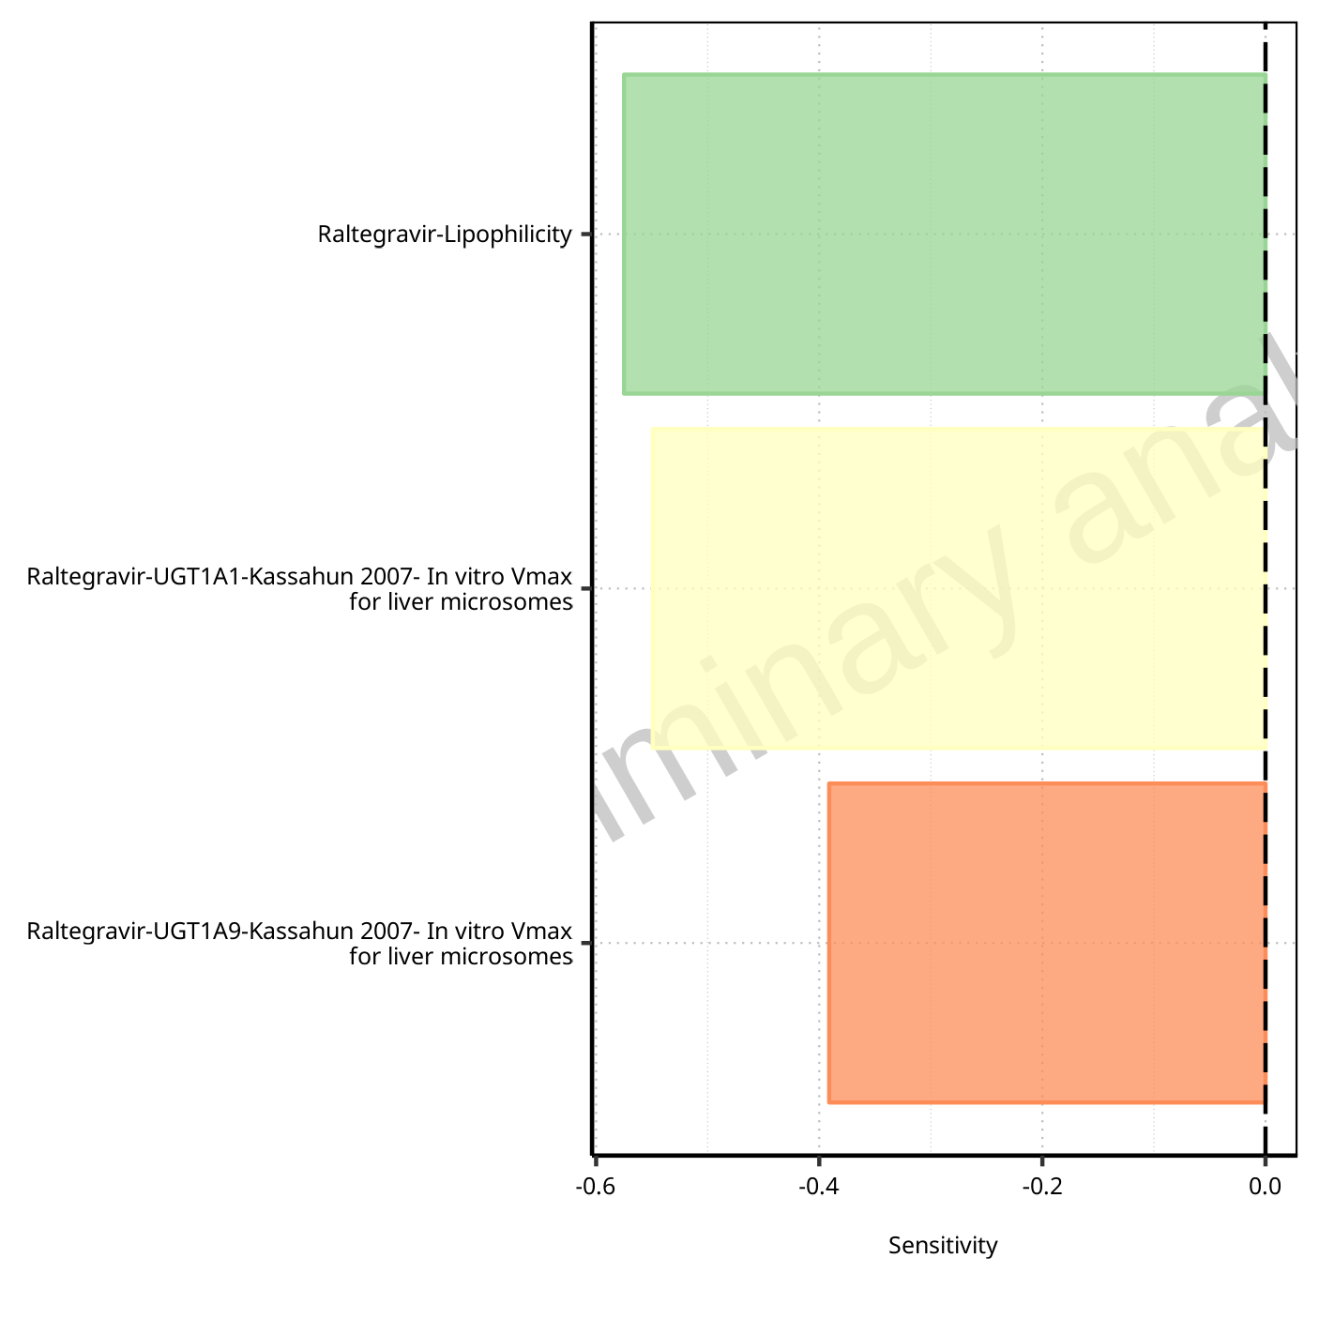

**Figure 1-58: Most sensitive parameters for C_trough_tLast of Raltegravir.**

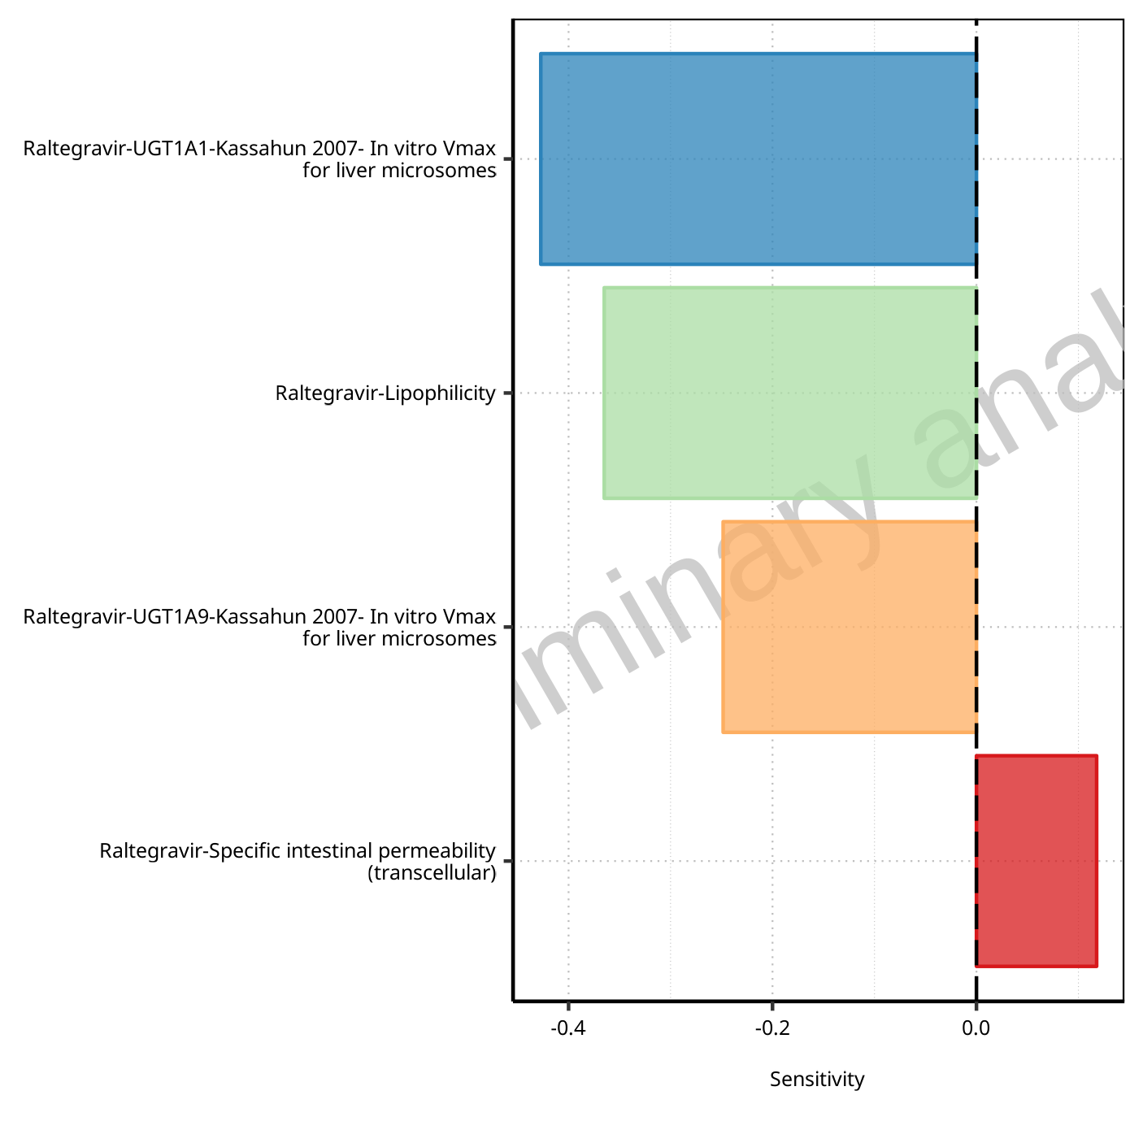

**Figure 1-59: Most sensitive parameters for AUC_t1_t2 of Raltegravir.**

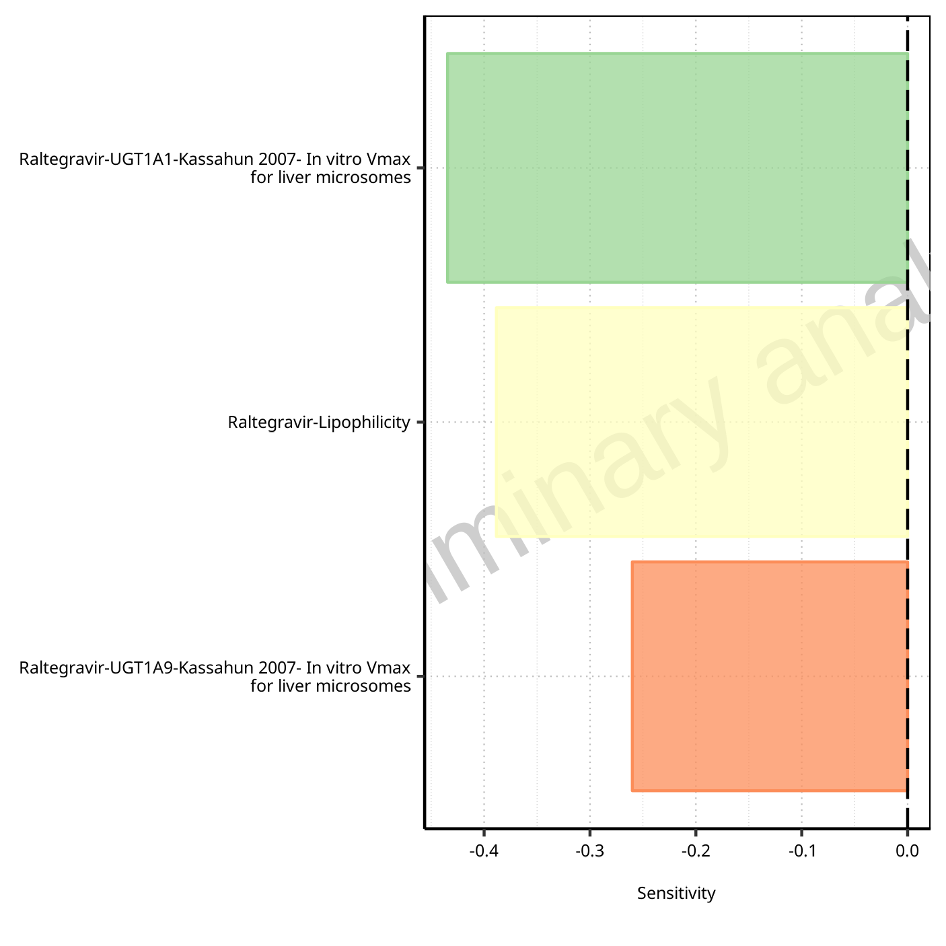

**Figure 1-60: Most sensitive parameters for AUC_tLast_minus_1_tLast of Raltegravir.**

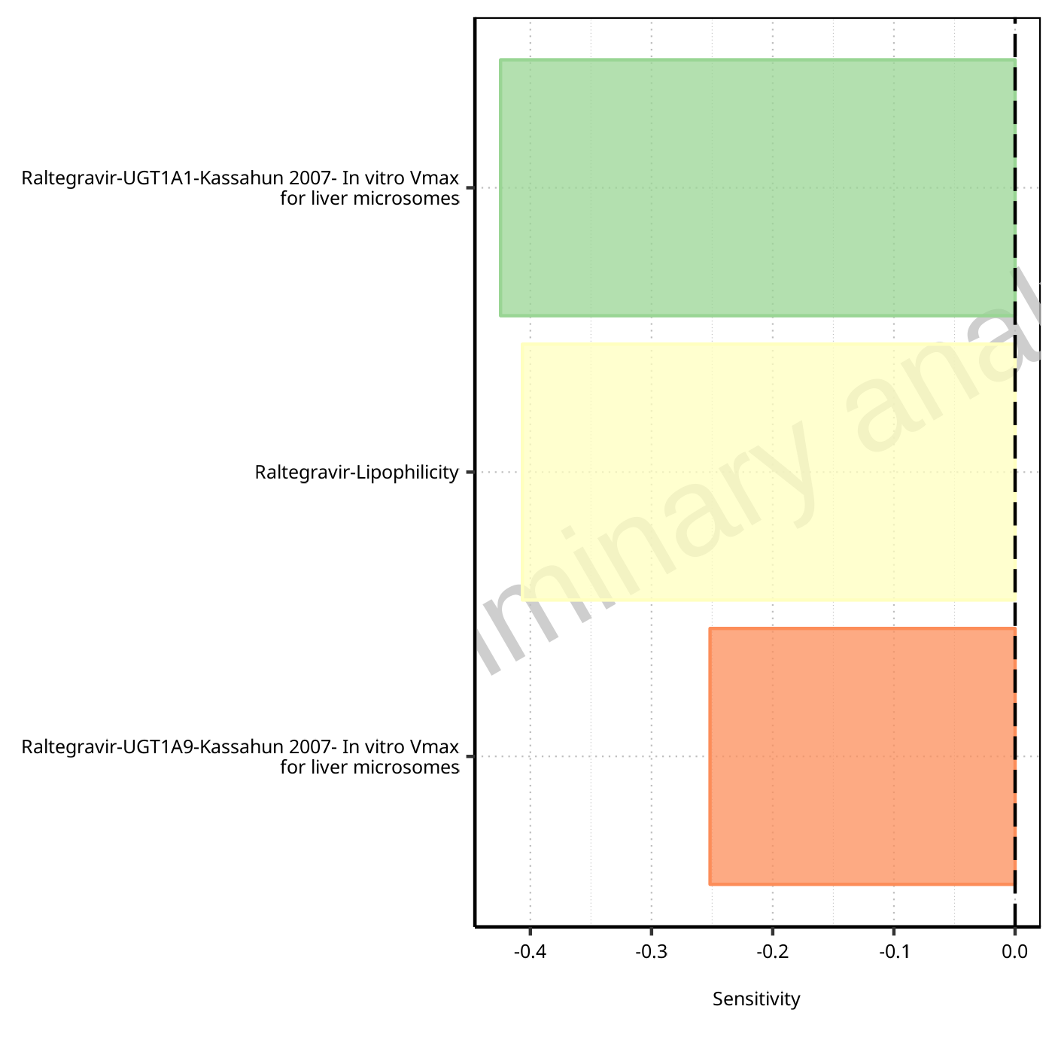

**Figure 1-61: Most sensitive parameters for AUC_inf_t1 of Raltegravir.**

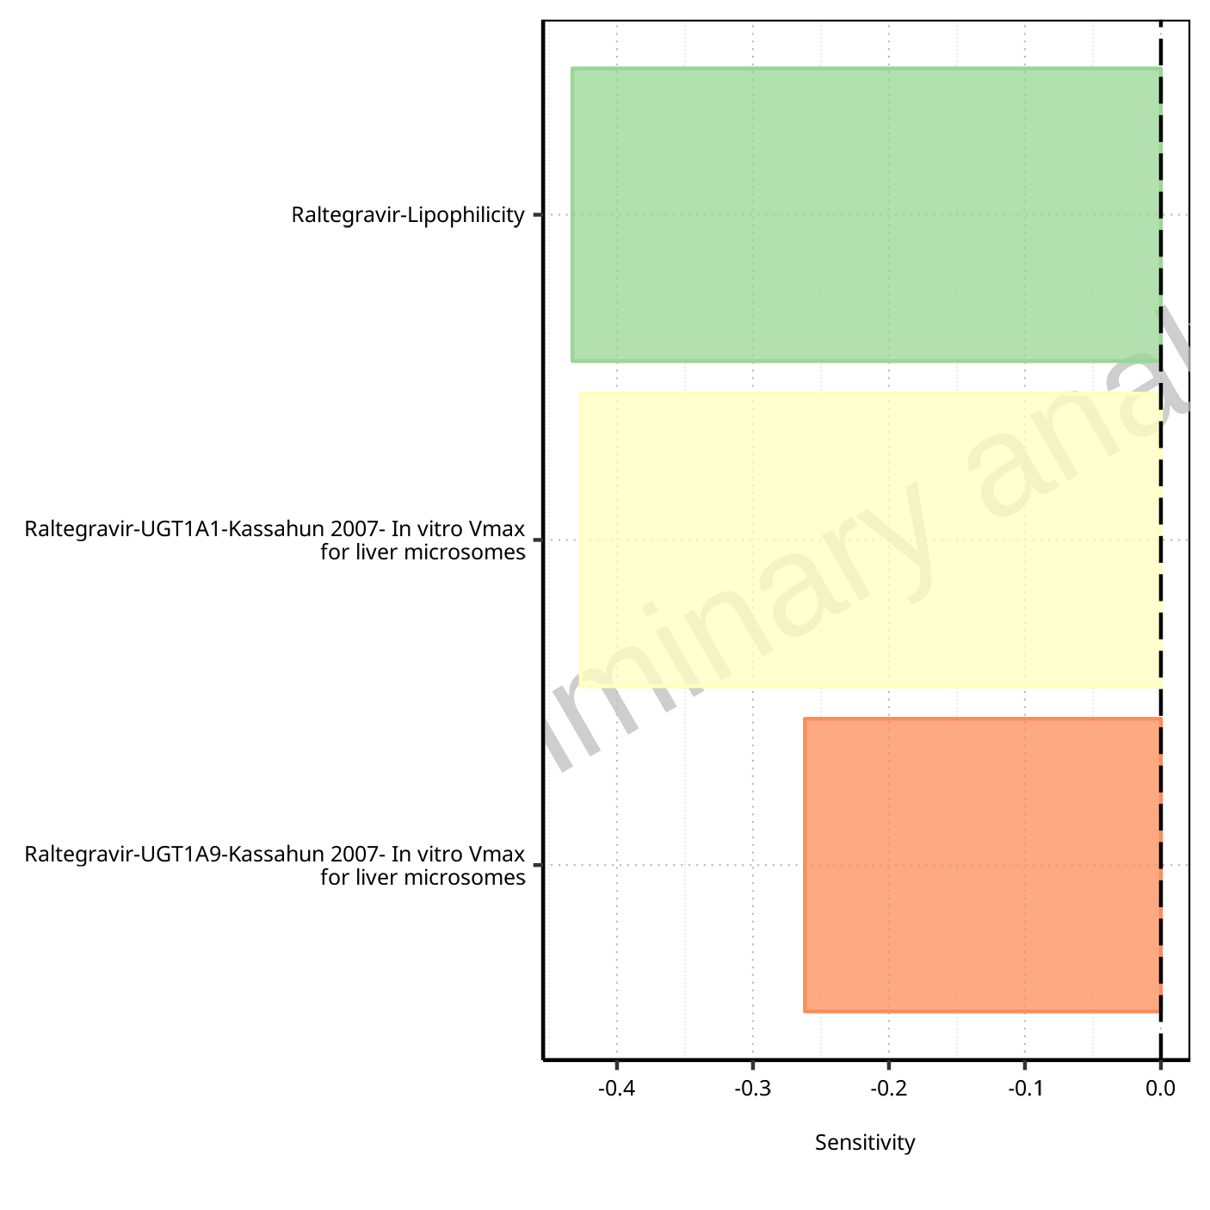

**Figure 1-62: Most sensitive parameters for AUC_inf_tLast of Raltegravir.**

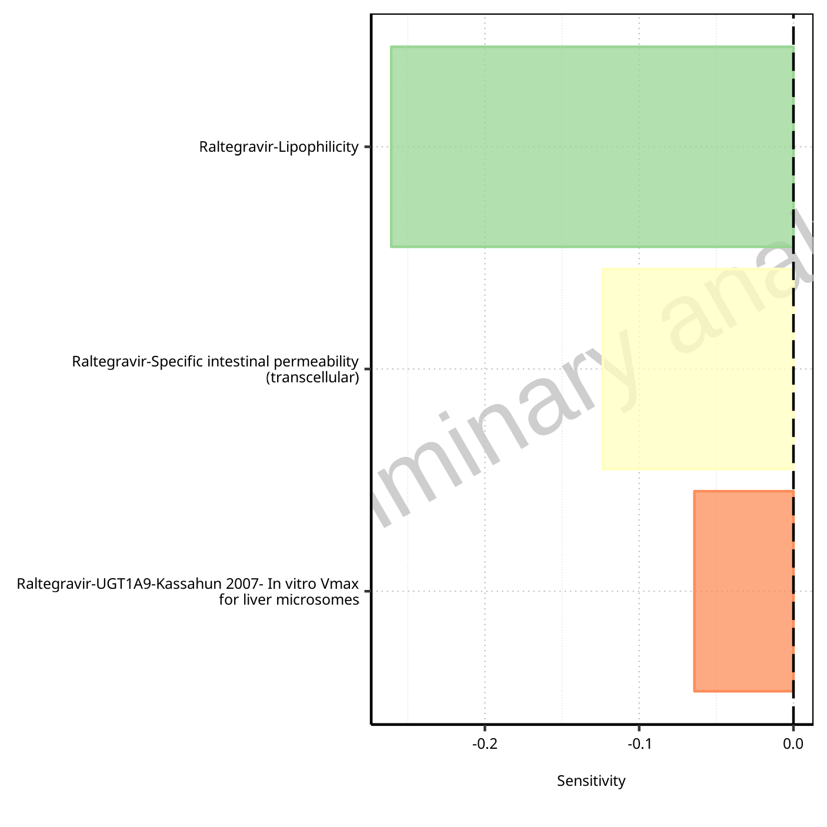

**Figure 1-63: Most sensitive parameters for MRT of Raltegravir.**

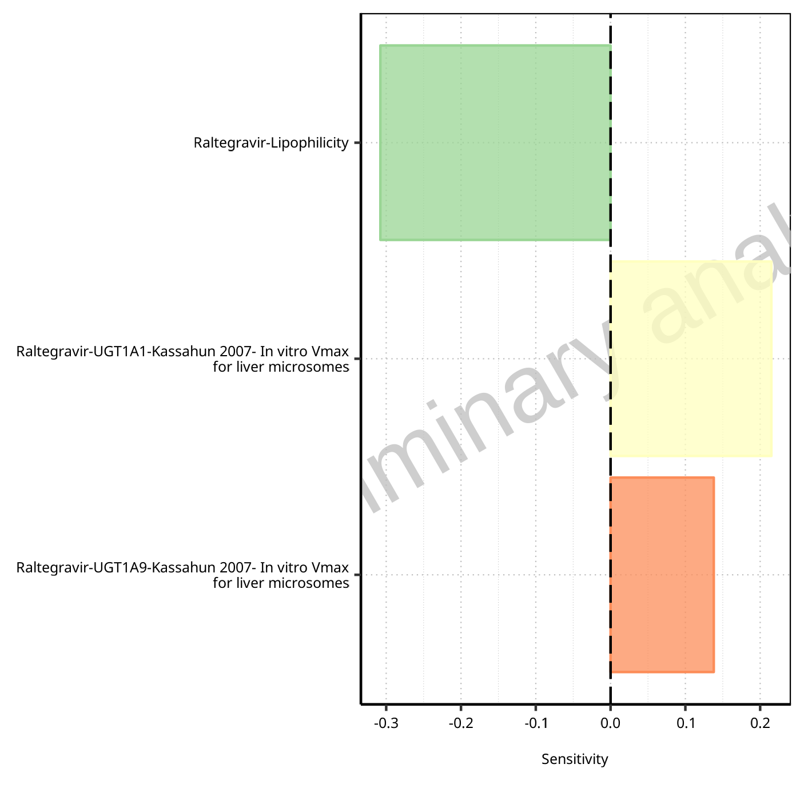

**Figure 1-64: Most sensitive parameters for Thalf of Raltegravir.**

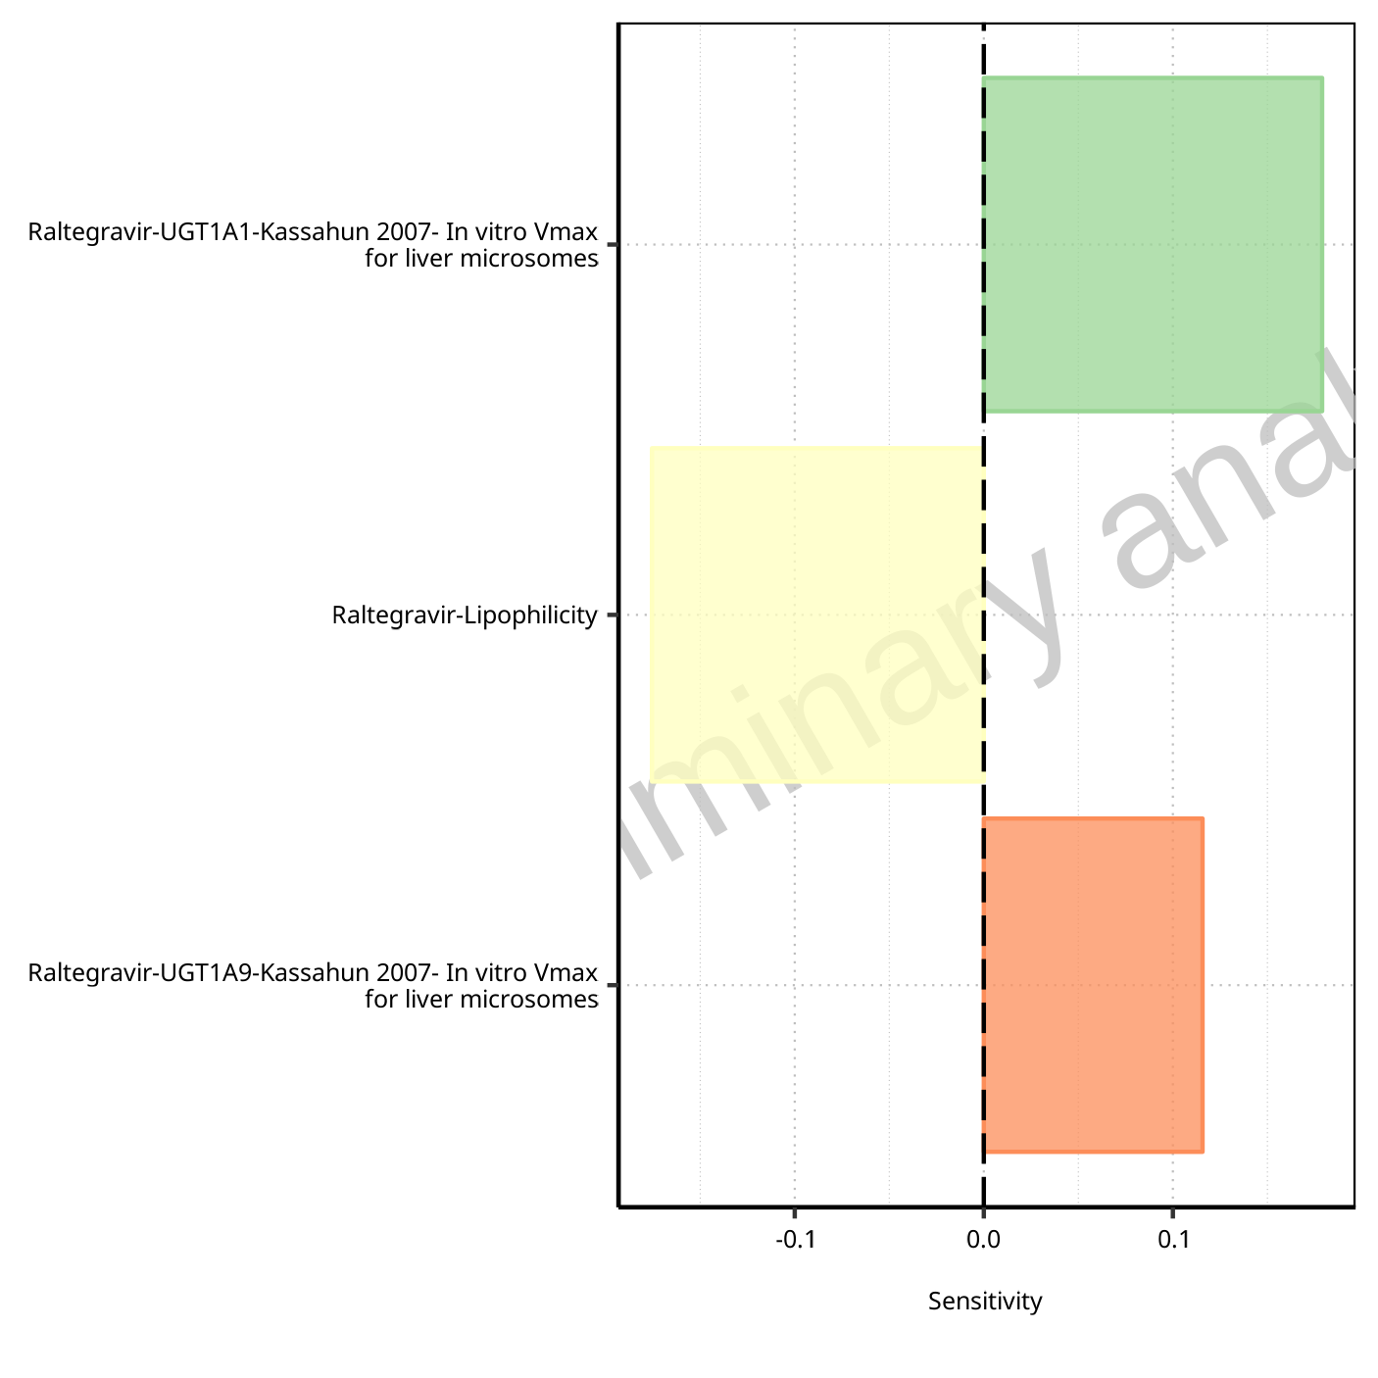

**Figure 1-65: Most sensitive parameters for Thalf_tLast_tEnd of Raltegravir.**

## Sensitivity Analysis for Raltegravir 400mg chewable fasted

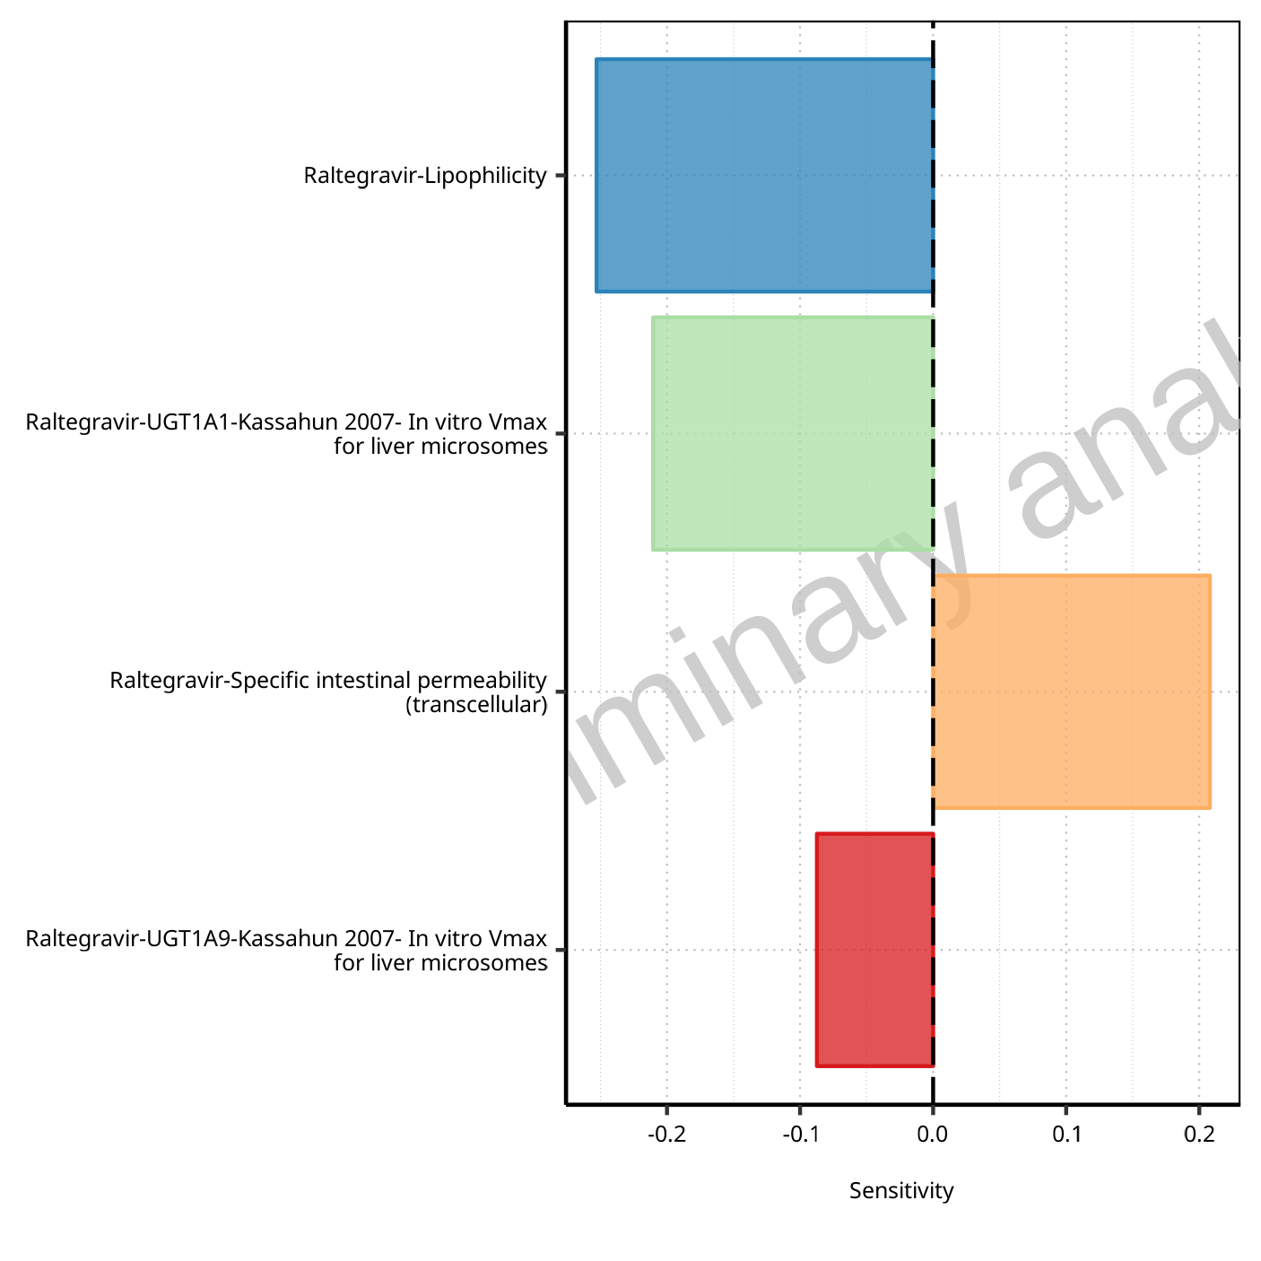

**Figure 1-66: Most sensitive parameters for C_max of Raltegravir.**



**Figure 1-67: Most sensitive parameters for t_max of Raltegravir.**

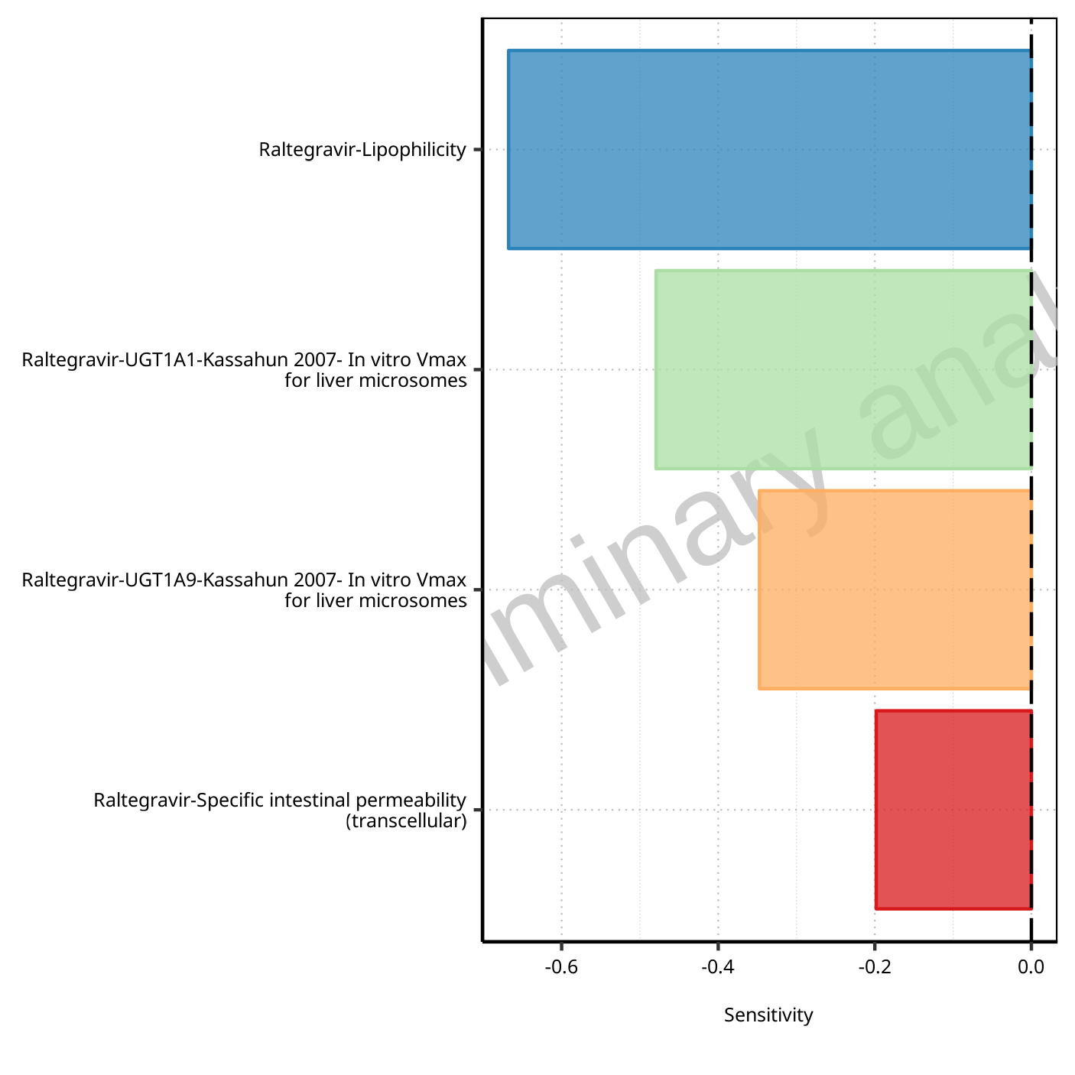

**Figure 1-68: Most sensitive parameters for C_tEnd of Raltegravir.**

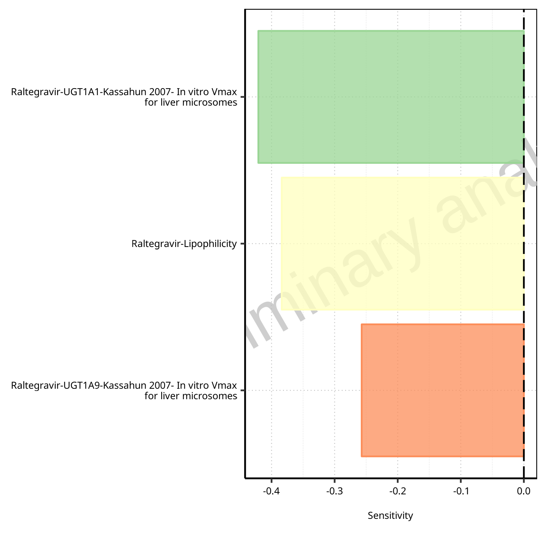

**Figure 1-69: Most sensitive parameters for AUC of Raltegravir.**

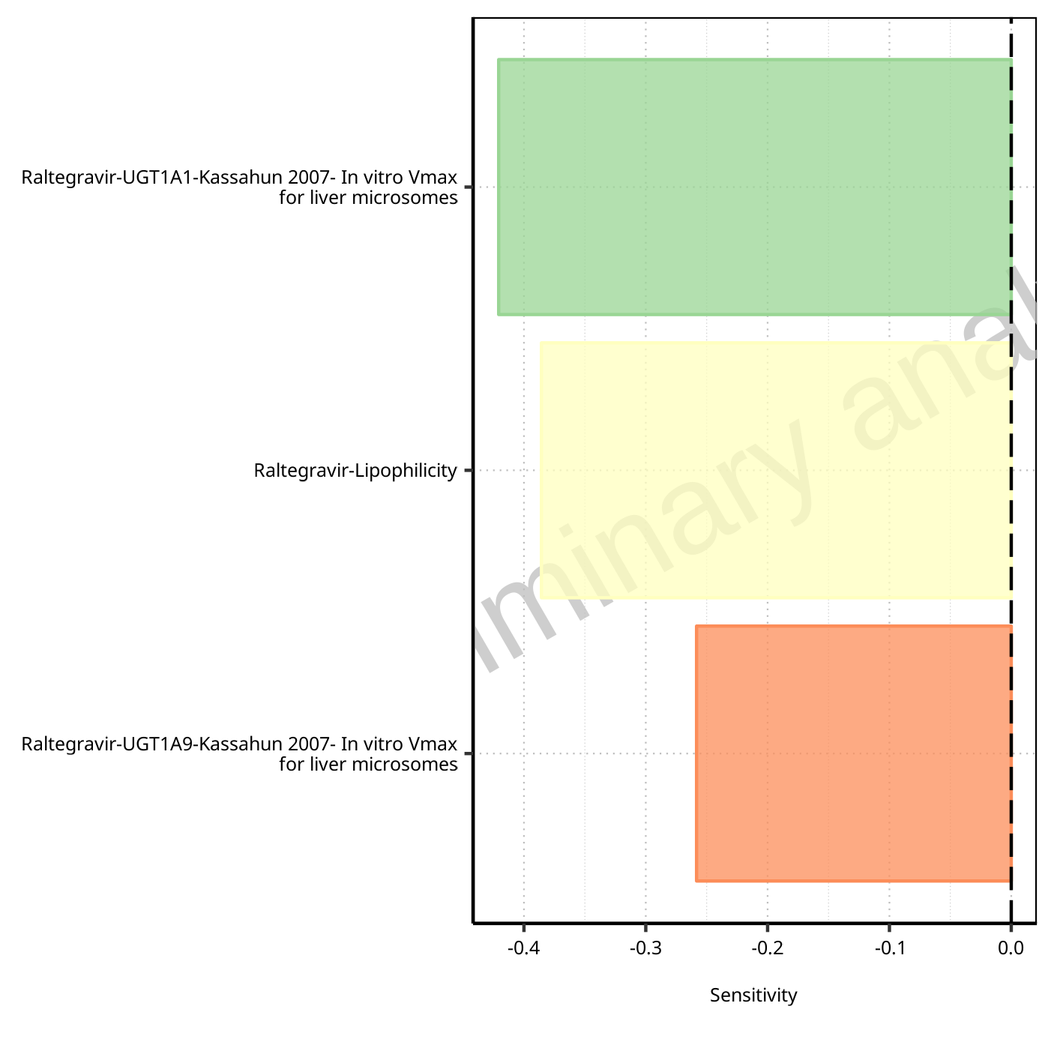

**Figure 1-70: Most sensitive parameters for AUC_inf of Raltegravir.**

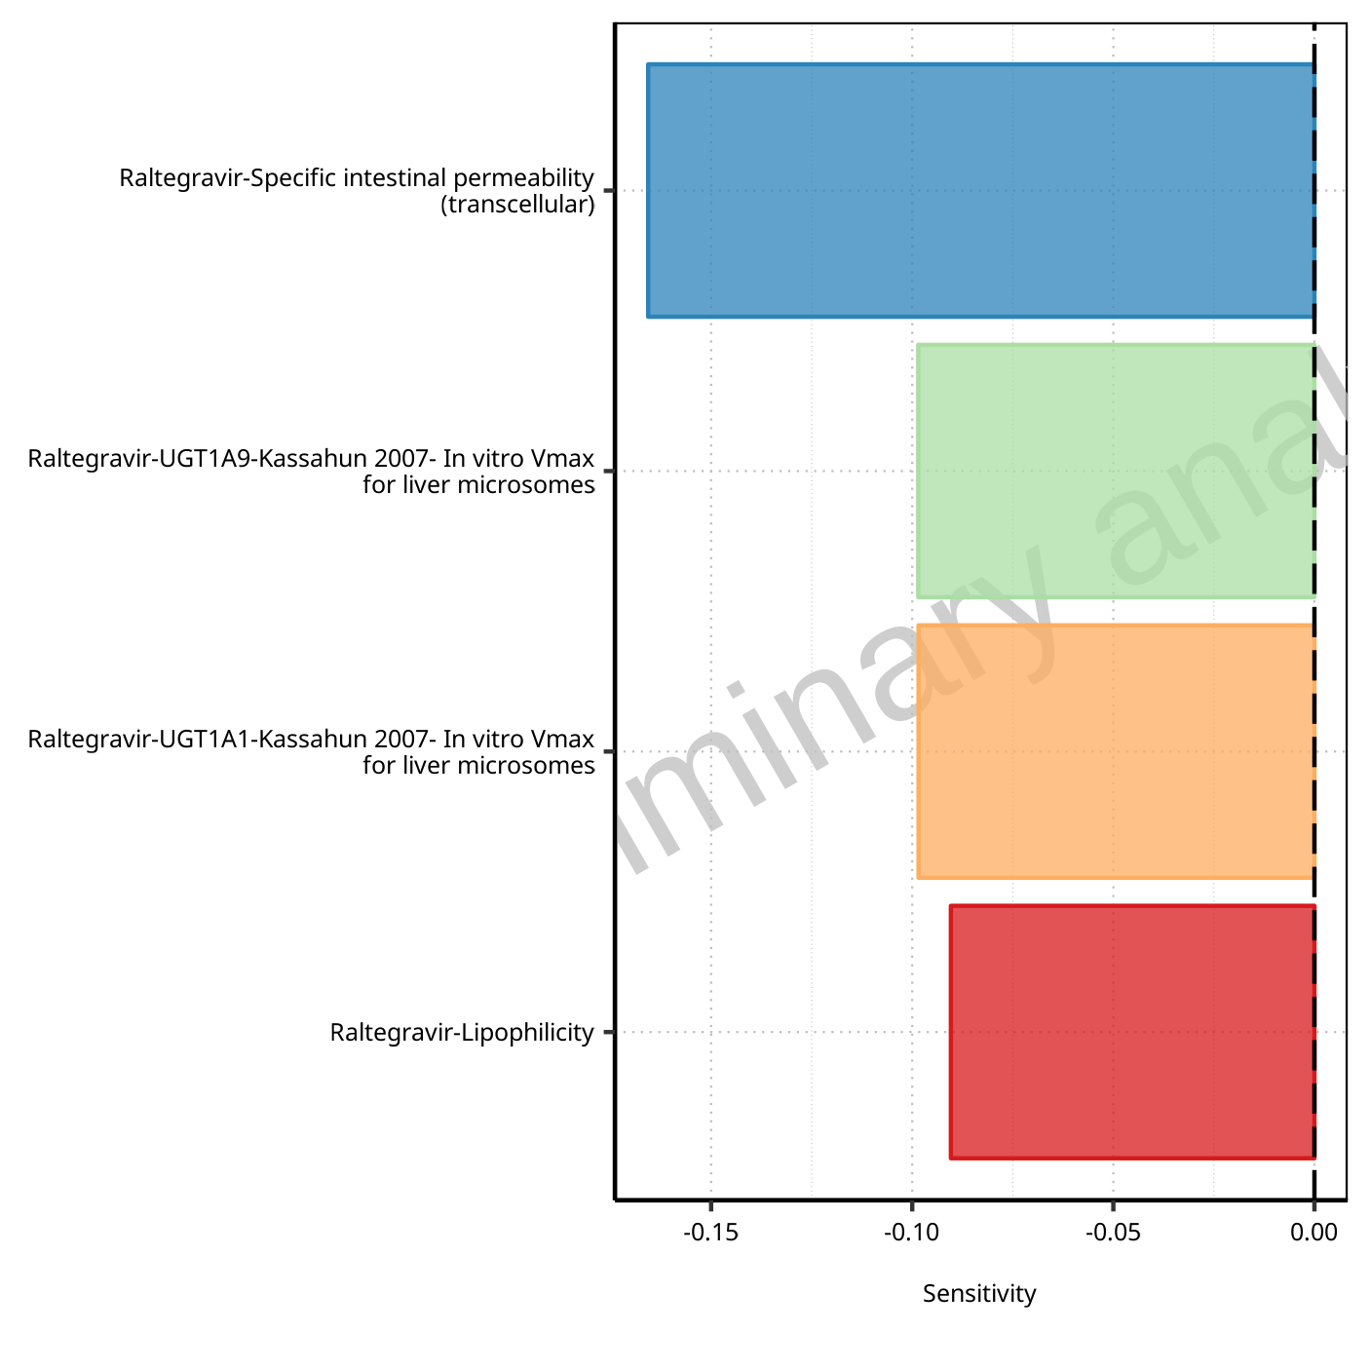

**Figure 1-71: Most sensitive parameters for MRT of Raltegravir.**

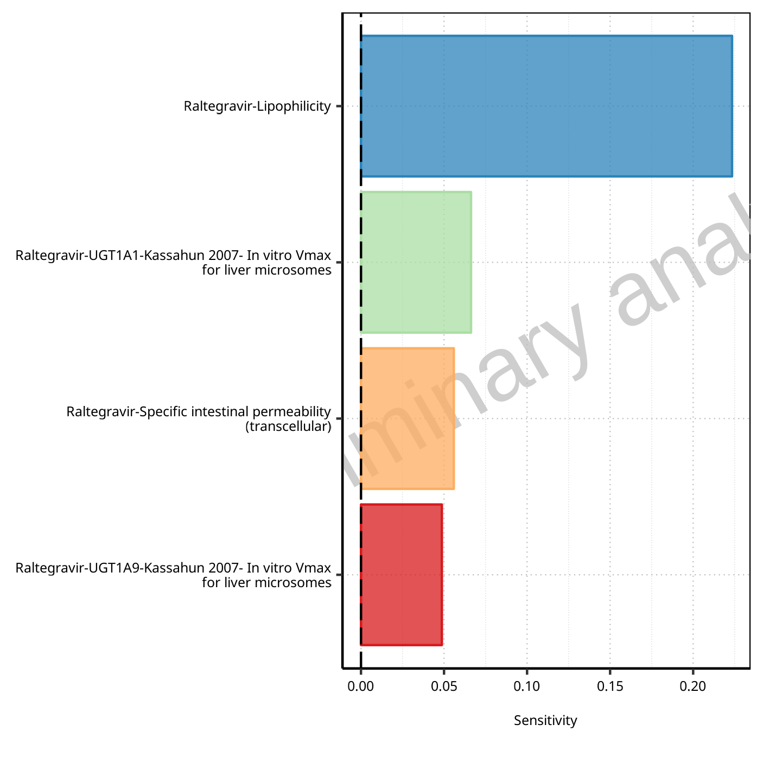

**Figure 1-72: Most sensitive parameters for Thalf of Raltegravir.**

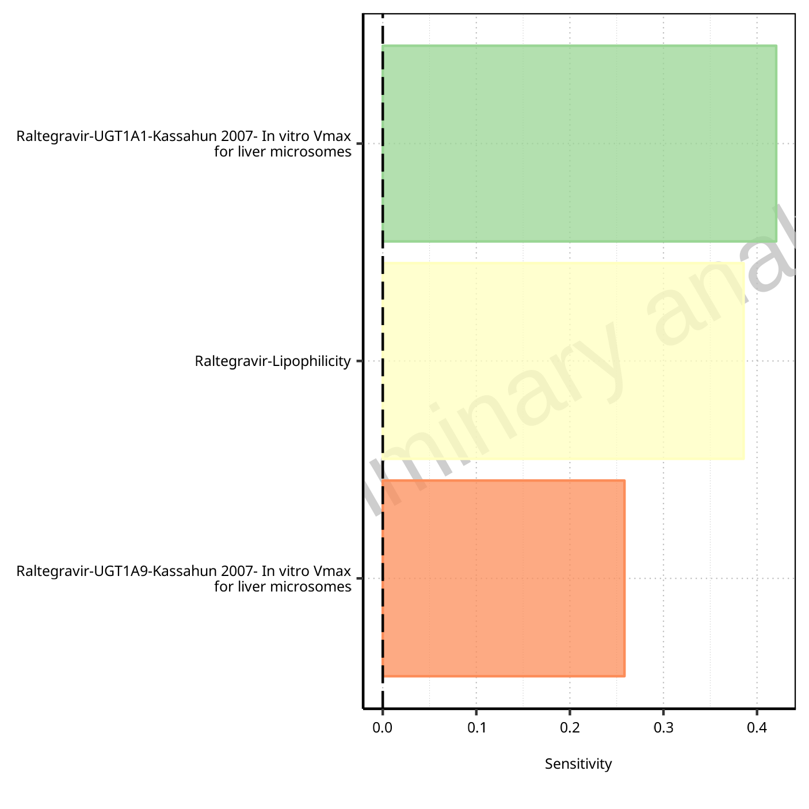

**Figure 1-73: Most sensitive parameters for CL of Raltegravir.**

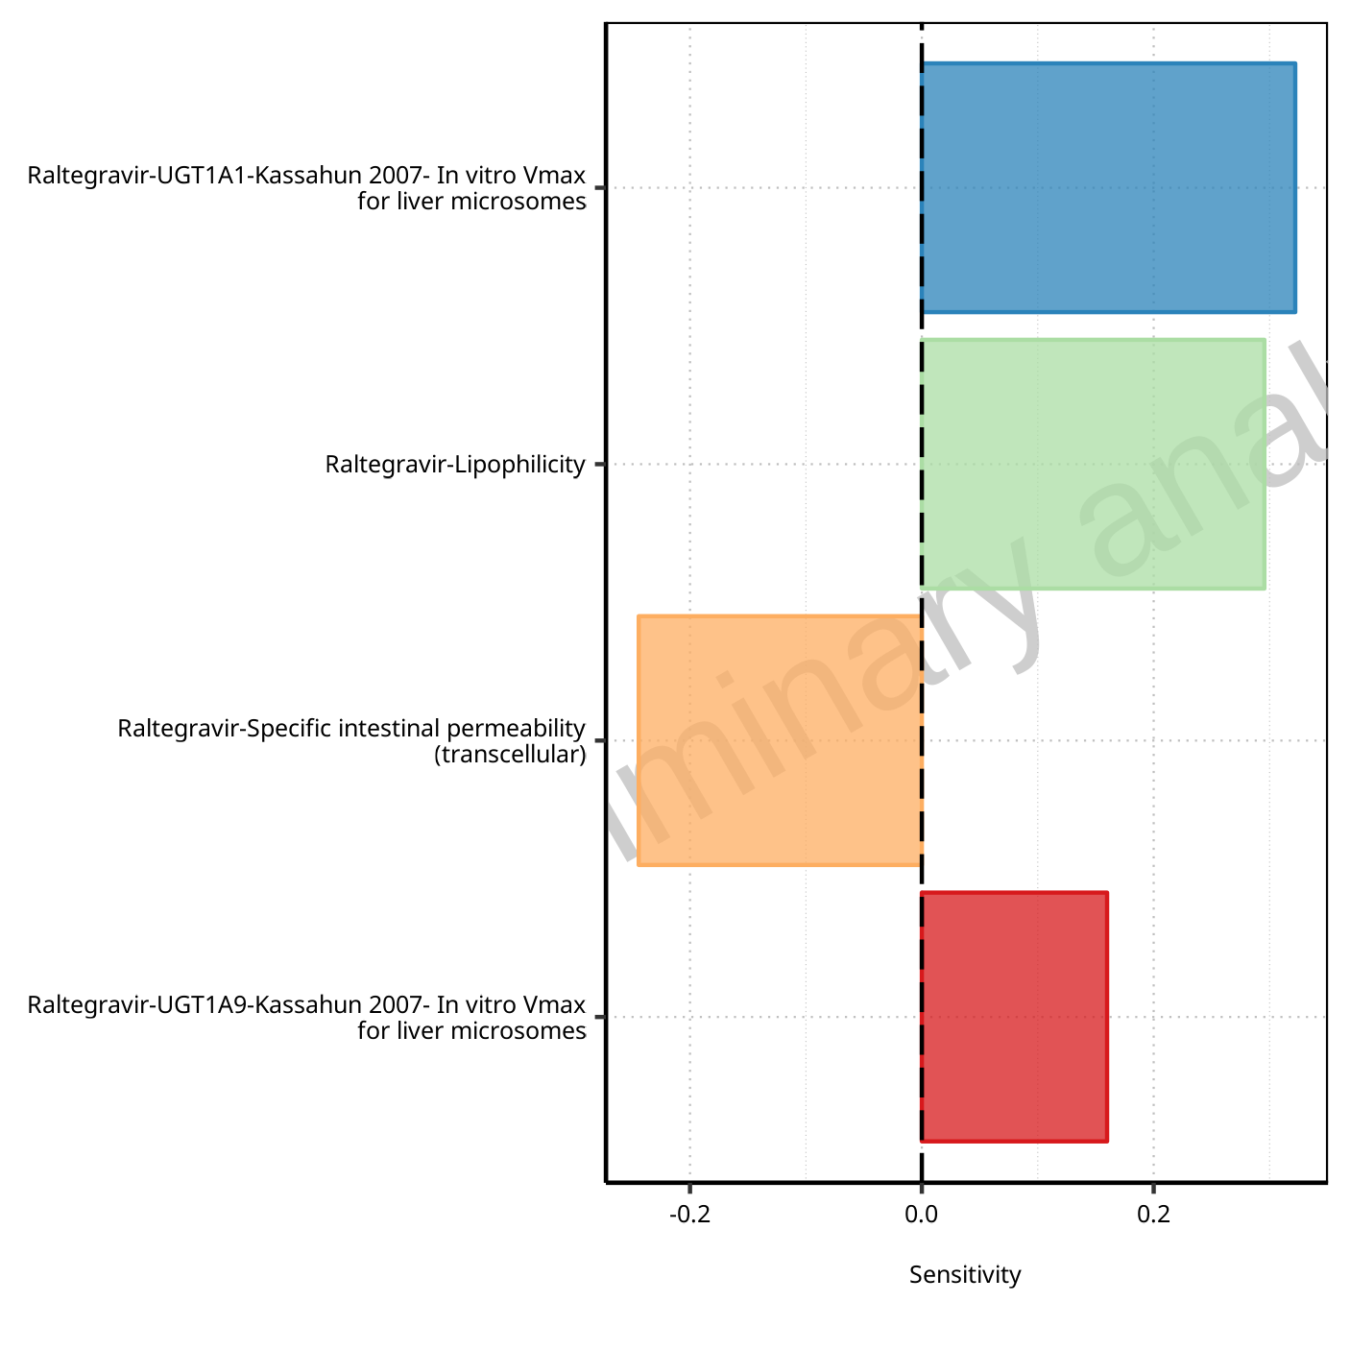

**Figure 1-74: Most sensitive parameters for Vss of Raltegravir.**

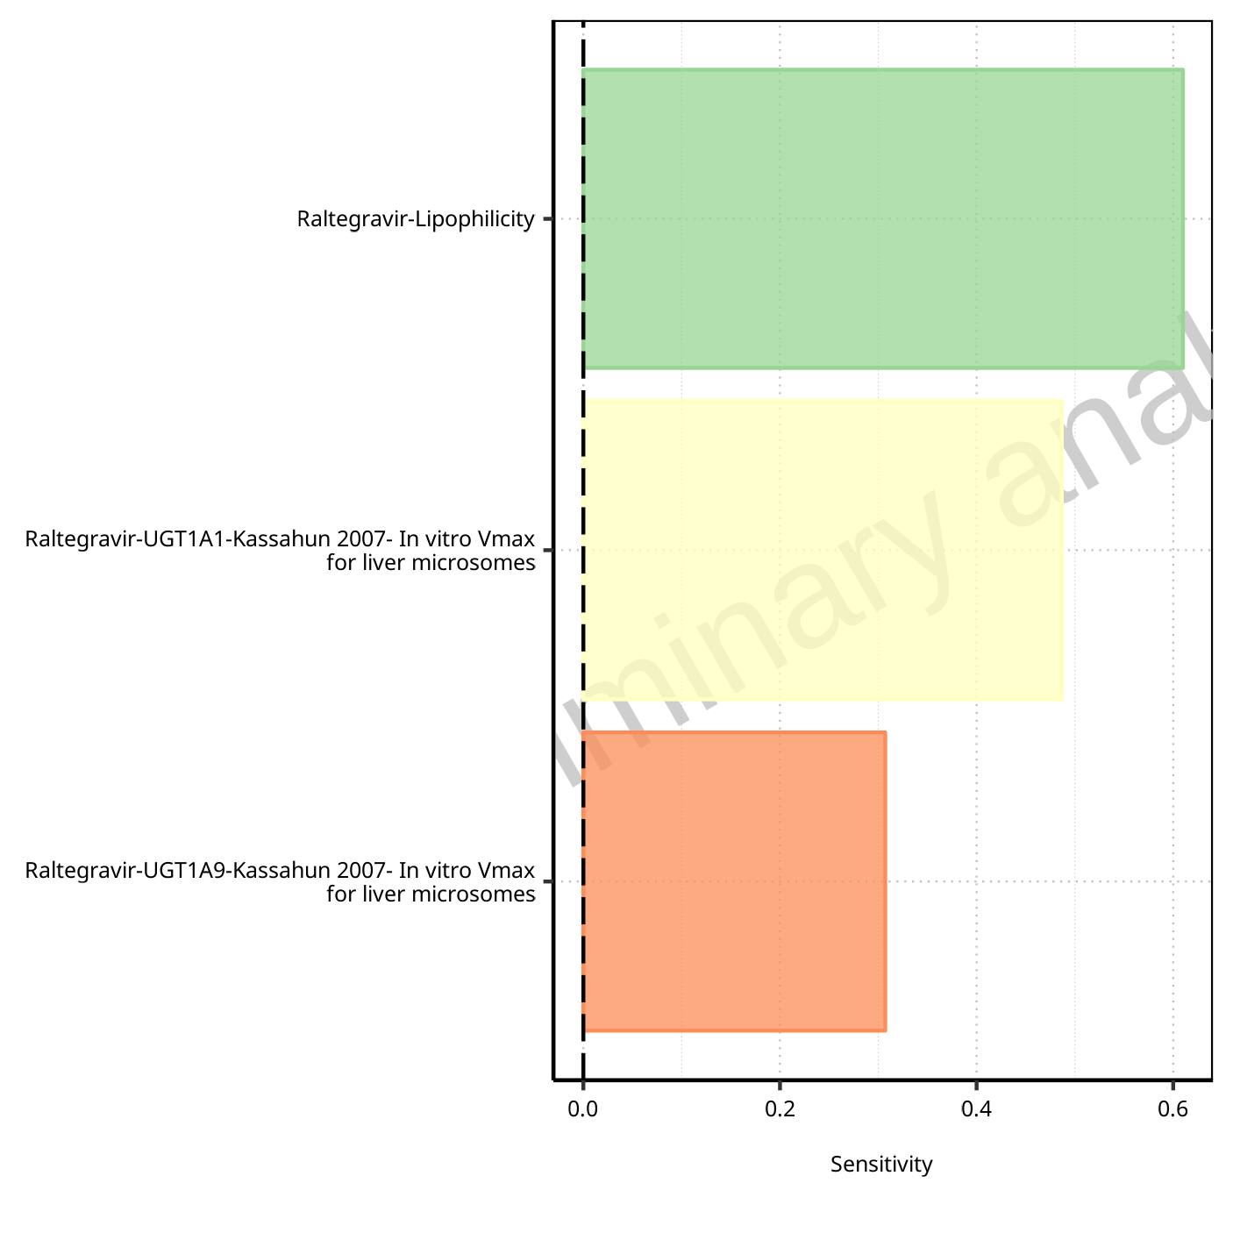

**Figure 1-75: Most sensitive parameters for Vd of Raltegravir.**

## Sensitivity Analysis for Raltegravir 400mg chewable fed

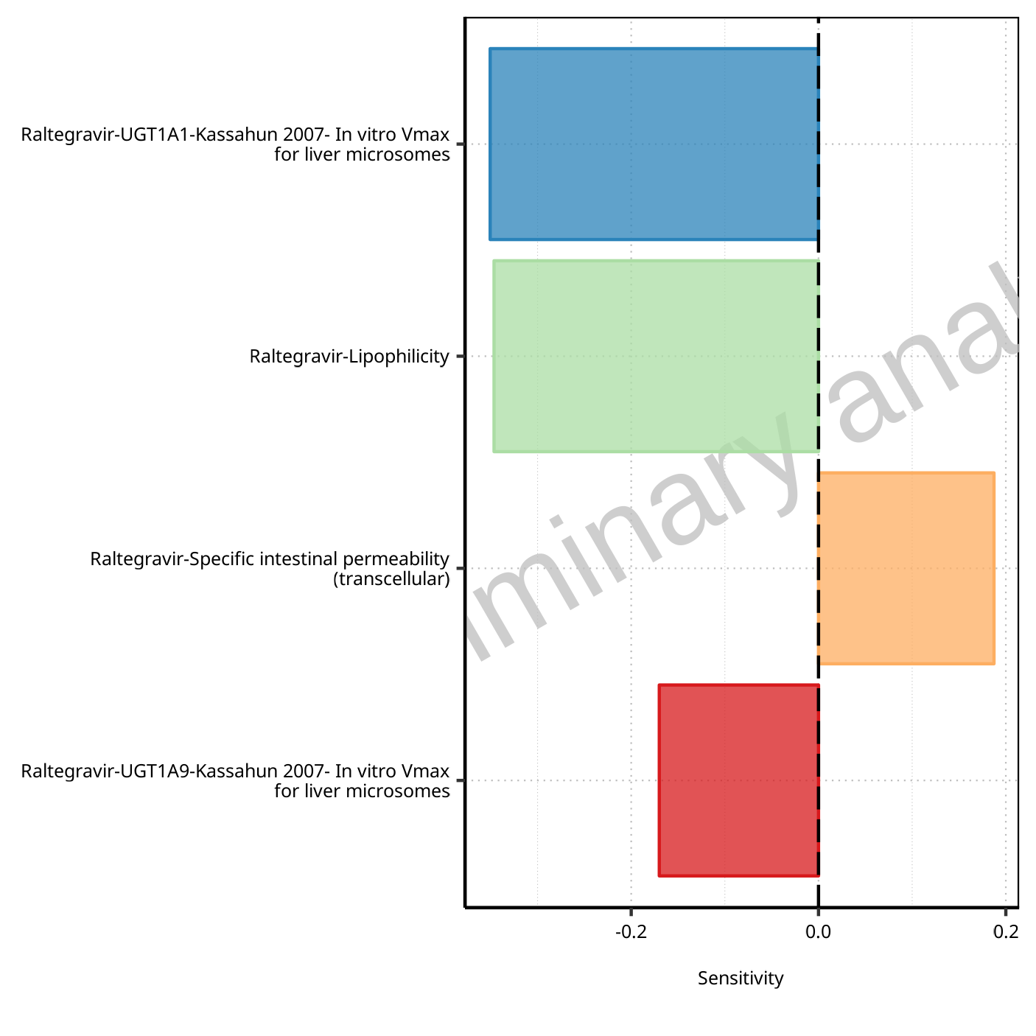

**Figure 1-76: Most sensitive parameters for C_max of Raltegravir.**



**Figure 1-77: Most sensitive parameters for t_max of Raltegravir.**

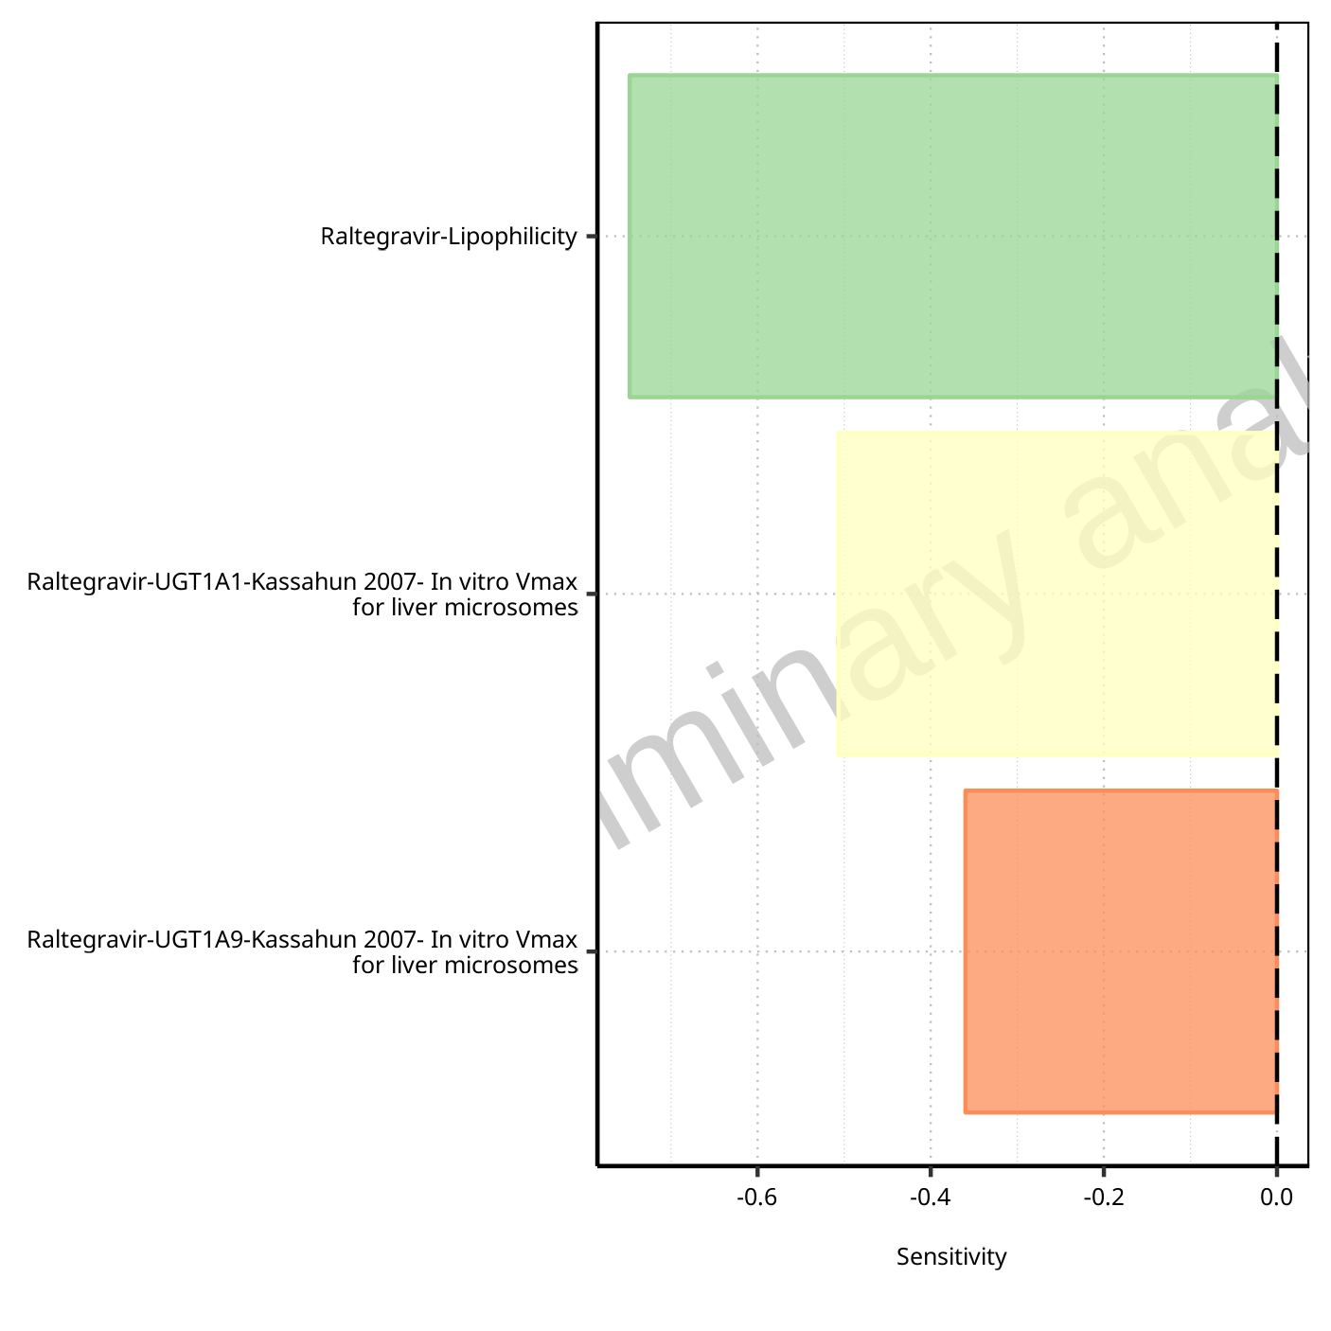

**Figure 1-78: Most sensitive parameters for C_tEnd of Raltegravir.**

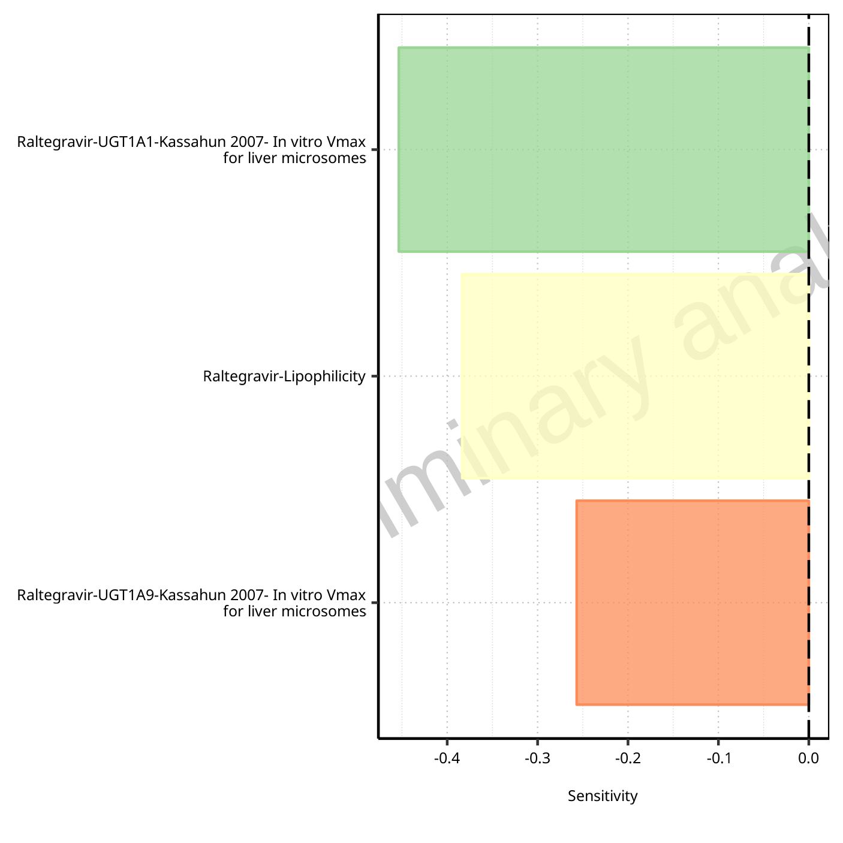

**Figure 1-79: Most sensitive parameters for AUC of Raltegravir.**

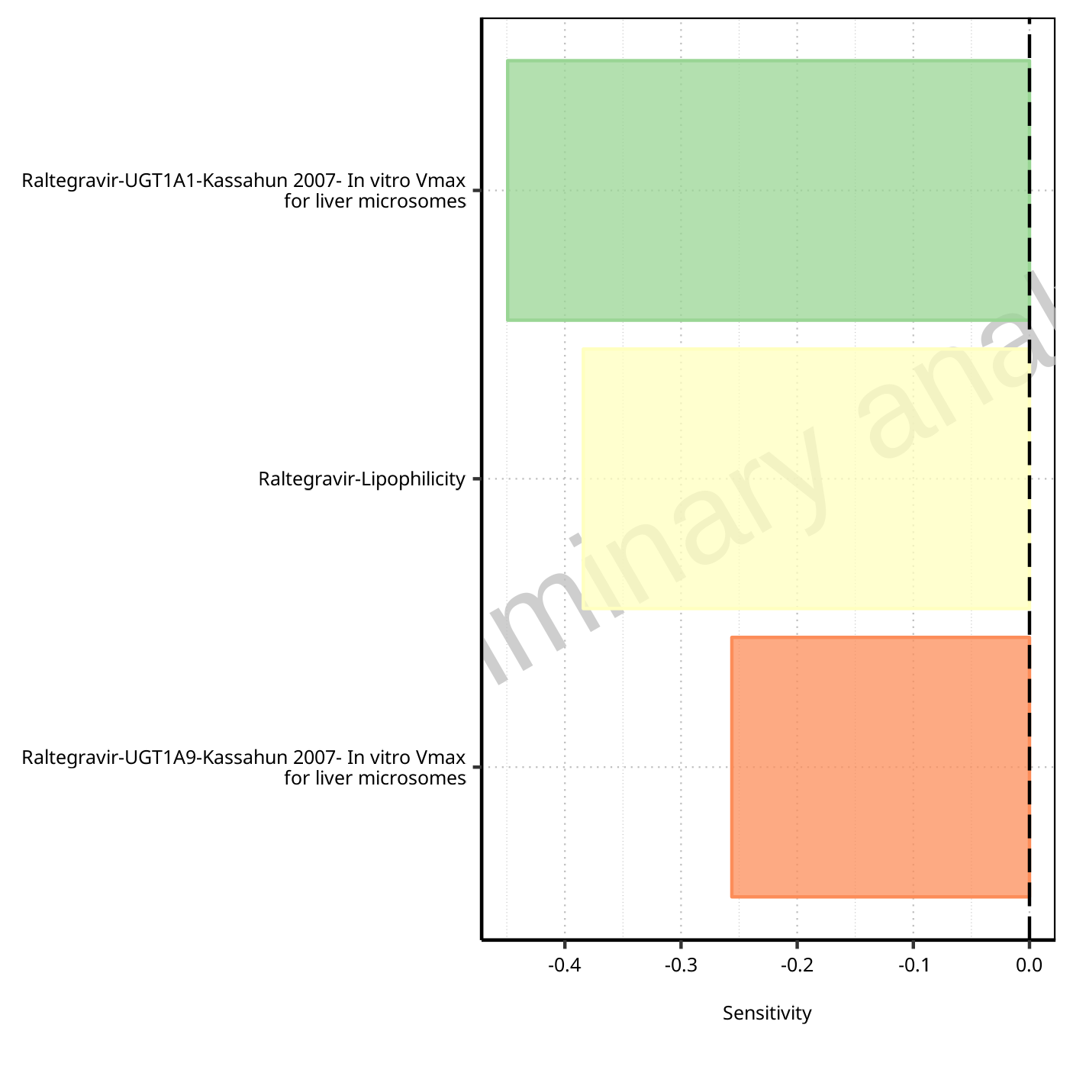

**Figure 1-80: Most sensitive parameters for AUC_inf of Raltegravir.**

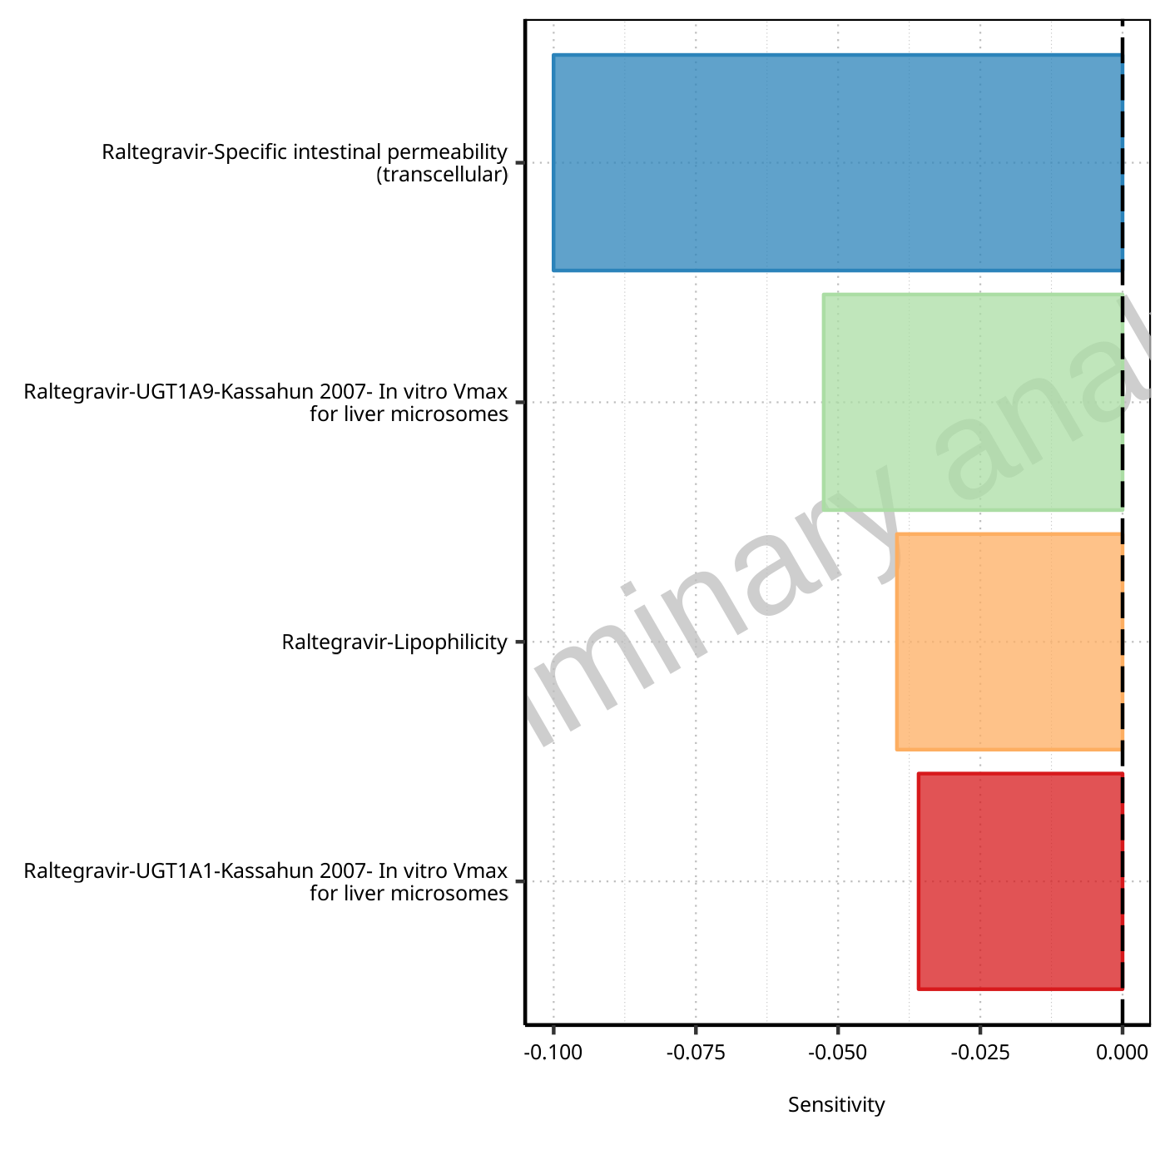

**Figure 1-81: Most sensitive parameters for MRT of Raltegravir.**

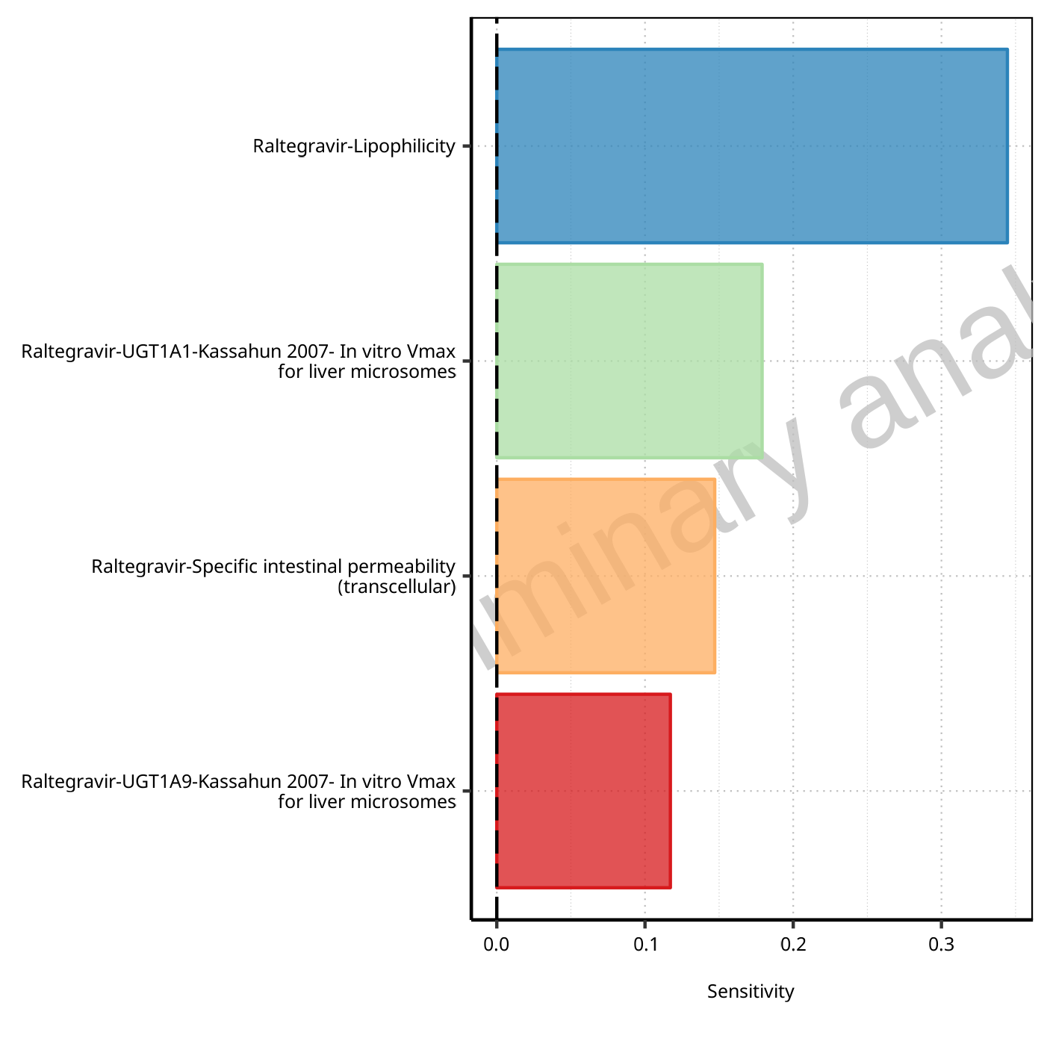

**Figure 1-82: Most sensitive parameters for Thalf of Raltegravir.**

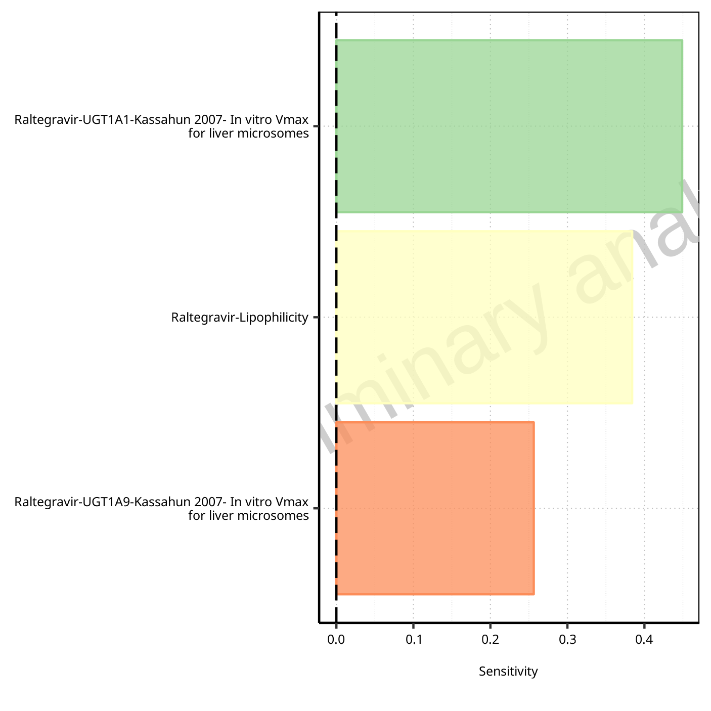

**Figure 1-83: Most sensitive parameters for CL of Raltegravir.**

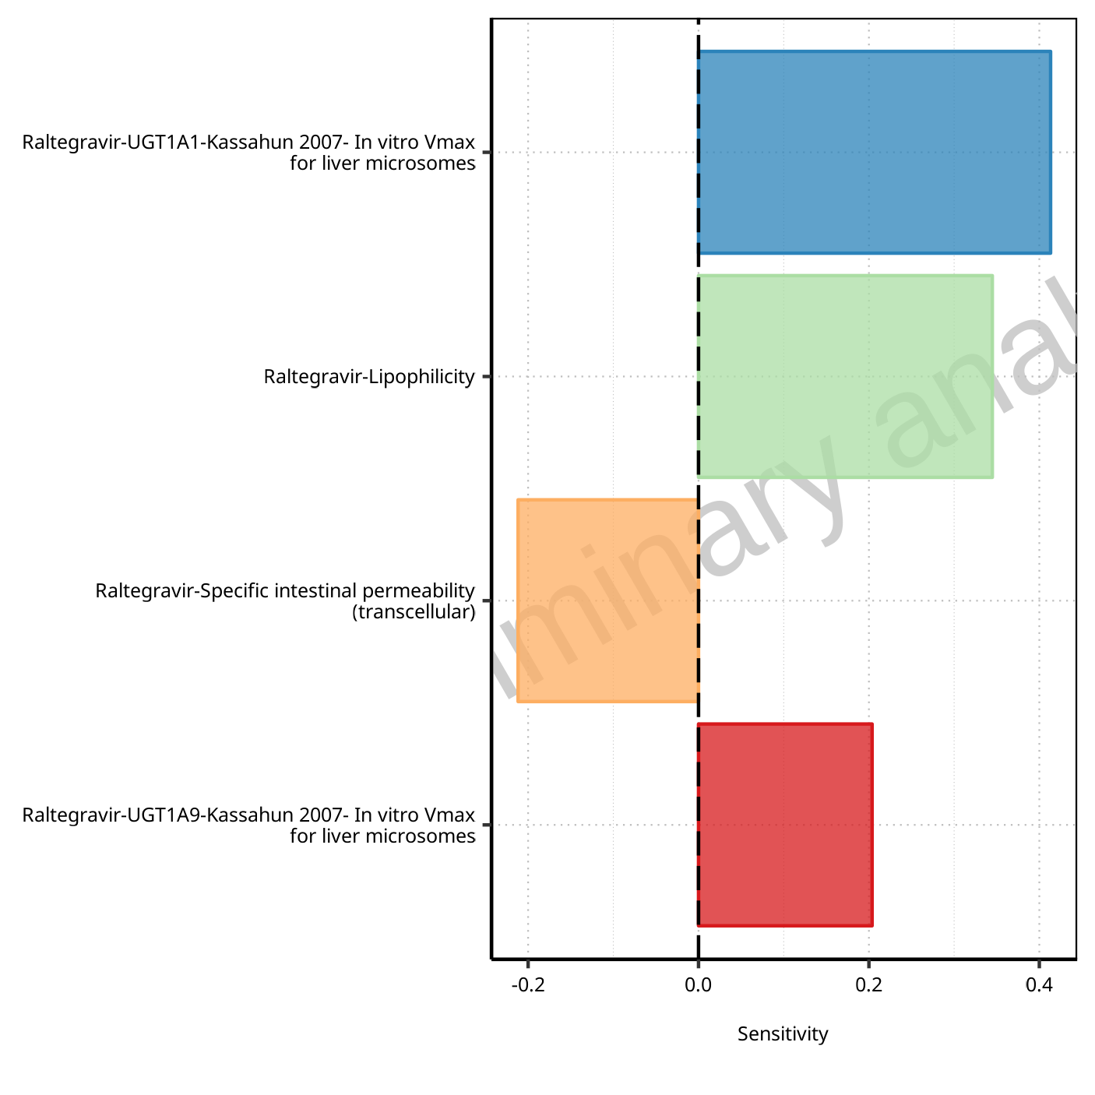

**Figure 1-84: Most sensitive parameters for Vss of Raltegravir.**

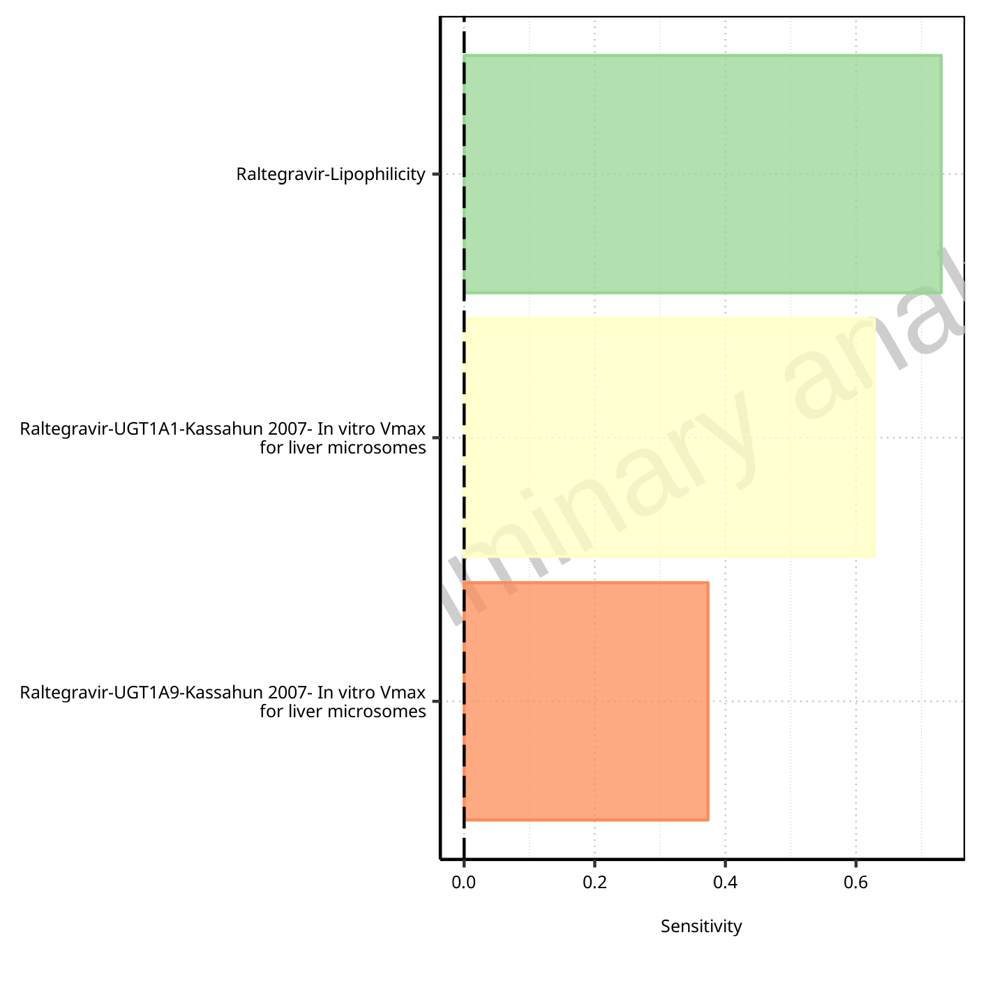

**Figure 1-85: Most sensitive parameters for Vd of Raltegravir.**

## Sensitivity Analysis for Raltegravir 400mg (granules in suspension)

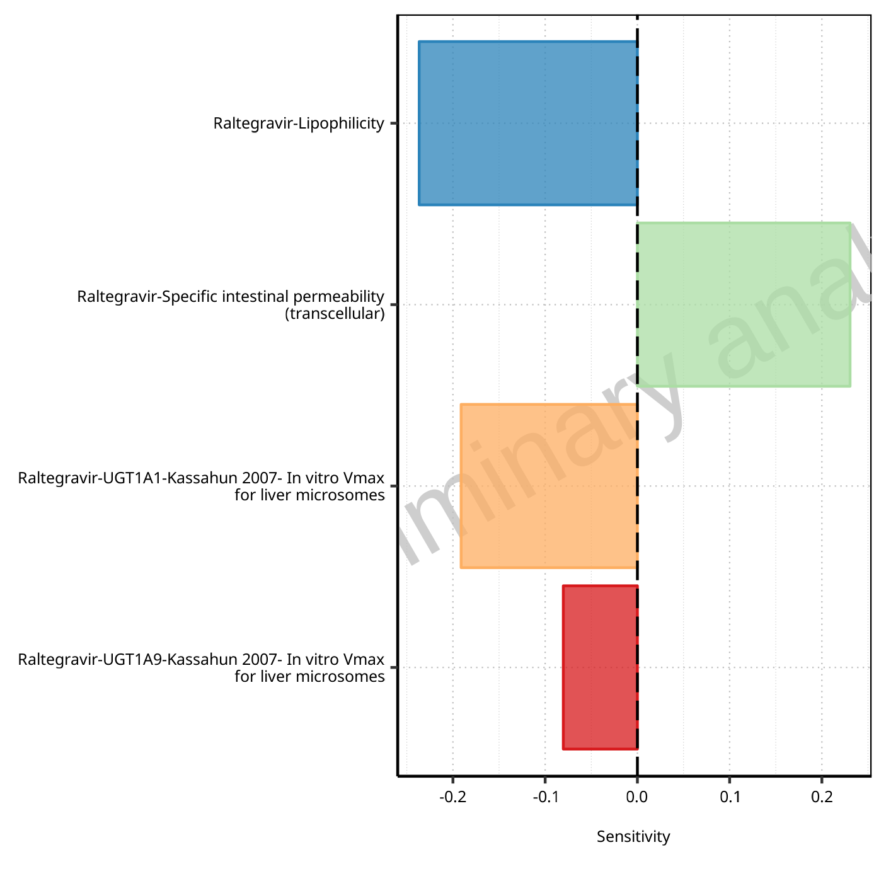

**Figure 1-86: Most sensitive parameters for C_max of Raltegravir.**

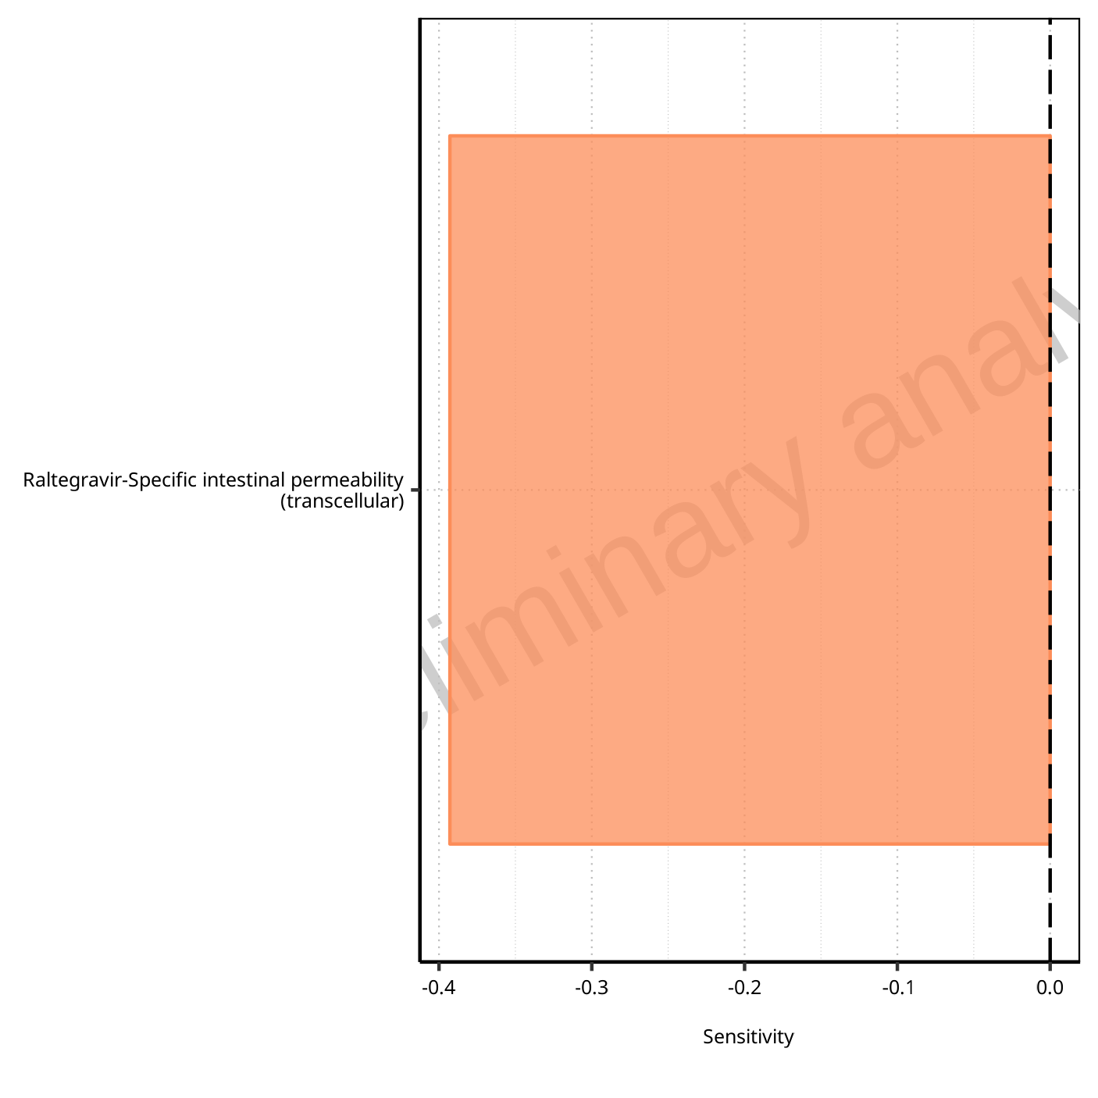

**Figure 1-87: Most sensitive parameters for t_max of Raltegravir.**

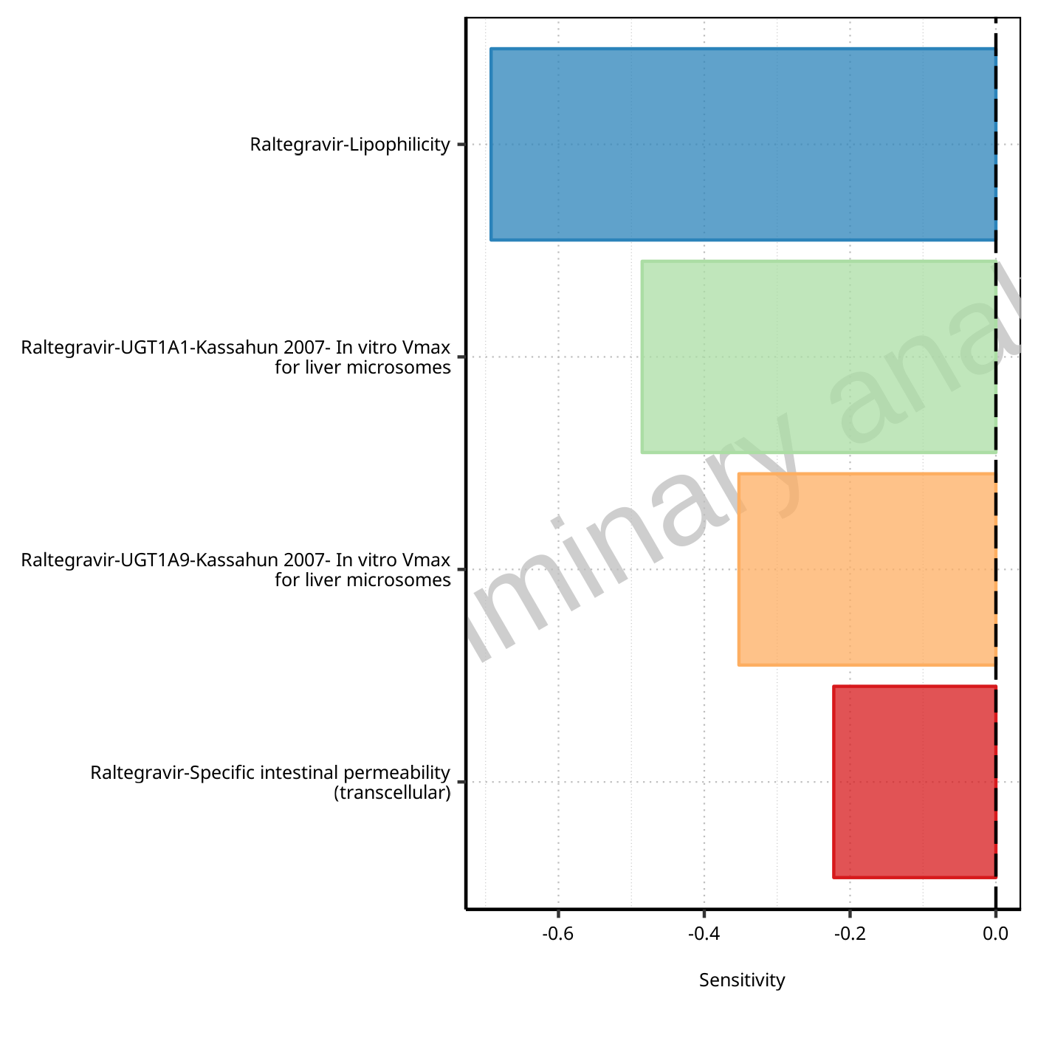

**Figure 1-88: Most sensitive parameters for C_tEnd of Raltegravir.**

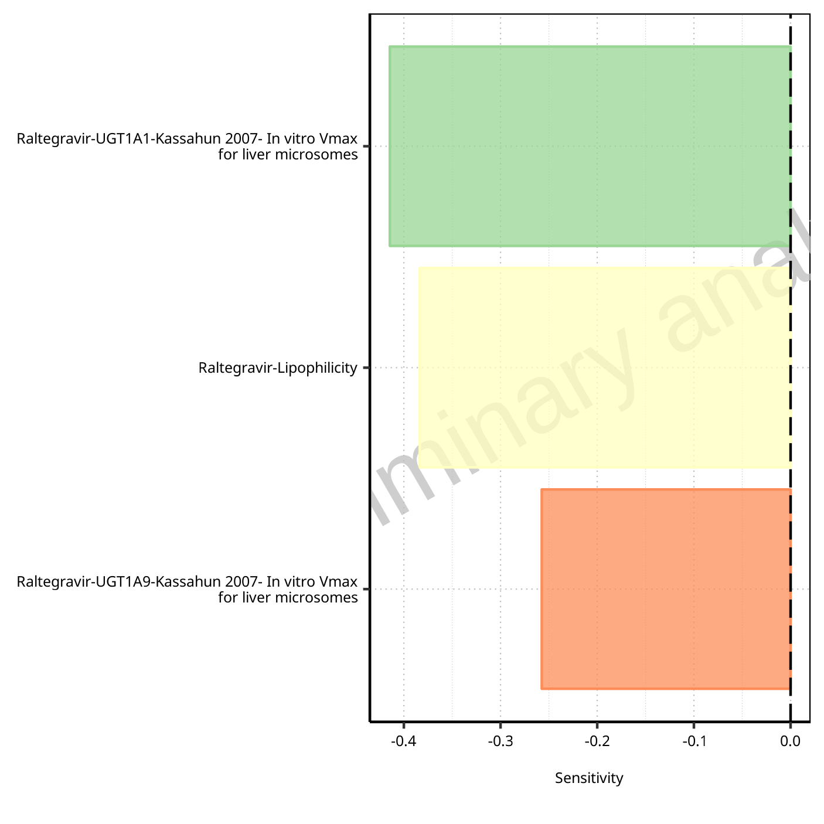

**Figure 1-89: Most sensitive parameters for AUC of Raltegravir.**

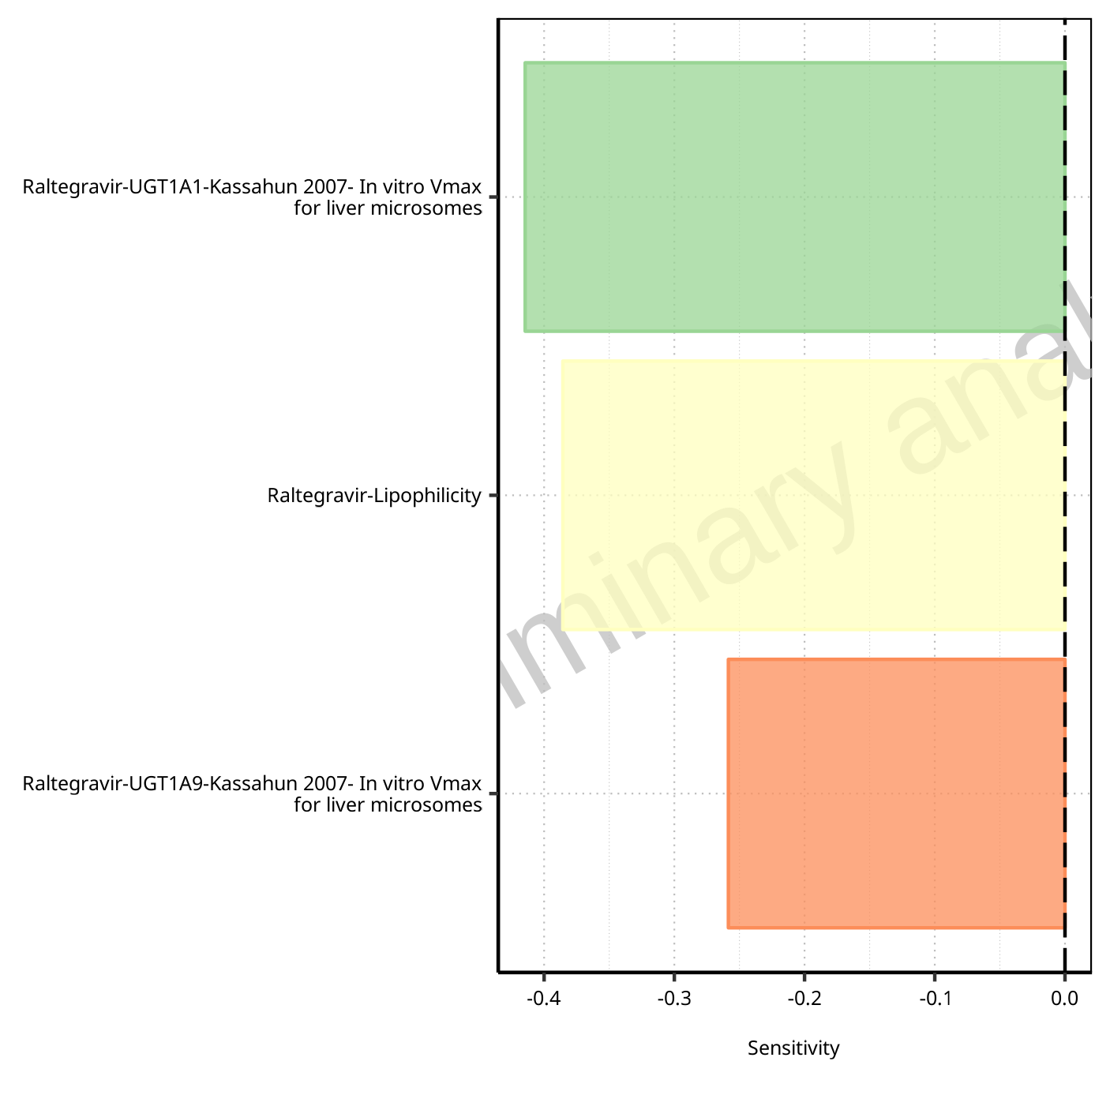

**Figure 1-90: Most sensitive parameters for AUC_inf of Raltegravir.**

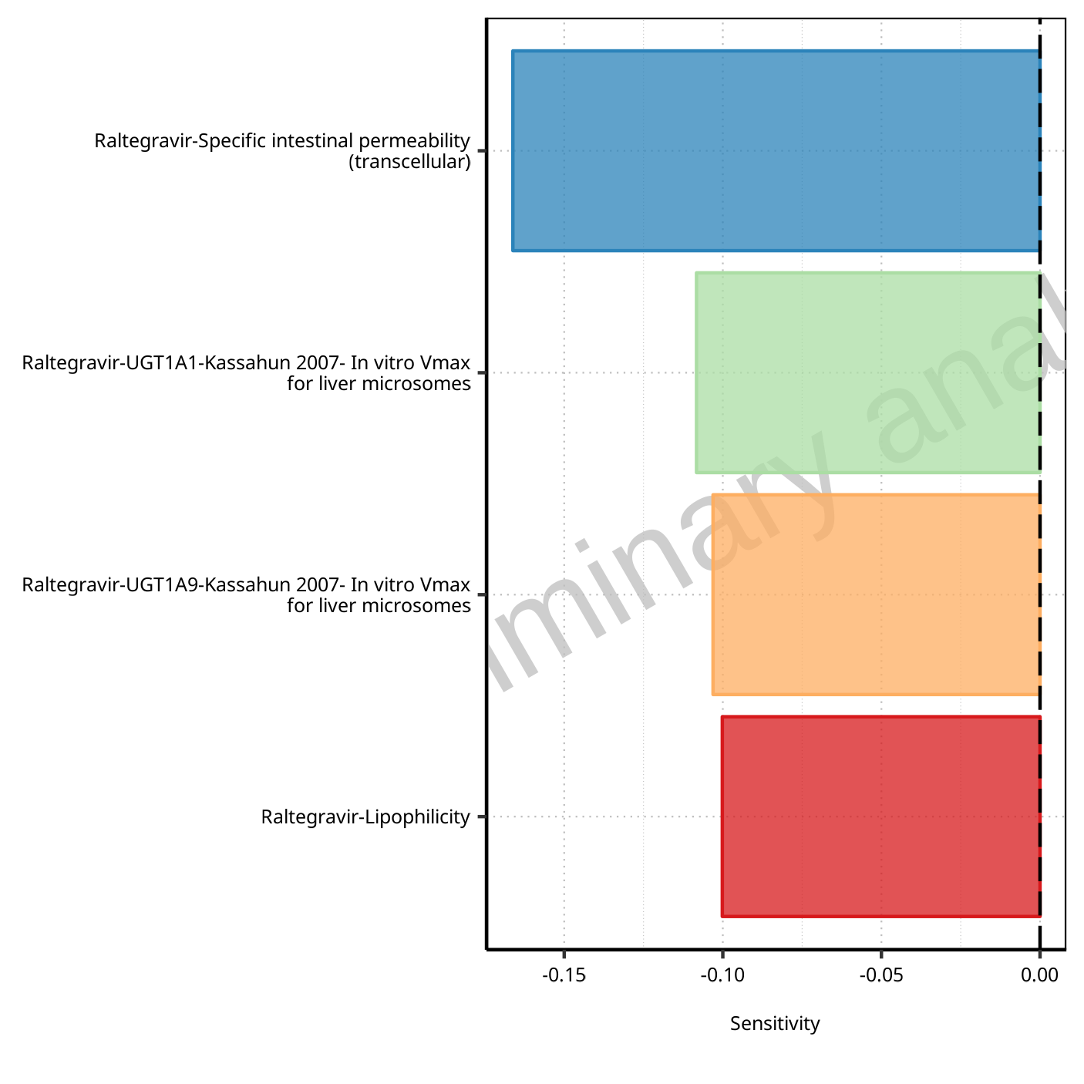

**Figure 1-91: Most sensitive parameters for MRT of Raltegravir.**

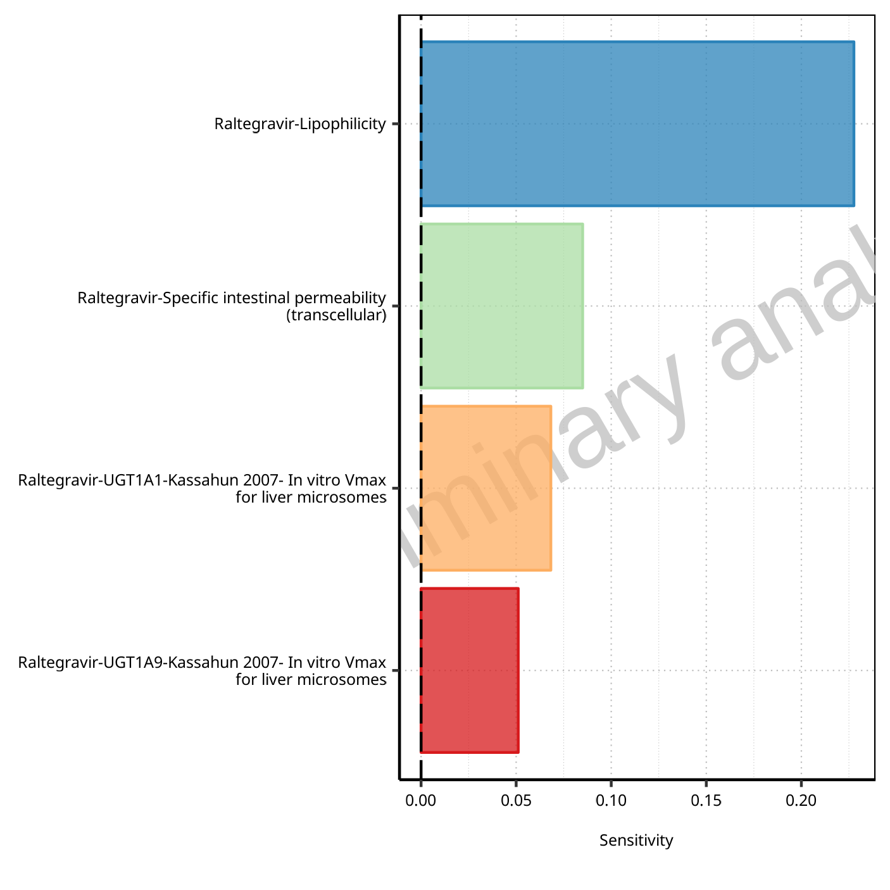

**Figure 1-92: Most sensitive parameters for Thalf of Raltegravir.**

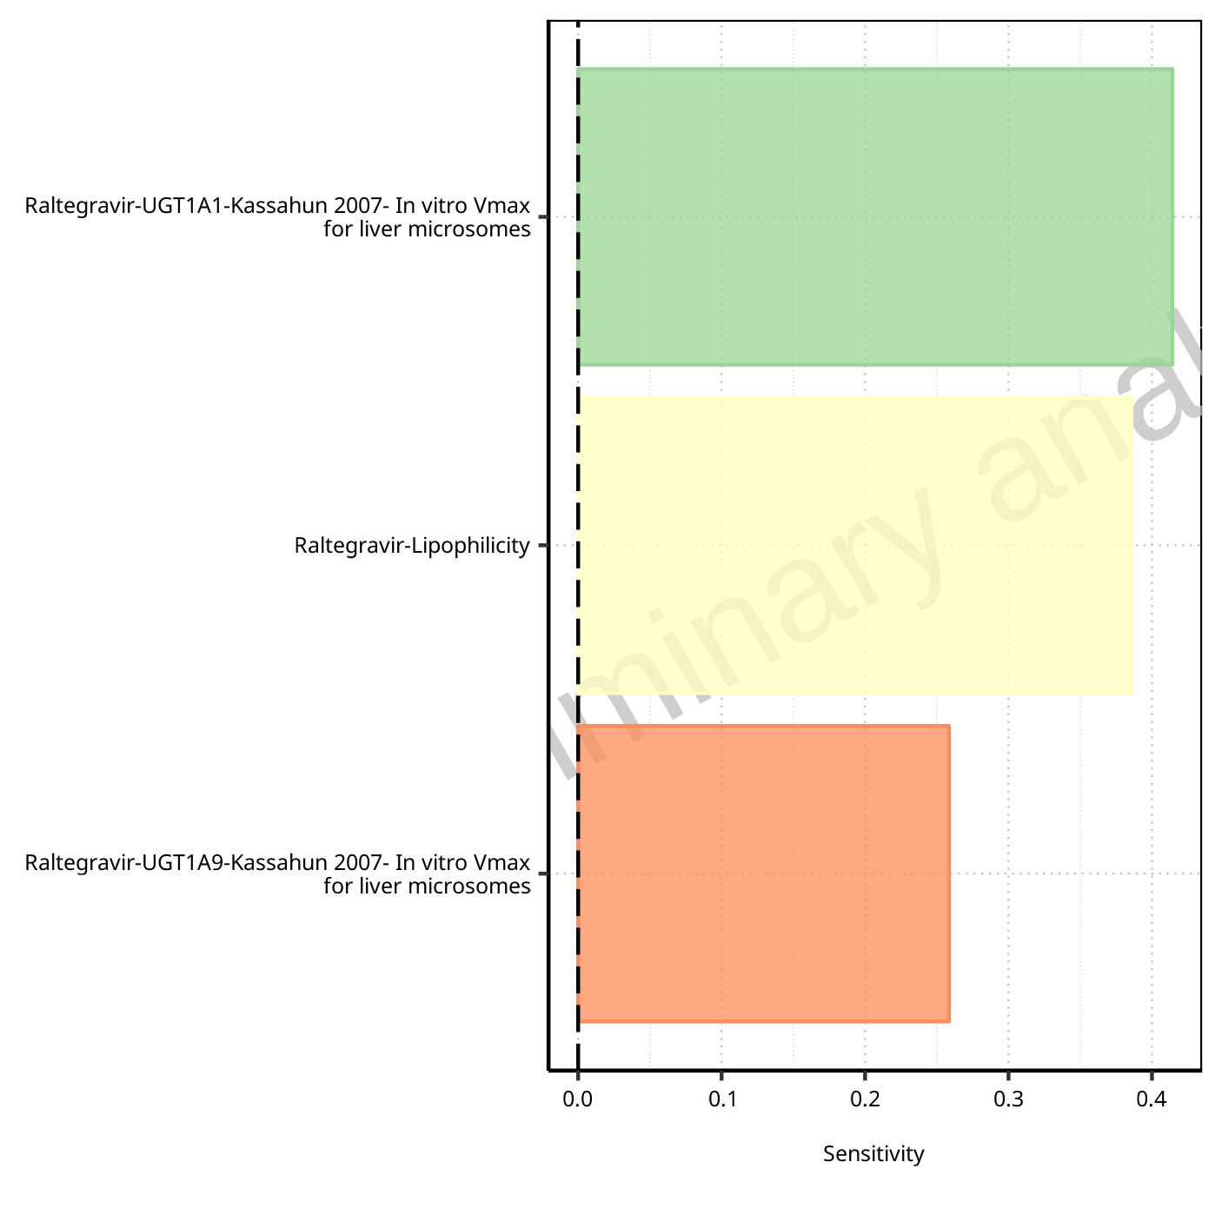

**Figure 1-93: Most sensitive parameters for CL of Raltegravir.**

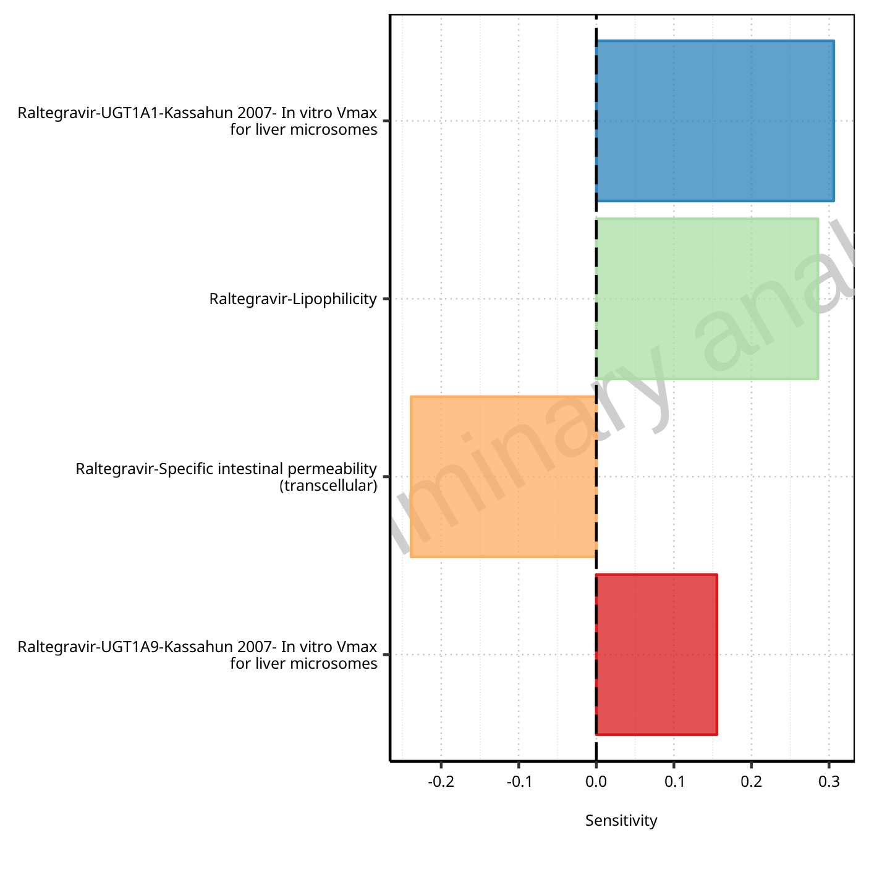

**Figure 1-94: Most sensitive parameters for Vss of Raltegravir.**

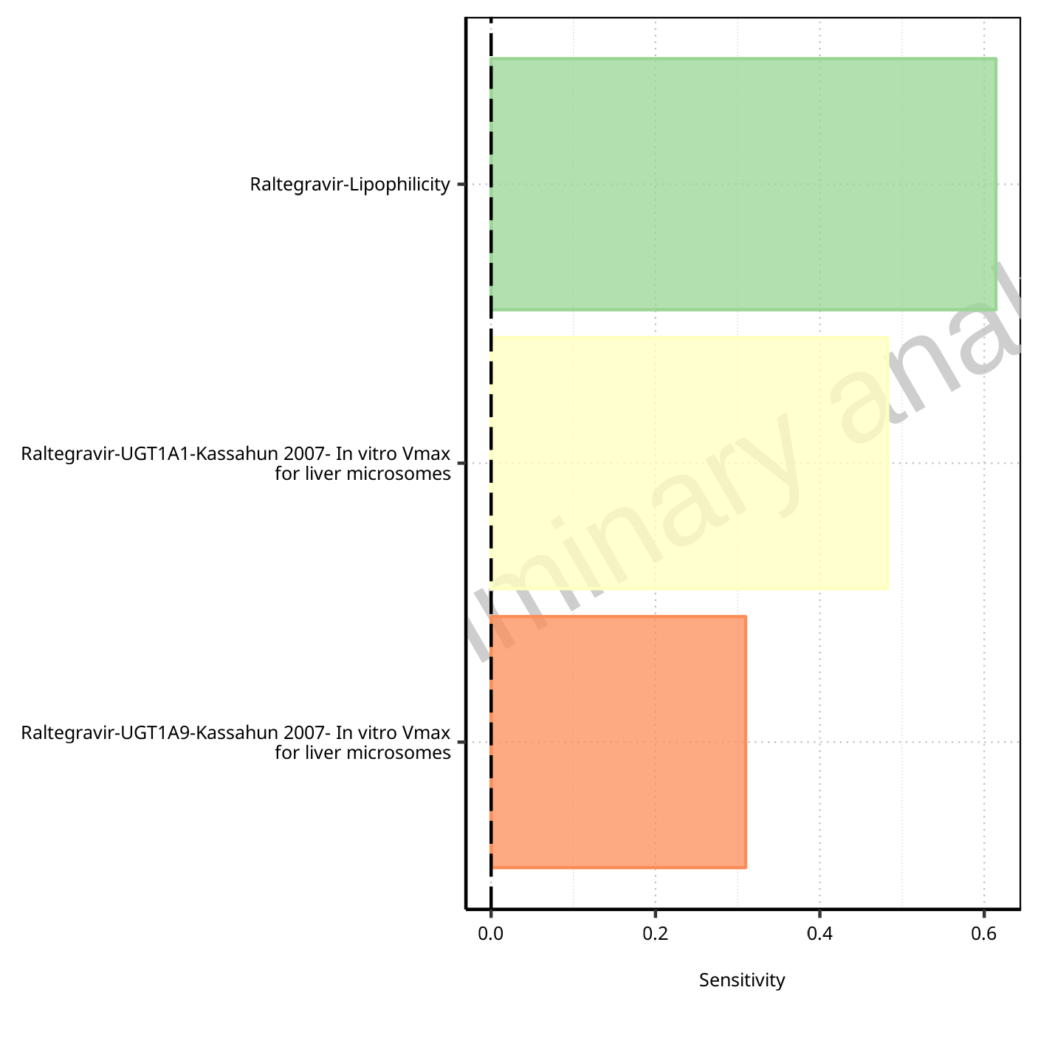

**Figure 1-95: Most sensitive parameters for Vd of Raltegravir.**

# PK parameters

## PK parameters for Raltegravir 10 mg (lactose formulation)

**Table 2-1: PK parameters for Raltegravir 10 mg (lactose formulation)**

| Path | Parameter | Value | Unit |
| --- | --- | --- | --- |
| Raltegravir | C_max | 110.49 | µg/l |
| Raltegravir | C_max_norm | 0.81 | kg/l |
| Raltegravir | t_max | 0.75 | h |
| Raltegravir | C_tEnd | 1.96 | µg/l |
| Raltegravir | AUC | 241.61 | µg*h/l |
| Raltegravir | AUC_norm | 1.76 | kg*h/l |
| Raltegravir | AUC_inf | 255.14 | µg*h/l |
| Raltegravir | AUC_inf_norm | 1.86 | kg*h/l |
| Raltegravir | MRT | 3.33 | h |
| Raltegravir | Thalf | 4.79 | h |
| Raltegravir | CL | 8.95 | ml/min/kg |
| Raltegravir | Vss | 1787.57 | ml/kg |
| Raltegravir | Vd | 3713.90 | ml/kg |

## PK parameters for Raltegravir 100 mg filmcoated tablet md

**Table 2-2: PK parameters for Raltegravir 100 mg filmcoated tablet md**

| Path | Parameter | Value | Unit |
| --- | --- | --- | --- |
| Raltegravir | C_max | 893.50 | µg/l |
| Raltegravir | C_max_norm | 0.03 | kg/l |
| Raltegravir | C_max_t1_t2 | 863.16 | µg/l |
| Raltegravir | C_max_t1_t2_norm | 0.63 | kg/l |
| Raltegravir | C_max_tLast_tEnd | 892.65 | µg/l |
| Raltegravir | C_max_tLast_tEnd_norm | 0.65 | kg/l |
| Raltegravir | t_max | 168.75 | h |
| Raltegravir | t_max_t1_t2 | 0.75 | h |
| Raltegravir | t_max_tLast_tEnd | 228.75 | h |
| Raltegravir | C_trough_t2 | 19.66 | µg/l |
| Raltegravir | C_trough_tLast | 31.92 | µg/l |
| Raltegravir | AUC_t1_t2 | 1978.76 | µg*h/l |
| Raltegravir | AUC_t1_t2_norm | 1.44 | kg*h/l |
| Raltegravir | AUC_tLast_minus_1_tLast | 2218.73 | µg*h/l |
| Raltegravir | AUC_tLast_minus_1_tLast_norm | 1.62 | kg*h/l |
| Raltegravir | AUC_inf_t1 | 2144.35 | µg*h/l |
| Raltegravir | AUC_inf_t1_norm | 1.57 | kg*h/l |
| Raltegravir | AUC_inf_tLast | 2536.55 | µg*h/l |
| Raltegravir | AUC_inf_tLast_norm | 1.85 | kg*h/l |
| Raltegravir | MRT | 3.96 | h |
| Raltegravir | Thalf | 5.84 | h |
| Raltegravir | Thalf_tLast_tEnd | 6.90 | h |

## PK parameters for Raltegravir 200 mg filmcoated tablet md

**Table 2-3: PK parameters for Raltegravir 200 mg filmcoated tablet md**

| Path | Parameter | Value | Unit |
| --- | --- | --- | --- |
| Raltegravir | C_max | 1811.96 | µg/l |
| Raltegravir | C_max_norm | 0.03 | kg/l |
| Raltegravir | C_max_t1_t2 | 1748.66 | µg/l |
| Raltegravir | C_max_t1_t2_norm | 0.64 | kg/l |
| Raltegravir | C_max_tLast_tEnd | 1808.60 | µg/l |
| Raltegravir | C_max_tLast_tEnd_norm | 0.66 | kg/l |
| Raltegravir | t_max | 204.75 | h |
| Raltegravir | t_max_t1_t2 | 0.75 | h |
| Raltegravir | t_max_tLast_tEnd | 228.75 | h |
| Raltegravir | C_trough_t2 | 39.47 | µg/l |
| Raltegravir | C_trough_tLast | 64.03 | µg/l |
| Raltegravir | AUC_t1_t2 | 3998.12 | µg*h/l |
| Raltegravir | AUC_t1_t2_norm | 1.46 | kg*h/l |
| Raltegravir | AUC_tLast_minus_1_tLast | 4480.74 | µg*h/l |
| Raltegravir | AUC_tLast_minus_1_tLast_norm | 1.64 | kg*h/l |
| Raltegravir | AUC_inf_t1 | 4329.13 | µg*h/l |
| Raltegravir | AUC_inf_t1_norm | 1.58 | kg*h/l |
| Raltegravir | AUC_inf_tLast | 5115.69 | µg*h/l |
| Raltegravir | AUC_inf_tLast_norm | 1.87 | kg*h/l |
| Raltegravir | MRT | 3.94 | h |
| Raltegravir | Thalf | 5.81 | h |
| Raltegravir | Thalf_tLast_tEnd | 6.87 | h |

## PK parameters for Filmcoated_tablet_400mg_sd

**Table 2-4: PK parameters for Filmcoated_tablet_400mg_sd**

| Path | Parameter | Value | Unit |
| --- | --- | --- | --- |
| Raltegravir | C_max | 3568.56 | µg/l |
| Raltegravir | C_max_norm | 0.65 | kg/l |
| Raltegravir | t_max | 0.75 | h |
| Raltegravir | C_tEnd | 28.27 | µg/l |
| Raltegravir | AUC | 8703.65 | µg*h/l |
| Raltegravir | AUC_norm | 1.59 | kg*h/l |
| Raltegravir | AUC_inf | 9072.43 | µg*h/l |
| Raltegravir | AUC_inf_norm | 1.66 | kg*h/l |
| Raltegravir | MRT | 4.89 | h |
| Raltegravir | Thalf | 9.04 | h |
| Raltegravir | CL | 10.07 | ml/min/kg |
| Raltegravir | Vss | 2954.74 | ml/kg |
| Raltegravir | Vd | 7878.98 | ml/kg |

## PK parameters for Raltegravir 400 mg filmcoated tablet md

**Table 2-5: PK parameters for Raltegravir 400 mg filmcoated tablet md**

| Path | Parameter | Value | Unit |
| --- | --- | --- | --- |
| Raltegravir | C_max | 3691.84 | µg/l |
| Raltegravir | C_max_norm | 0.03 | kg/l |
| Raltegravir | C_max_t1_t2 | 3569.01 | µg/l |
| Raltegravir | C_max_t1_t2_norm | 0.65 | kg/l |
| Raltegravir | C_max_tLast_tEnd | 3689.99 | µg/l |
| Raltegravir | C_max_tLast_tEnd_norm | 0.67 | kg/l |
| Raltegravir | t_max | 72.75 | h |
| Raltegravir | t_max_t1_t2 | 0.75 | h |
| Raltegravir | t_max_tLast_tEnd | 228.75 | h |
| Raltegravir | C_trough_t2 | 79.75 | µg/l |
| Raltegravir | C_trough_tLast | 129.19 | µg/l |
| Raltegravir | AUC_t1_t2 | 8128.05 | µg*h/l |
| Raltegravir | AUC_t1_t2_norm | 1.48 | kg*h/l |
| Raltegravir | AUC_tLast_minus_1_tLast | 9098.53 | µg*h/l |
| Raltegravir | AUC_tLast_minus_1_tLast_norm | 1.66 | kg*h/l |
| Raltegravir | AUC_inf_t1 | 8798.72 | µg*h/l |
| Raltegravir | AUC_inf_t1_norm | 1.61 | kg*h/l |
| Raltegravir | AUC_inf_tLast | 10365.92 | µg*h/l |
| Raltegravir | AUC_inf_tLast_norm | 1.89 | kg*h/l |
| Raltegravir | MRT | 3.93 | h |
| Raltegravir | Thalf | 5.83 | h |
| Raltegravir | Thalf_tLast_tEnd | 6.80 | h |

## PK parameters for Raltegravir 400mg chewable fasted

**Table 2-6: PK parameters for Raltegravir 400mg chewable fasted**

| Path | Parameter | Value | Unit |
| --- | --- | --- | --- |
| Raltegravir | C_max | 6330.52 | µg/l |
| Raltegravir | C_max_norm | 1.16 | kg/l |
| Raltegravir | t_max | 0.75 | h |
| Raltegravir | C_tEnd | 35.84 | µg/l |
| Raltegravir | AUC | 14694.82 | µg*h/l |
| Raltegravir | AUC_norm | 2.68 | kg*h/l |
| Raltegravir | AUC_inf | 15124.21 | µg*h/l |
| Raltegravir | AUC_inf_norm | 2.76 | kg*h/l |
| Raltegravir | MRT | 4.19 | h |
| Raltegravir | Thalf | 8.31 | h |
| Raltegravir | CL | 6.04 | ml/min/kg |
| Raltegravir | Vss | 1516.69 | ml/kg |
| Raltegravir | Vd | 4340.96 | ml/kg |

## PK parameters for Raltegravir 400mg chewable fed

**Table 2-7: PK parameters for Raltegravir 400mg chewable fed**

| Path | Parameter | Value | Unit |
| --- | --- | --- | --- |
| Raltegravir | C_max | 2580.44 | µg/l |
| Raltegravir | C_max_norm | 0.47 | kg/l |
| Raltegravir | t_max | 2.50 | h |
| Raltegravir | C_tEnd | 35.93 | µg/l |
| Raltegravir | AUC | 14119.09 | µg*h/l |
| Raltegravir | AUC_norm | 2.58 | kg*h/l |
| Raltegravir | AUC_inf | 14606.36 | µg*h/l |
| Raltegravir | AUC_inf_norm | 2.67 | kg*h/l |
| Raltegravir | MRT | 5.99 | h |
| Raltegravir | Thalf | 9.40 | h |
| Raltegravir | CL | 6.25 | ml/min/kg |
| Raltegravir | Vss | 2246.85 | ml/kg |
| Raltegravir | Vd | 5087.80 | ml/kg |

## PK parameters for Raltegravir 400mg (granules in suspension)

**Table 2-8: PK parameters for Raltegravir 400mg (granules in suspension)**

| Path | Parameter | Value | Unit |
| --- | --- | --- | --- |
| Raltegravir | C_max | 8156.79 | µg/l |
| Raltegravir | C_max_norm | 1.49 | kg/l |
| Raltegravir | t_max | 0.70 | h |
| Raltegravir | C_tEnd | 42.19 | µg/l |
| Raltegravir | AUC | 18791.01 | µg*h/l |
| Raltegravir | AUC_norm | 3.43 | kg*h/l |
| Raltegravir | AUC_inf | 19278.71 | µg*h/l |
| Raltegravir | AUC_inf_norm | 3.52 | kg*h/l |
| Raltegravir | MRT | 4.02 | h |
| Raltegravir | Thalf | 8.01 | h |
| Raltegravir | CL | 4.74 | ml/min/kg |
| Raltegravir | Vss | 1142.66 | ml/kg |
| Raltegravir | Vd | 3285.73 | ml/kg |

# Absorption

## Absorption for Raltegravir 10 mg (lactose formulation)

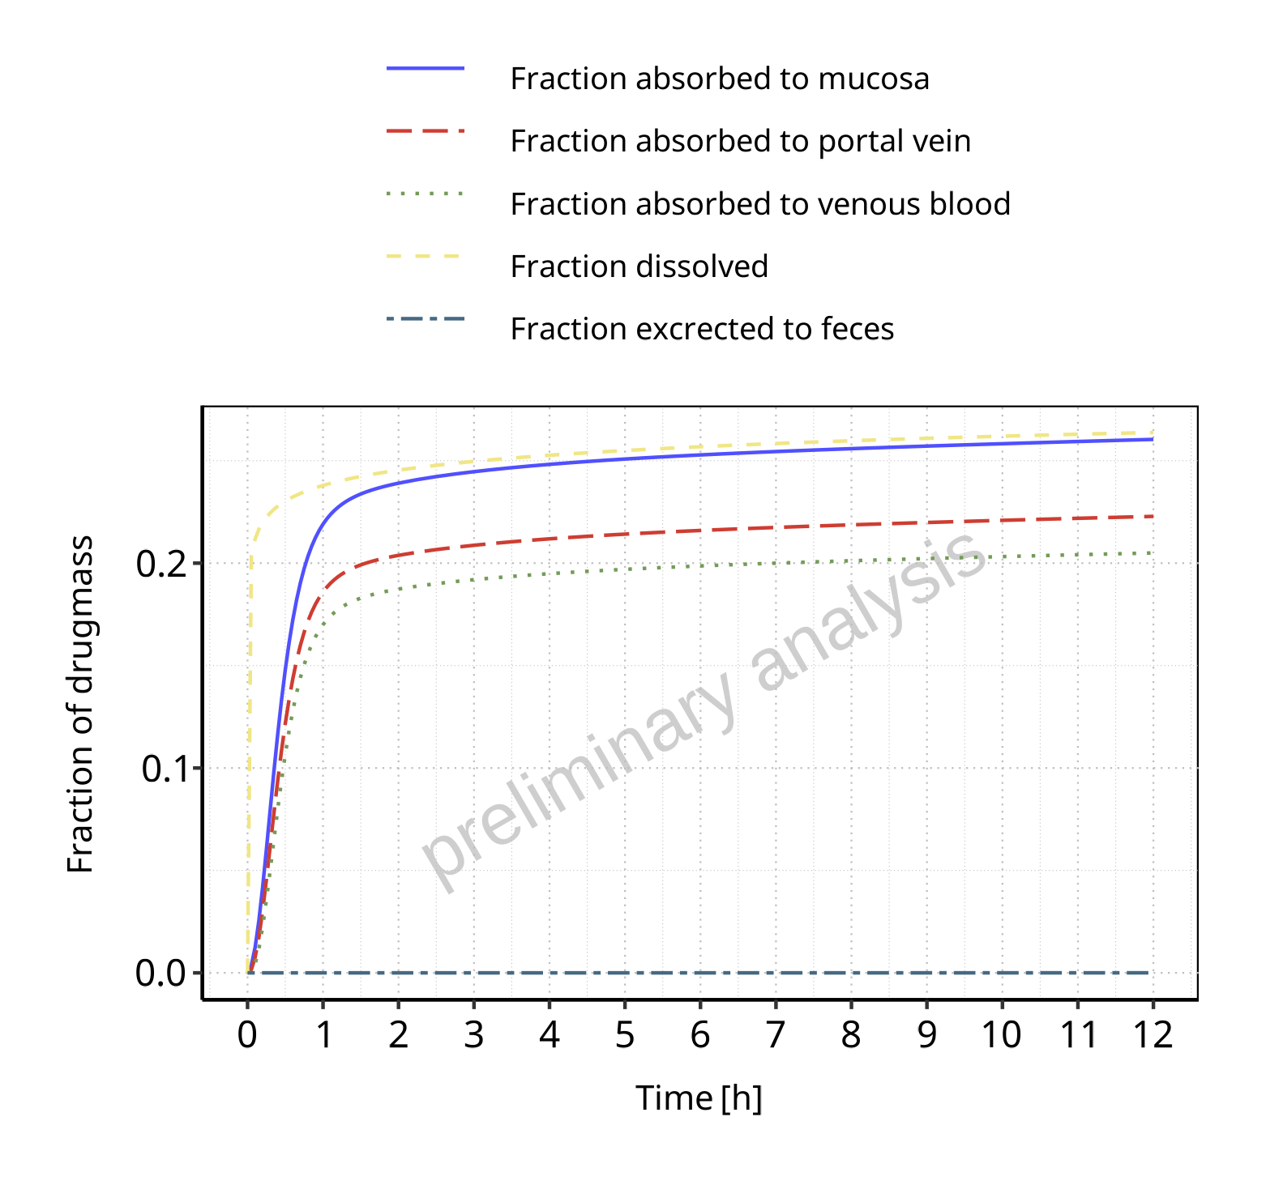

**Figure 3-1: Absorption of Raltegravir**

## Absorption for Raltegravir 100 mg filmcoated tablet md

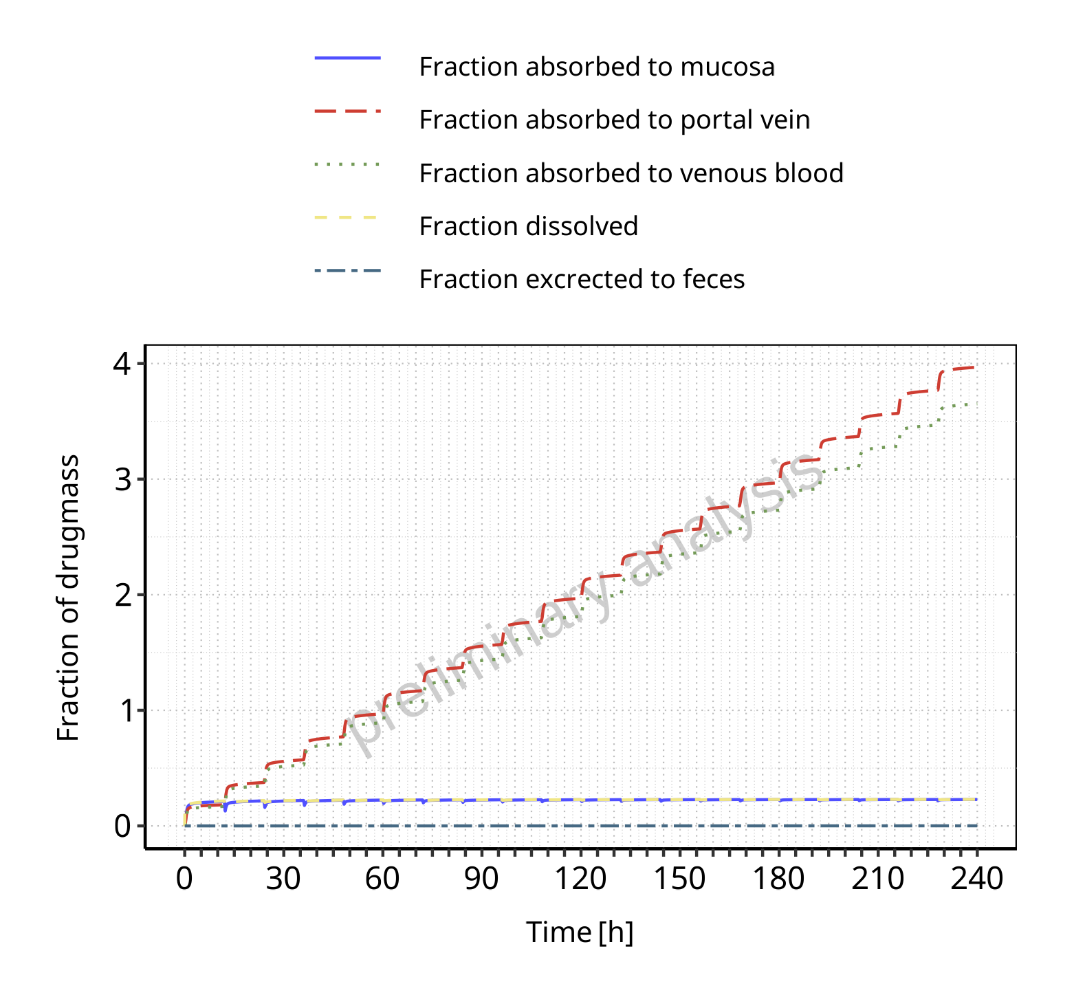

**Figure 3-2: Absorption of Raltegravir**

## Absorption for Raltegravir 200 mg filmcoated tablet md

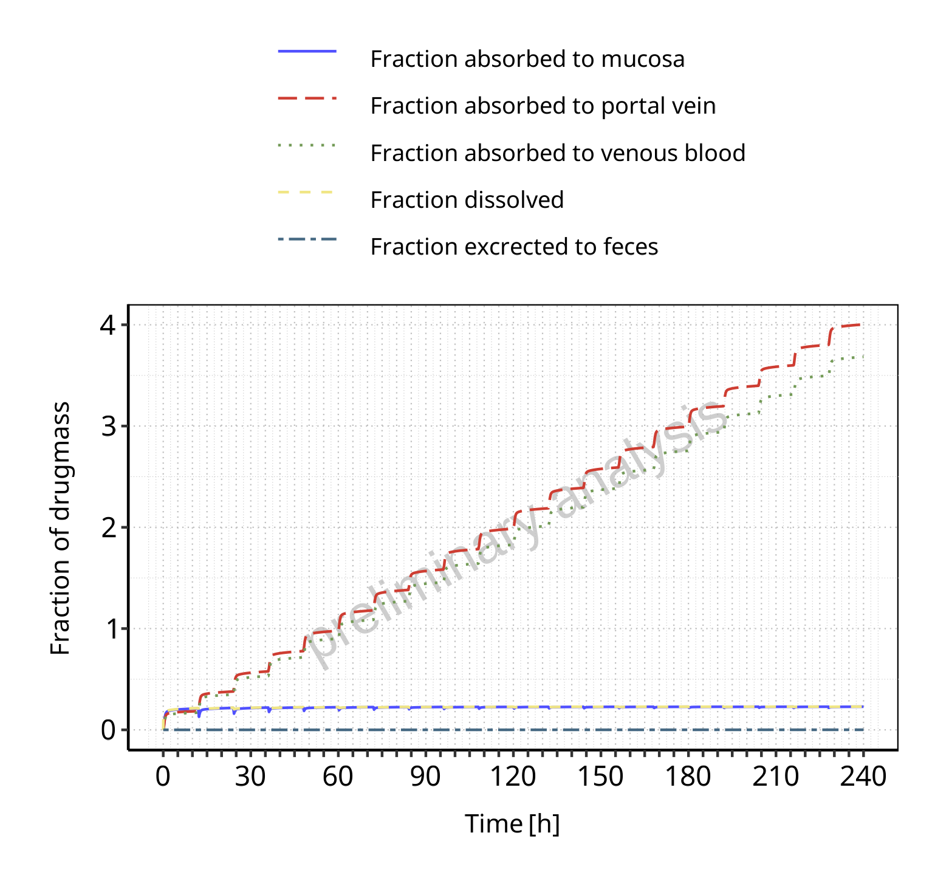

**Figure 3-3: Absorption of Raltegravir**

## Absorption for Filmcoated_tablet_400mg_sd

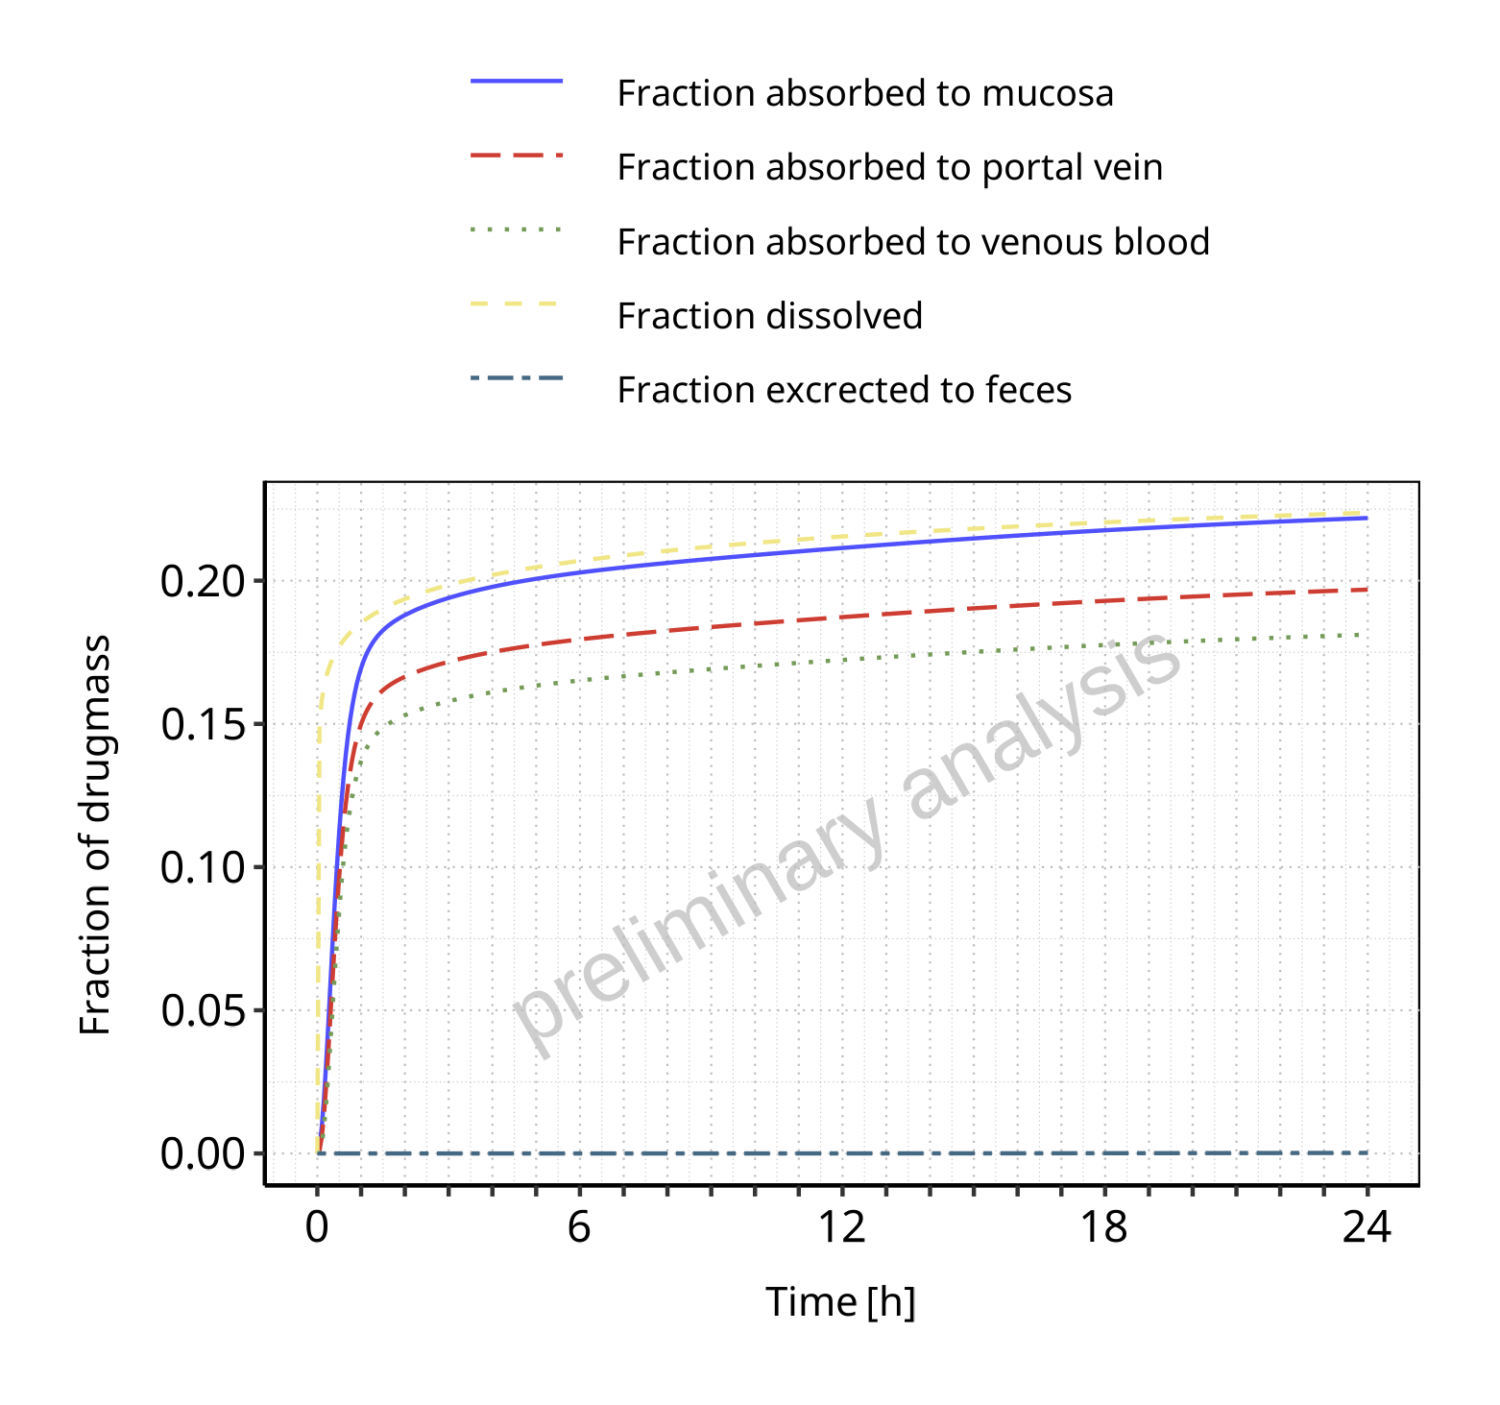

**Figure 3-4: Absorption of Raltegravir**

## Absorption for Raltegravir 400 mg filmcoated tablet md

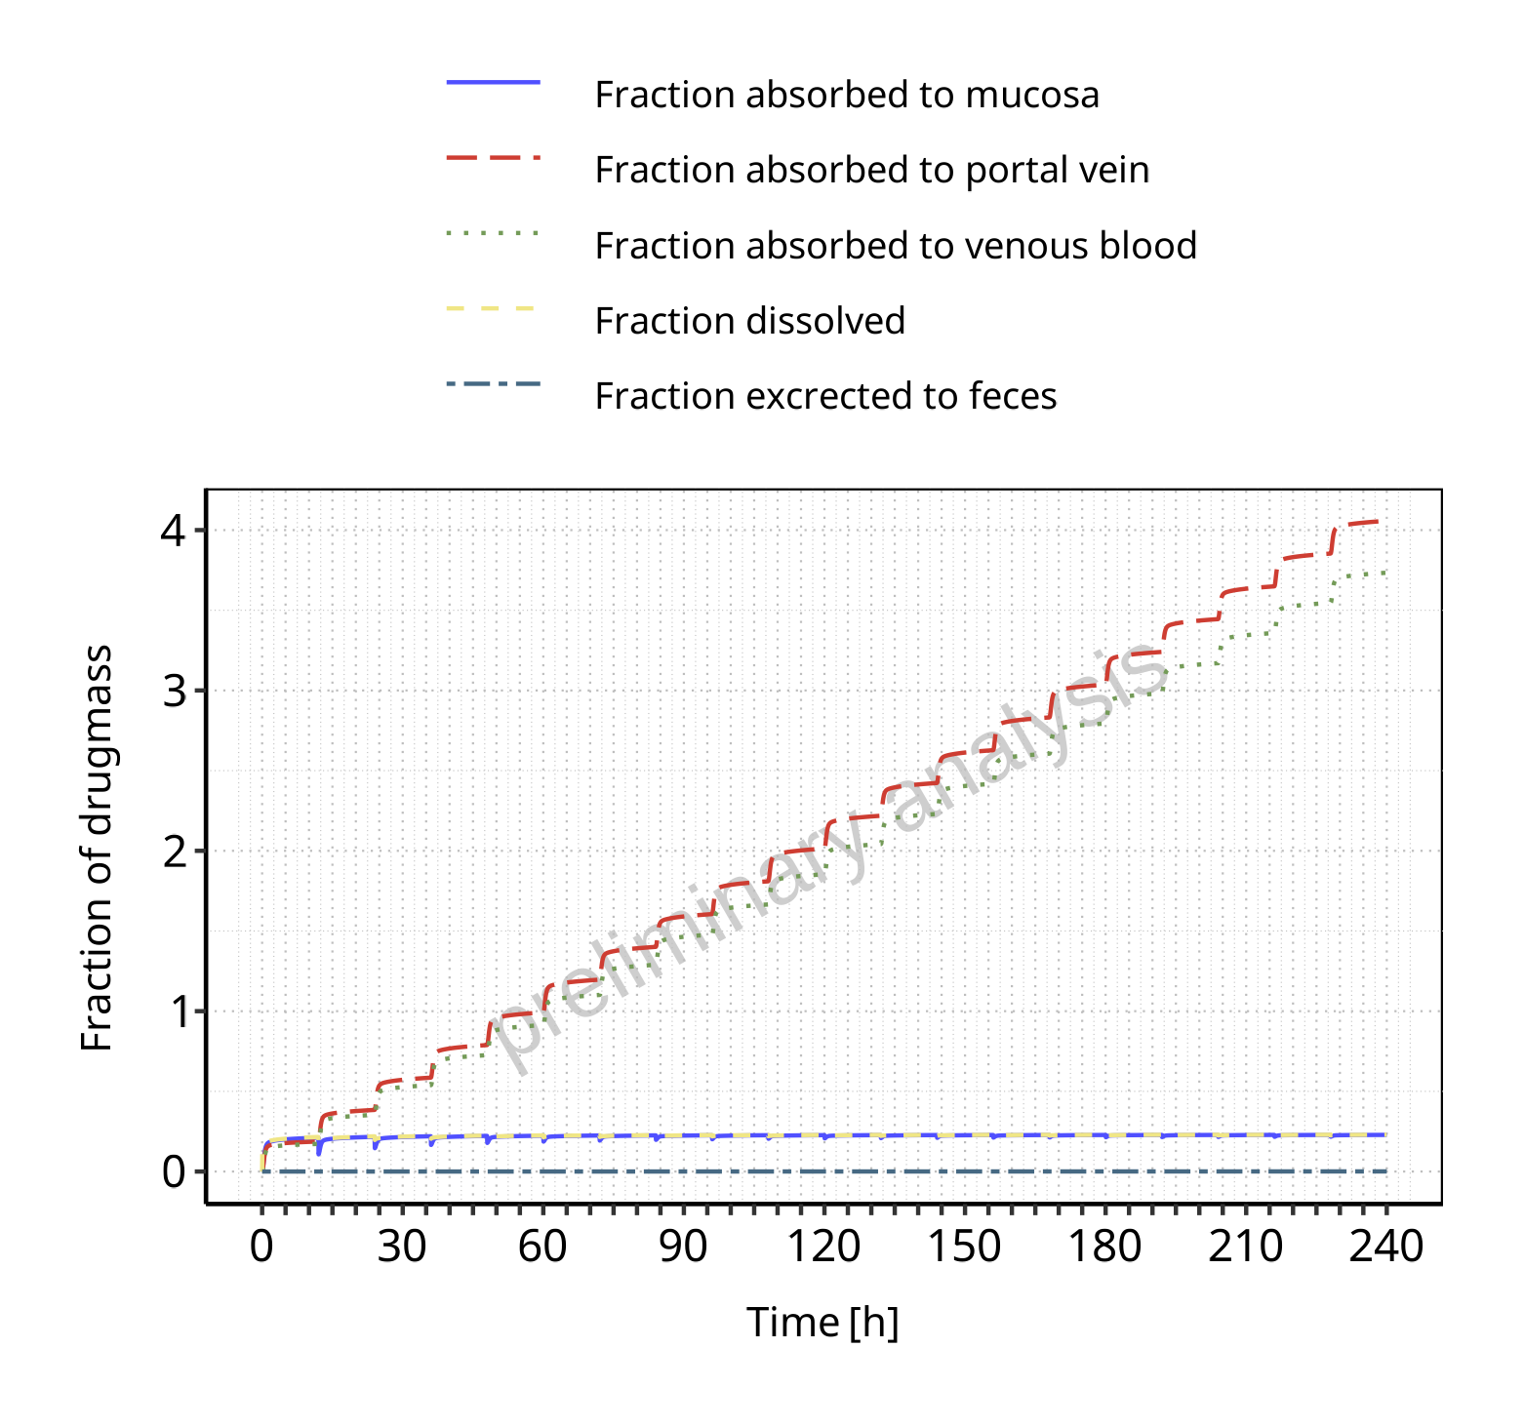

**Figure 3-5: Absorption of Raltegravir**

## Absorption for Raltegravir 400mg chewable fasted

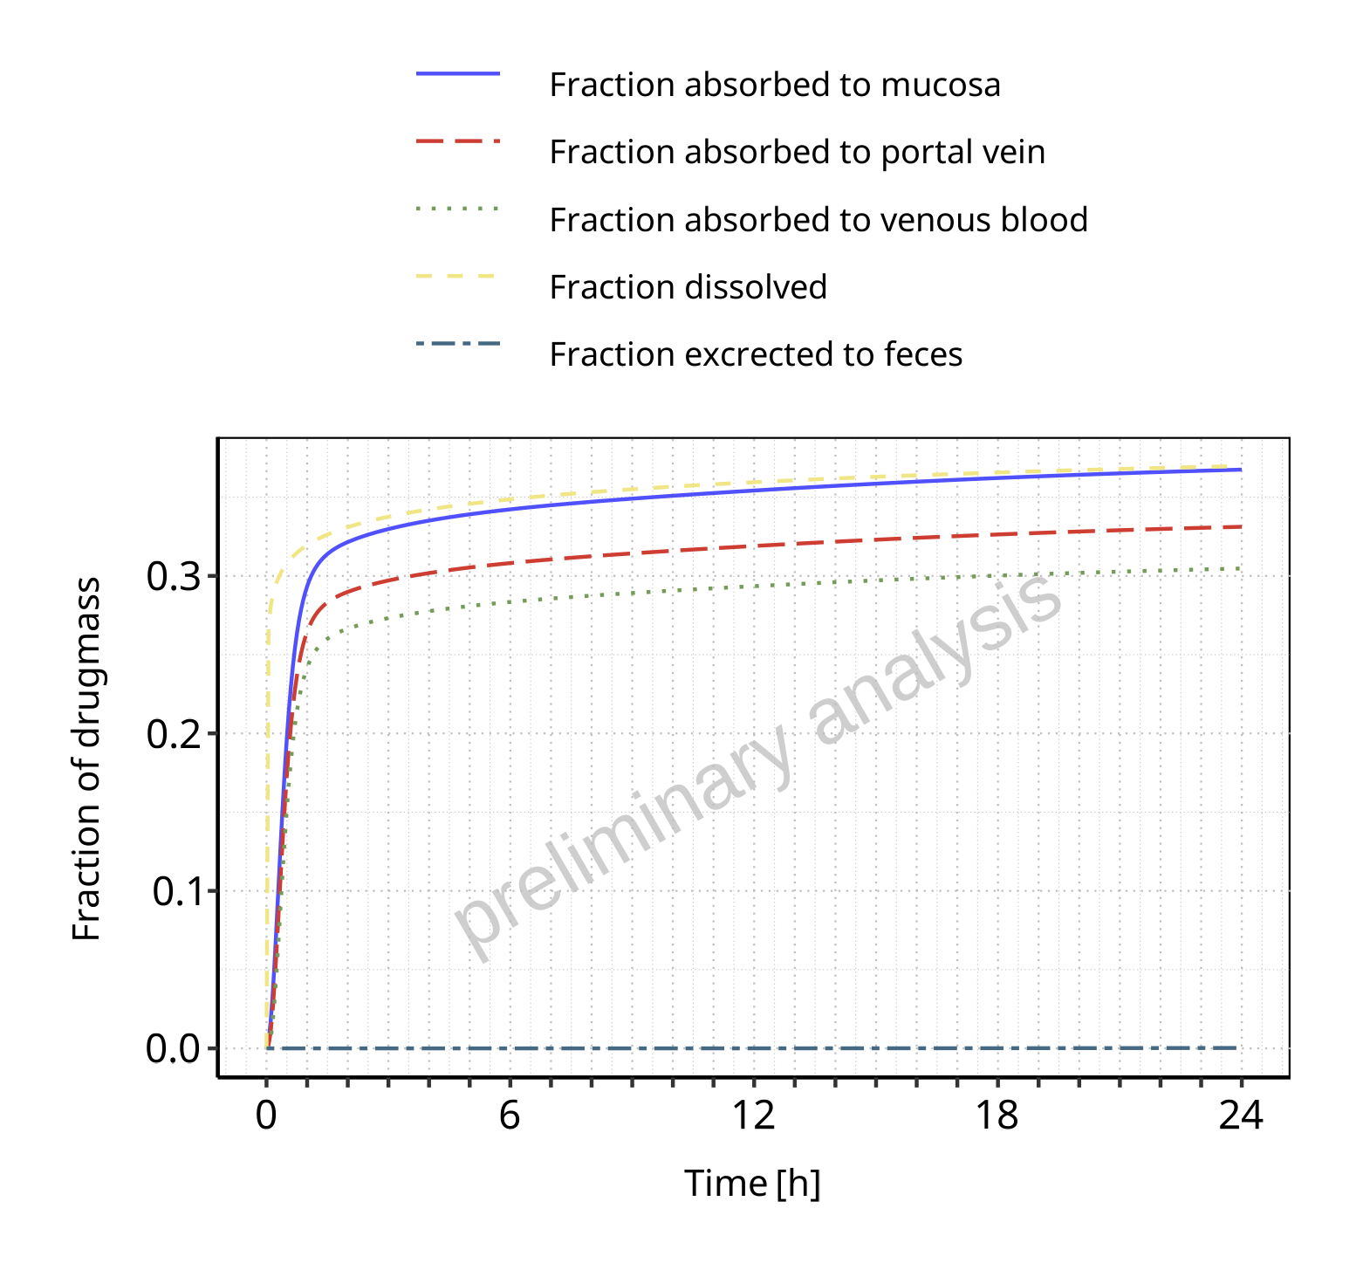

**Figure 3-6: Absorption of Raltegravir**

## Absorption for Raltegravir 400mg chewable fed

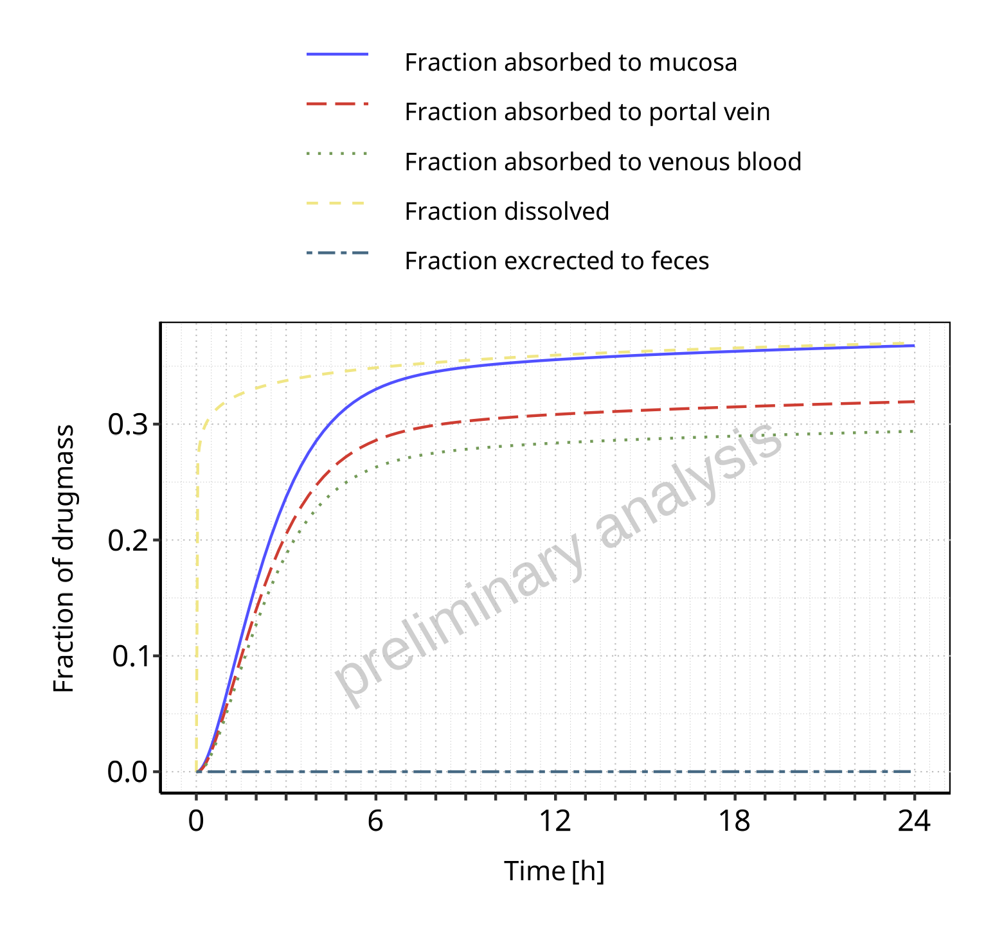

**Figure 3-7: Absorption of Raltegravir**

## Absorption for Raltegravir 400mg (granules in suspension)

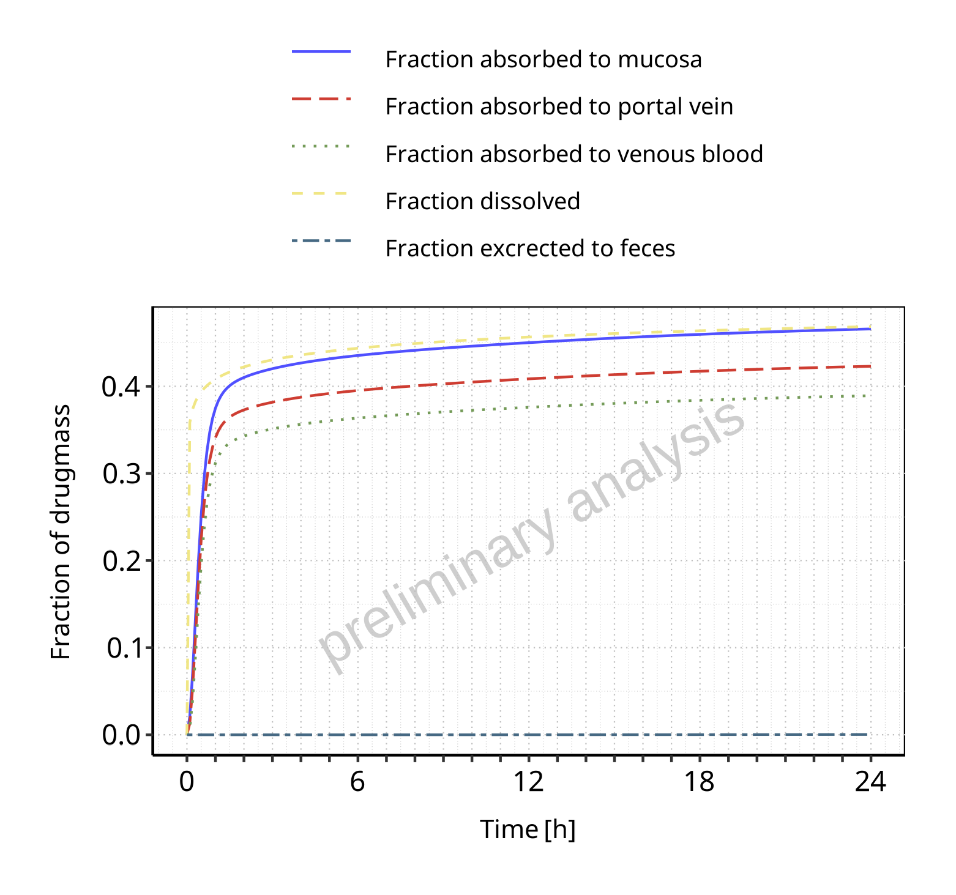

**Figure 3-8: Absorption of Raltegravir**

# Mass Balance

## Mass Balance for Raltegravir 10 mg (lactose formulation)

### Mass Balance for Raltegravir

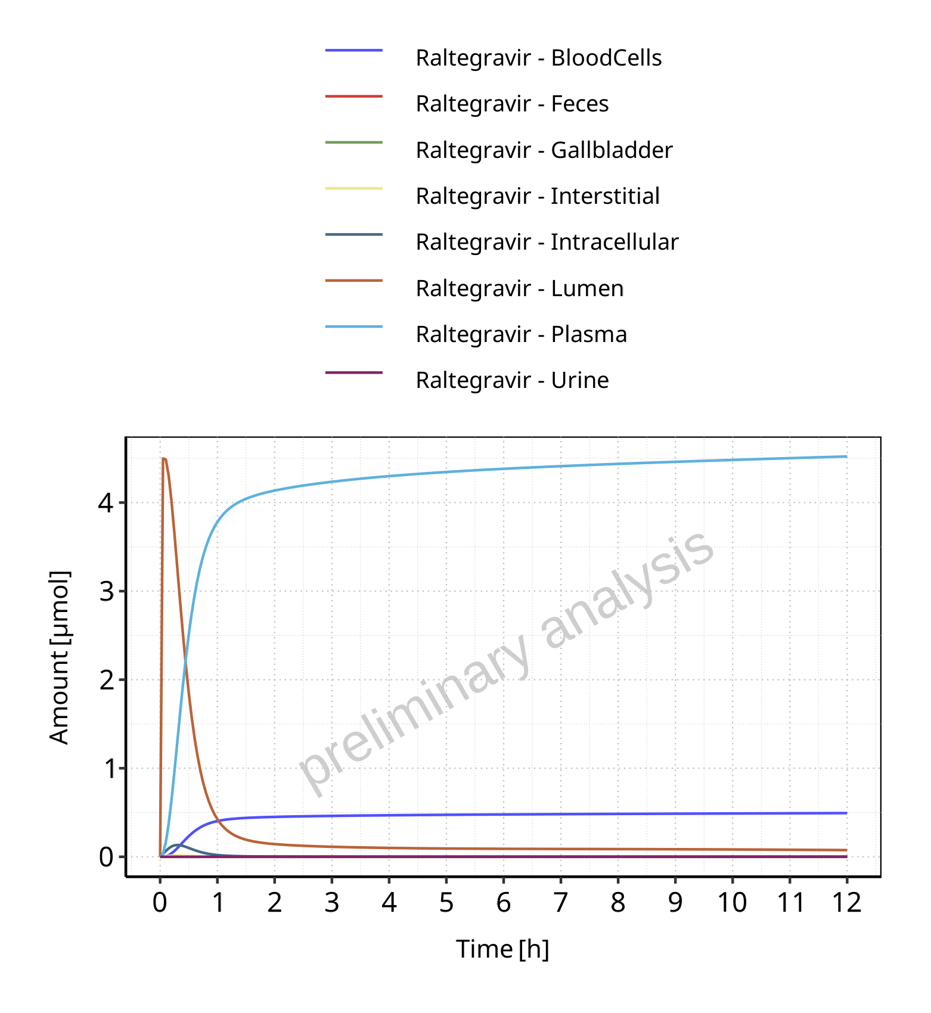

**Figure 4-1: Amount of drug vs time within the different compartments for Raltegravir**

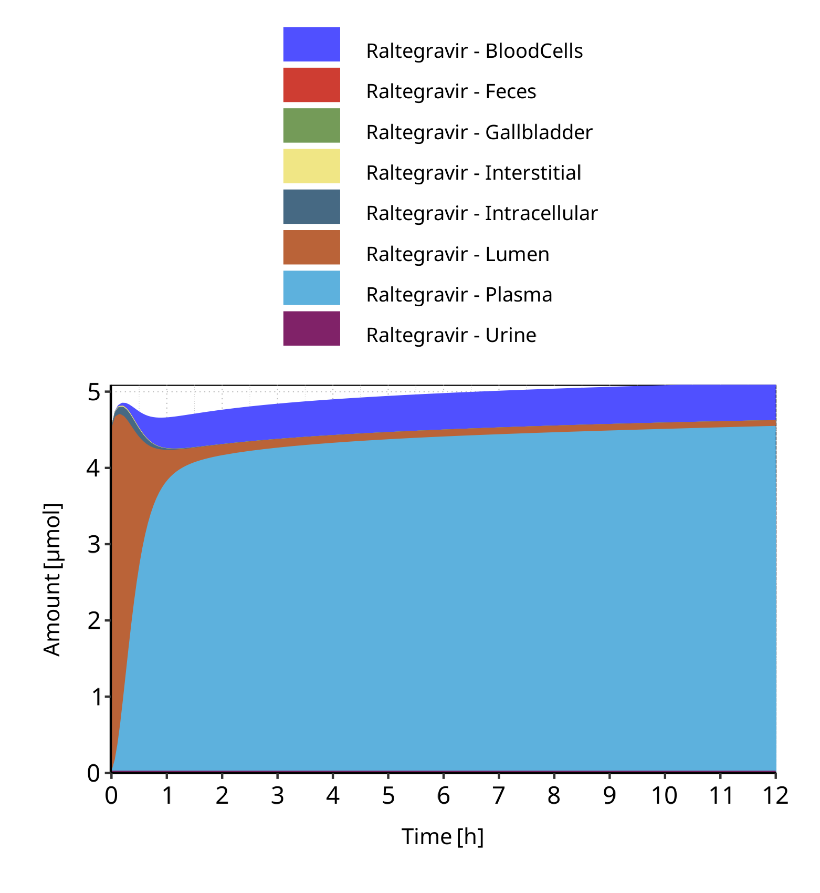

**Figure 4-2: Cumulated amount of drug vs time within the different compartments for Raltegravir**

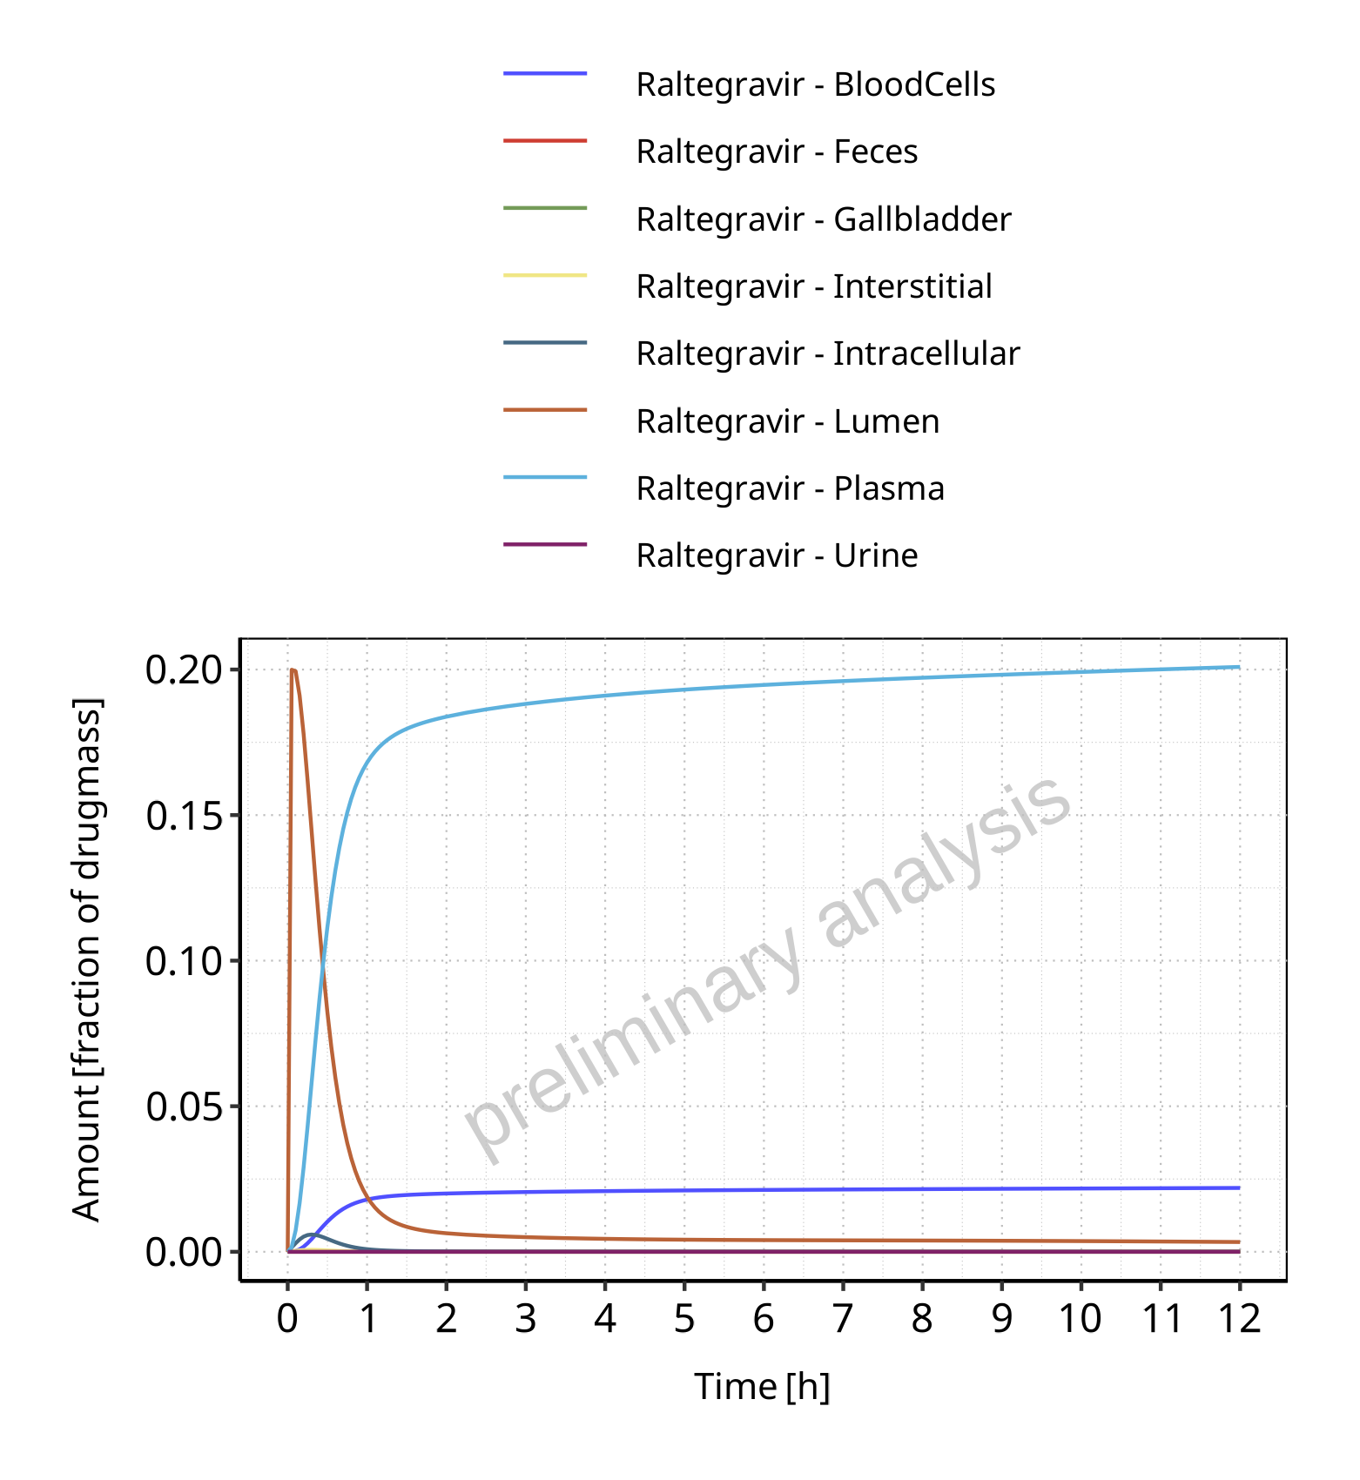

**Figure 4-3: Amount of drug vs time within the different compartments normalized to applicated drugmass for Raltegravir**

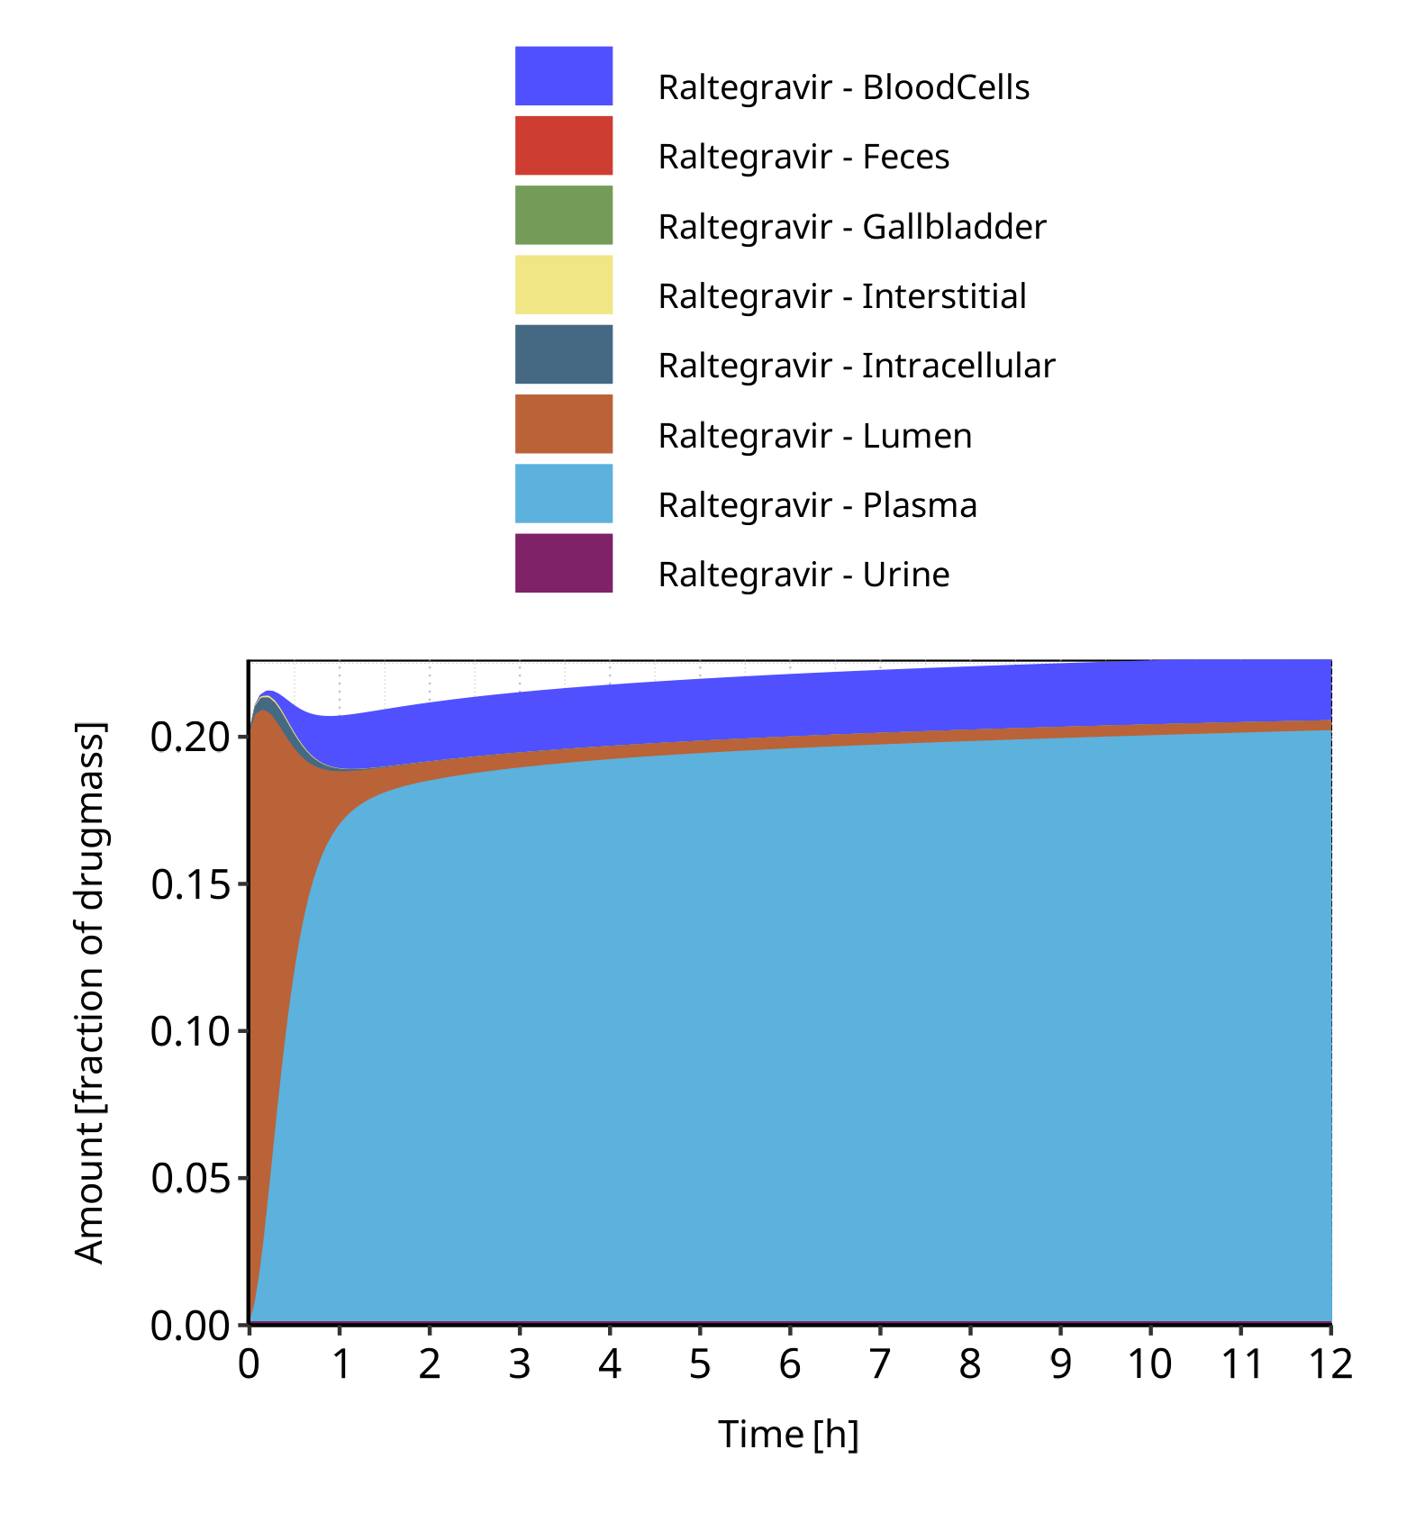

**Figure 4-4: Cumulated amount of drug vs time within the different compartments normalized to applicated drugmass for Raltegravir**

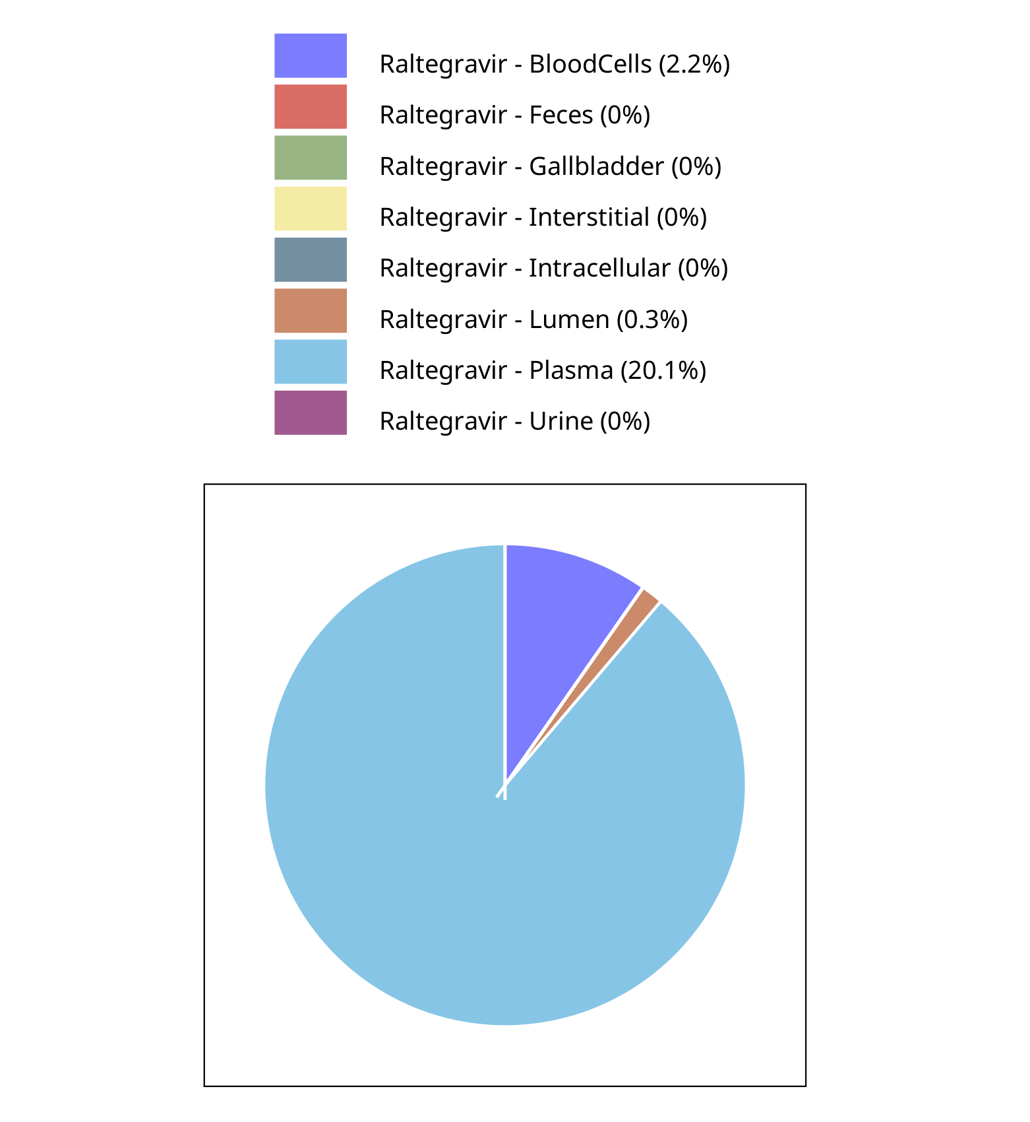

**Figure 4-5: Fraction of drug within the different compartments at 12.00h for Raltegravir**

## Mass Balance for Raltegravir 100 mg filmcoated tablet md

### Mass Balance for Raltegravir

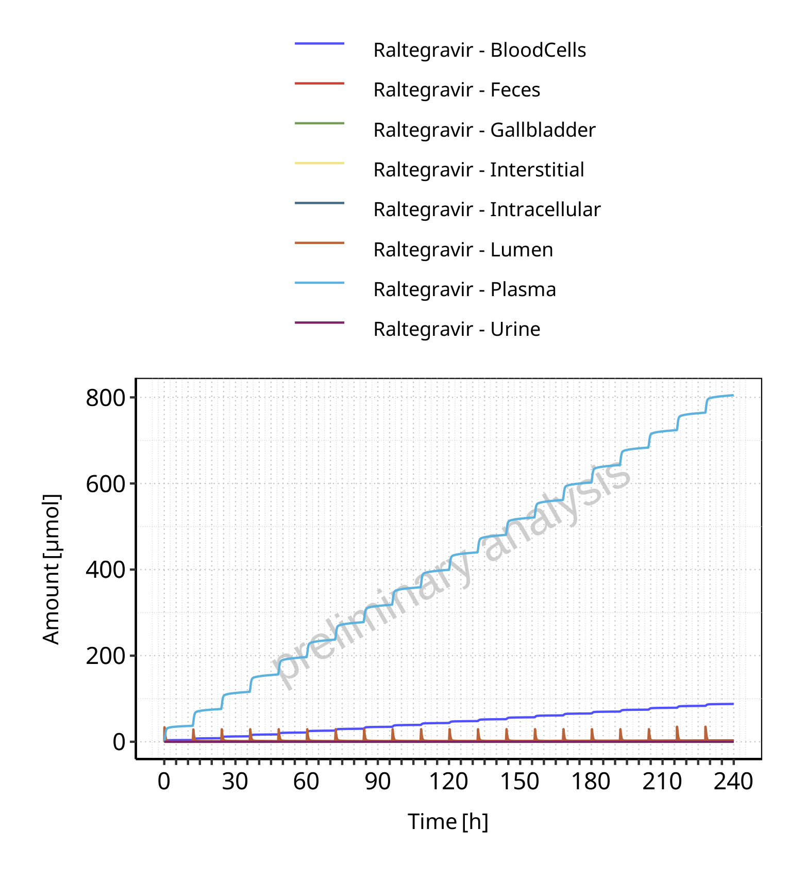

**Figure 4-6: Amount of drug vs time within the different compartments for Raltegravir**

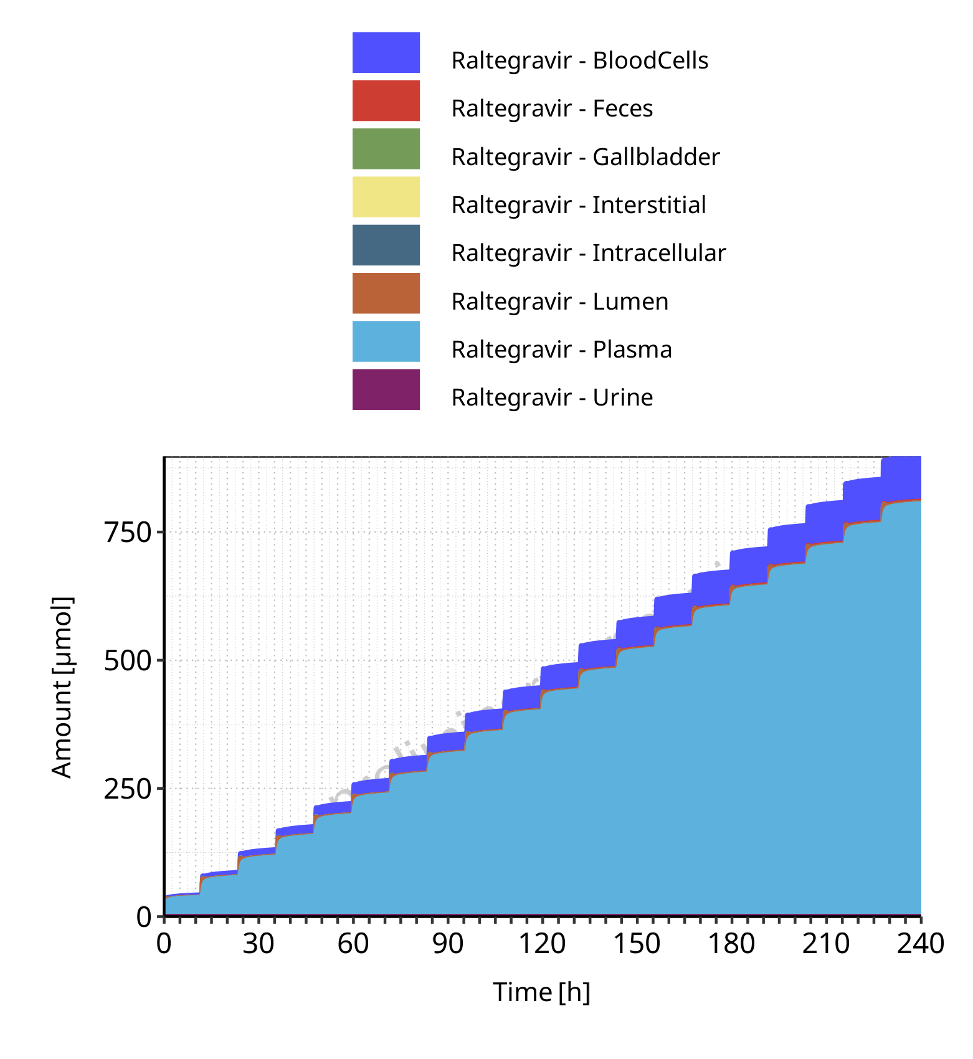

**Figure 4-7: Cumulated amount of drug vs time within the different compartments for Raltegravir**

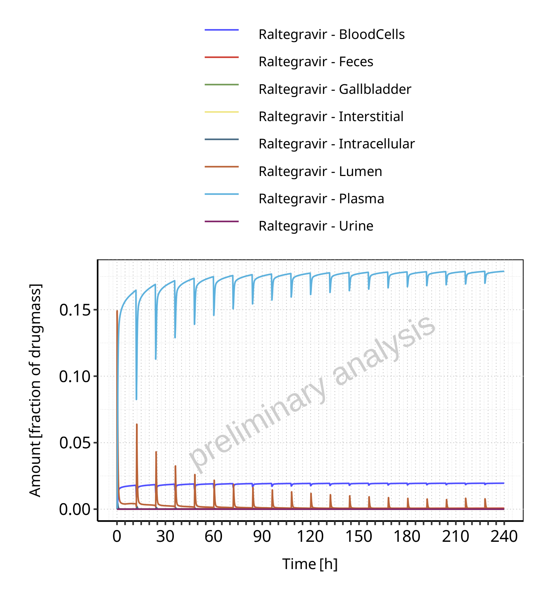

**Figure 4-8: Amount of drug vs time within the different compartments normalized to applicated drugmass for Raltegravir**

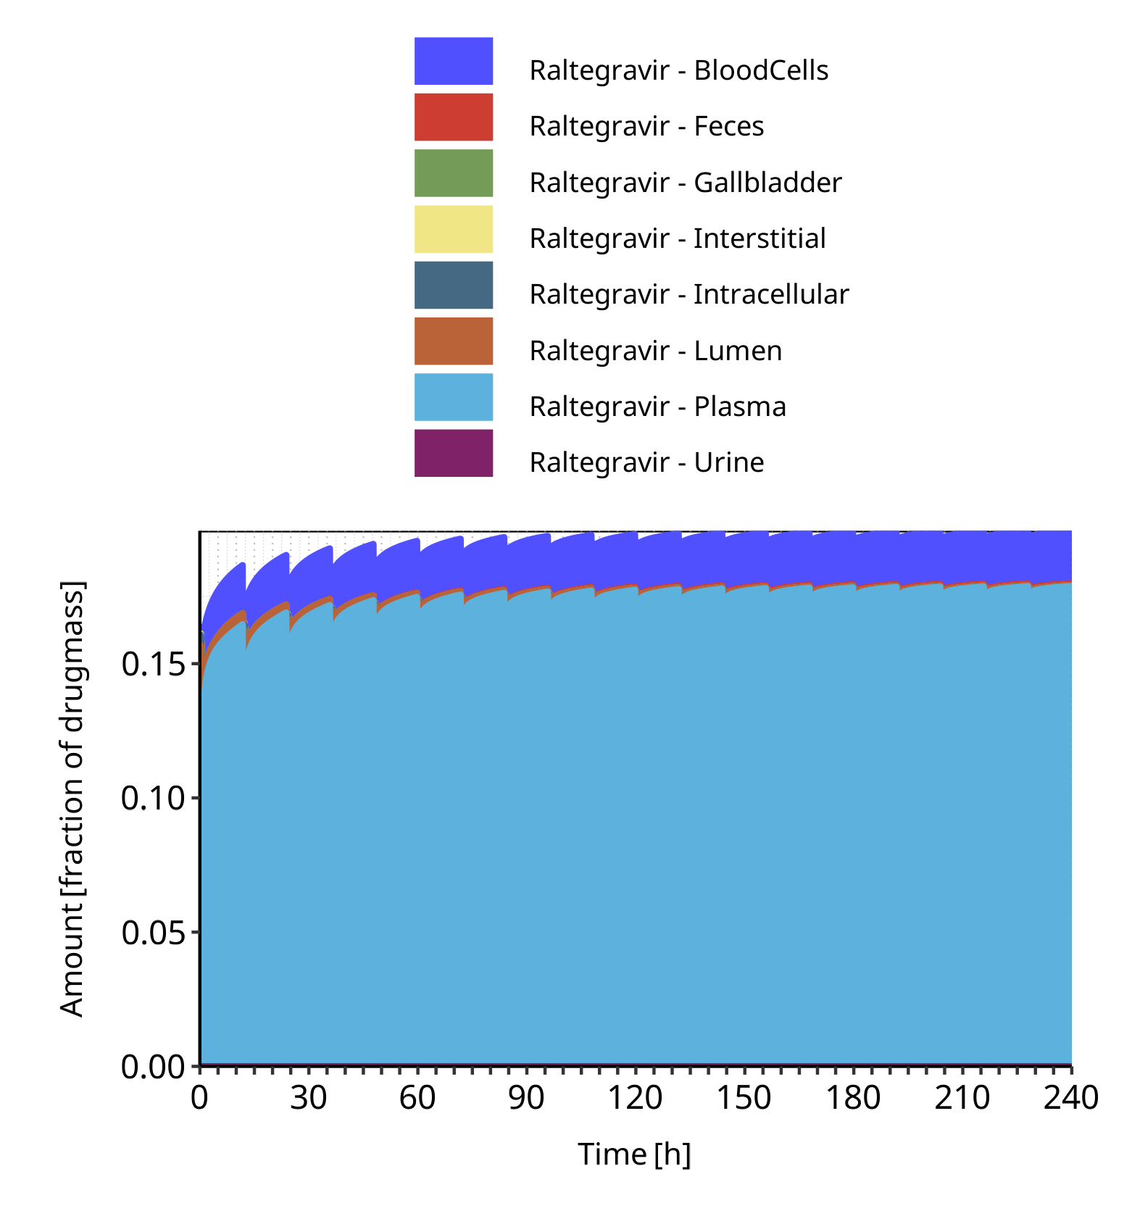

**Figure 4-9: Cumulated amount of drug vs time within the different compartments normalized to applicated drugmass for Raltegravir**

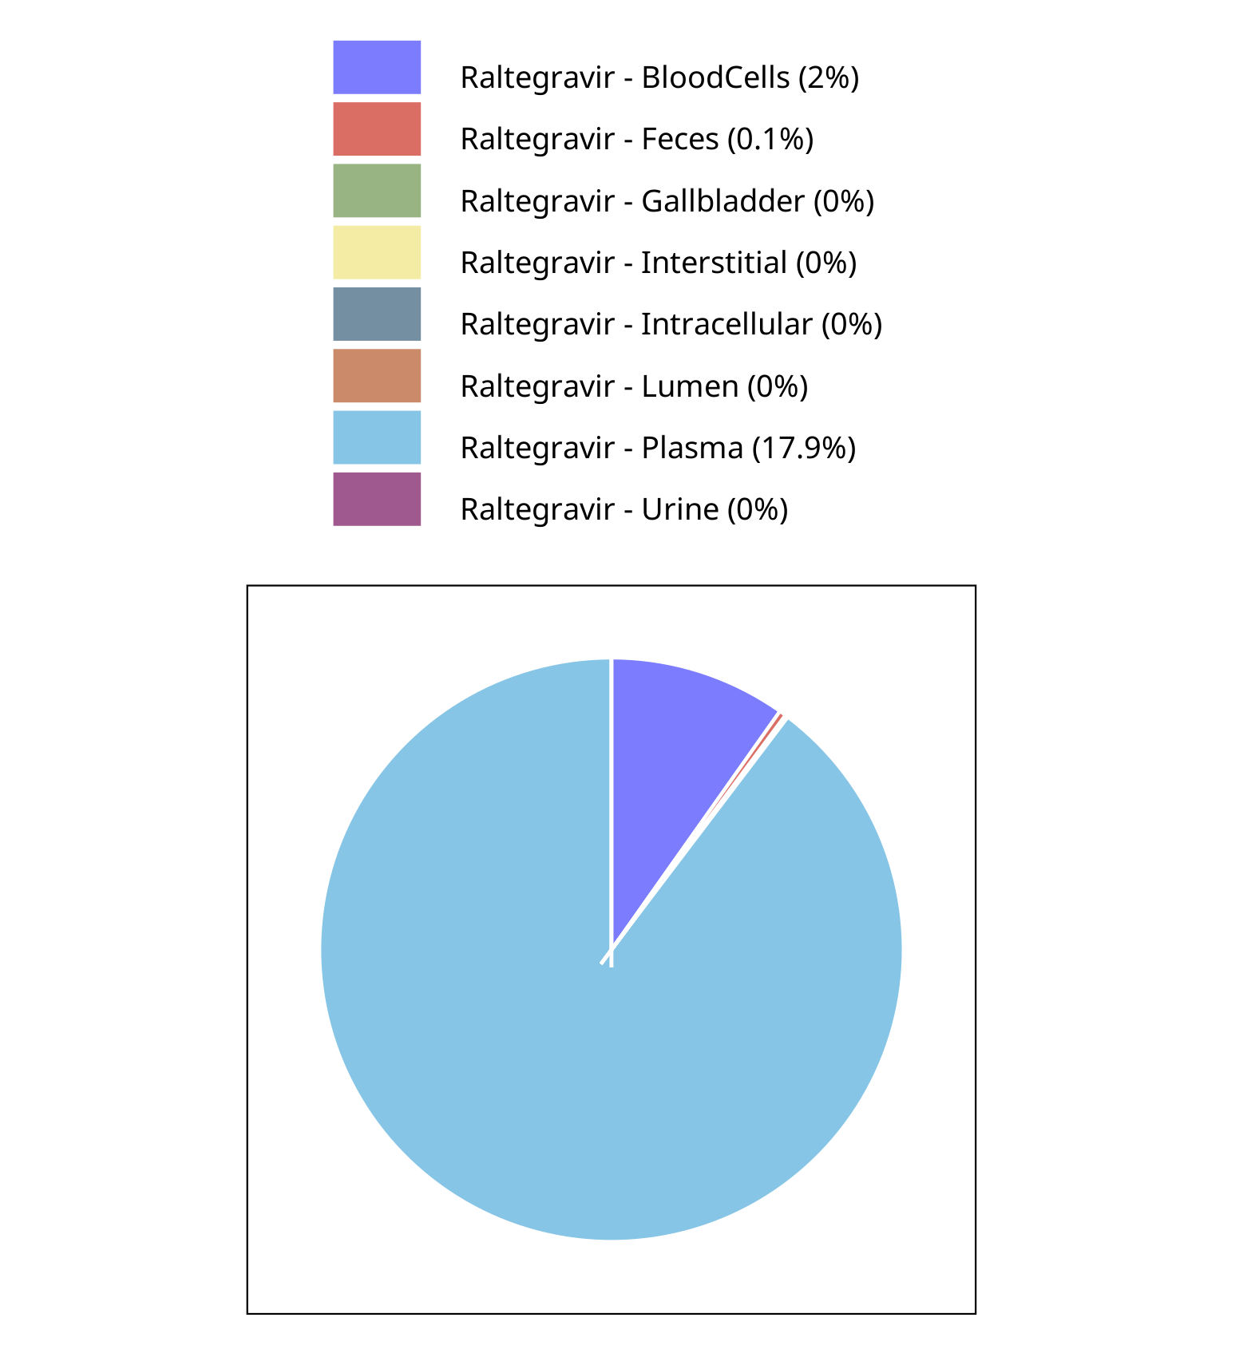

**Figure 4-10: Fraction of drug within the different compartments at 240.00h for Raltegravir**

## Mass Balance for Raltegravir 200 mg filmcoated tablet md

### Mass Balance for Raltegravir

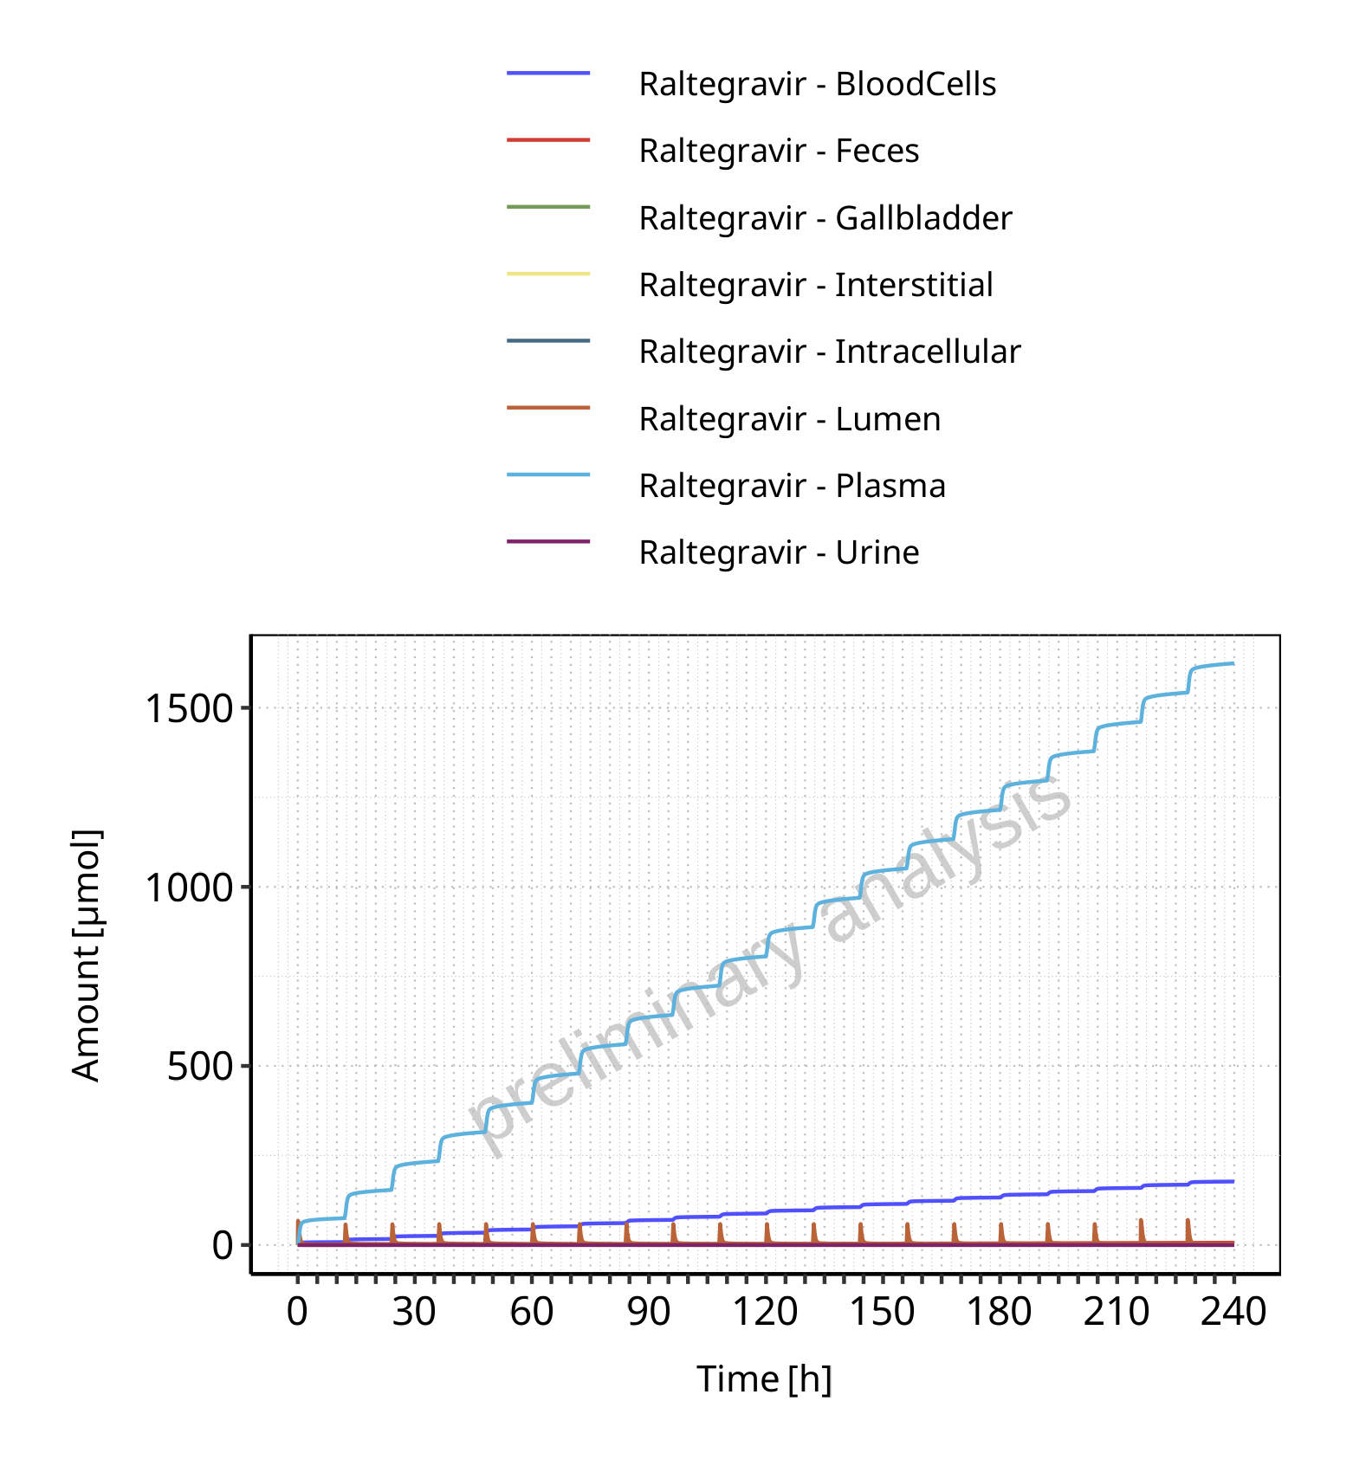

**Figure 4-11: Amount of drug vs time within the different compartments for Raltegravir**

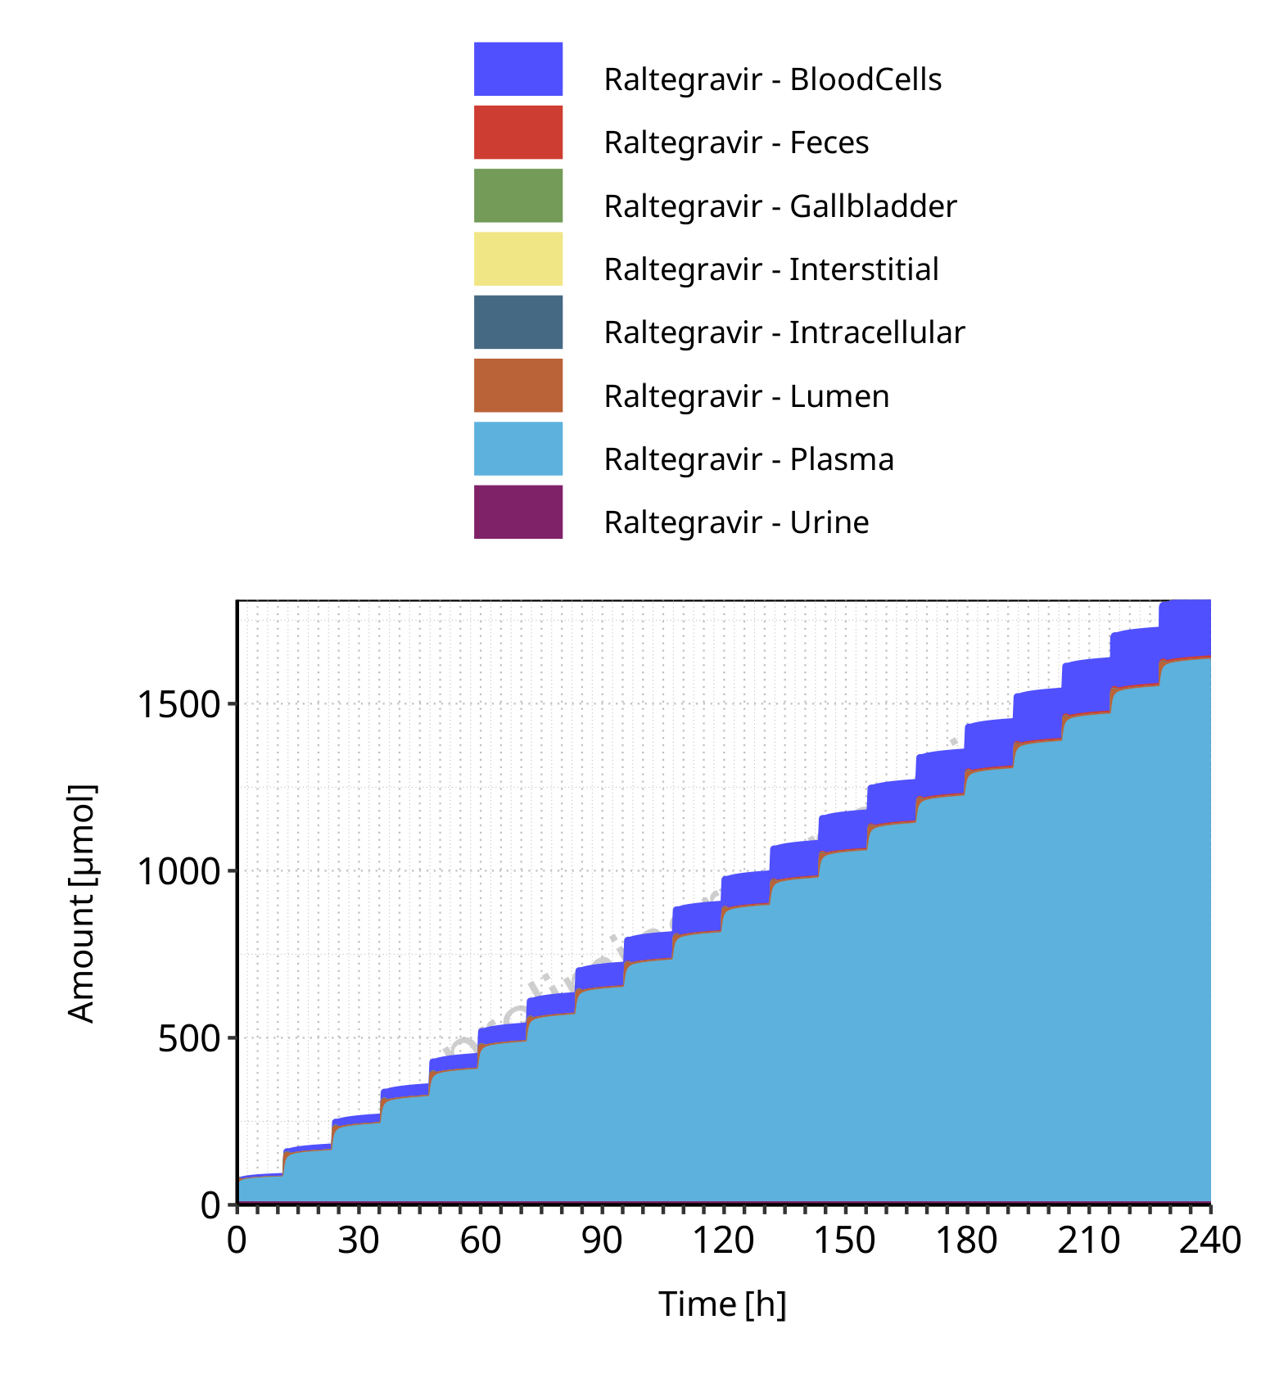

**Figure 4-12: Cumulated amount of drug vs time within the different compartments for Raltegravir**

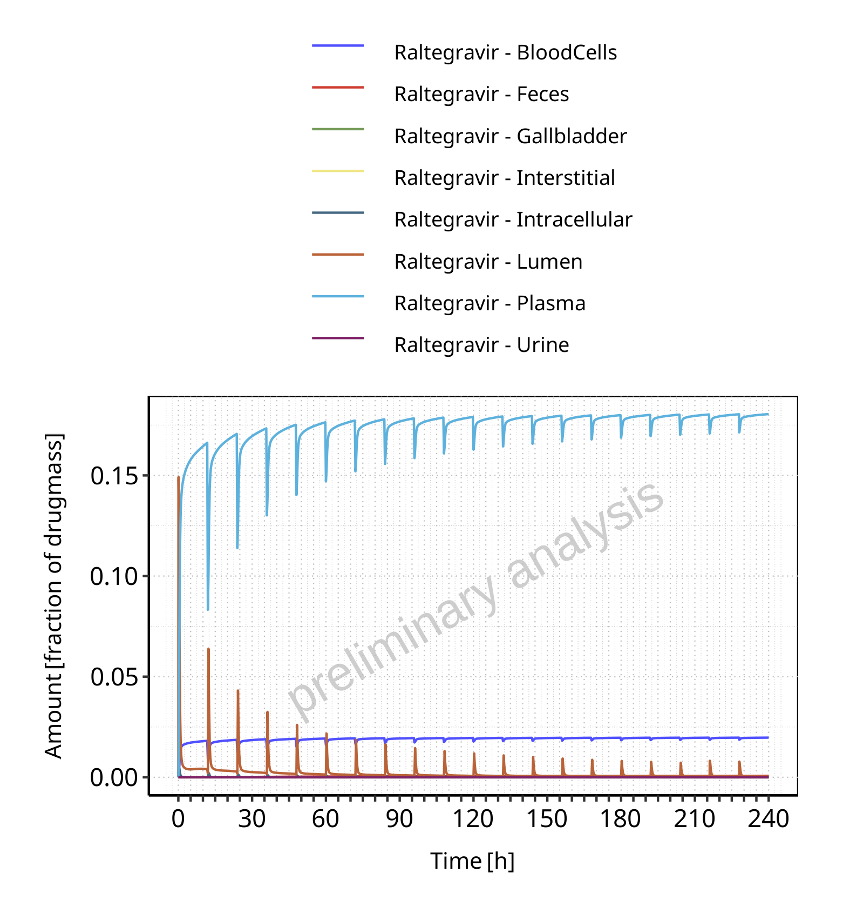

**Figure 4-13: Amount of drug vs time within the different compartments normalized to applicated drugmass for Raltegravir**

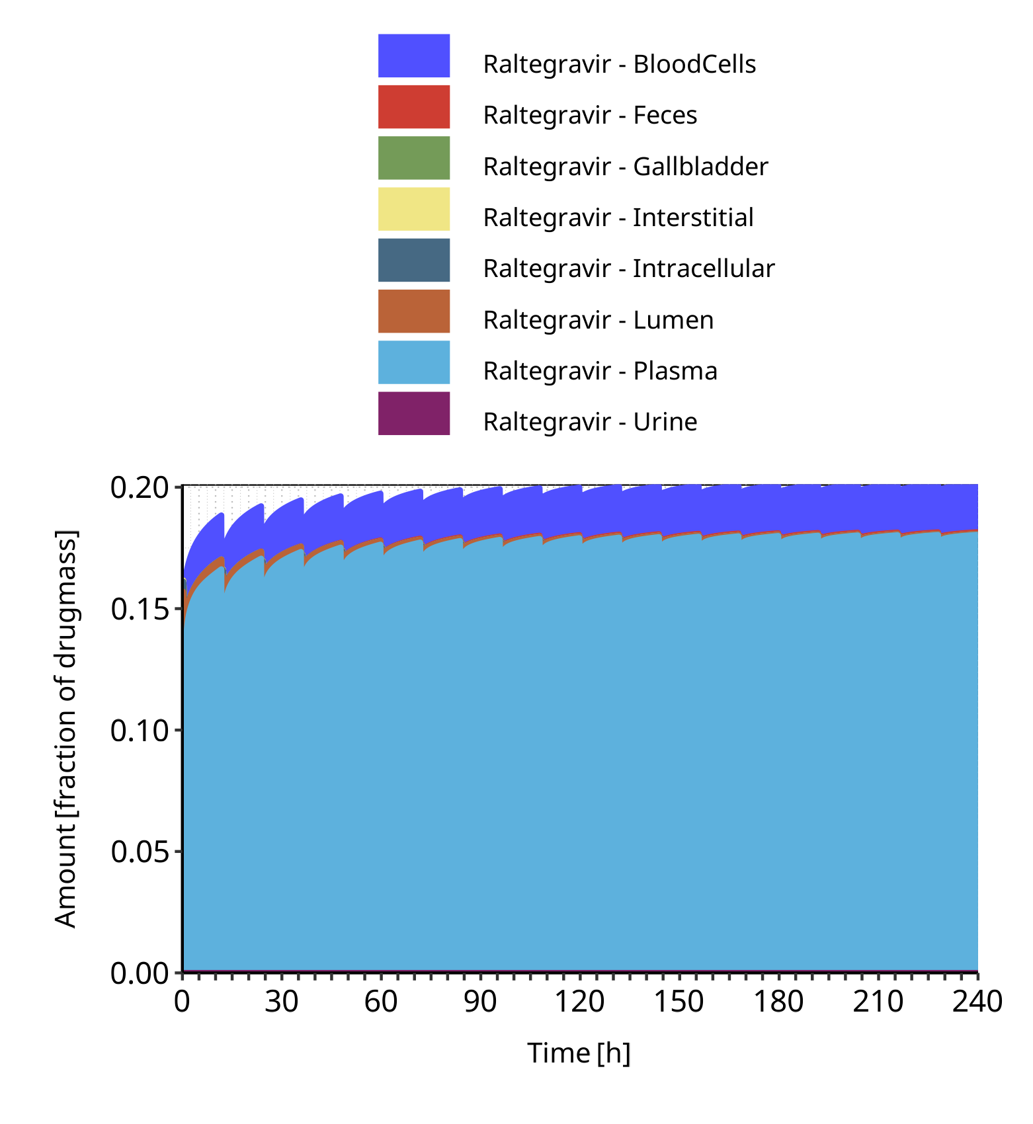

**Figure 4-14: Cumulated amount of drug vs time within the different compartments normalized to applicated drugmass for Raltegravir**

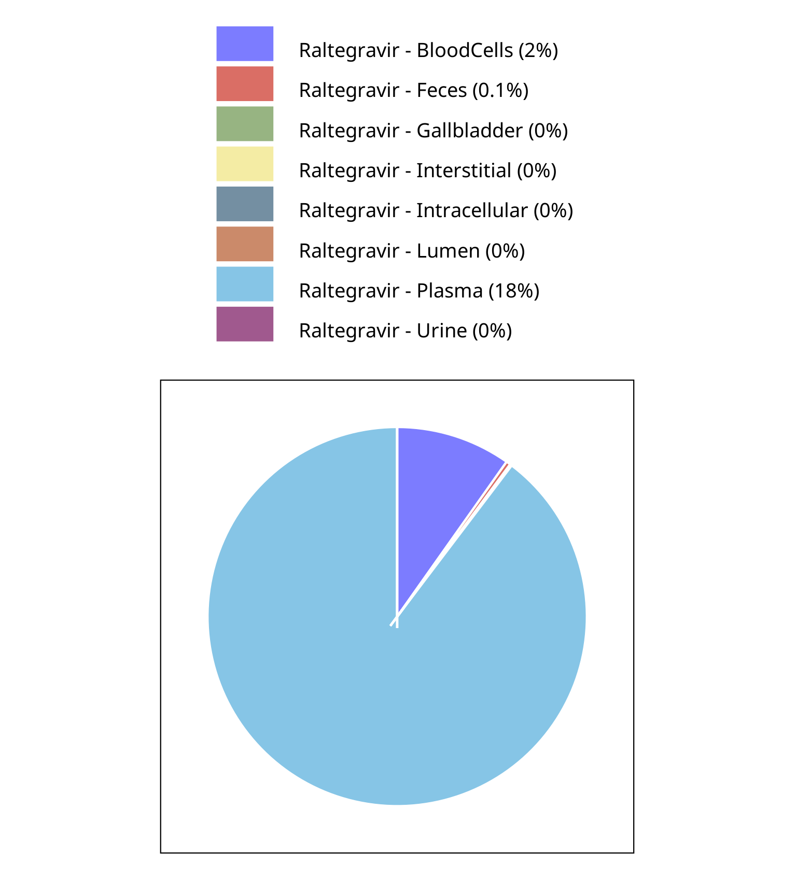

**Figure 4-15: Fraction of drug within the different compartments at 240.00h for Raltegravir**

## Mass Balance for Filmcoated_tablet_400mg_sd

### Mass Balance for Raltegravir

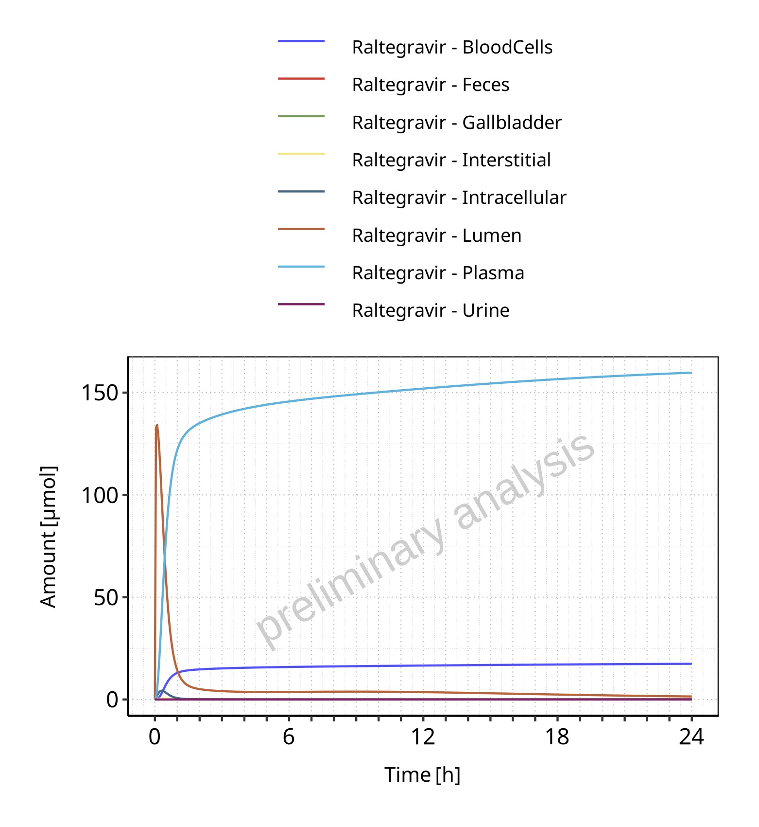

**Figure 4-16: Amount of drug vs time within the different compartments for Raltegravir**

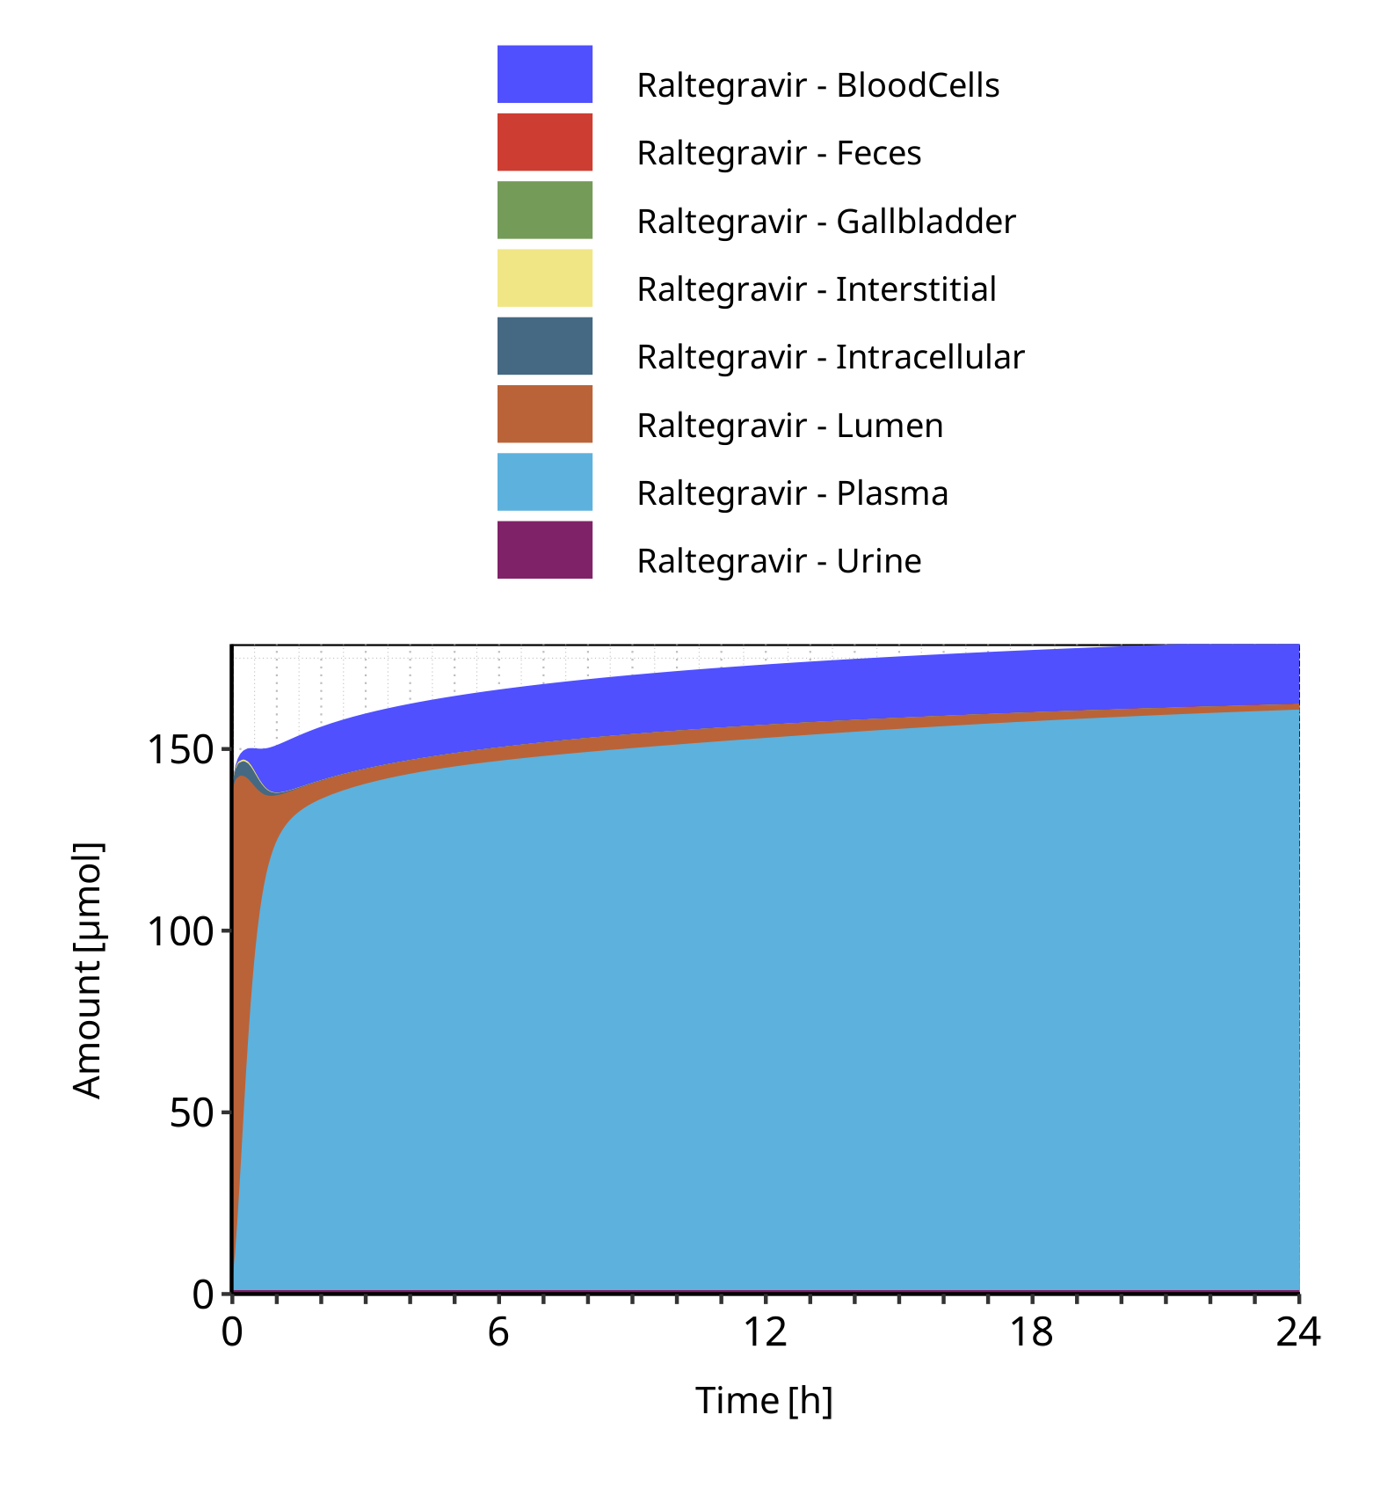

**Figure 4-17: Cumulated amount of drug vs time within the different compartments for Raltegravir**

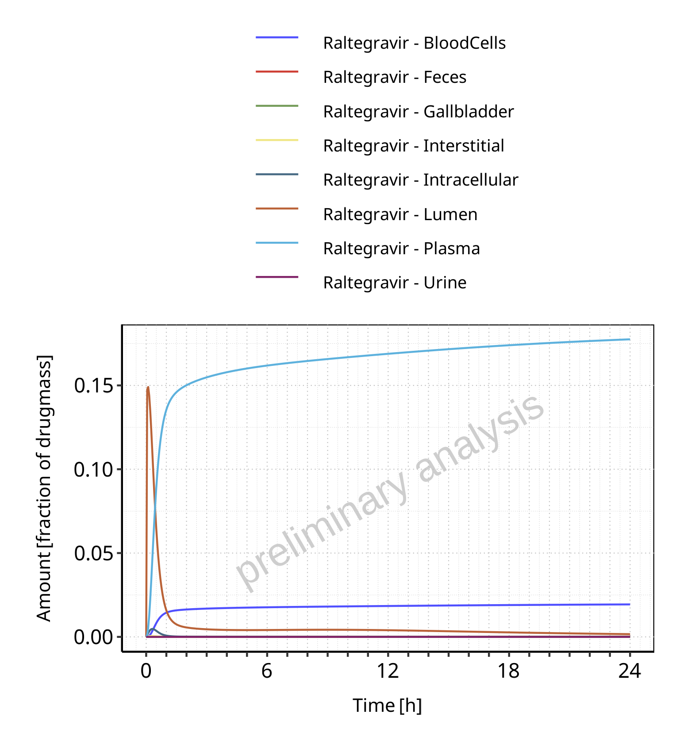

**Figure 4-18: Amount of drug vs time within the different compartments normalized to applicated drugmass for Raltegravir**

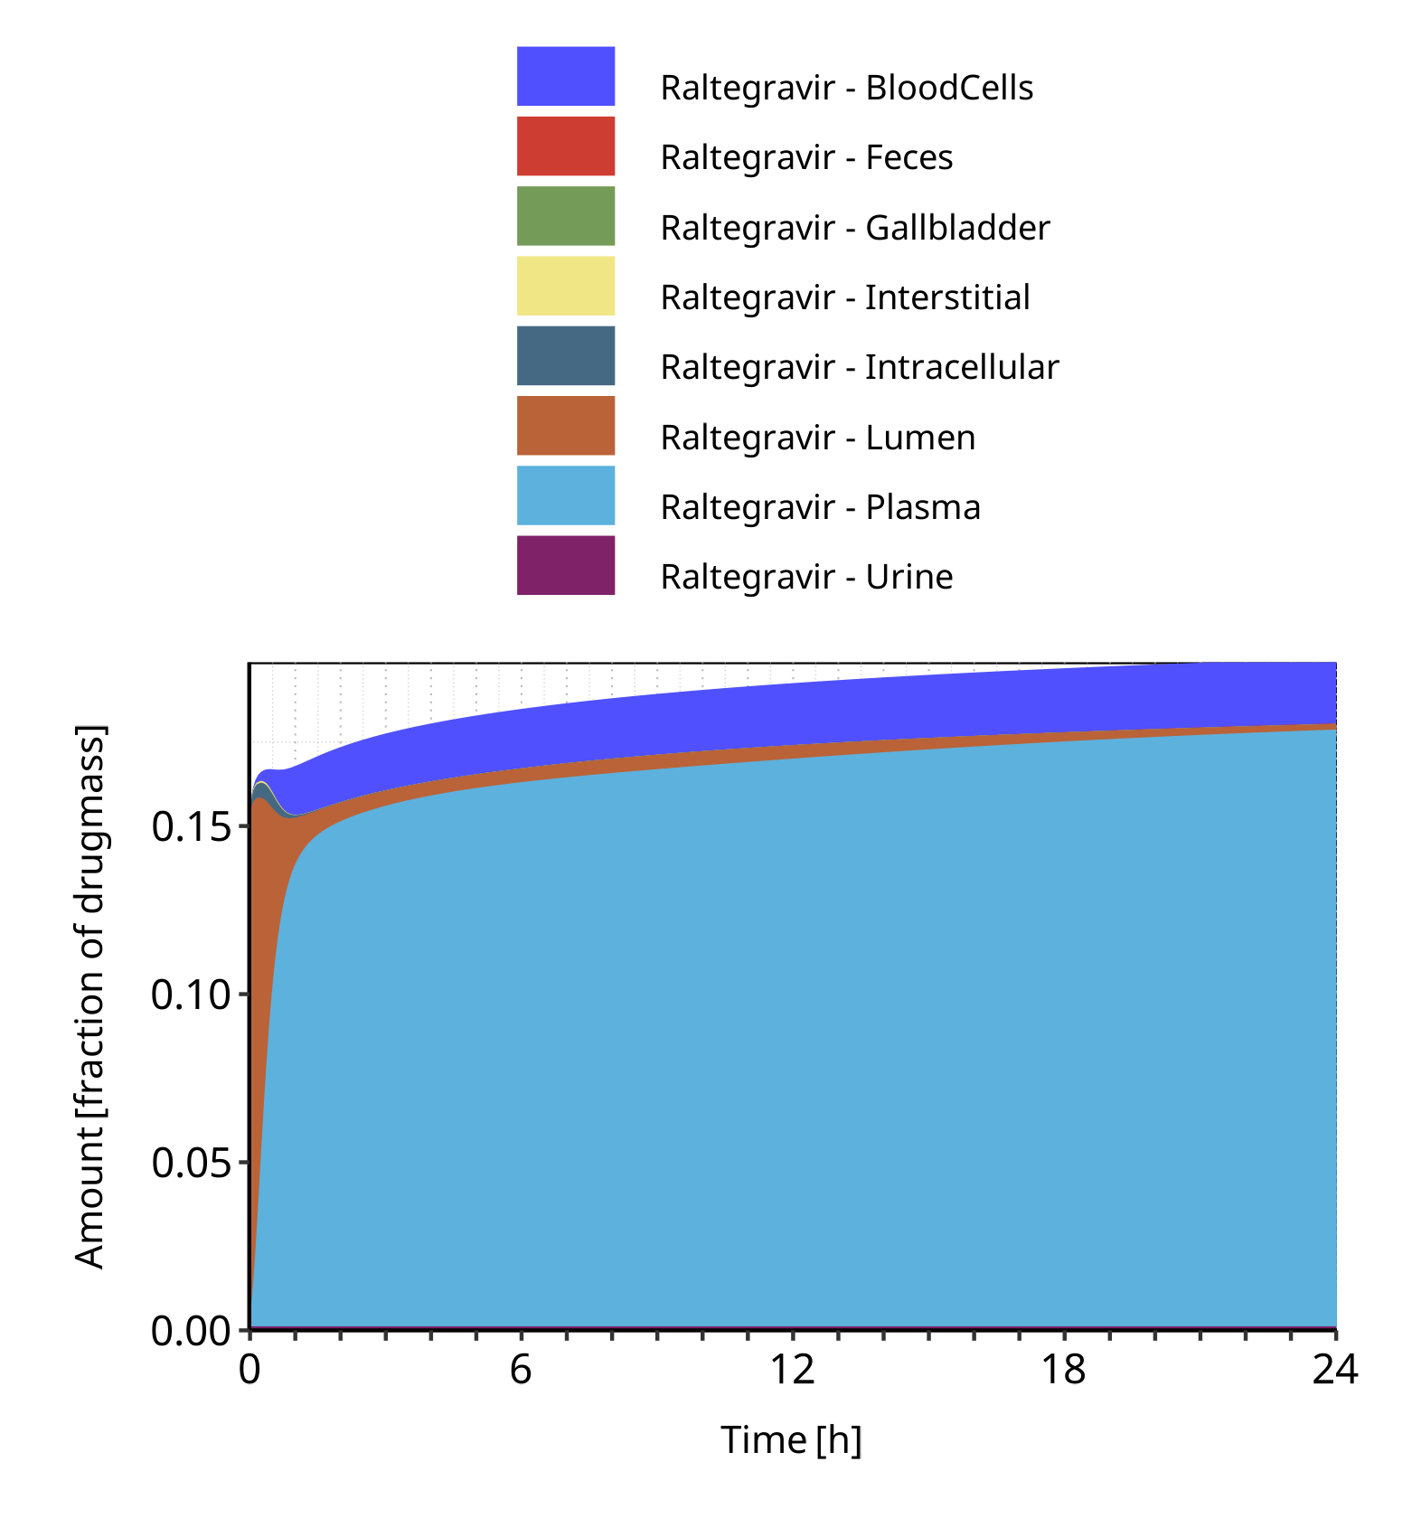

**Figure 4-19: Cumulated amount of drug vs time within the different compartments normalized to applicated drugmass for Raltegravir**

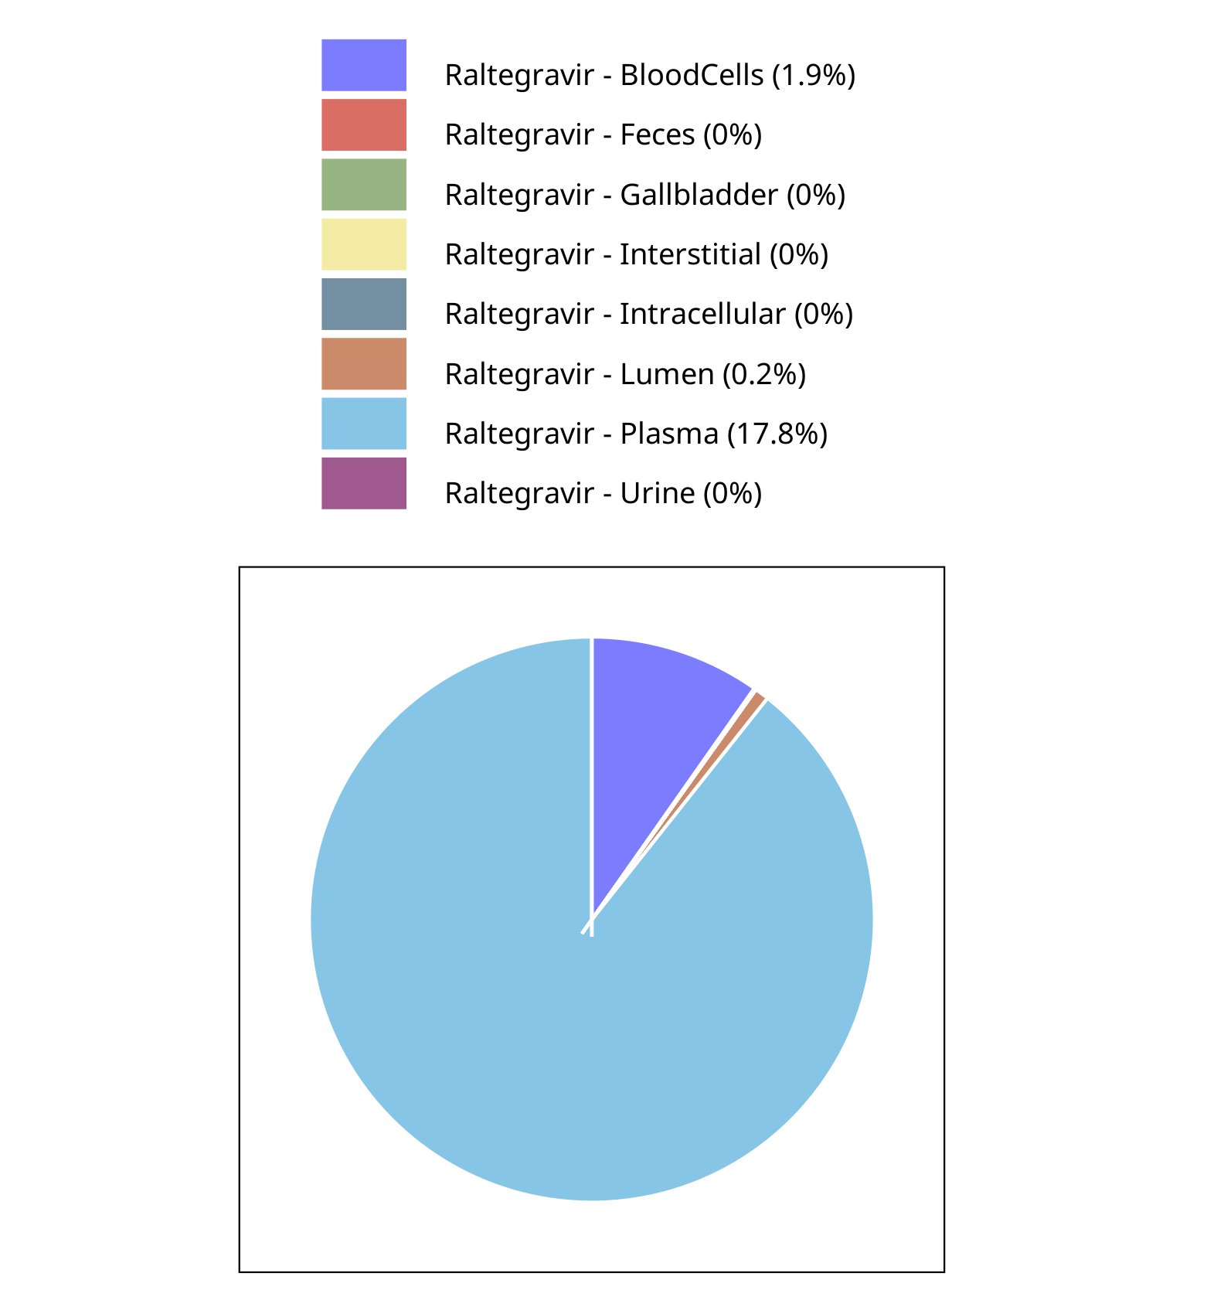

**Figure 4-20: Fraction of drug within the different compartments at 24.00h for Raltegravir**

## Mass Balance for Raltegravir 400 mg filmcoated tablet md

### Mass Balance for Raltegravir

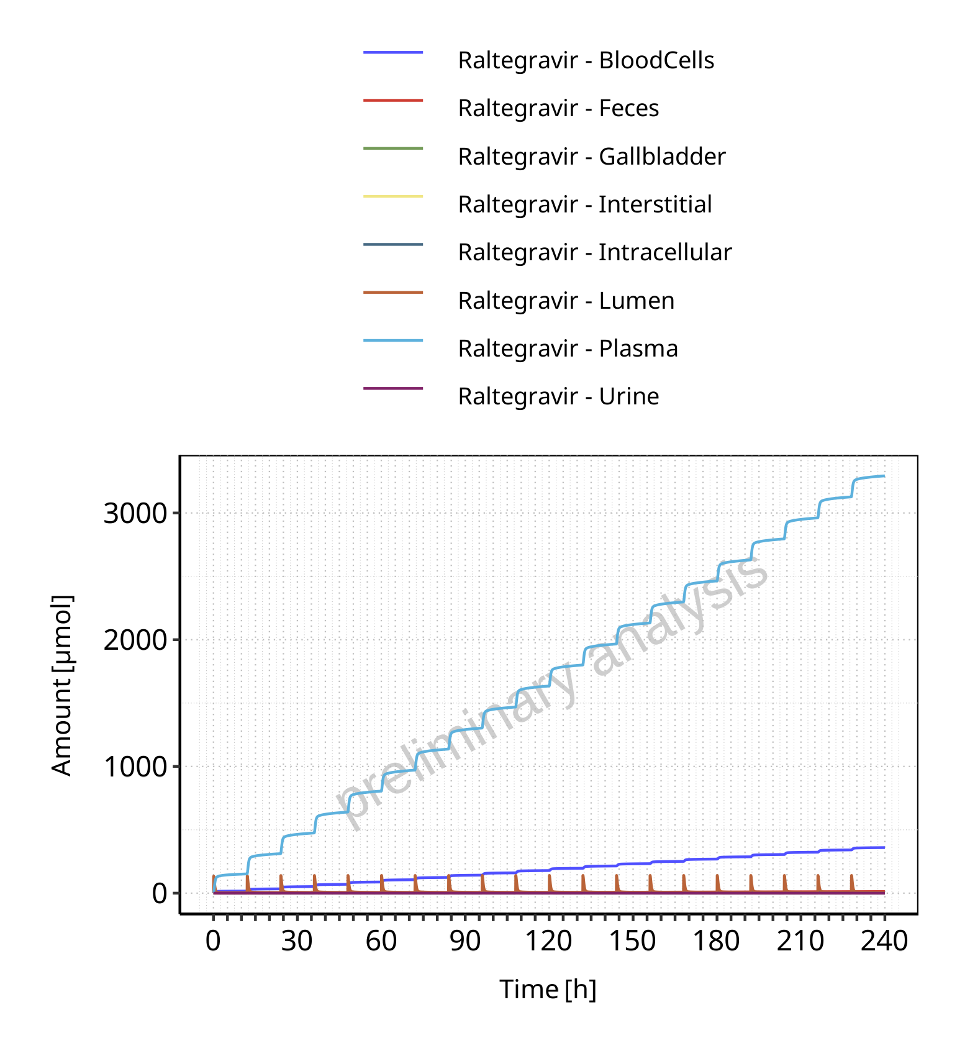

**Figure 4-21: Amount of drug vs time within the different compartments for Raltegravir**

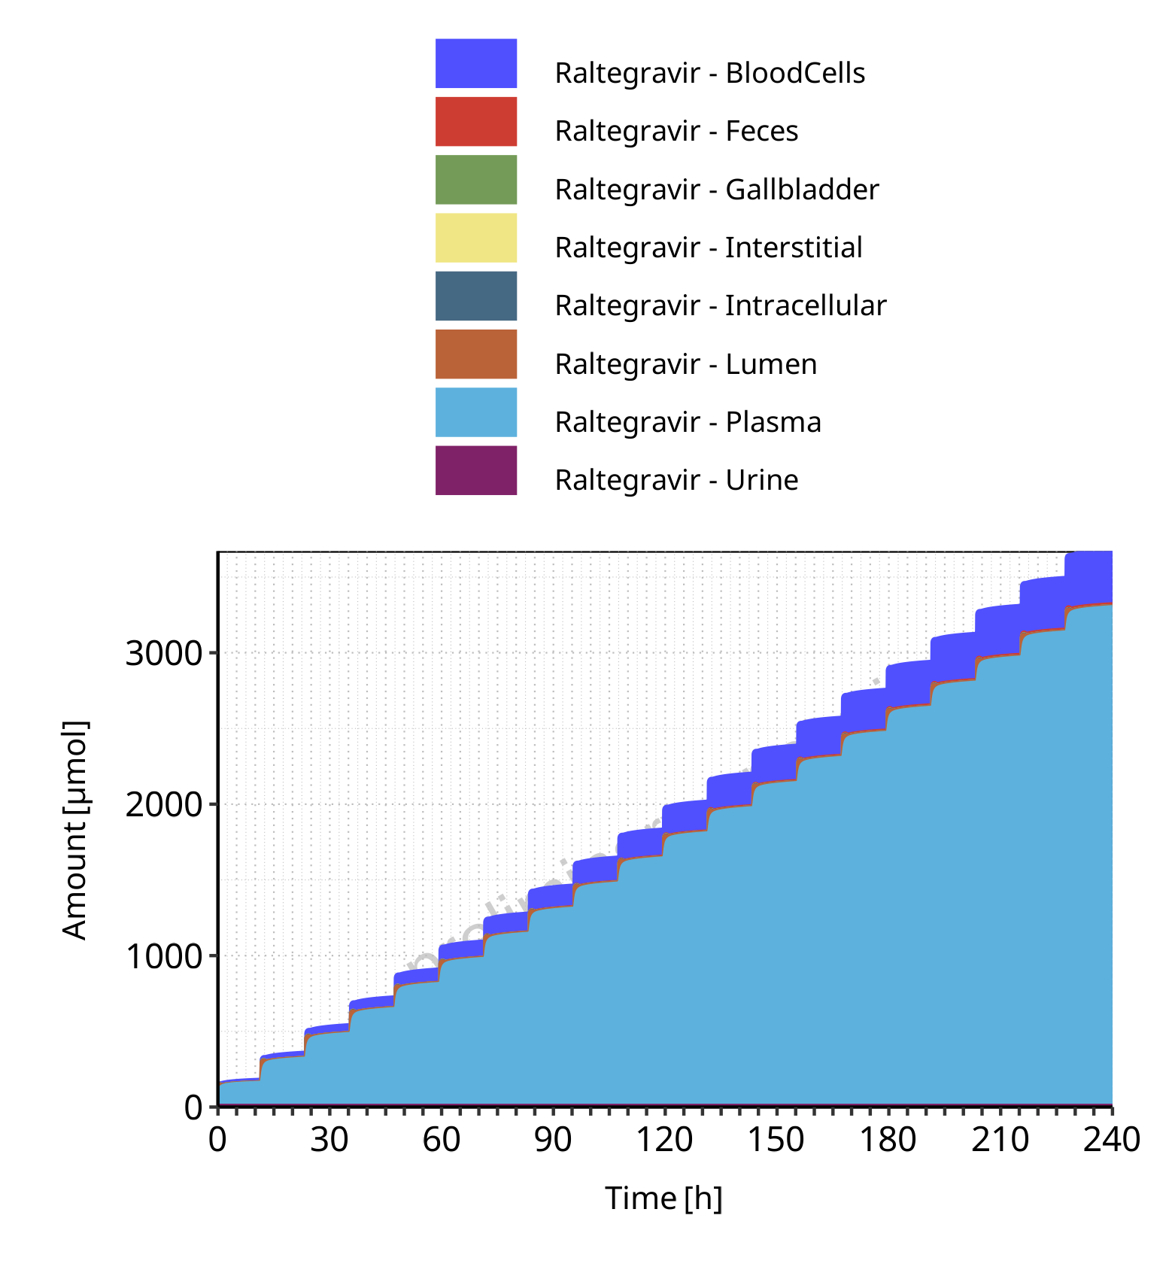

**Figure 4-22: Cumulated amount of drug vs time within the different compartments for Raltegravir**

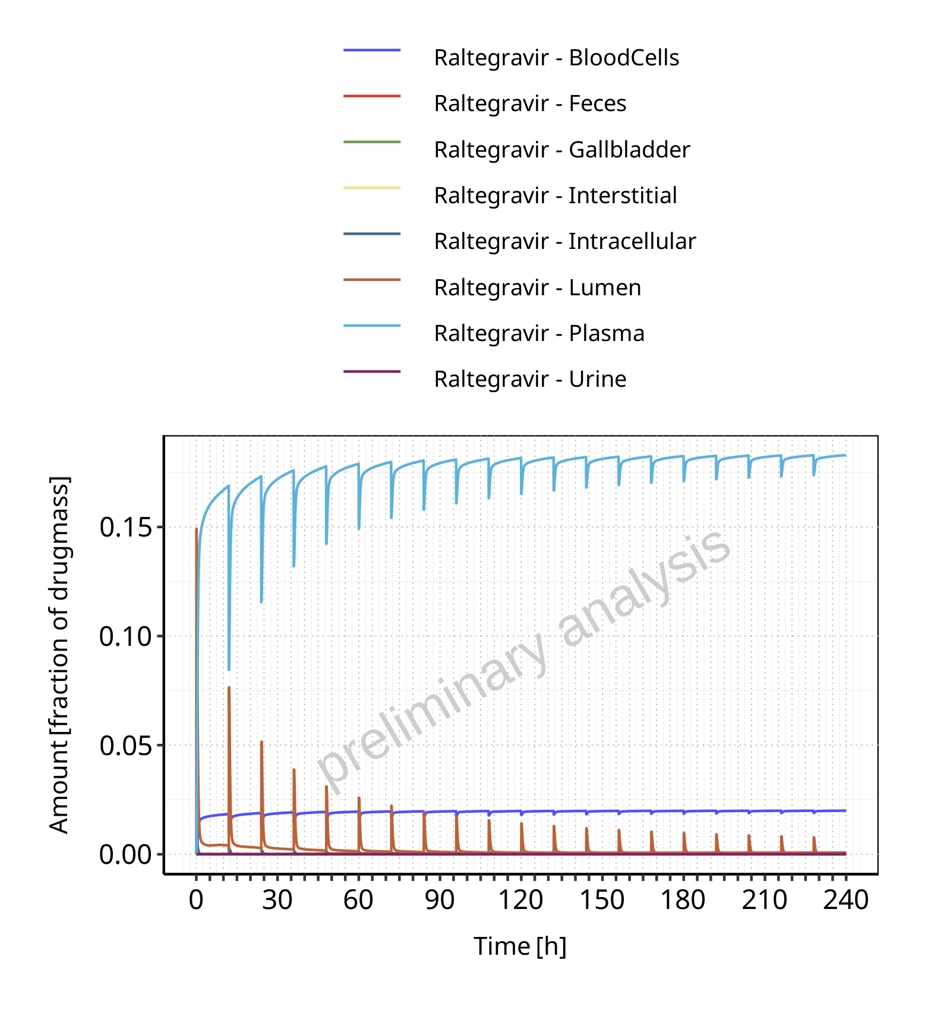

**Figure 4-23: Amount of drug vs time within the different compartments normalized to applicated drugmass for Raltegravir**

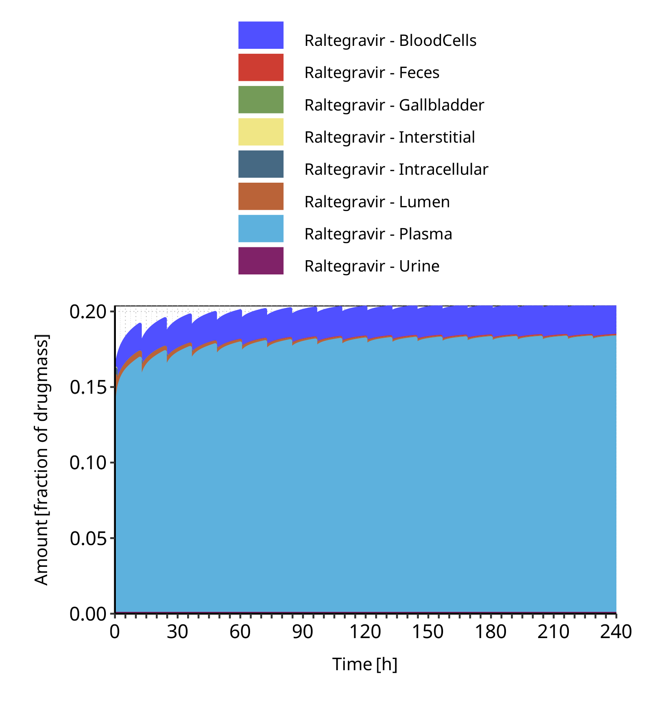

**Figure 4-24: Cumulated amount of drug vs time within the different compartments normalized to applicated drugmass for Raltegravir**

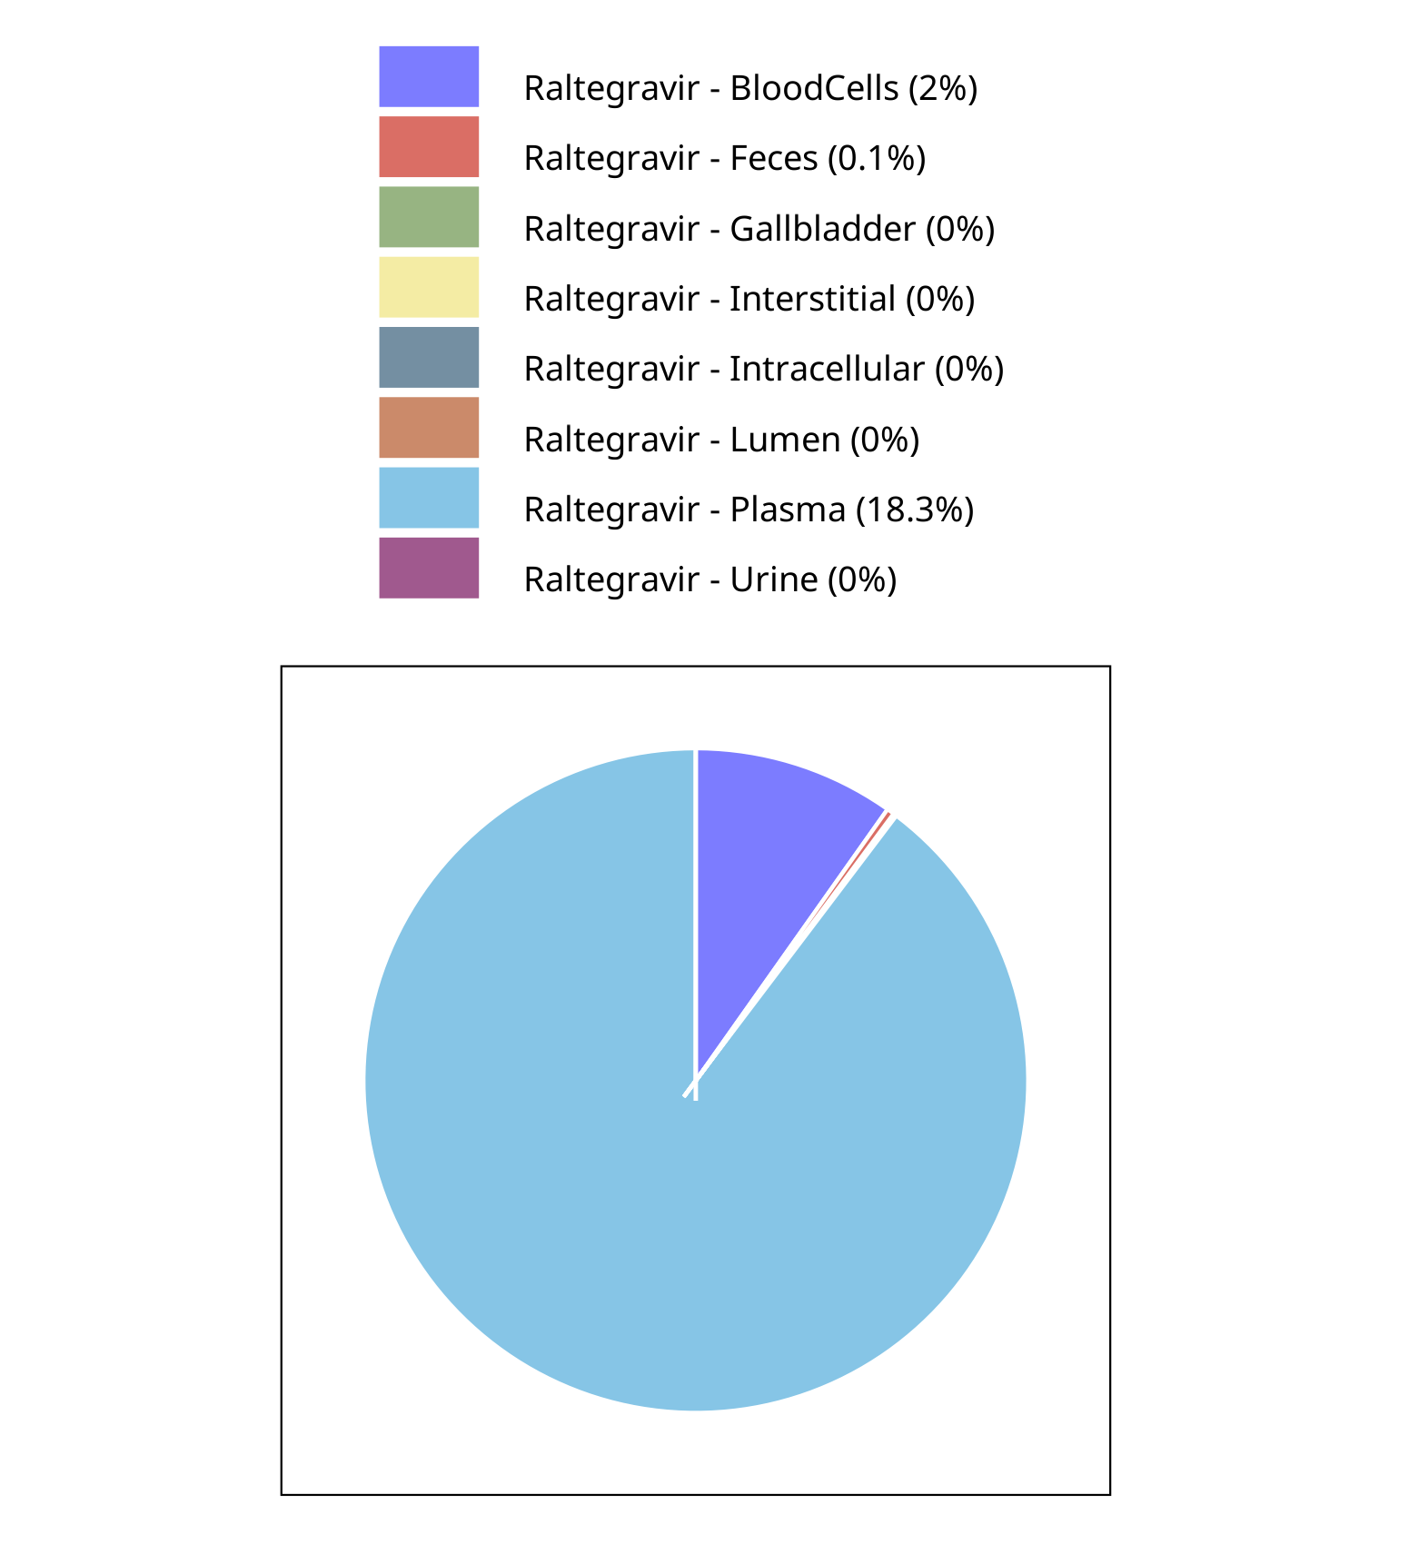

**Figure 4-25: Fraction of drug within the different compartments at 240.00h for Raltegravir**

## Mass Balance for Raltegravir 400mg chewable fasted

### Mass Balance for Raltegravir

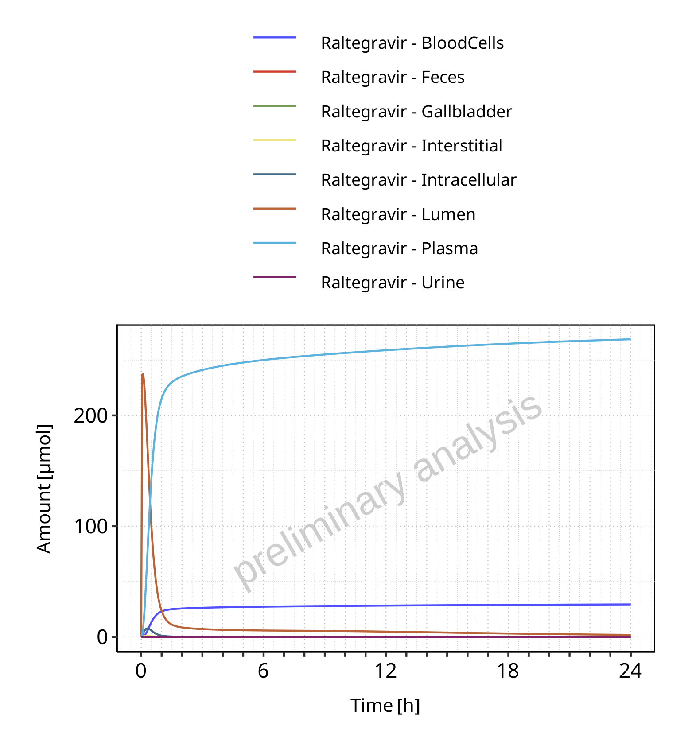

**Figure 4-26: Amount of drug vs time within the different compartments for Raltegravir**

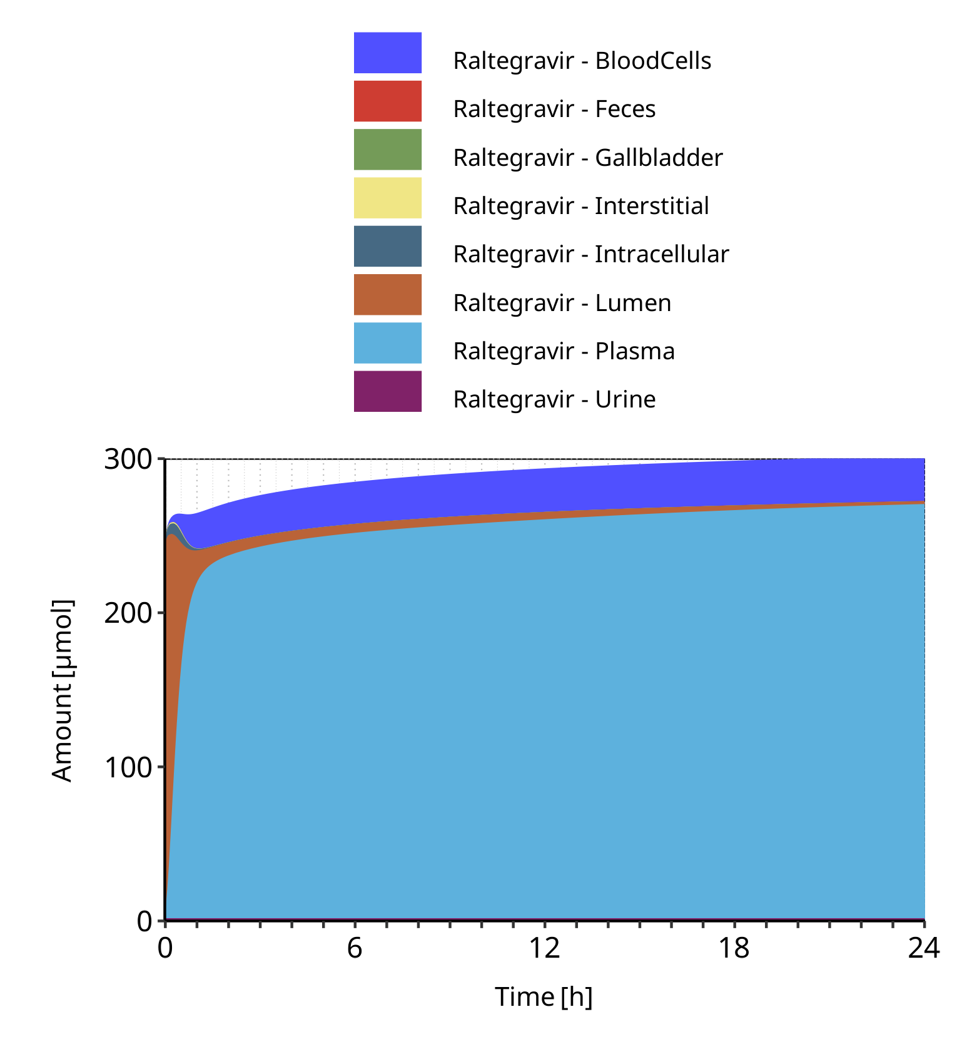

**Figure 4-27: Cumulated amount of drug vs time within the different compartments for Raltegravir**

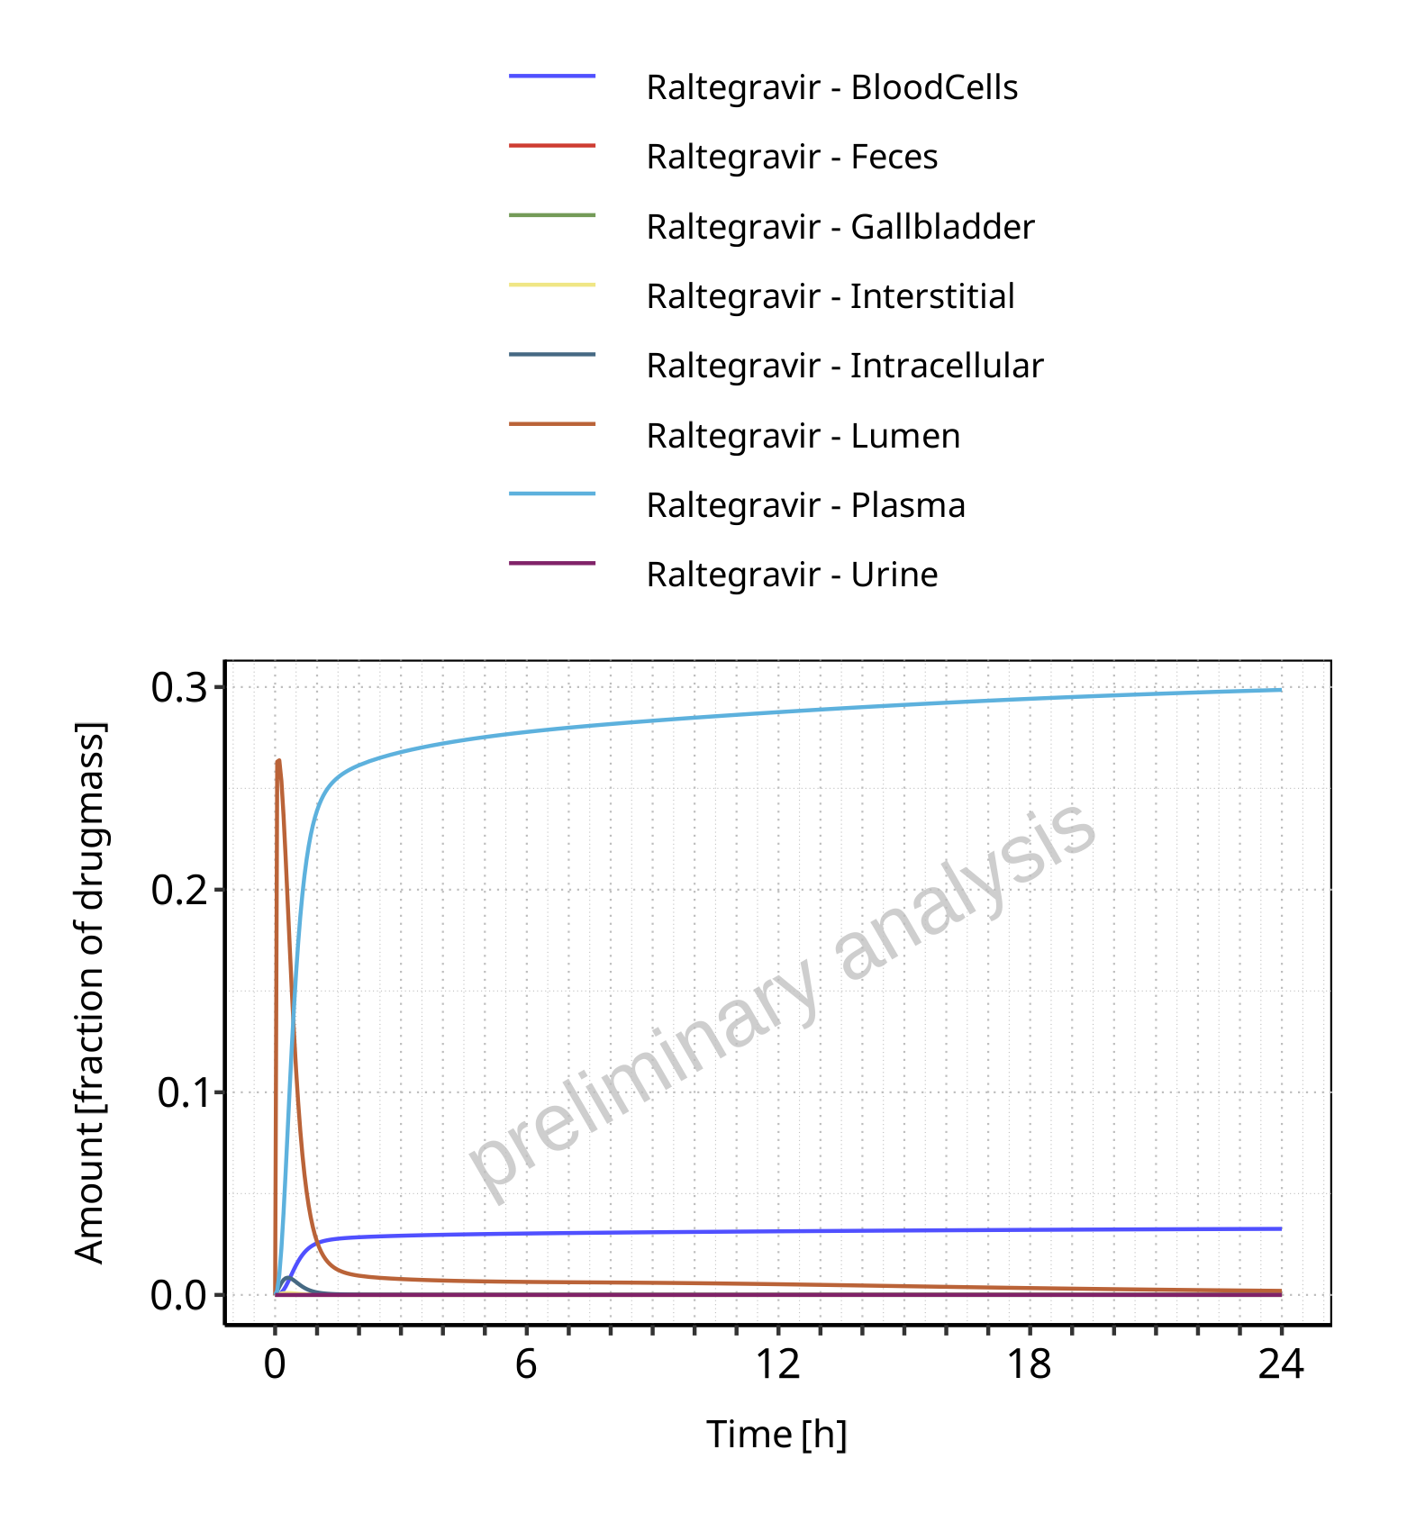

**Figure 4-28: Amount of drug vs time within the different compartments normalized to applicated drugmass for Raltegravir**

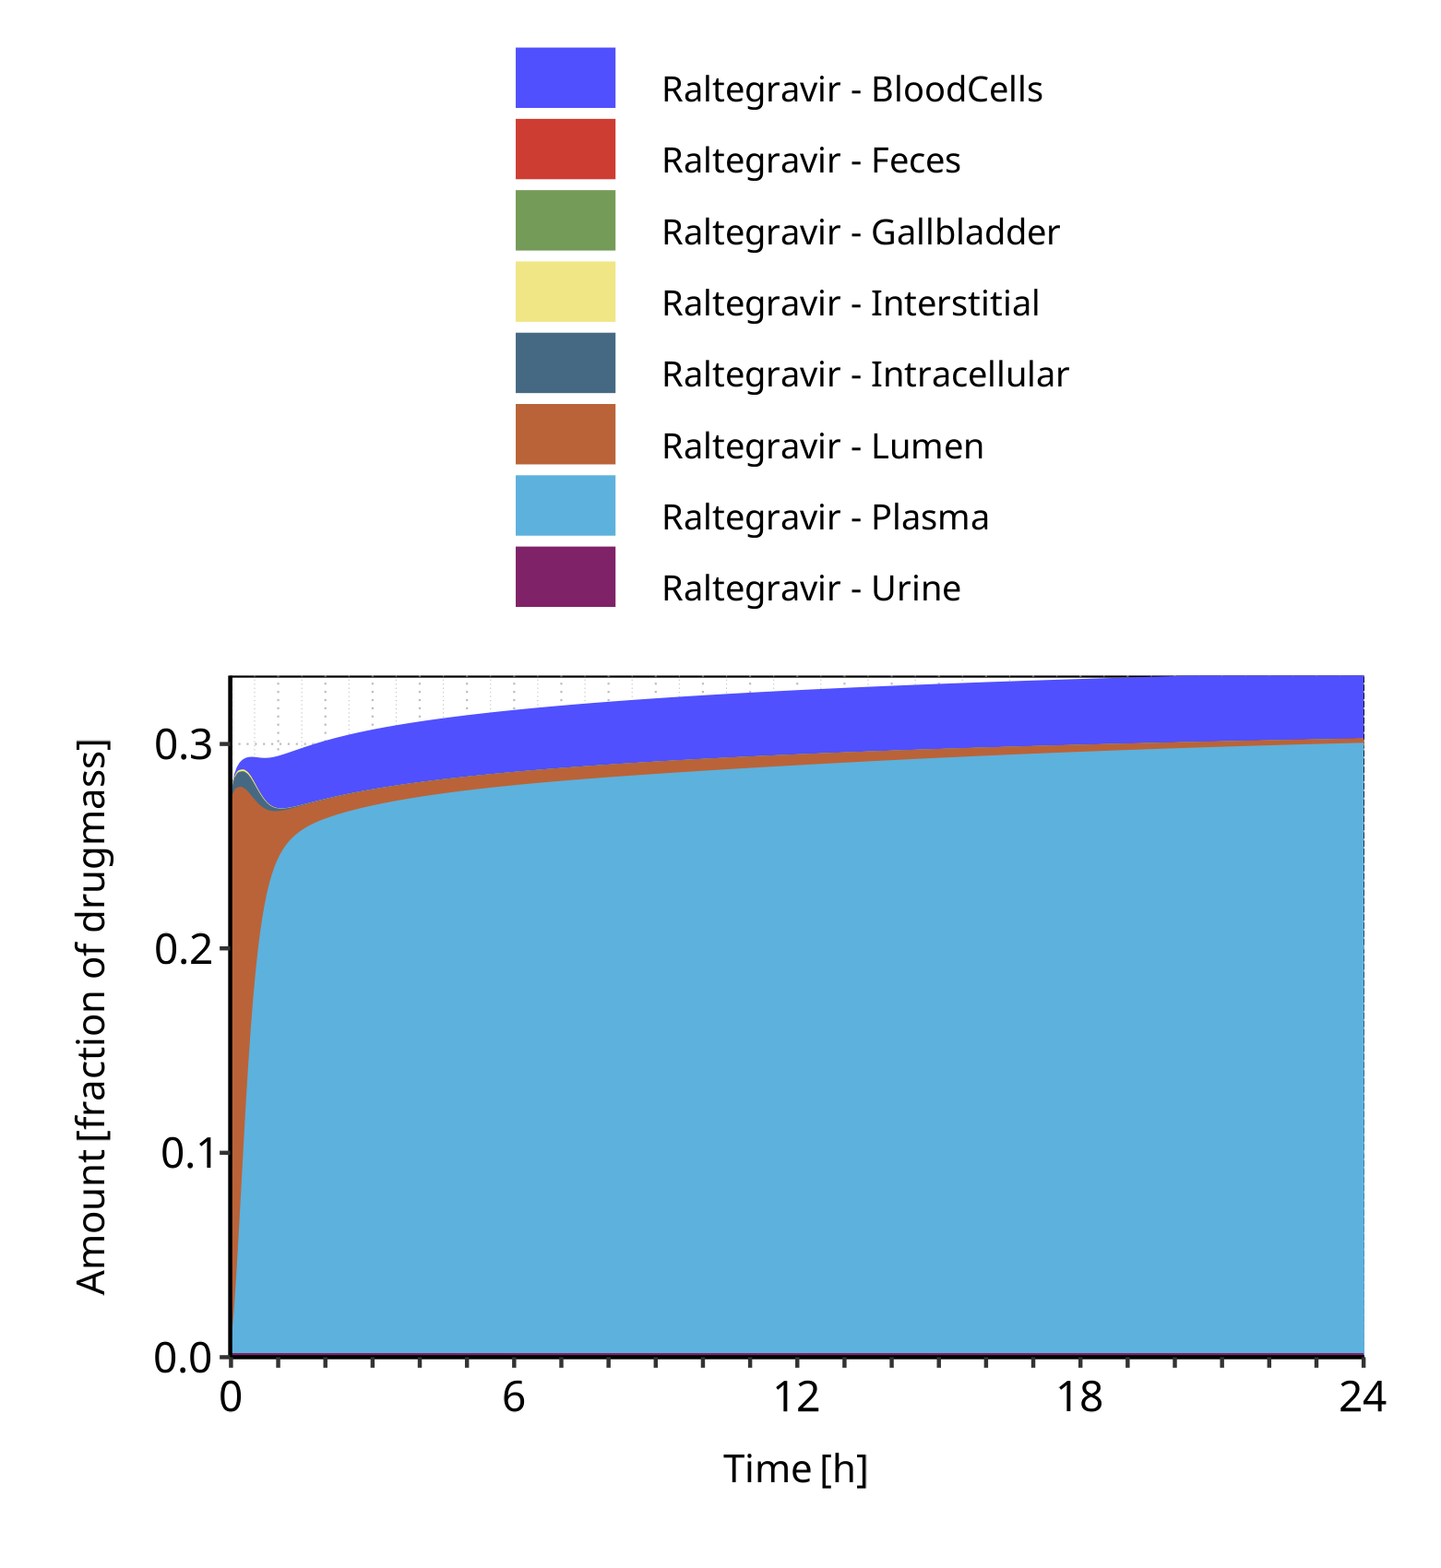

**Figure 4-29: Cumulated amount of drug vs time within the different compartments normalized to applicated drugmass for Raltegravir**

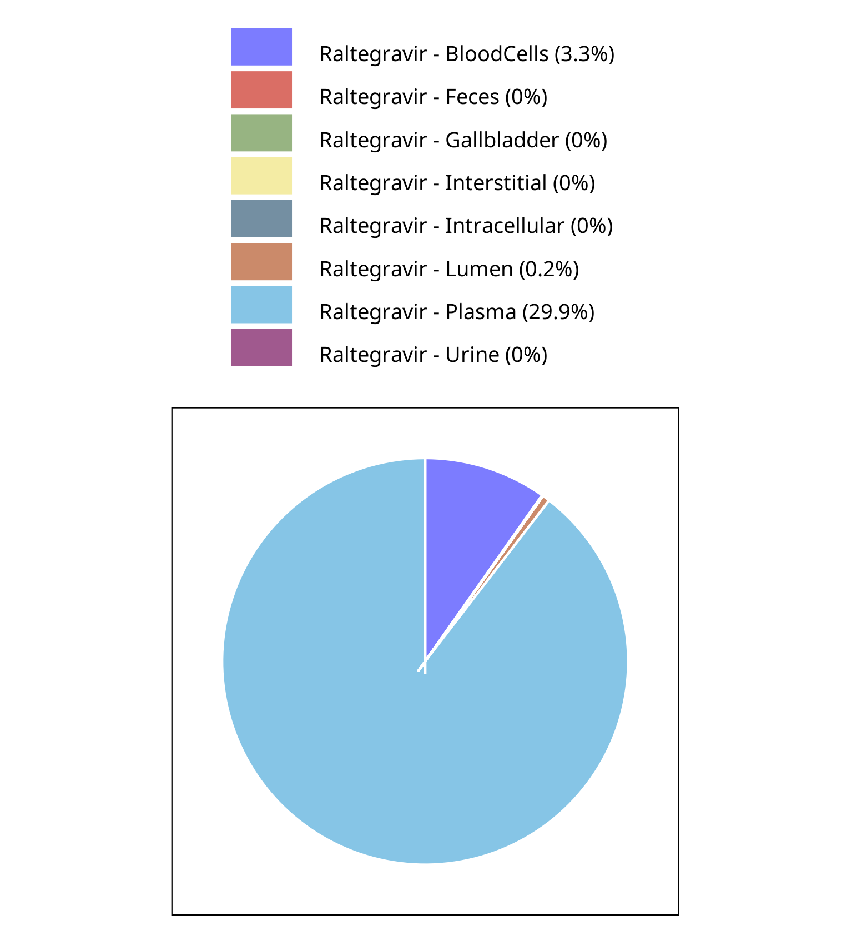

**Figure 4-30: Fraction of drug within the different compartments at 24.00h for Raltegravir**

## Mass Balance for Raltegravir 400mg chewable fed

### Mass Balance for Raltegravir

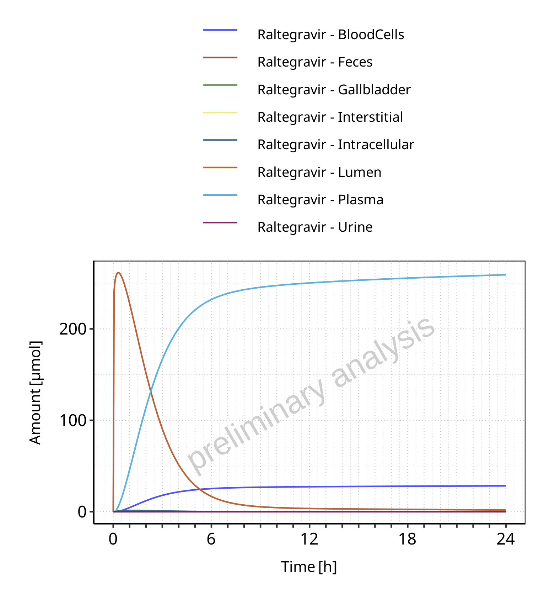

**Figure 4-31: Amount of drug vs time within the different compartments for Raltegravir**

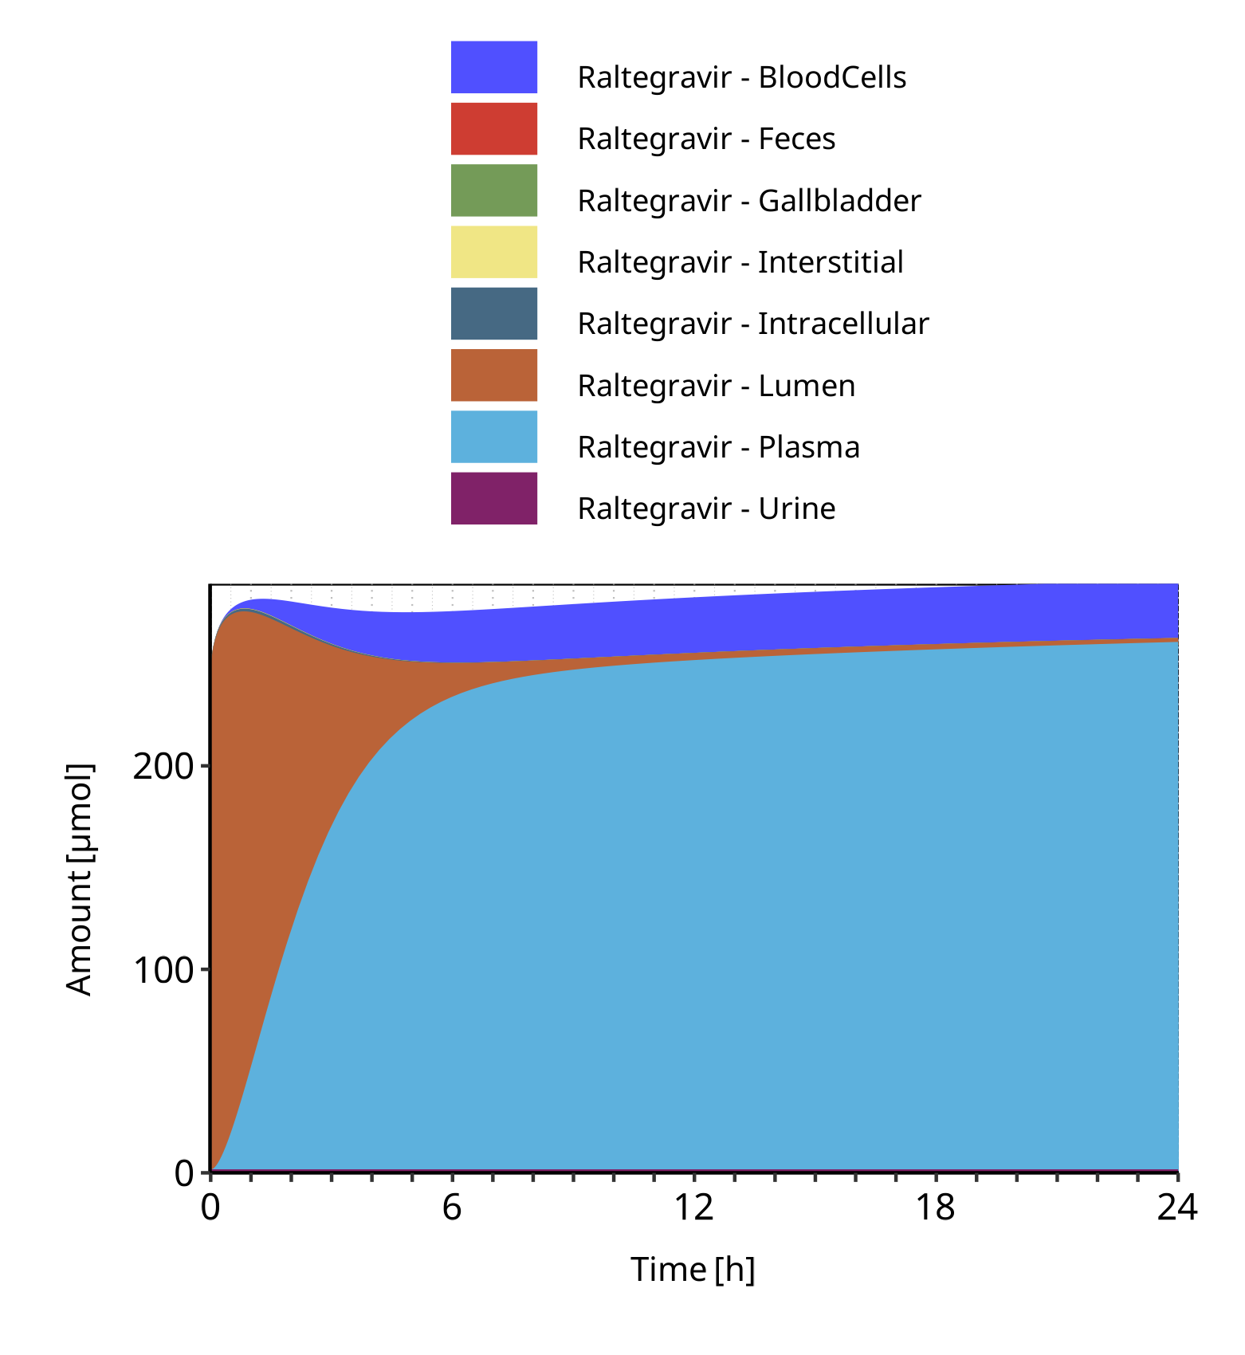

**Figure 4-32: Cumulated amount of drug vs time within the different compartments for Raltegravir**

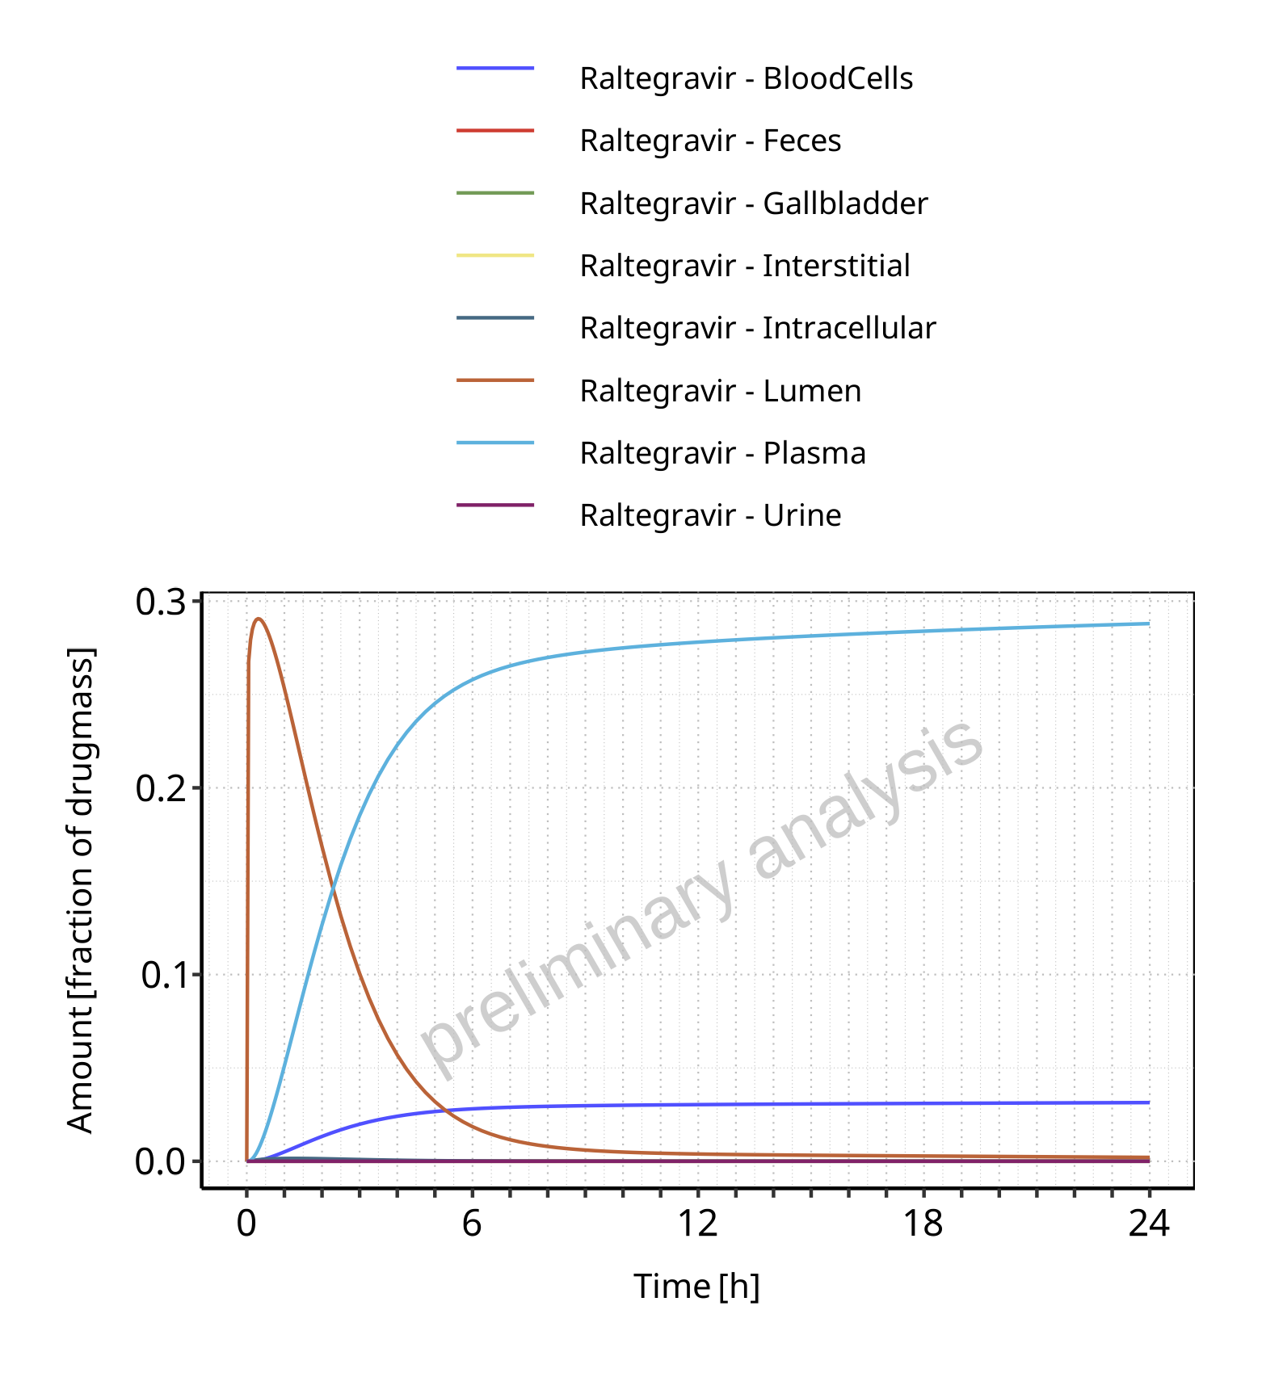

**Figure 4-33: Amount of drug vs time within the different compartments normalized to applicated drugmass for Raltegravir**

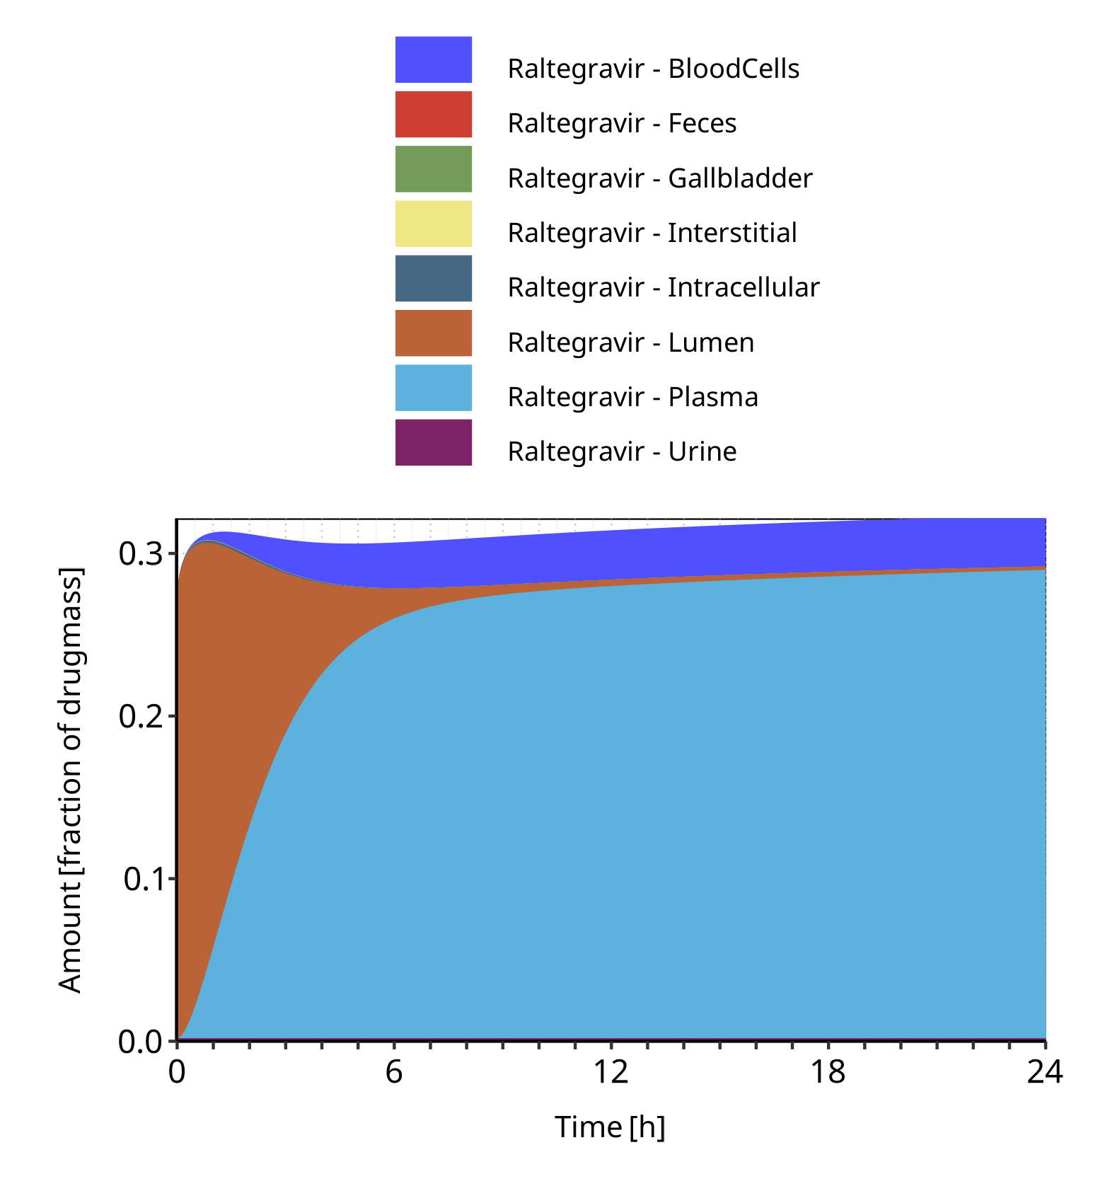

**Figure 4-34: Cumulated amount of drug vs time within the different compartments normalized to applicated drugmass for Raltegravir**

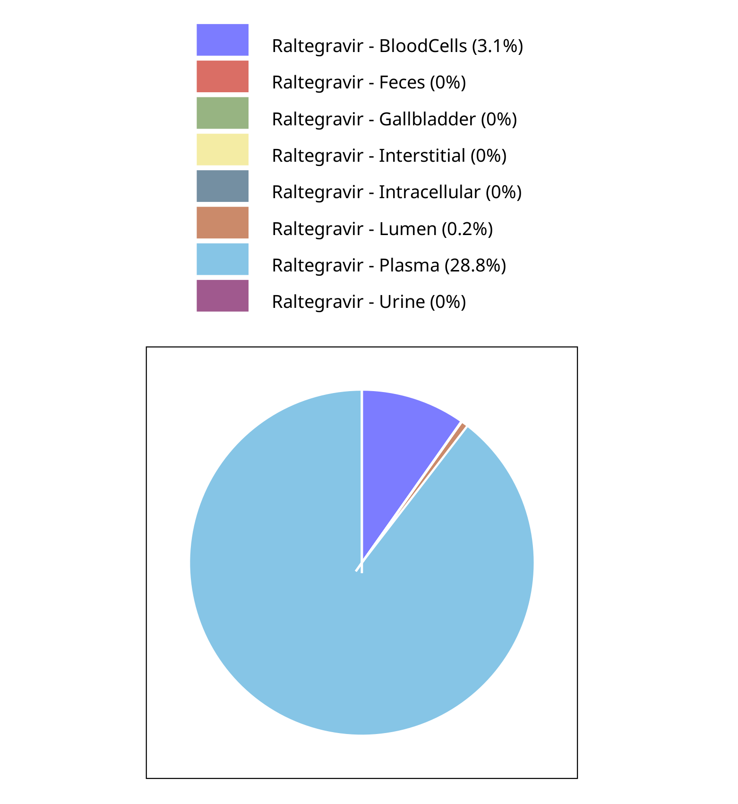

**Figure 4-35: Fraction of drug within the different compartments at 24.00h for Raltegravir**

## Mass Balance for Raltegravir 400mg (granules in suspension)

### Mass Balance for Raltegravir

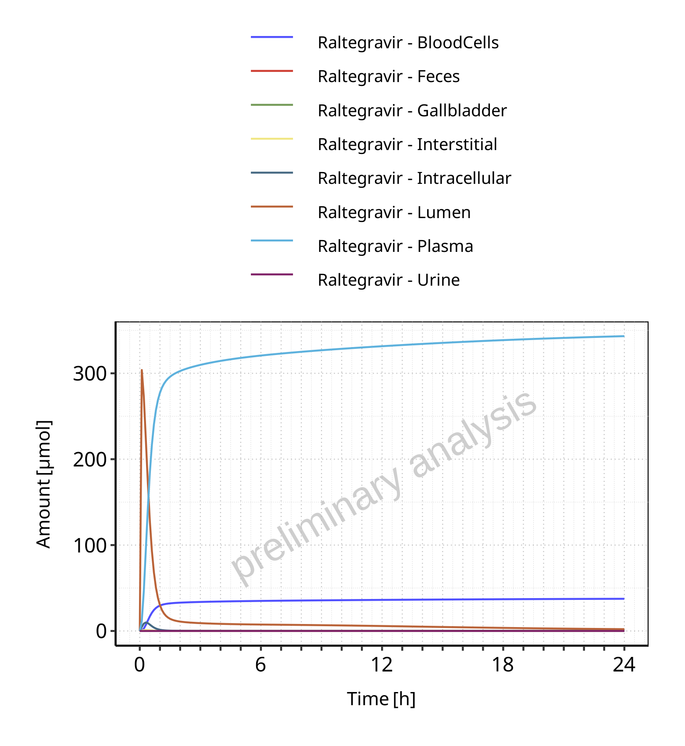

**Figure 4-36: Amount of drug vs time within the different compartments for Raltegravir**

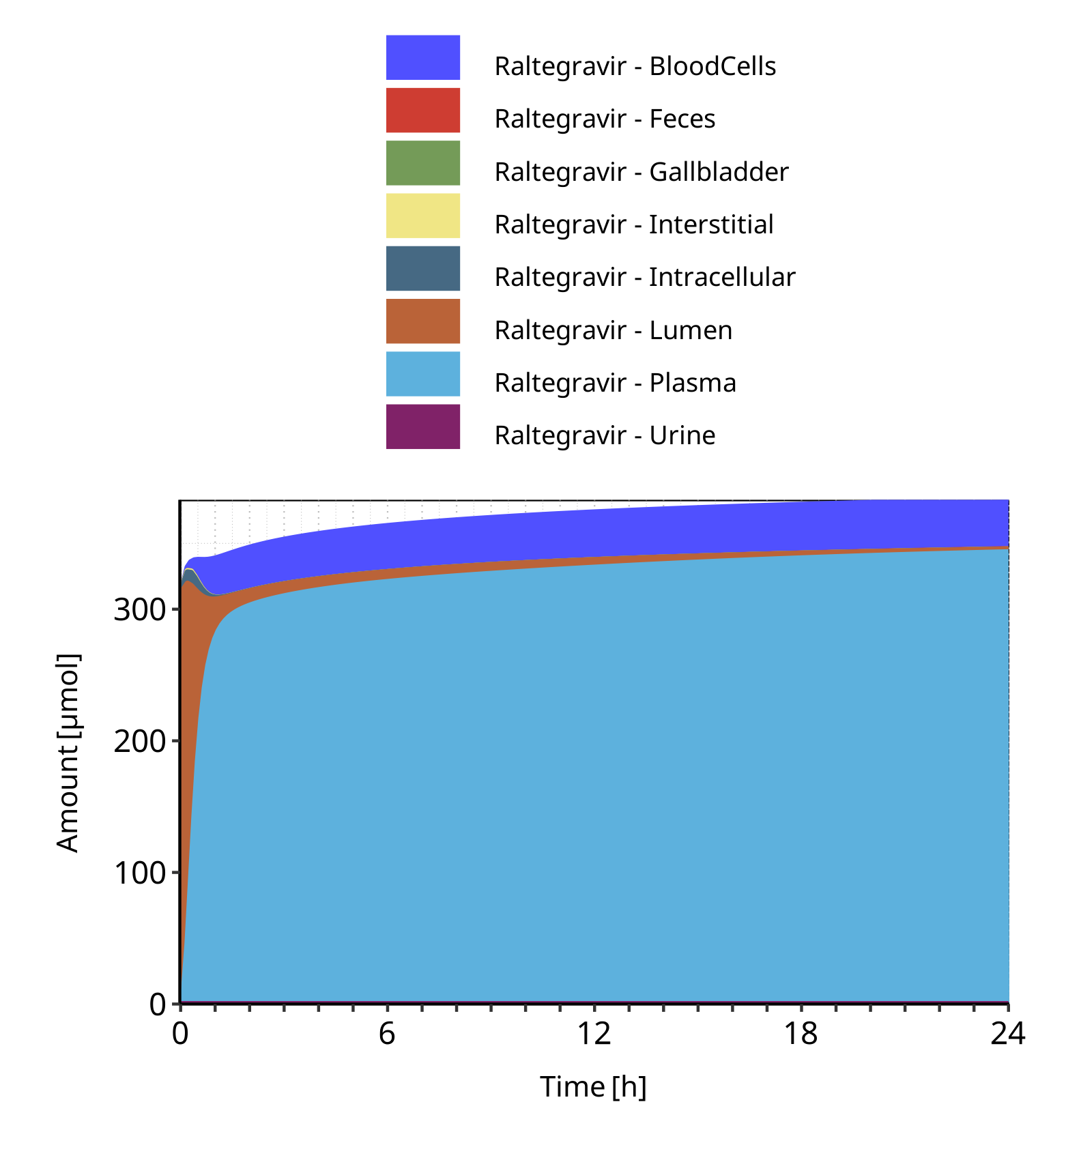

**Figure 4-37: Cumulated amount of drug vs time within the different compartments for Raltegravir**

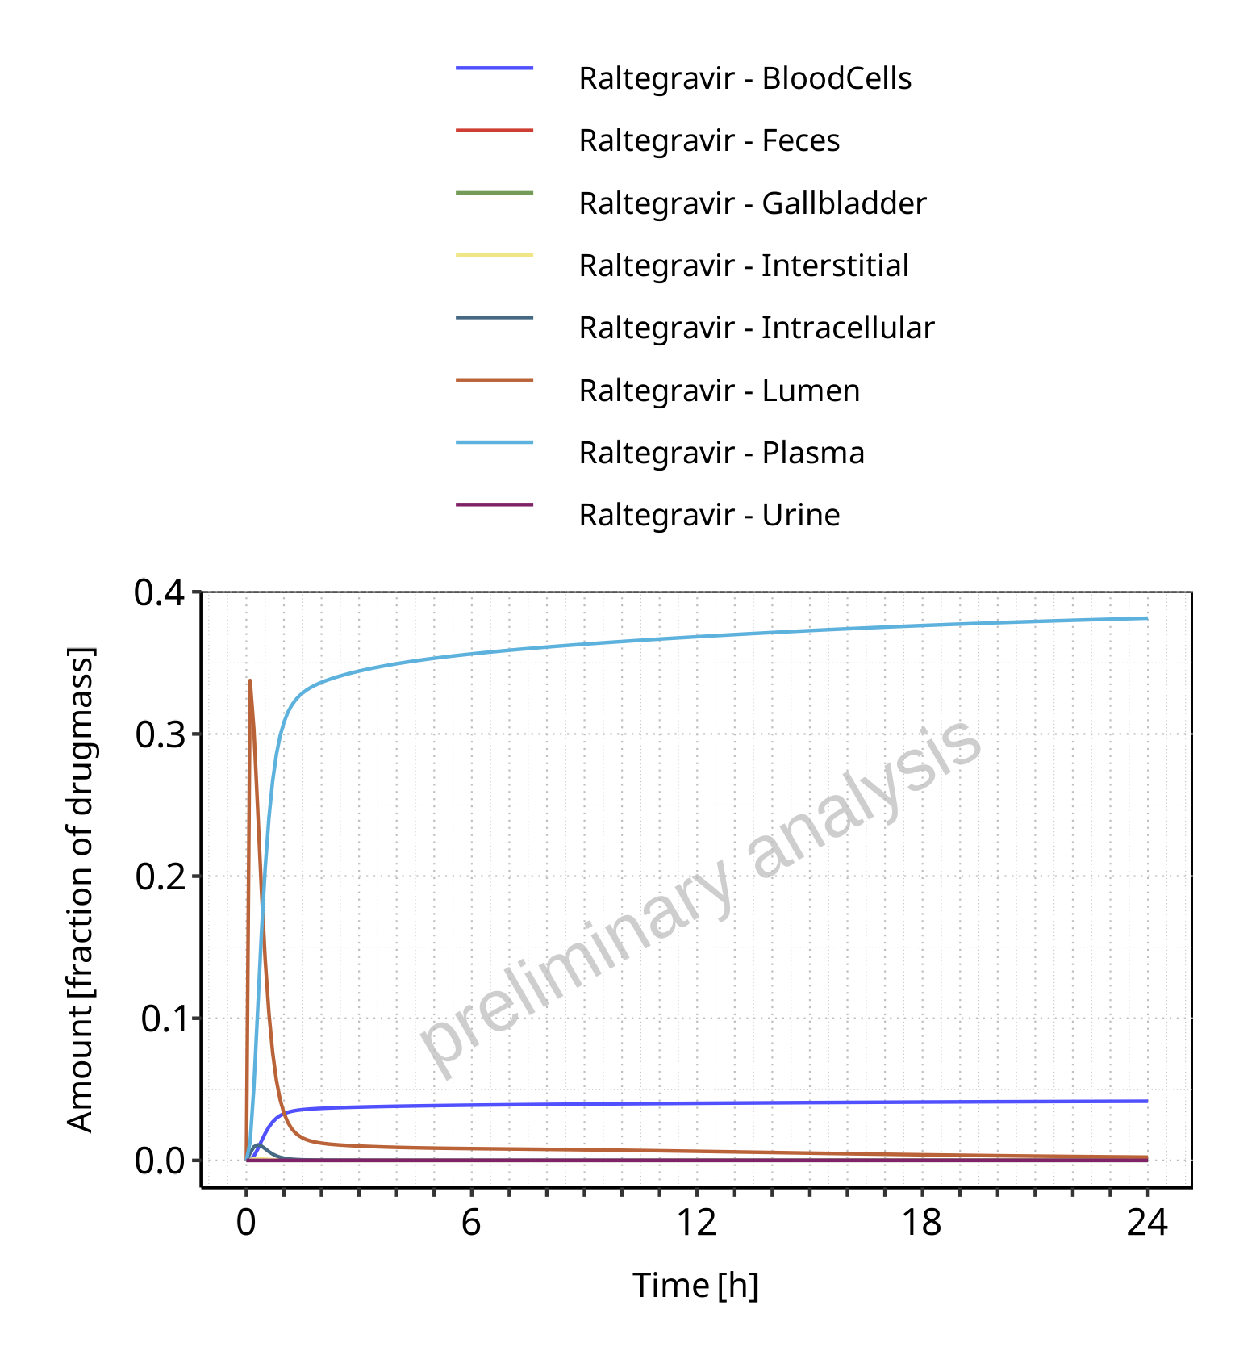

**Figure 4-38: Amount of drug vs time within the different compartments normalized to applicated drugmass for Raltegravir**

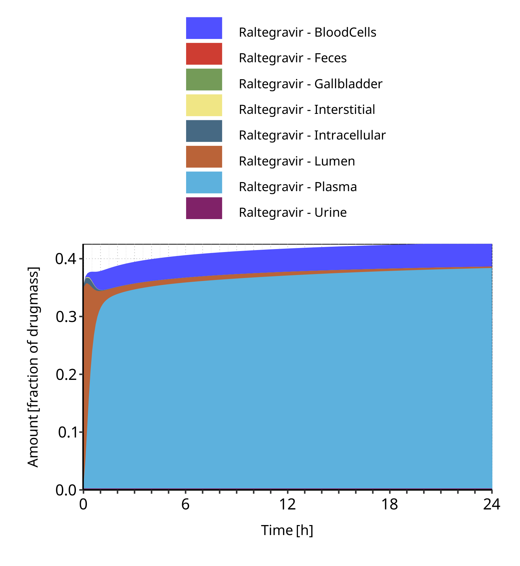

**Figure 4-39: Cumulated amount of drug vs time within the different compartments normalized to applicated drugmass for Raltegravir**

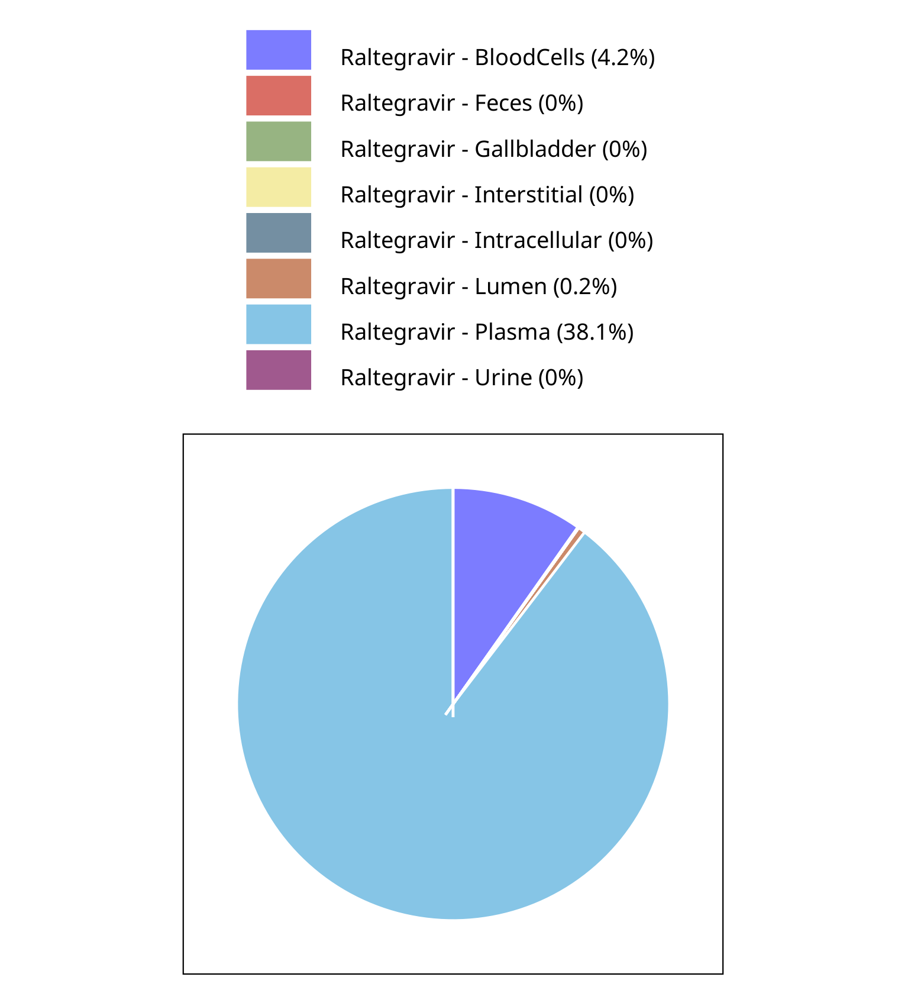

**Figure 4-40: Fraction of drug within the different compartments at 24.00h for Raltegravir**

# Time profiles and residual plots

## Time profiles and residual plots for Raltegravir 10 mg (lactose formulation)

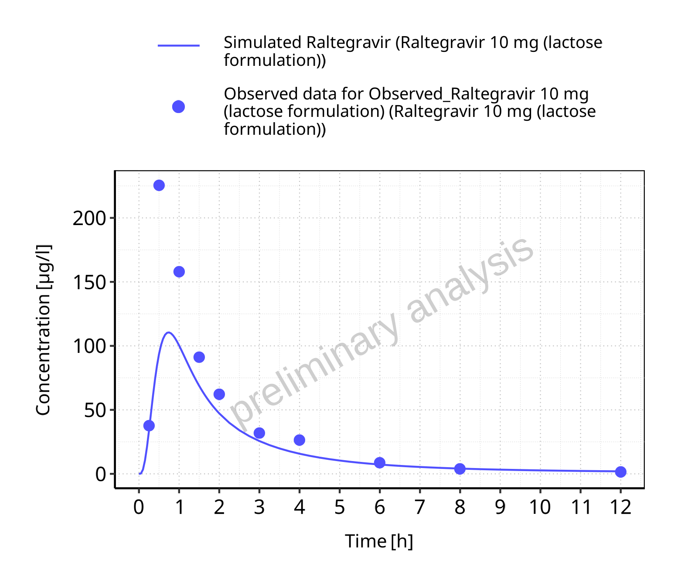

**Figure 5-1: Time profiles for Raltegravir 10 mg (lactose formulation). Data source: Data/Raltegravir_PK.txt. Time profiles are plotted in a linear scale.**

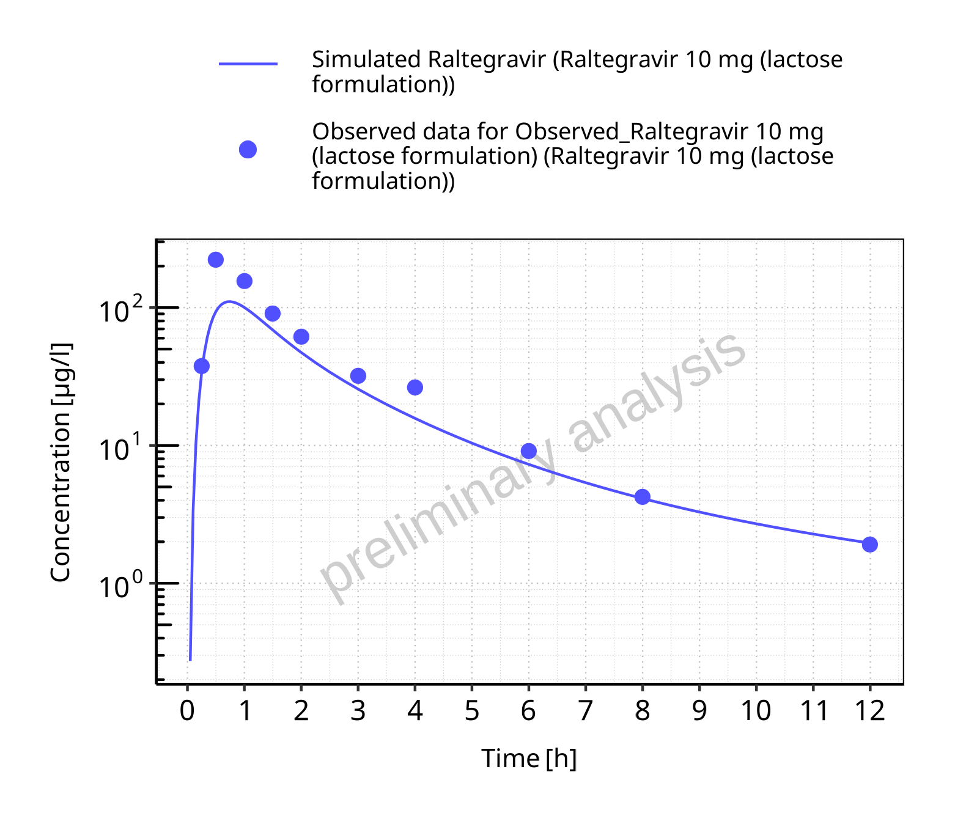

**Figure 5-2: Time profiles for Raltegravir 10 mg (lactose formulation). Data source: Data/Raltegravir_PK.txt. Time profiles are plotted in a logarithmic scale.**

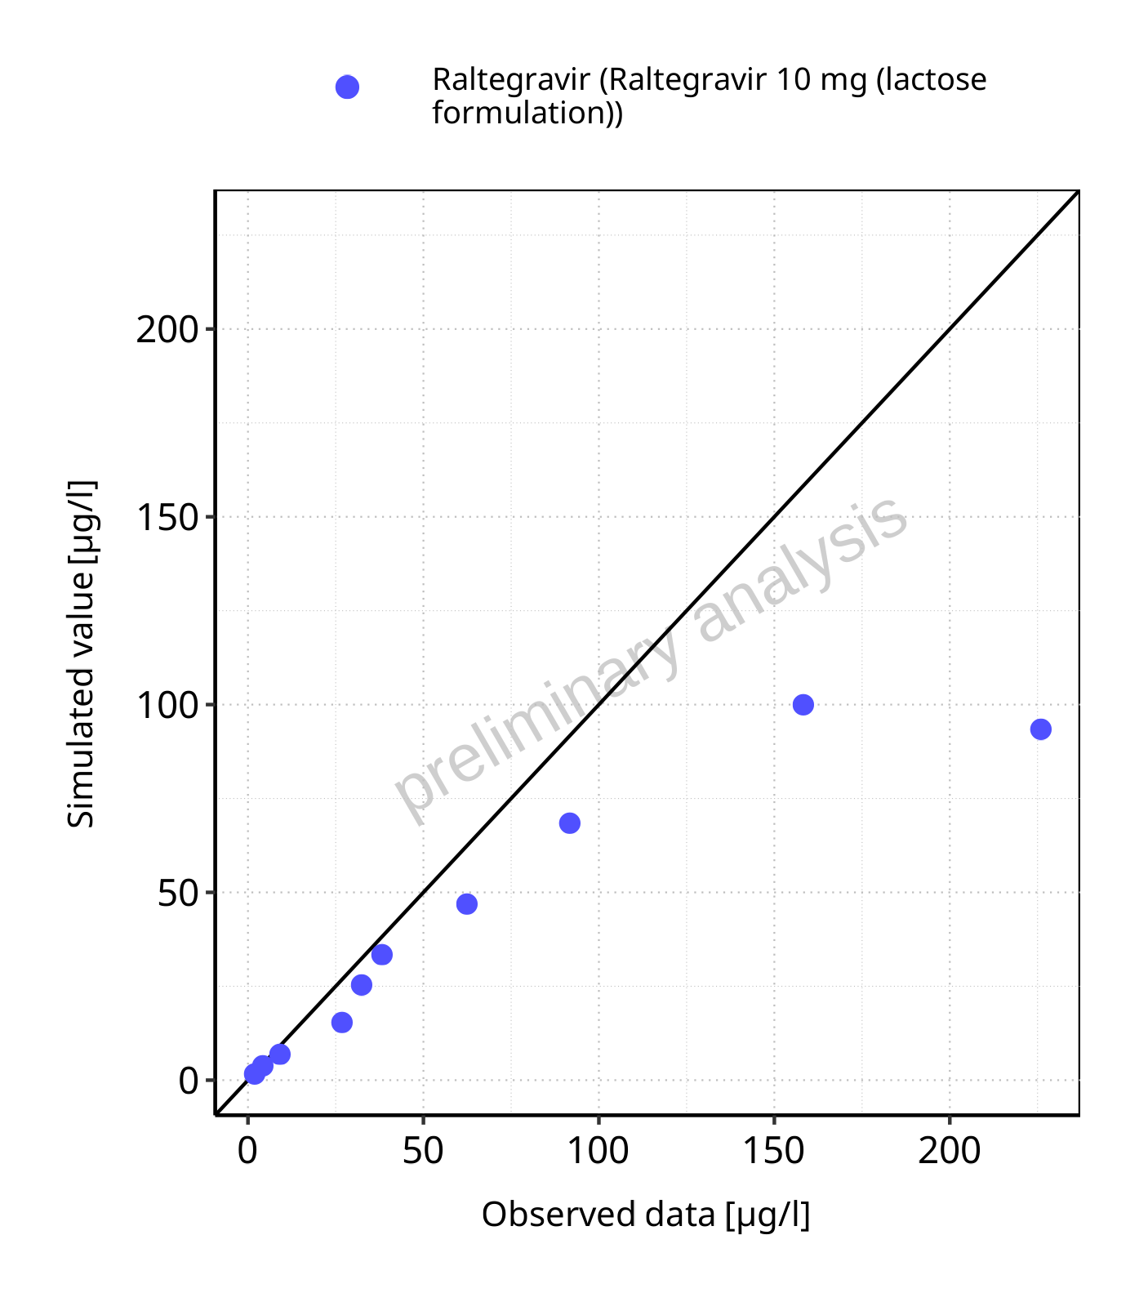

**Figure 5-3: Predicted vs observed for Raltegravir 10 mg (lactose formulation). Data source: Data/Raltegravir_PK.txt. Predictions and observations are plotted in a linear scale.**



**Figure 5-4: Predicted vs observed for Raltegravir 10 mg (lactose formulation). Data source: Data/Raltegravir_PK.txt. Predictions and observations are plotted in a logarithmic scale.**

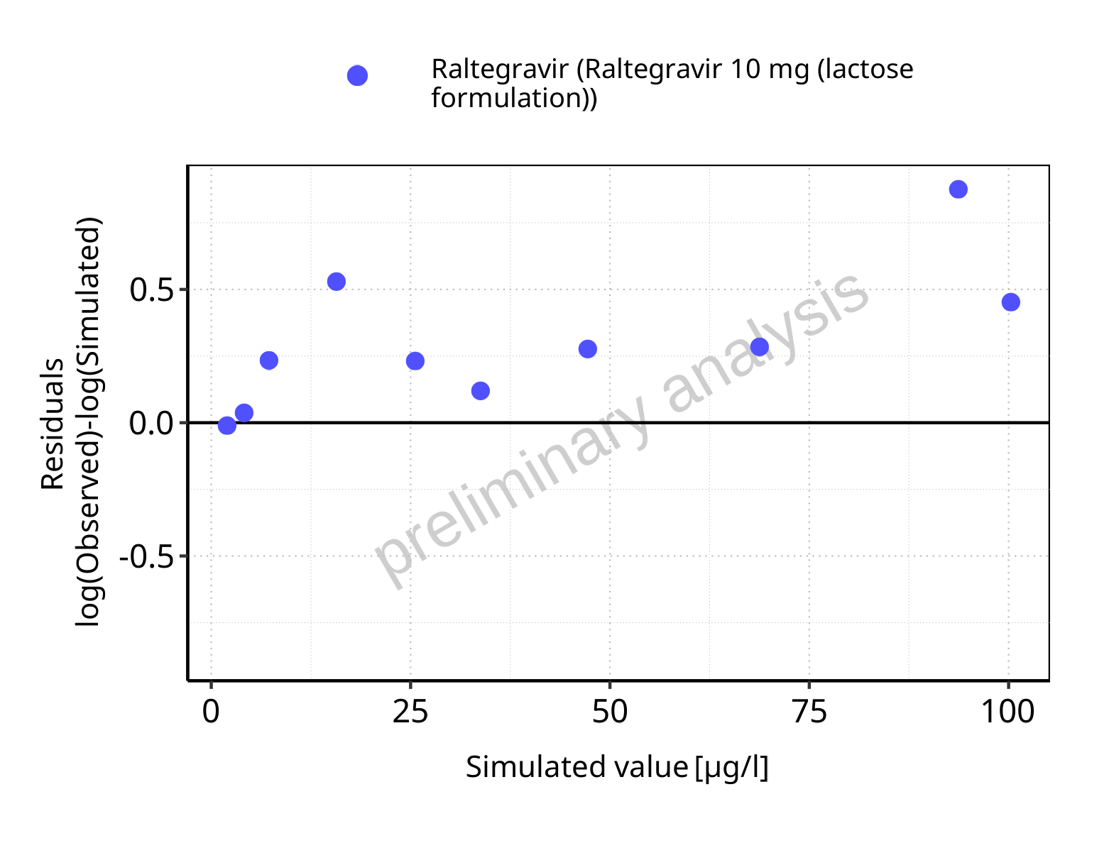

**Figure 5-5: Logarithmic residuals vs predicted values for Raltegravir 10 mg (lactose formulation). Data source: Data/Raltegravir_PK.txt.**

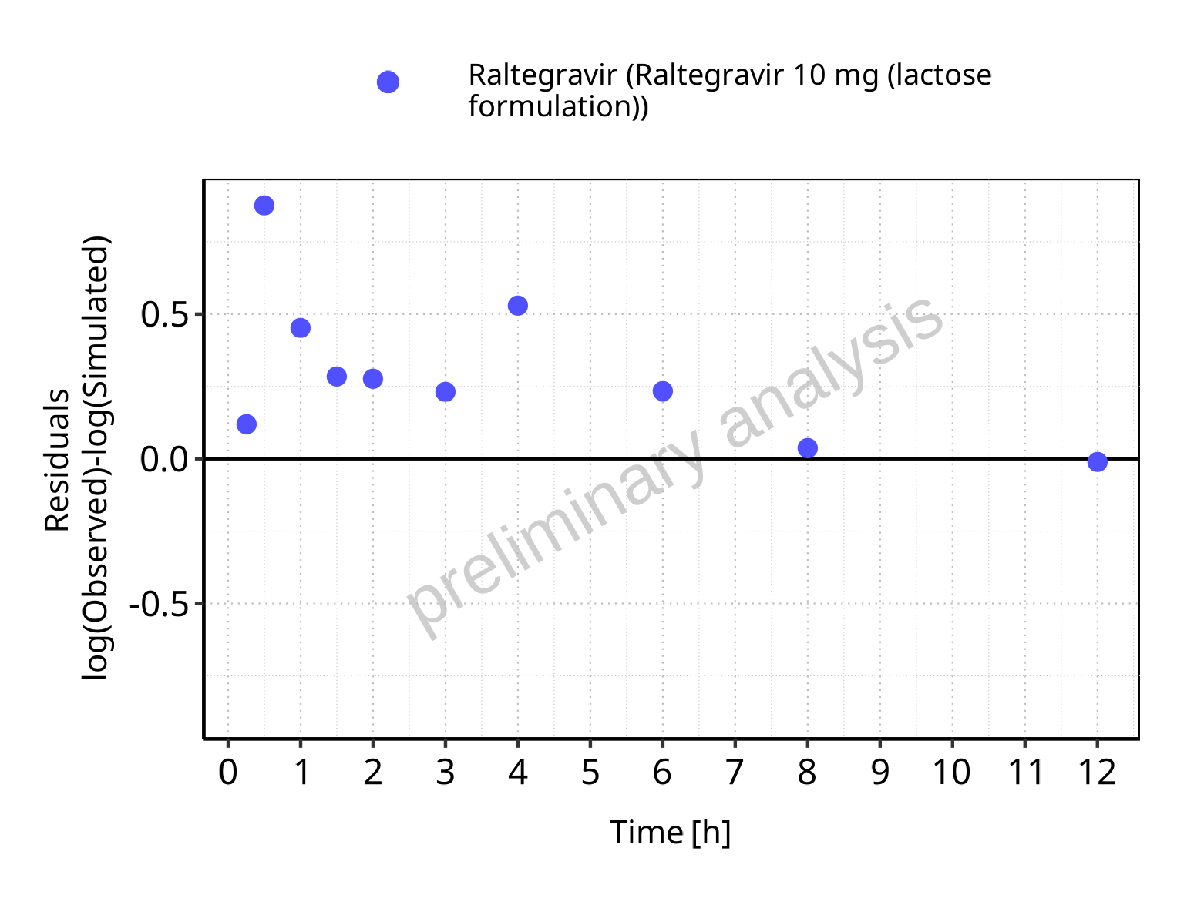

**Figure 5-6: Logarithmic residuals vs time values for Raltegravir 10 mg (lactose formulation). Data source: Data/Raltegravir_PK.txt.**

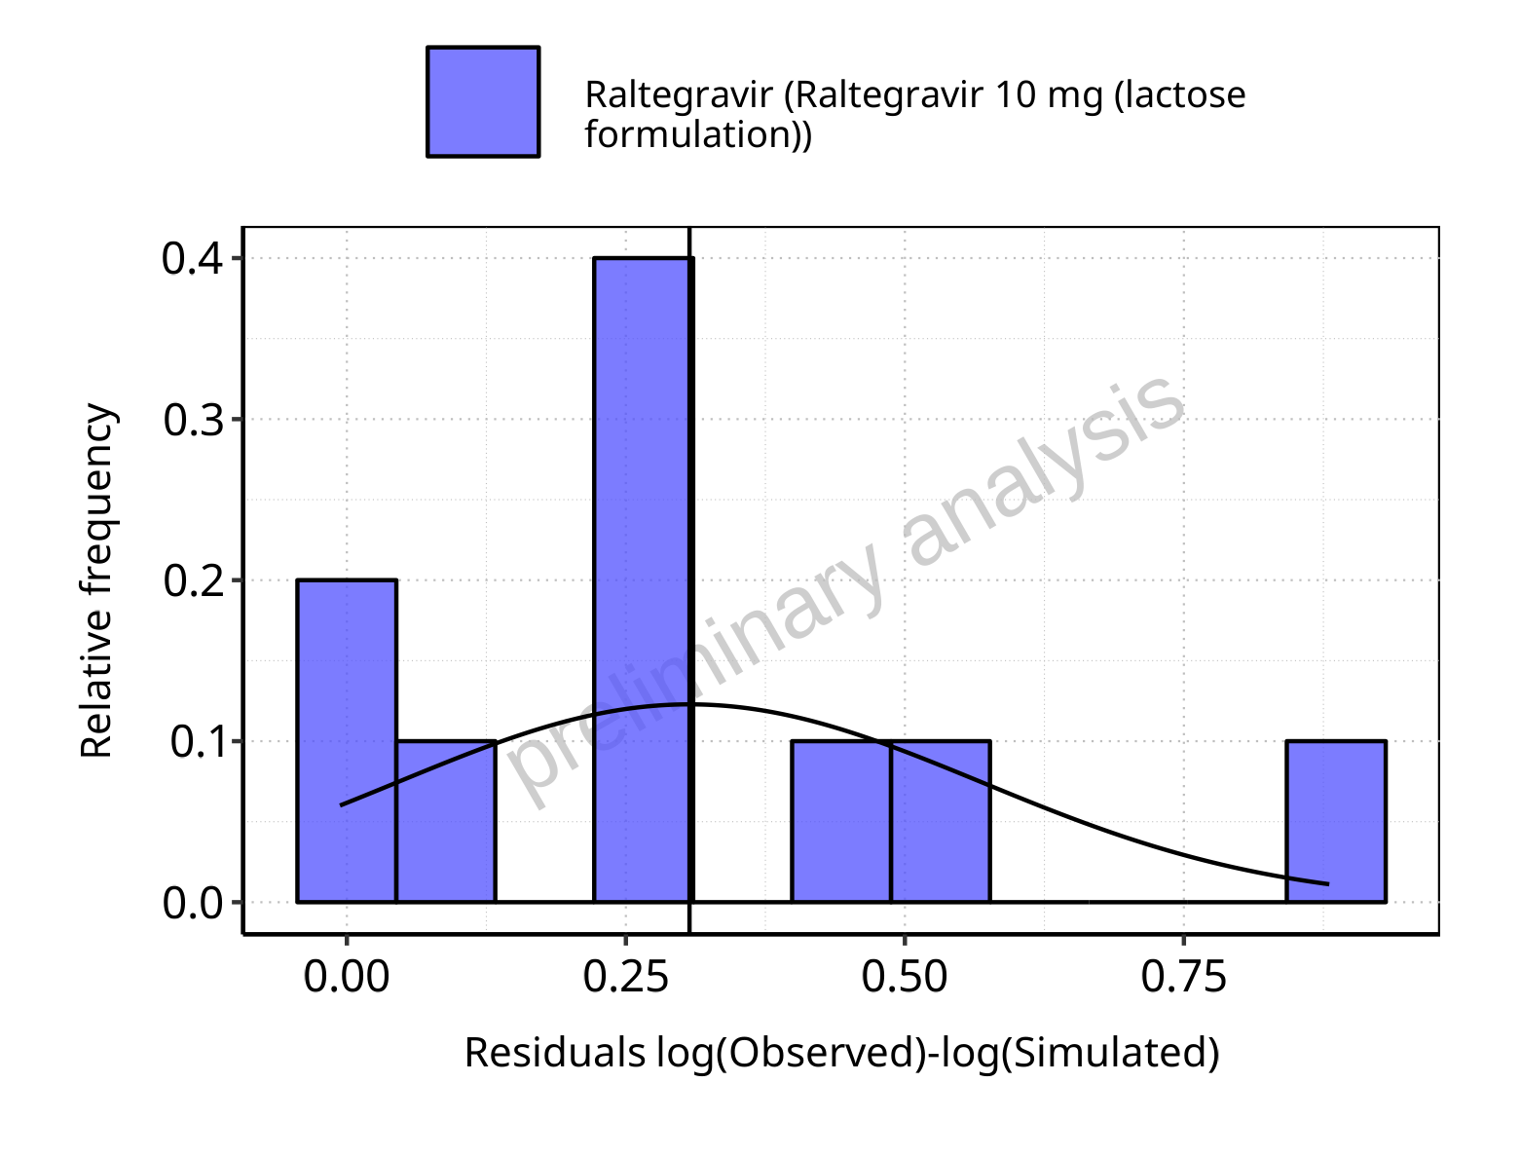

**Figure 5-7: Logarithmic residuals distribution (stacked) for Raltegravir 10 mg (lactose formulation). Data source: Data/Raltegravir_PK.txt.**

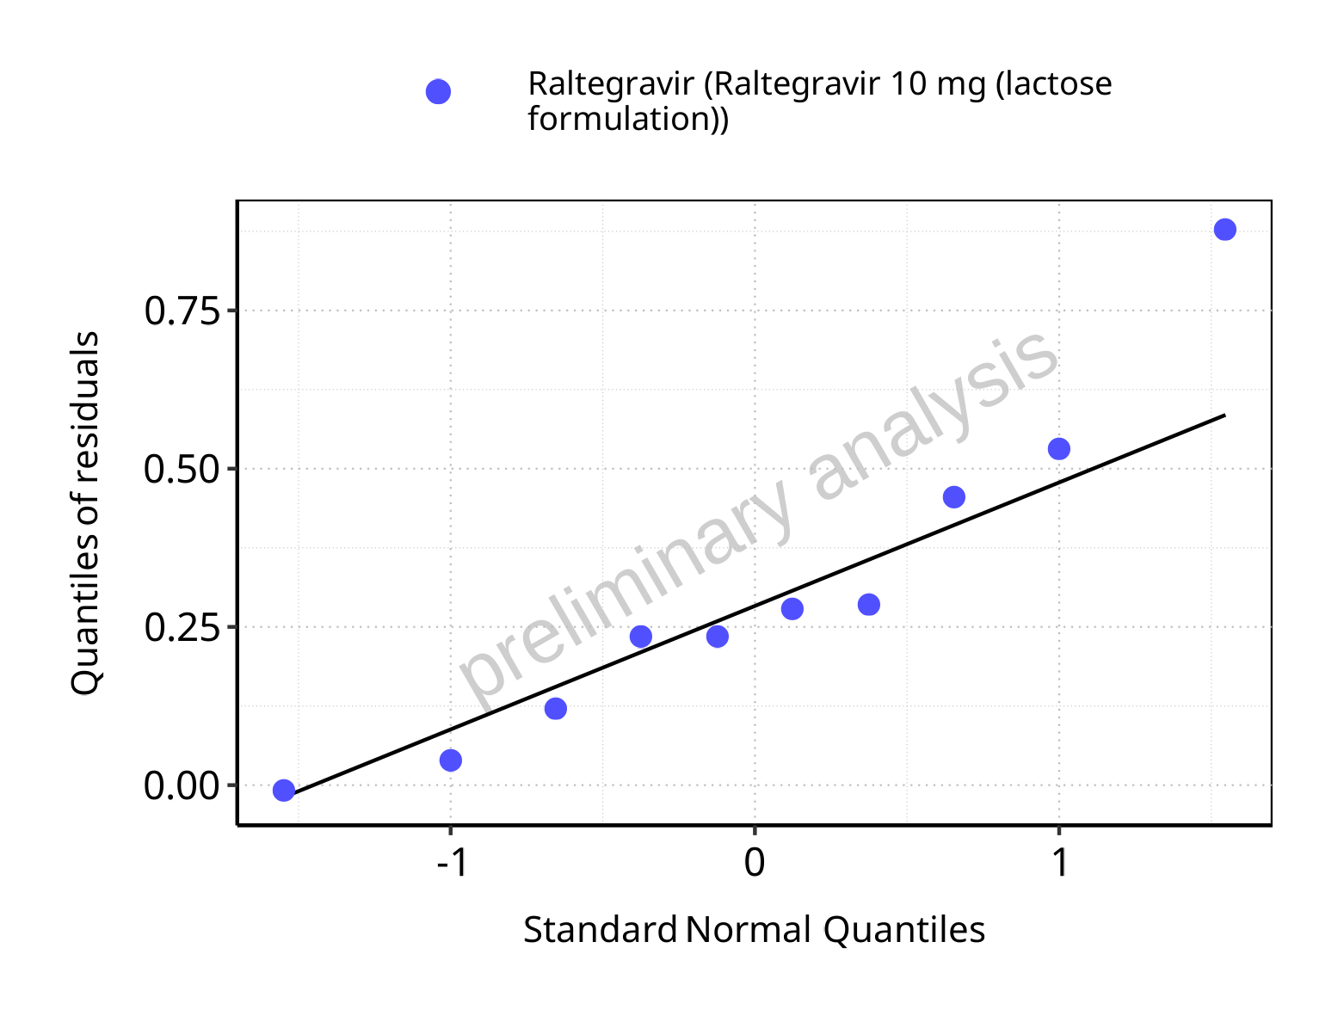

**Figure 5-8: Logarithmic residuals for Raltegravir 10 mg (lactose formulation) as quantile-quantile plot. Data source: Data/Raltegravir_PK.txt.**

## Time profiles and residual plots for Raltegravir 100 mg filmcoated tablet md

### For total simulation time range

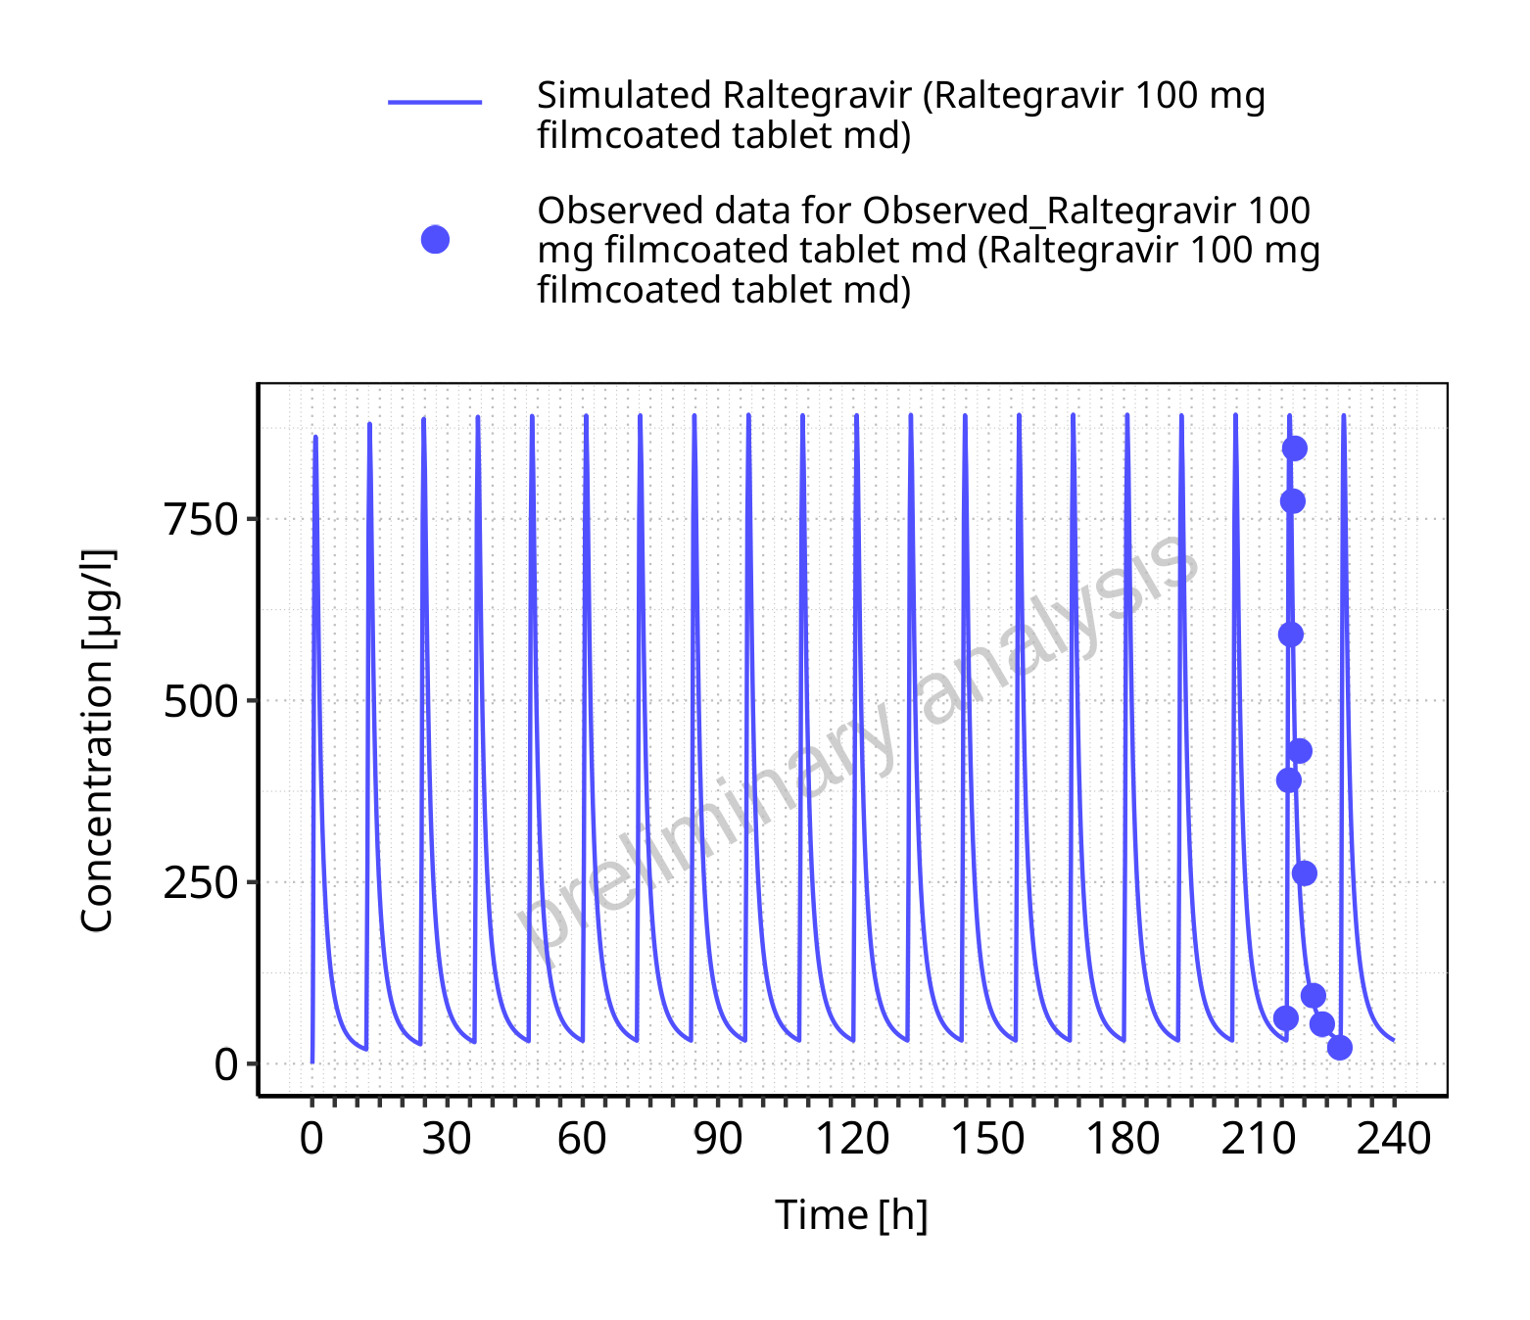

**Figure 5-9: Time profiles for Raltegravir 100 mg filmcoated tablet md. Data source: Data/Raltegravir_PK.txt. Time profiles are plotted in a linear scale.**

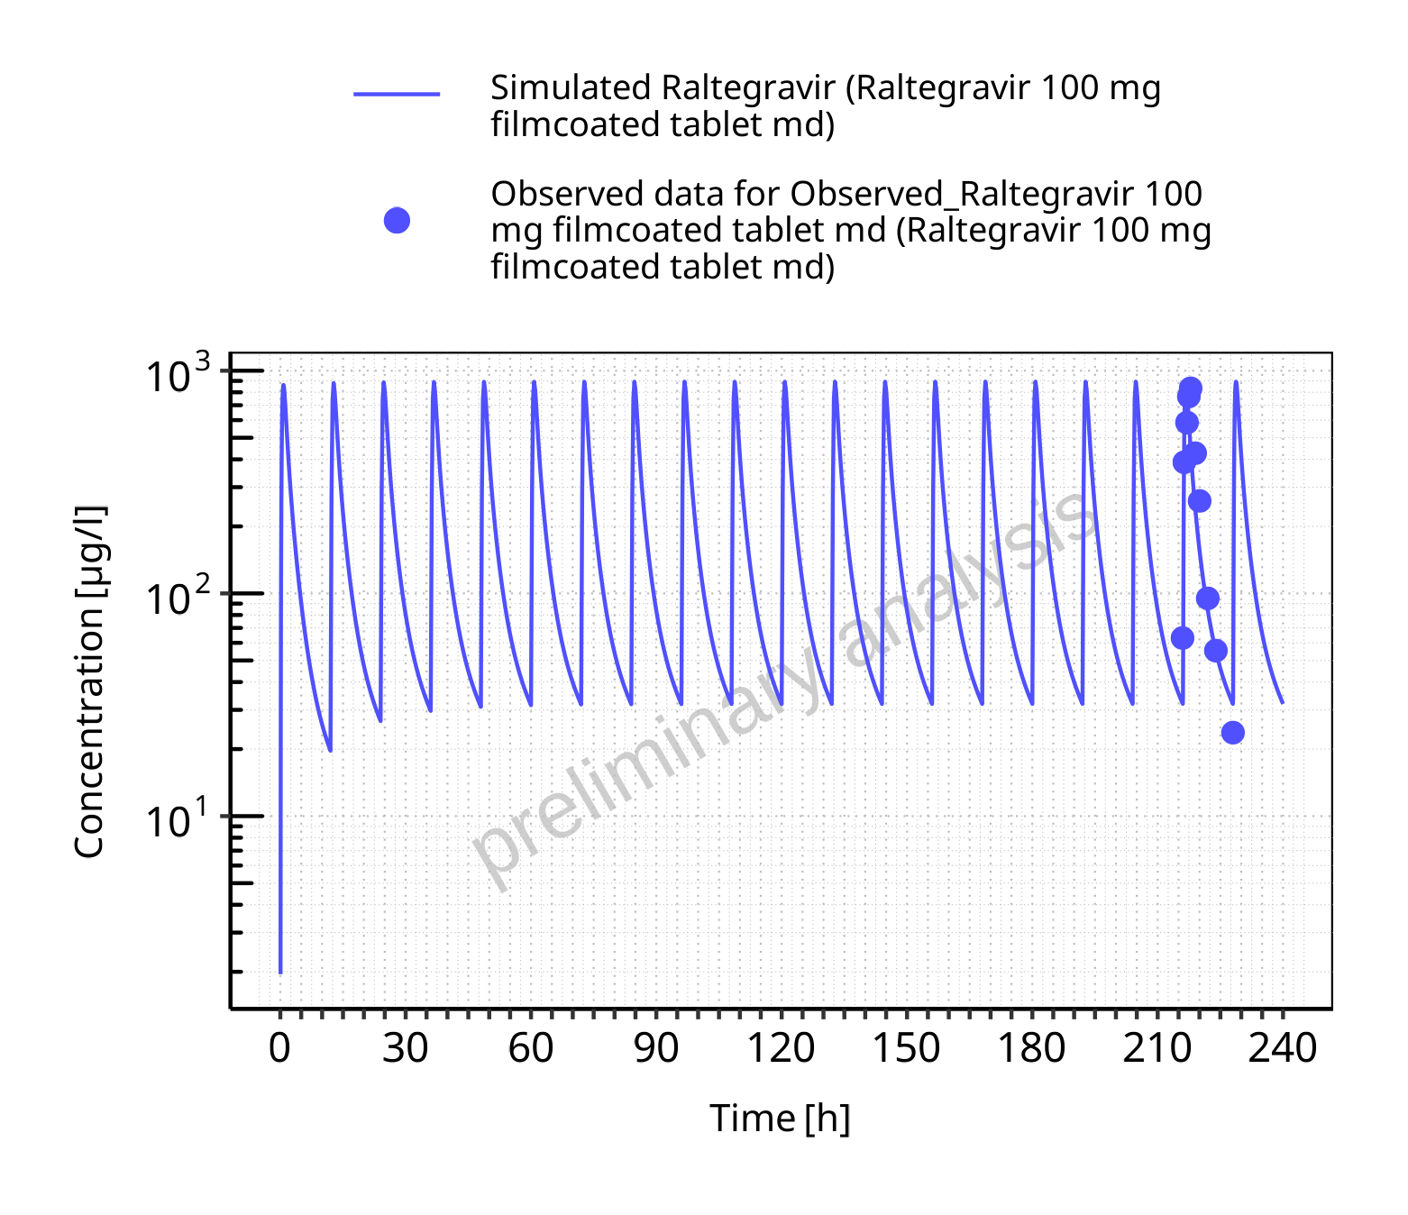

**Figure 5-10: Time profiles for Raltegravir 100 mg filmcoated tablet md. Data source: Data/Raltegravir_PK.txt. Time profiles are plotted in a logarithmic scale.**

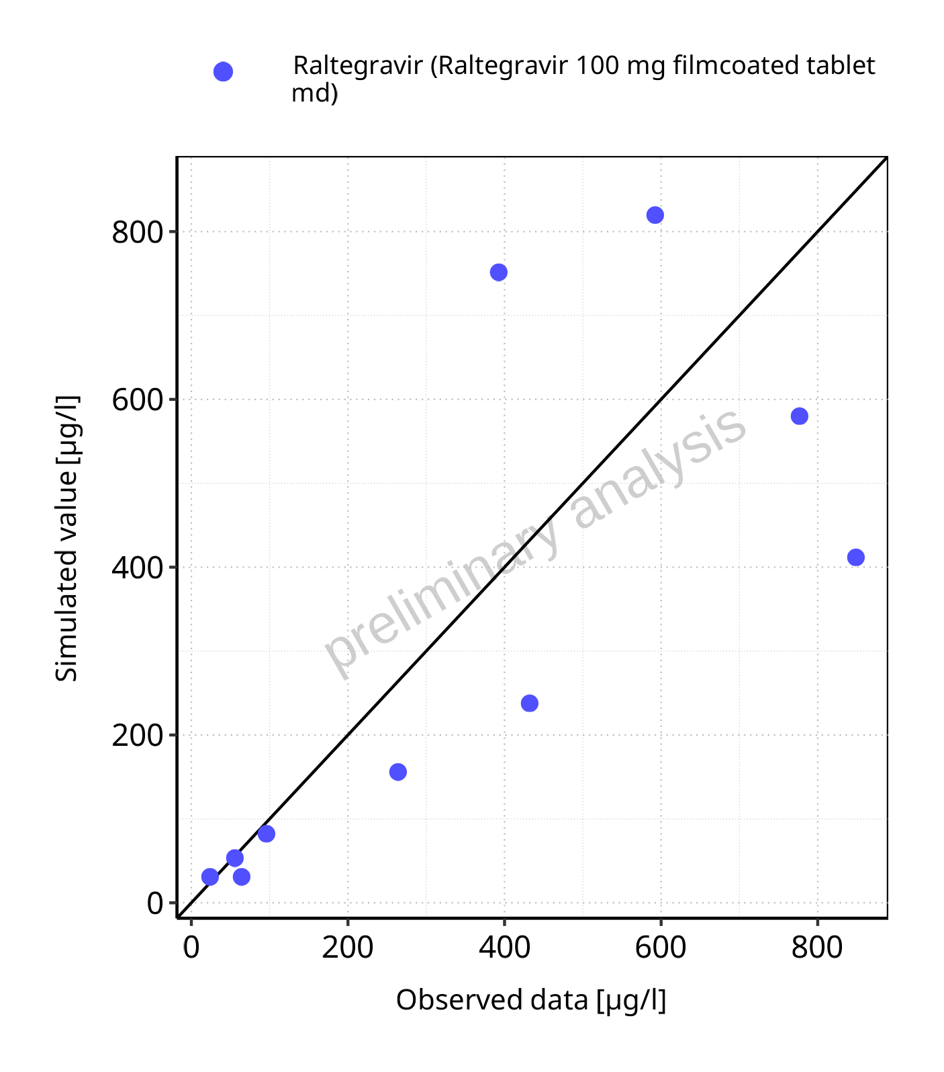

**Figure 5-11: Predicted vs observed for Raltegravir 100 mg filmcoated tablet md. Data source: Data/Raltegravir_PK.txt. Predictions and observations are plotted in a linear scale.**



**Figure 5-12: Predicted vs observed for Raltegravir 100 mg filmcoated tablet md. Data source: Data/Raltegravir_PK.txt. Predictions and observations are plotted in a logarithmic scale.**

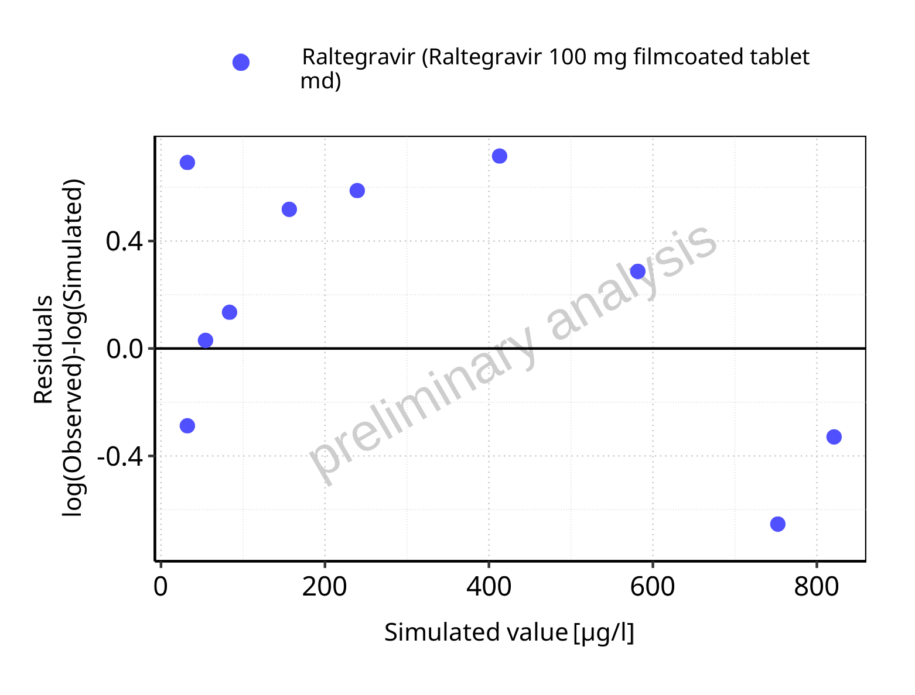

**Figure 5-13: Logarithmic residuals vs predicted values for Raltegravir 100 mg filmcoated tablet md. Data source: Data/Raltegravir_PK.txt.**

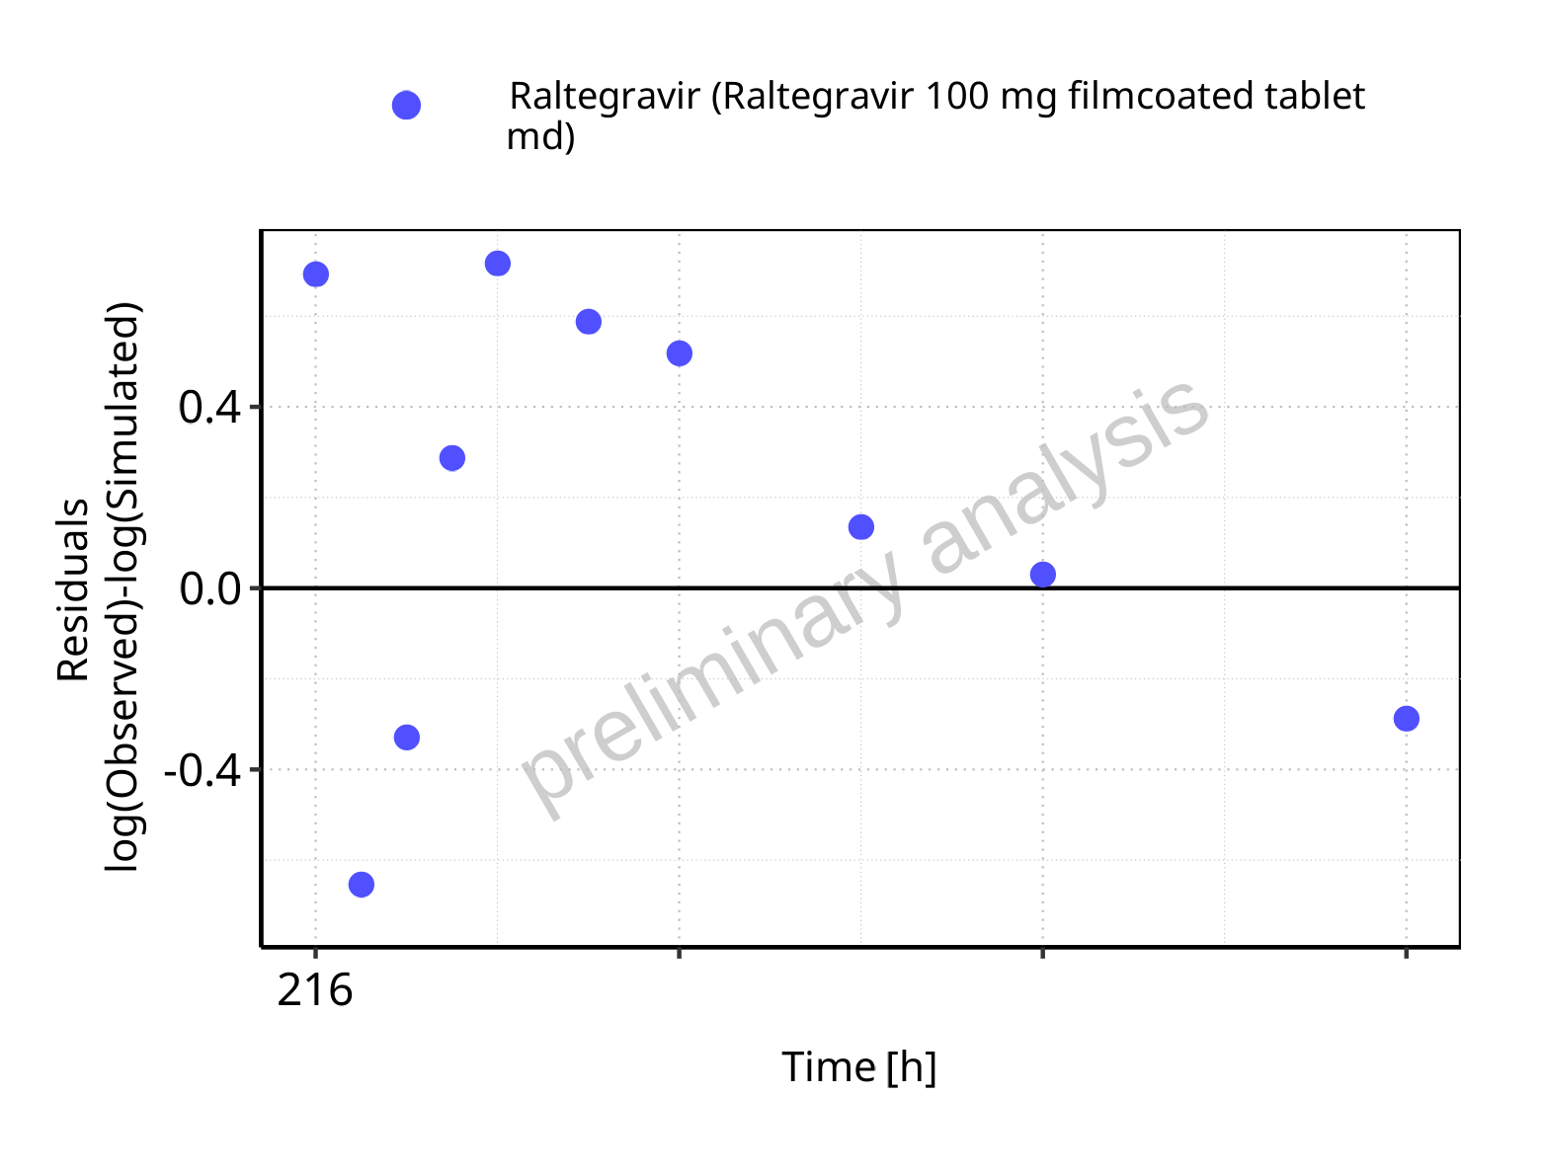

**Figure 5-14: Logarithmic residuals vs time values for Raltegravir 100 mg filmcoated tablet md. Data source: Data/Raltegravir_PK.txt.**

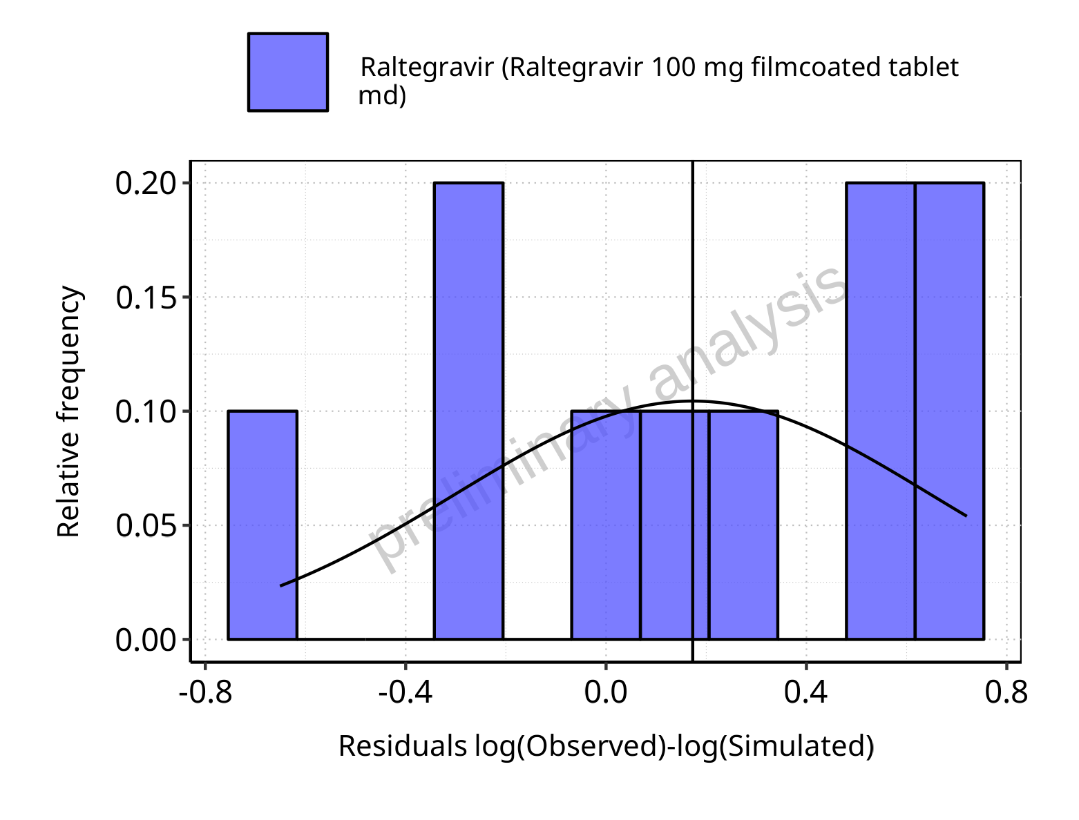

**Figure 5-15: Logarithmic residuals distribution (stacked) for Raltegravir 100 mg filmcoated tablet md. Data source: Data/Raltegravir_PK.txt.**

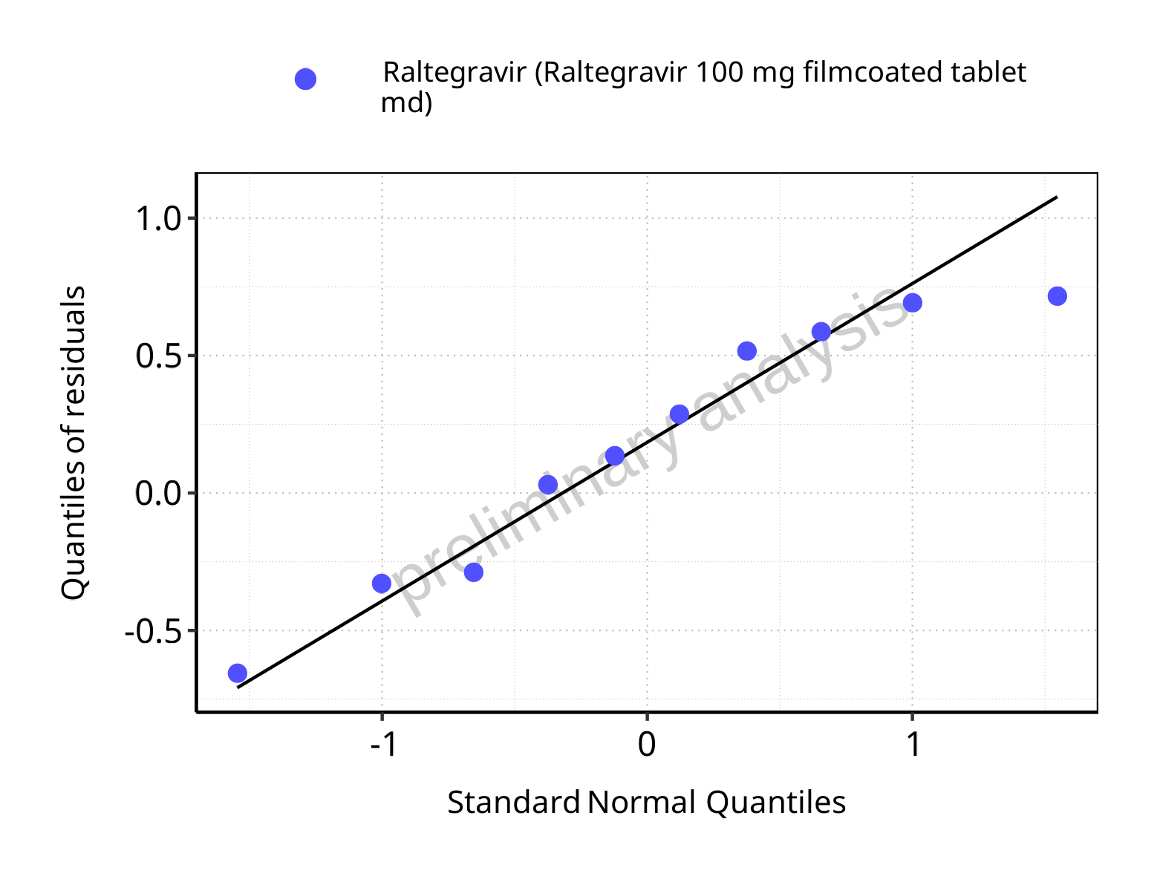

**Figure 5-16: Logarithmic residuals for Raltegravir 100 mg filmcoated tablet md as quantile-quantile plot. Data source: Data/Raltegravir_PK.txt.**

### For first application range

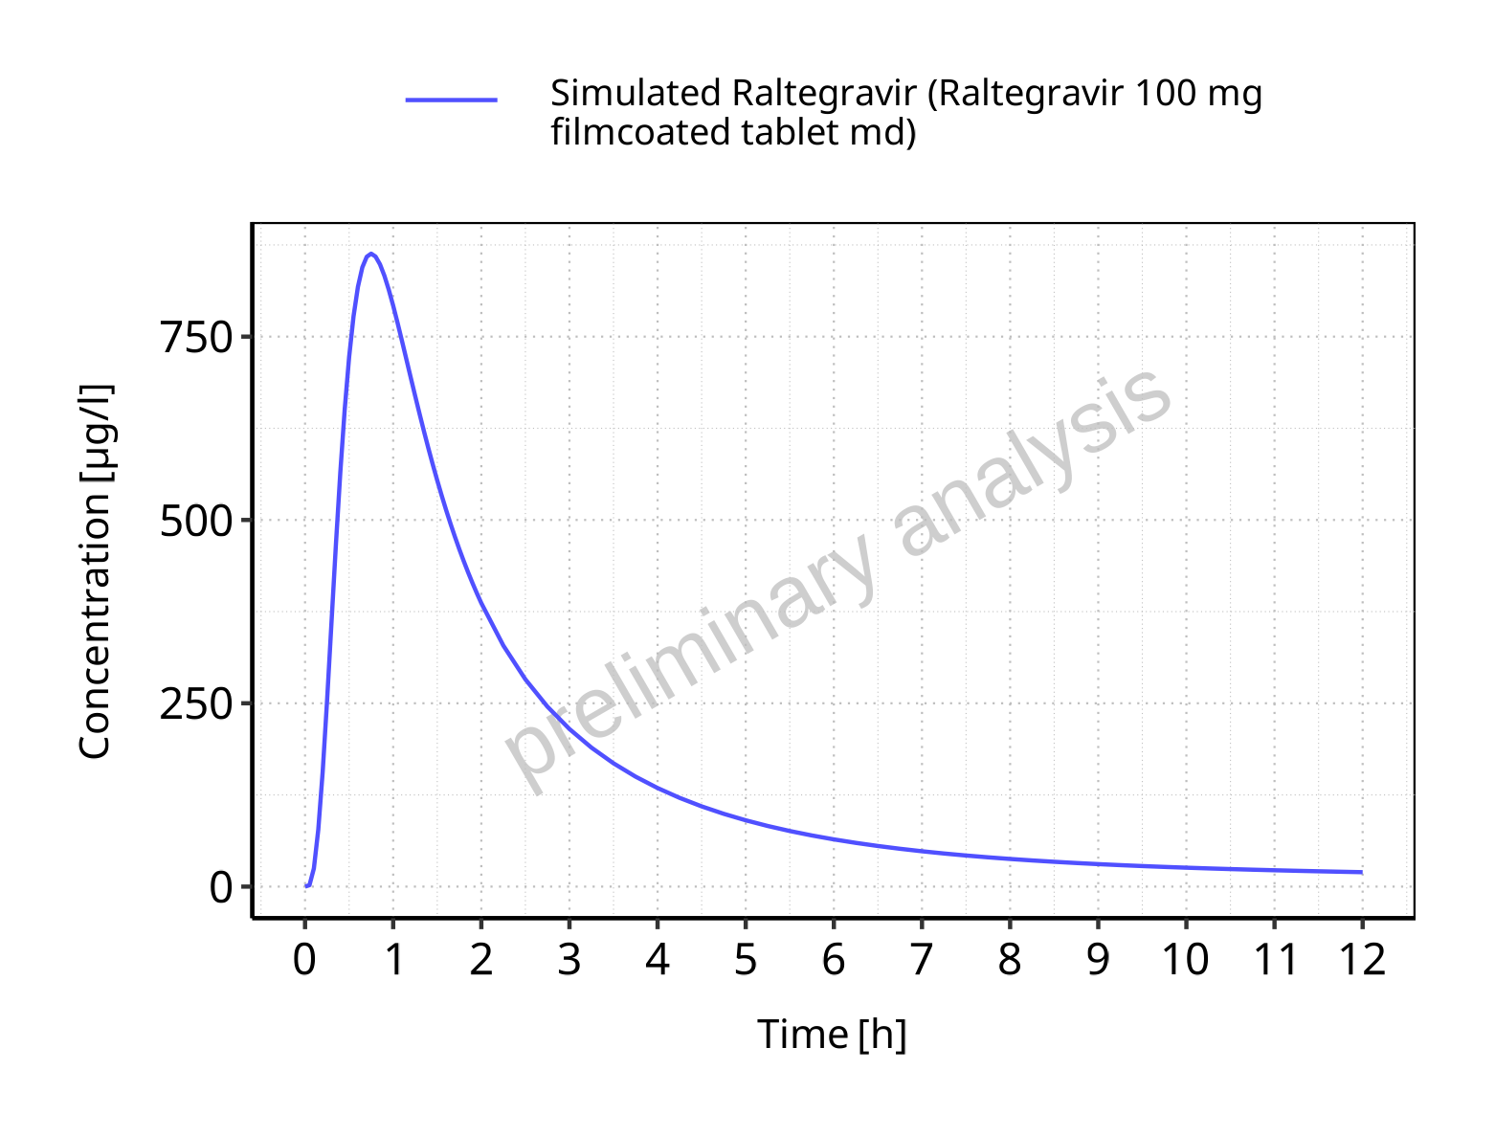

**Figure 5-17: Time profiles for Raltegravir 100 mg filmcoated tablet md. Data source: Data/Raltegravir_PK.txt. Time profiles are plotted in a linear scale.**

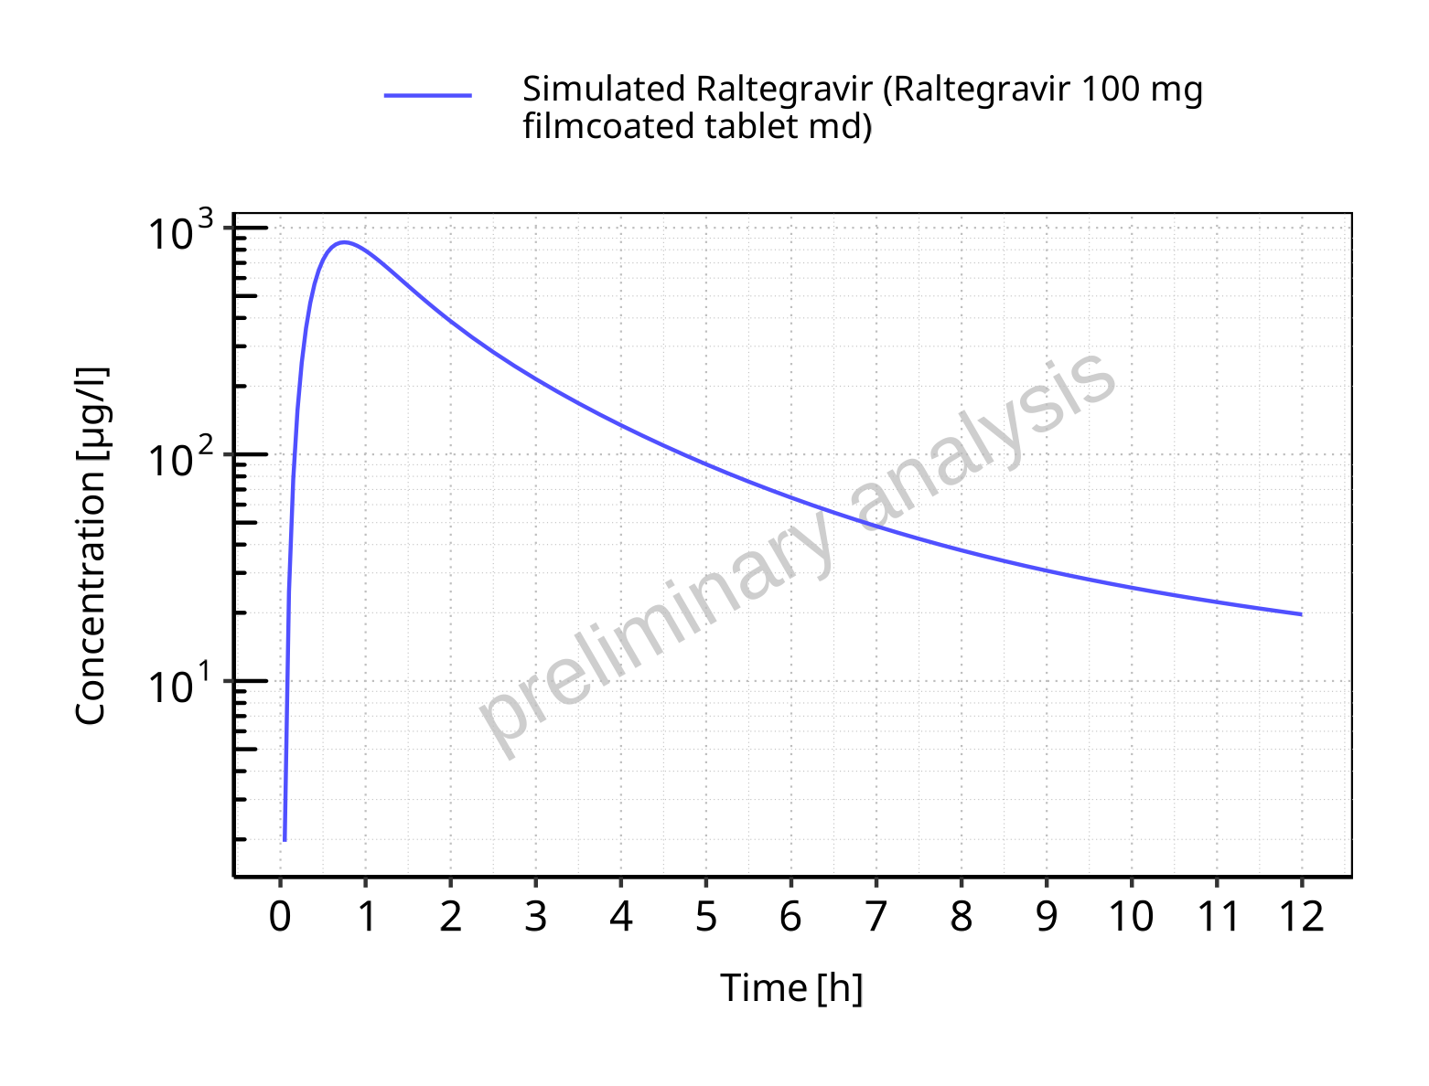

**Figure 5-18: Time profiles for Raltegravir 100 mg filmcoated tablet md. Data source: Data/Raltegravir_PK.txt. Time profiles are plotted in a logarithmic scale.**

### For last application range

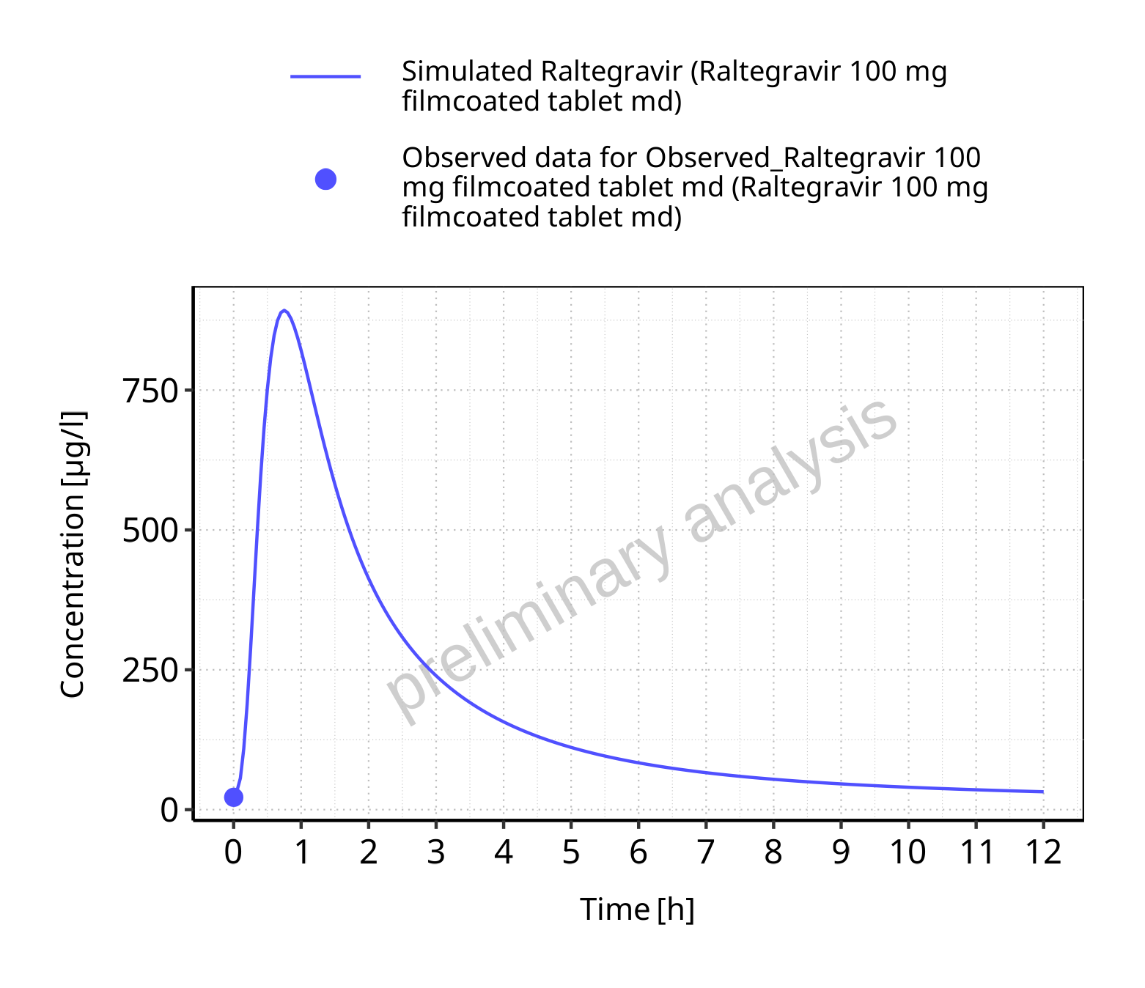

**Figure 5-19: Time profiles for Raltegravir 100 mg filmcoated tablet md. Data source: Data/Raltegravir_PK.txt. Time profiles are plotted in a linear scale.**

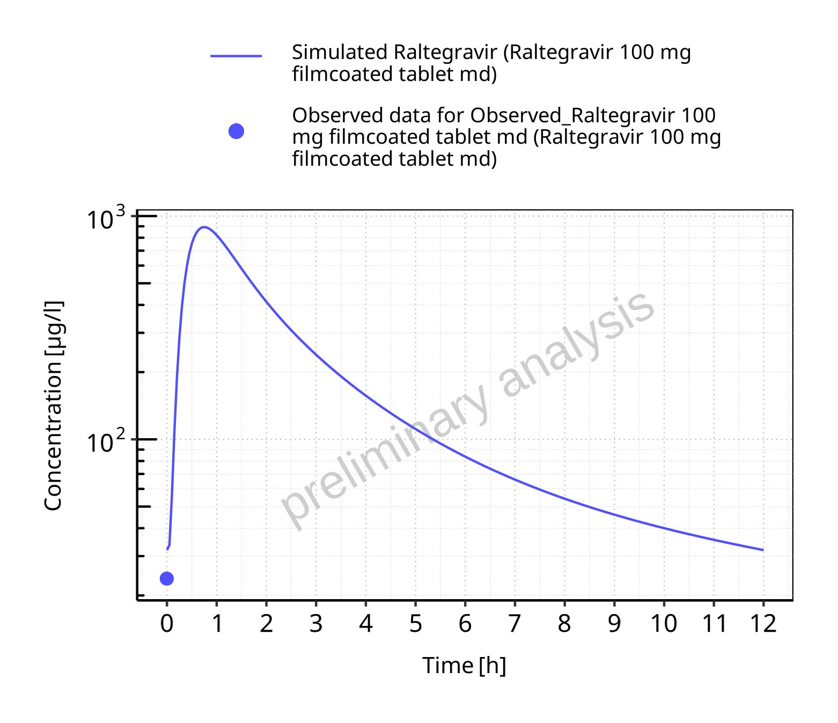

**Figure 5-20: Time profiles for Raltegravir 100 mg filmcoated tablet md. Data source: Data/Raltegravir_PK.txt. Time profiles are plotted in a logarithmic scale.**

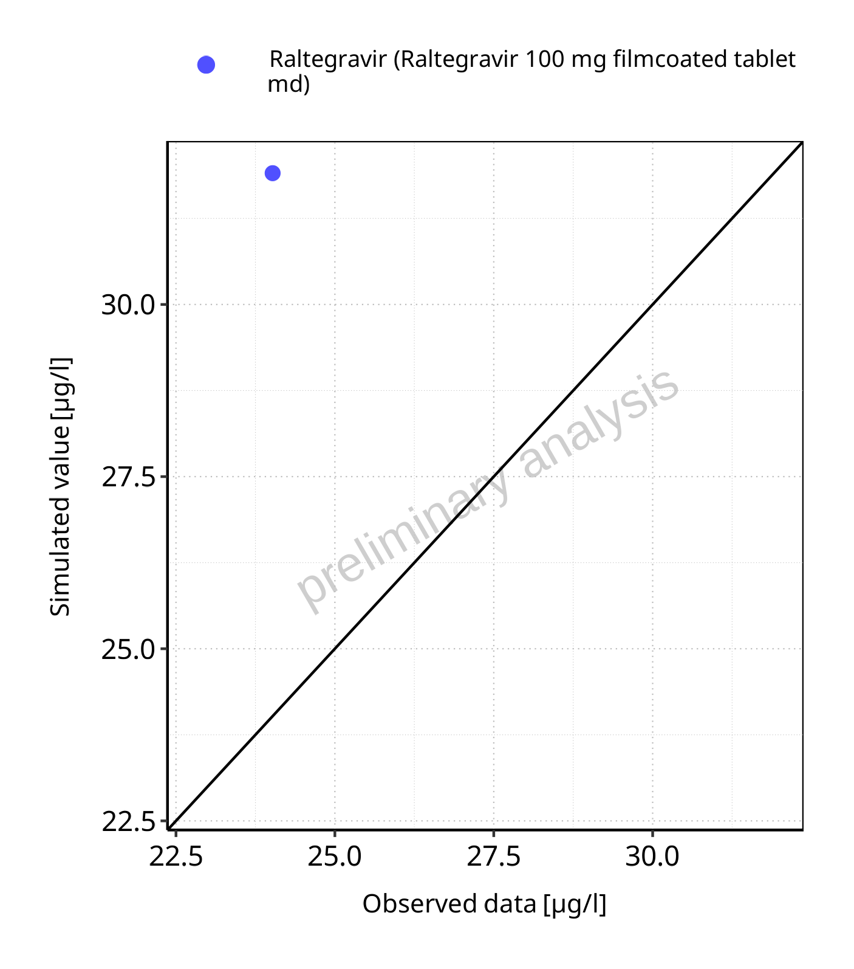

**Figure 5-21: Predicted vs observed for Raltegravir 100 mg filmcoated tablet md. Data source: Data/Raltegravir_PK.txt. Predictions and observations are plotted in a linear scale.**



**Figure 5-22: Predicted vs observed for Raltegravir 100 mg filmcoated tablet md. Data source: Data/Raltegravir_PK.txt. Predictions and observations are plotted in a logarithmic scale.**

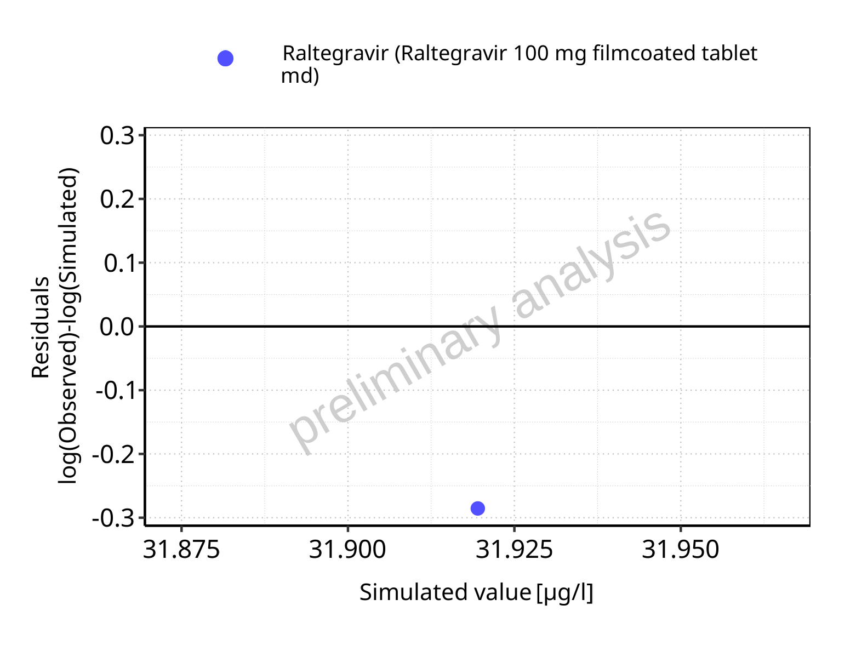

**Figure 5-23: Logarithmic residuals vs predicted values for Raltegravir 100 mg filmcoated tablet md. Data source: Data/Raltegravir_PK.txt.**

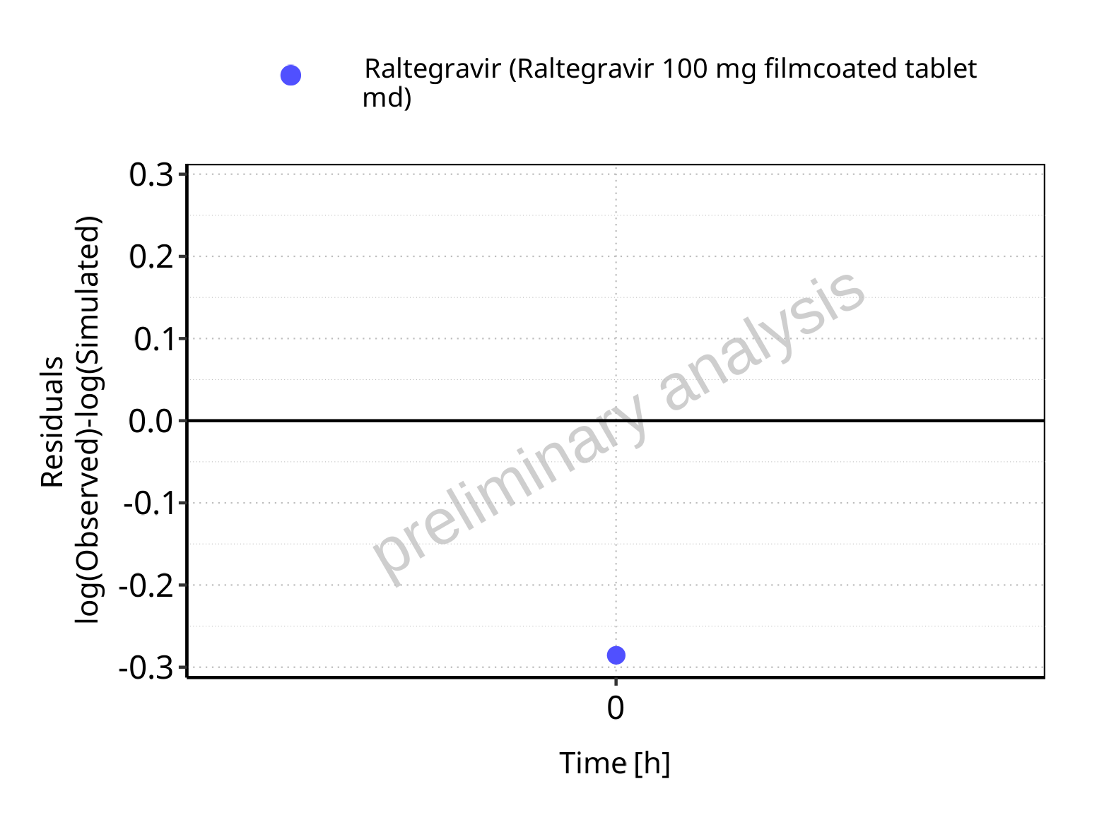

**Figure 5-24: Logarithmic residuals vs time values for Raltegravir 100 mg filmcoated tablet md. Data source: Data/Raltegravir_PK.txt.**

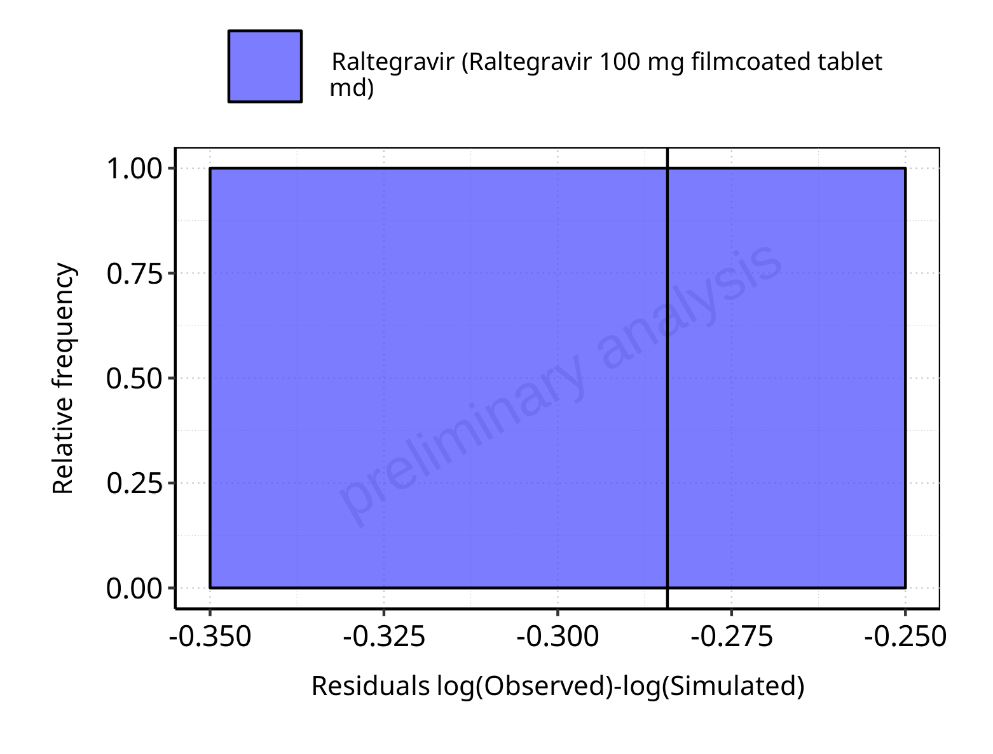

**Figure 5-25: Logarithmic residuals distribution (stacked) for Raltegravir 100 mg filmcoated tablet md. Data source: Data/Raltegravir_PK.txt.**

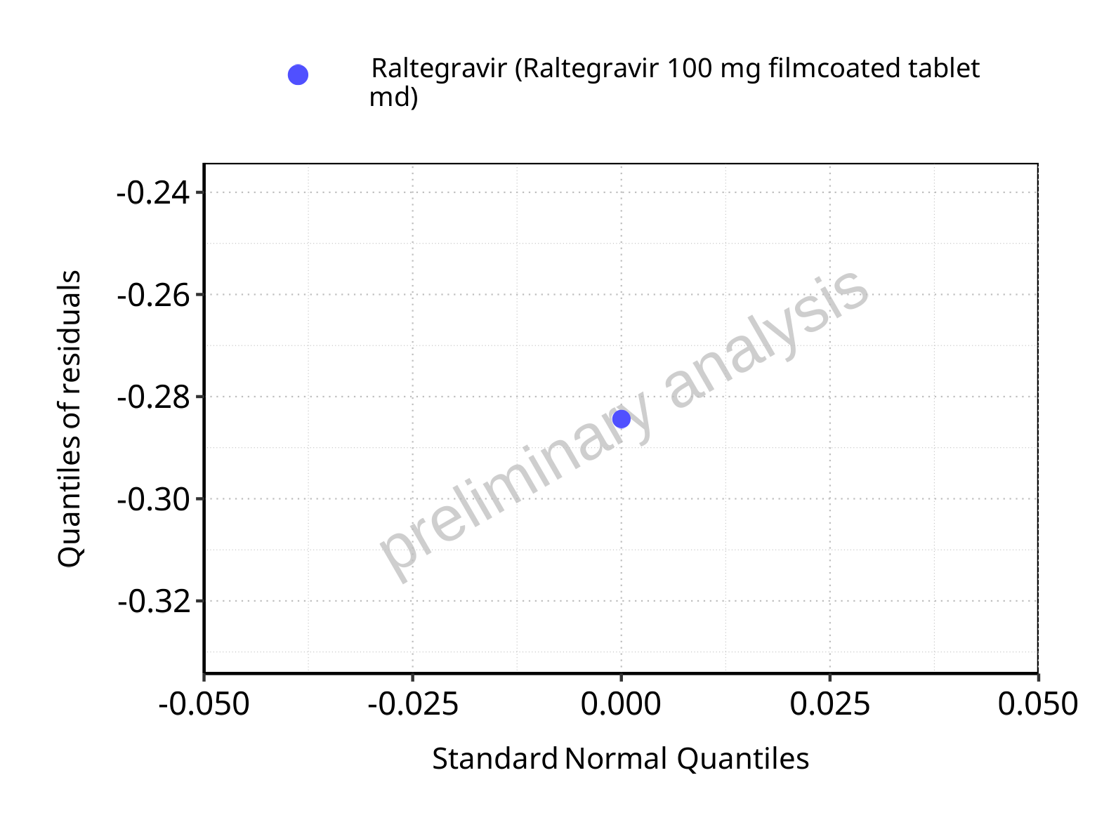

**Figure 5-26: Logarithmic residuals for Raltegravir 100 mg filmcoated tablet md as quantile-quantile plot. Data source: Data/Raltegravir_PK.txt.**

## Time profiles and residual plots for Raltegravir 200 mg filmcoated tablet md

### For total simulation time range

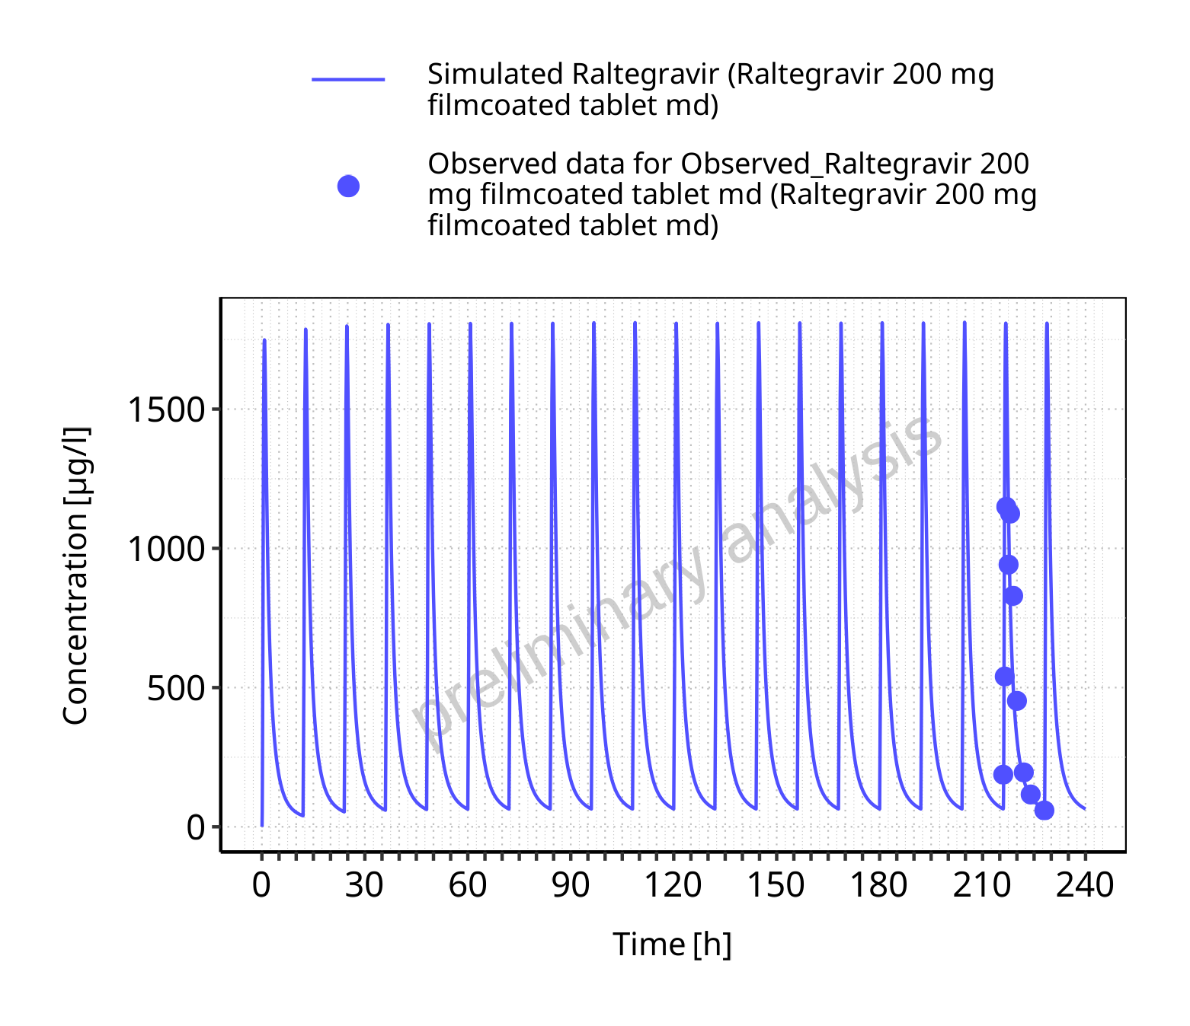

**Figure 5-27: Time profiles for Raltegravir 200 mg filmcoated tablet md. Data source: Data/Raltegravir_PK.txt. Time profiles are plotted in a linear scale.**

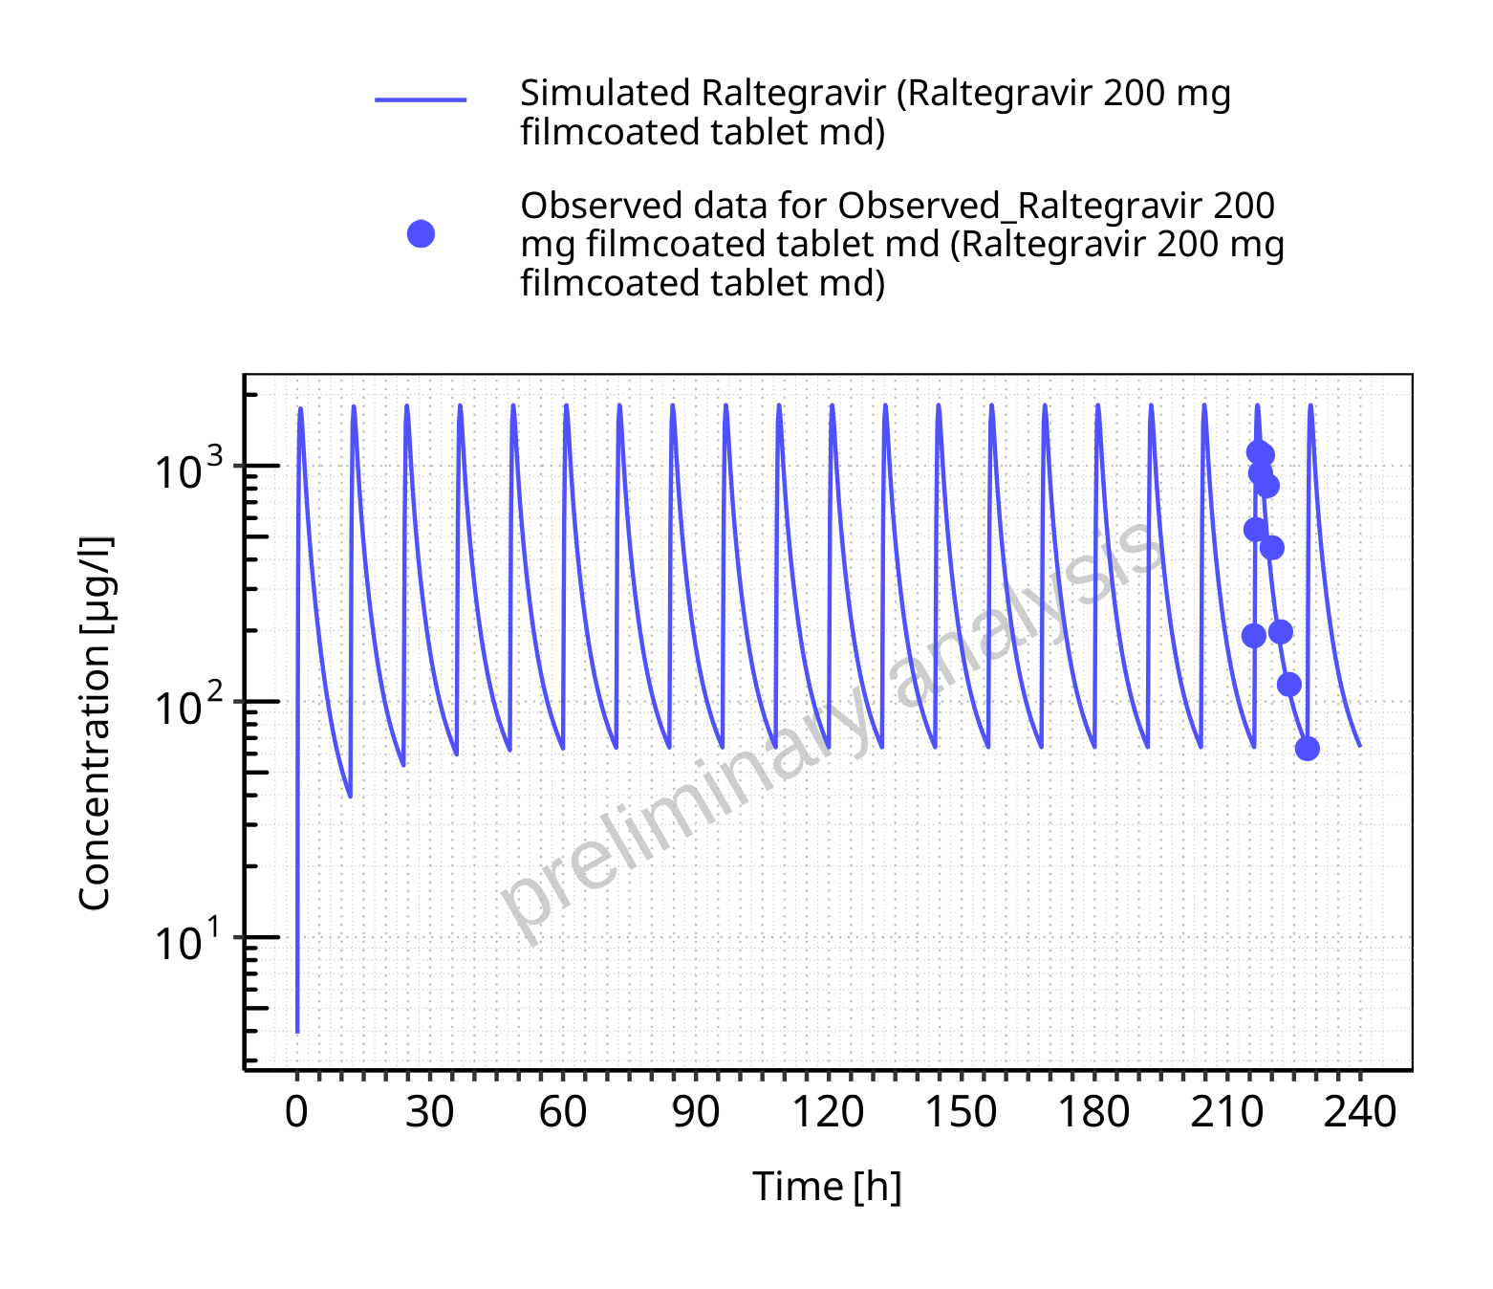

**Figure 5-28: Time profiles for Raltegravir 200 mg filmcoated tablet md. Data source: Data/Raltegravir_PK.txt. Time profiles are plotted in a logarithmic scale.**

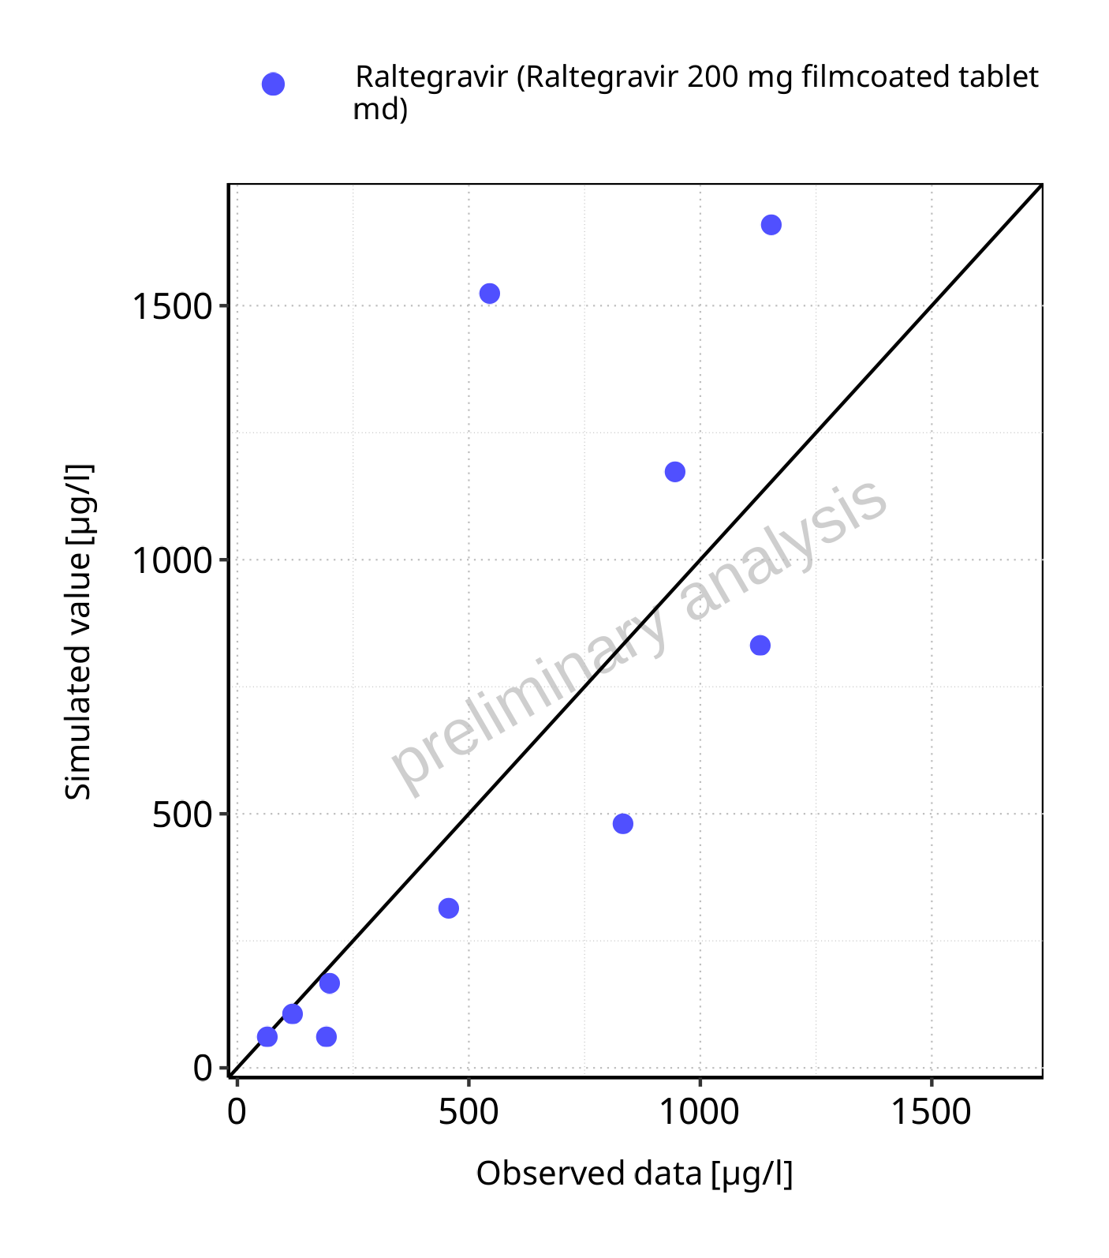

**Figure 5-29: Predicted vs observed for Raltegravir 200 mg filmcoated tablet md. Data source: Data/Raltegravir_PK.txt. Predictions and observations are plotted in a linear scale.**



**Figure 5-30: Predicted vs observed for Raltegravir 200 mg filmcoated tablet md. Data source: Data/Raltegravir_PK.txt. Predictions and observations are plotted in a logarithmic scale.**

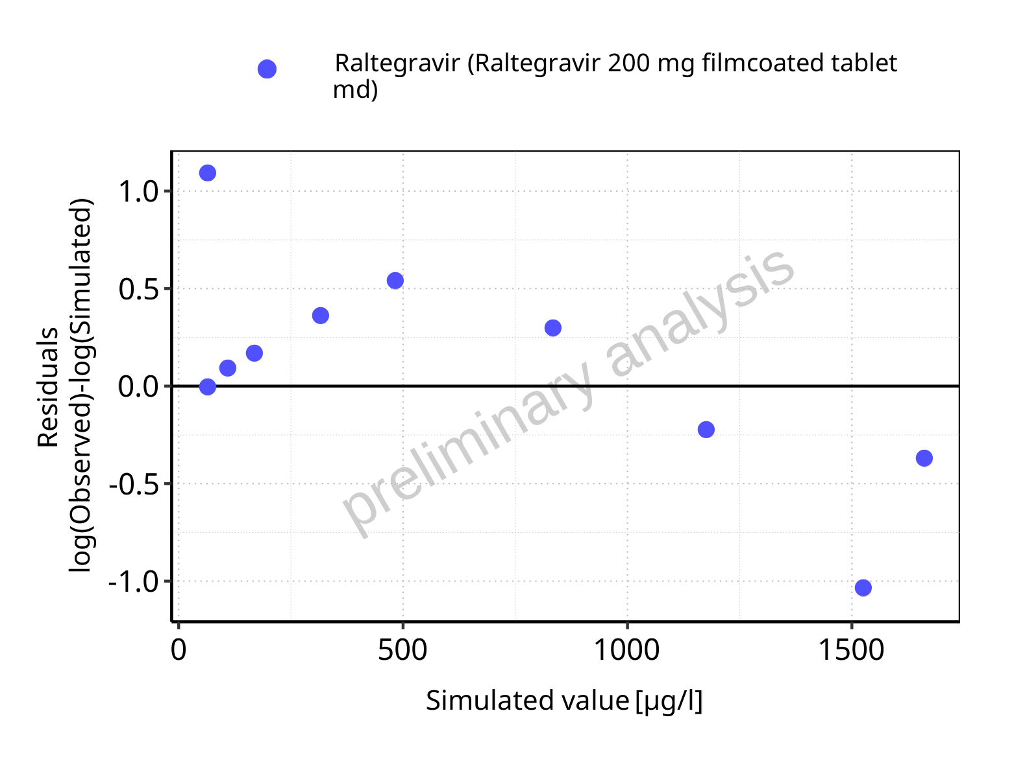

**Figure 5-31: Logarithmic residuals vs predicted values for Raltegravir 200 mg filmcoated tablet md. Data source: Data/Raltegravir_PK.txt.**

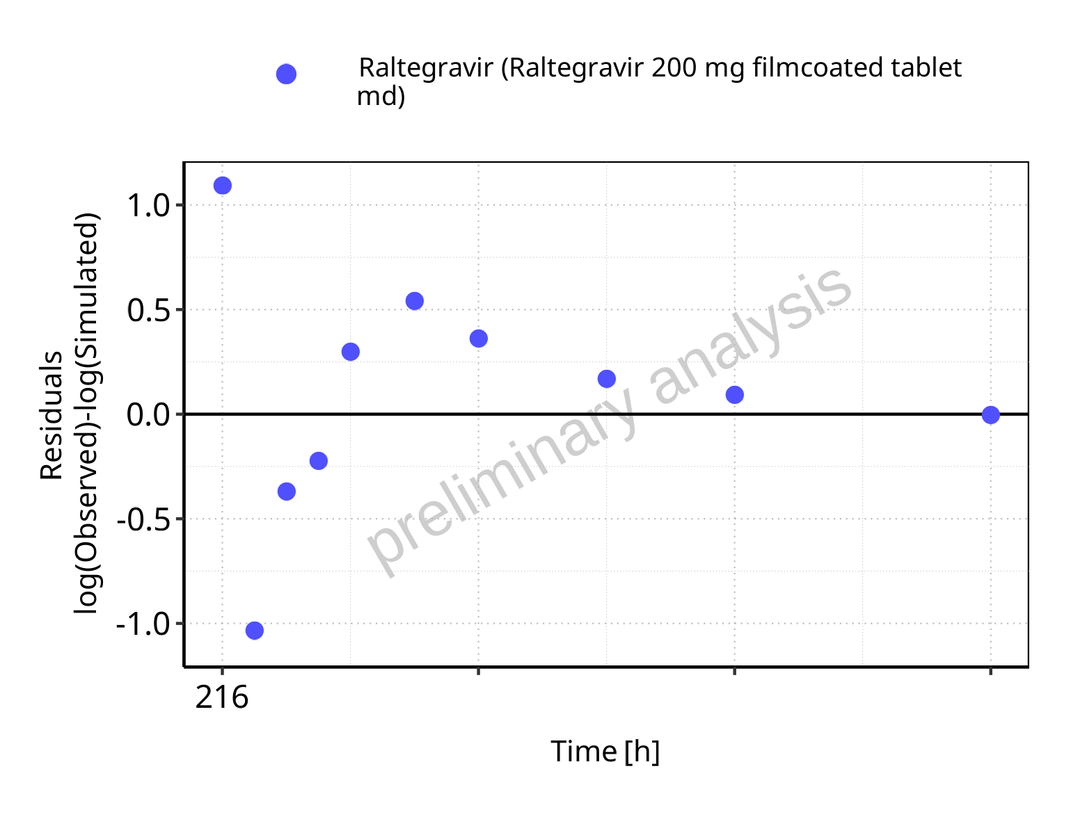

**Figure 5-32: Logarithmic residuals vs time values for Raltegravir 200 mg filmcoated tablet md. Data source: Data/Raltegravir_PK.txt.**

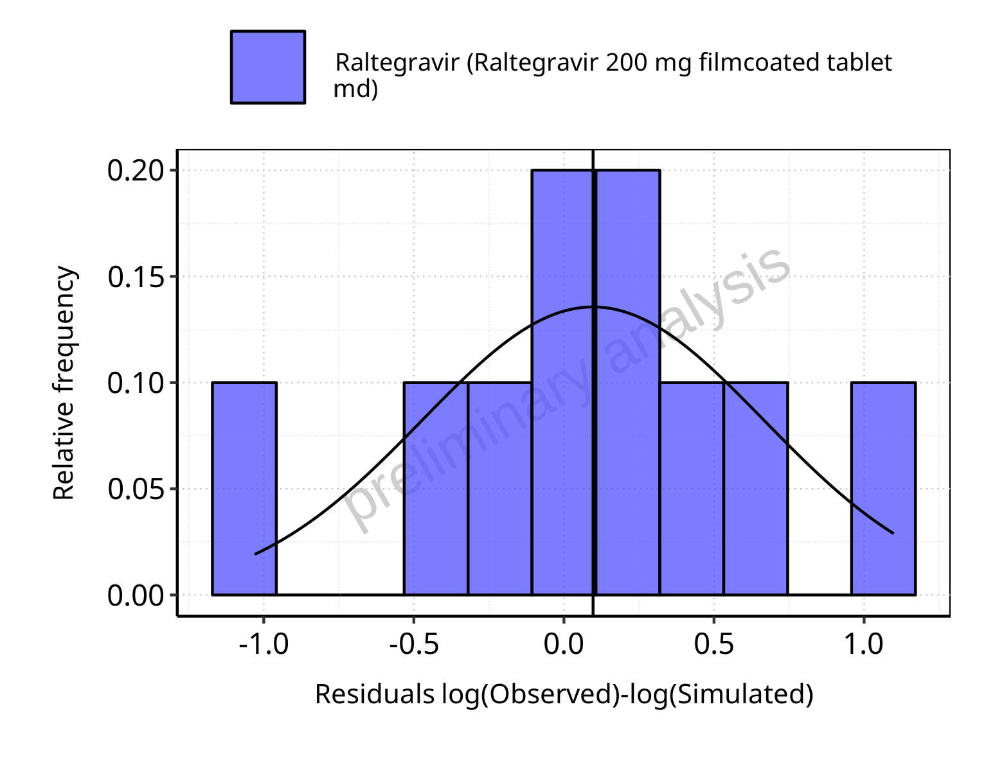

**Figure 5-33: Logarithmic residuals distribution (stacked) for Raltegravir 200 mg filmcoated tablet md. Data source: Data/Raltegravir_PK.txt.**

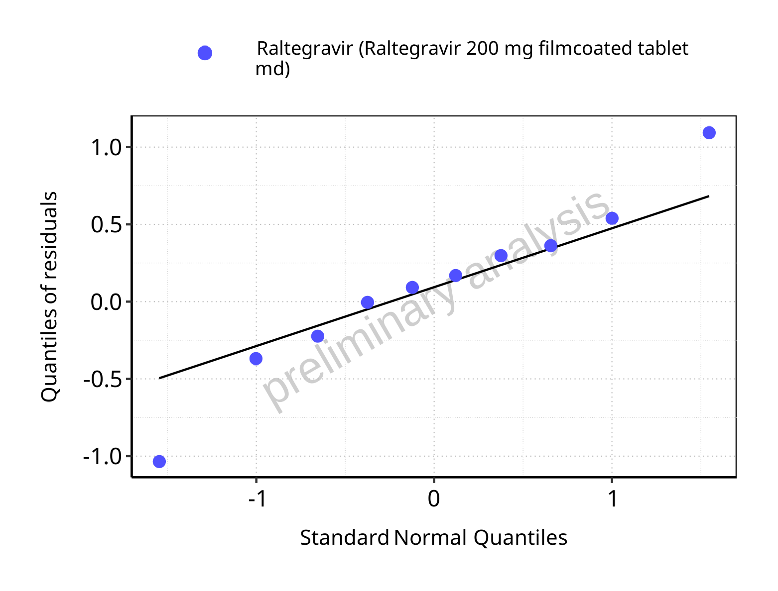

**Figure 5-34: Logarithmic residuals for Raltegravir 200 mg filmcoated tablet md as quantile-quantile plot. Data source: Data/Raltegravir_PK.txt.**

### For first application range

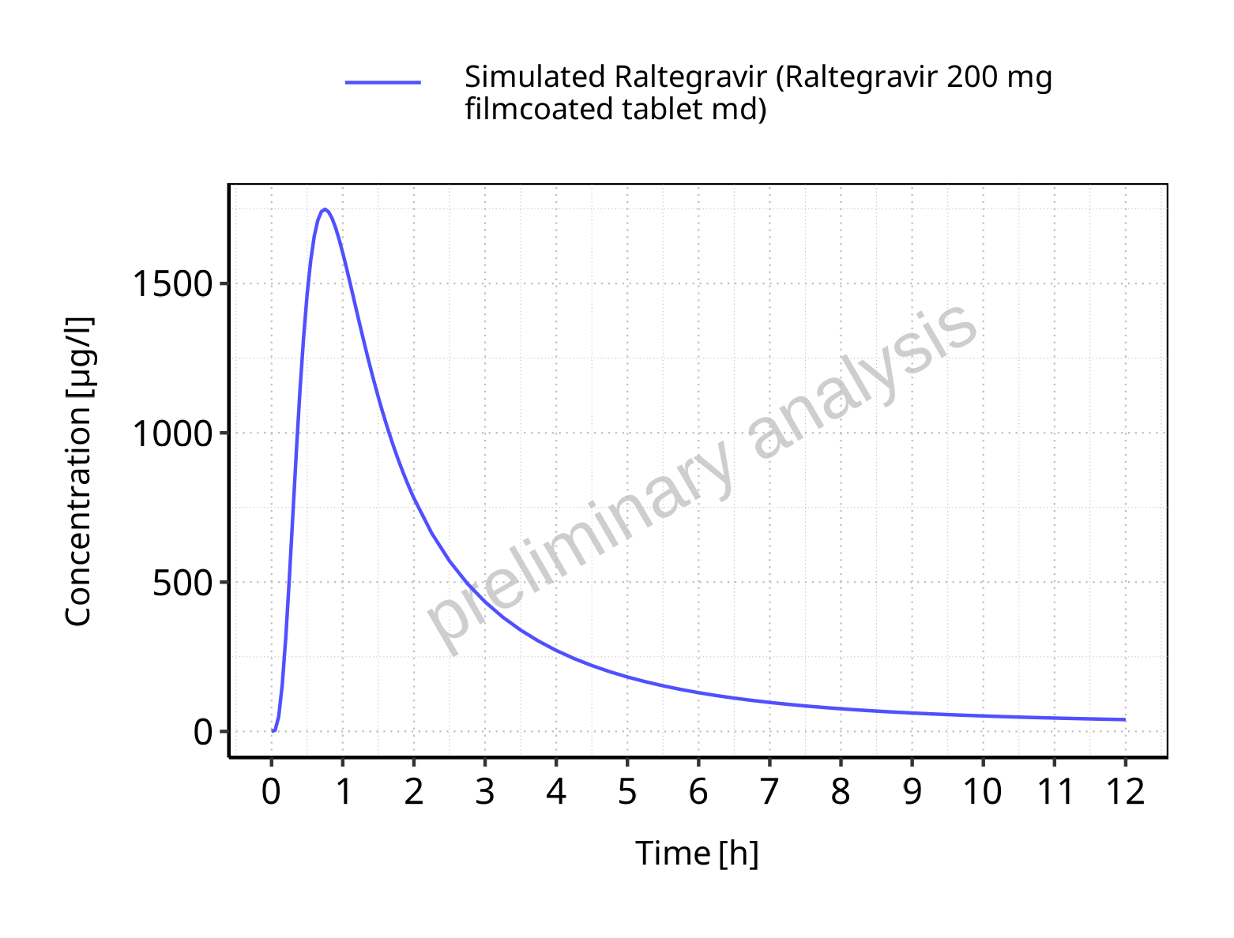

**Figure 5-35: Time profiles for Raltegravir 200 mg filmcoated tablet md. Data source: Data/Raltegravir_PK.txt. Time profiles are plotted in a linear scale.**

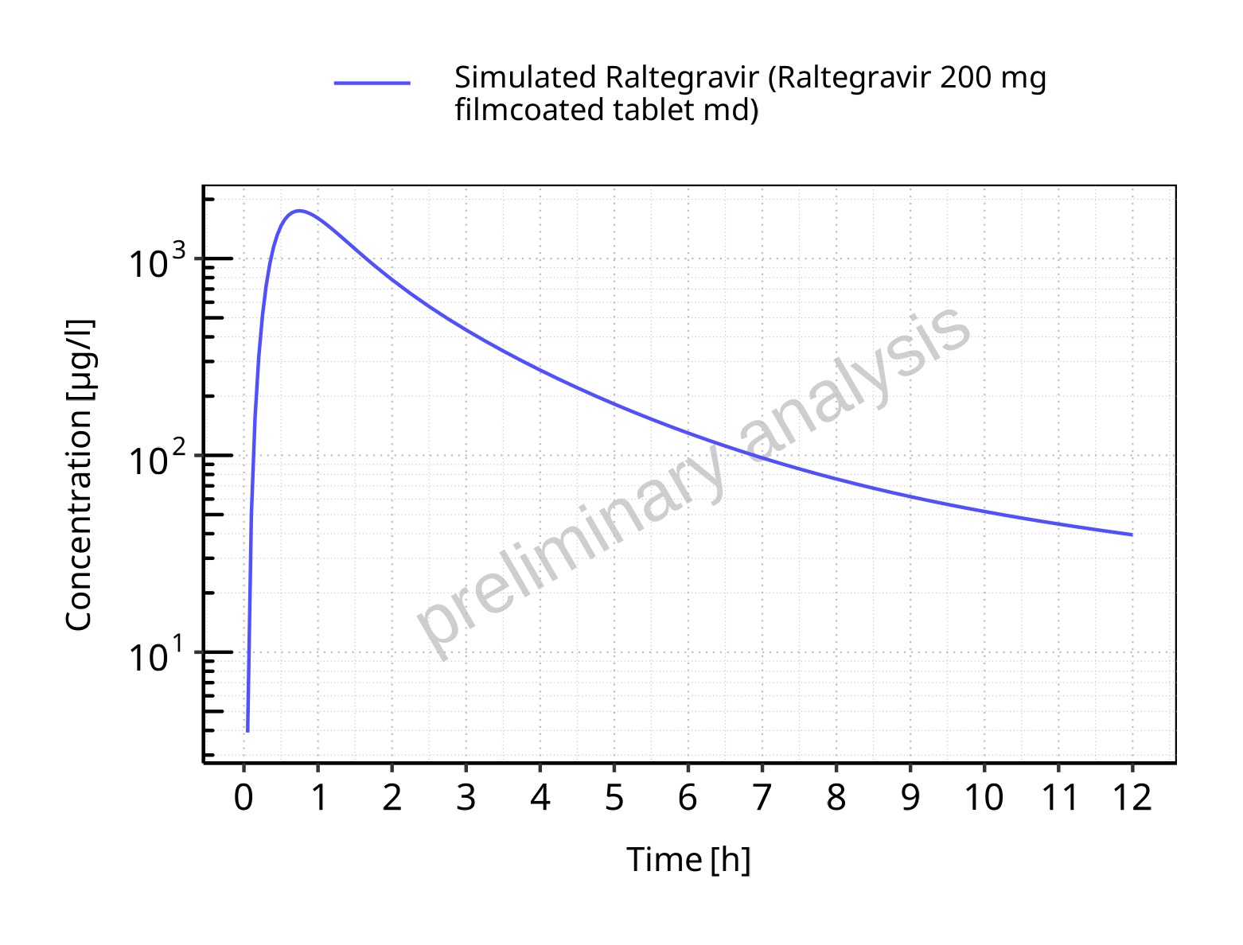

**Figure 5-36: Time profiles for Raltegravir 200 mg filmcoated tablet md. Data source: Data/Raltegravir_PK.txt. Time profiles are plotted in a logarithmic scale.**

### For last application range

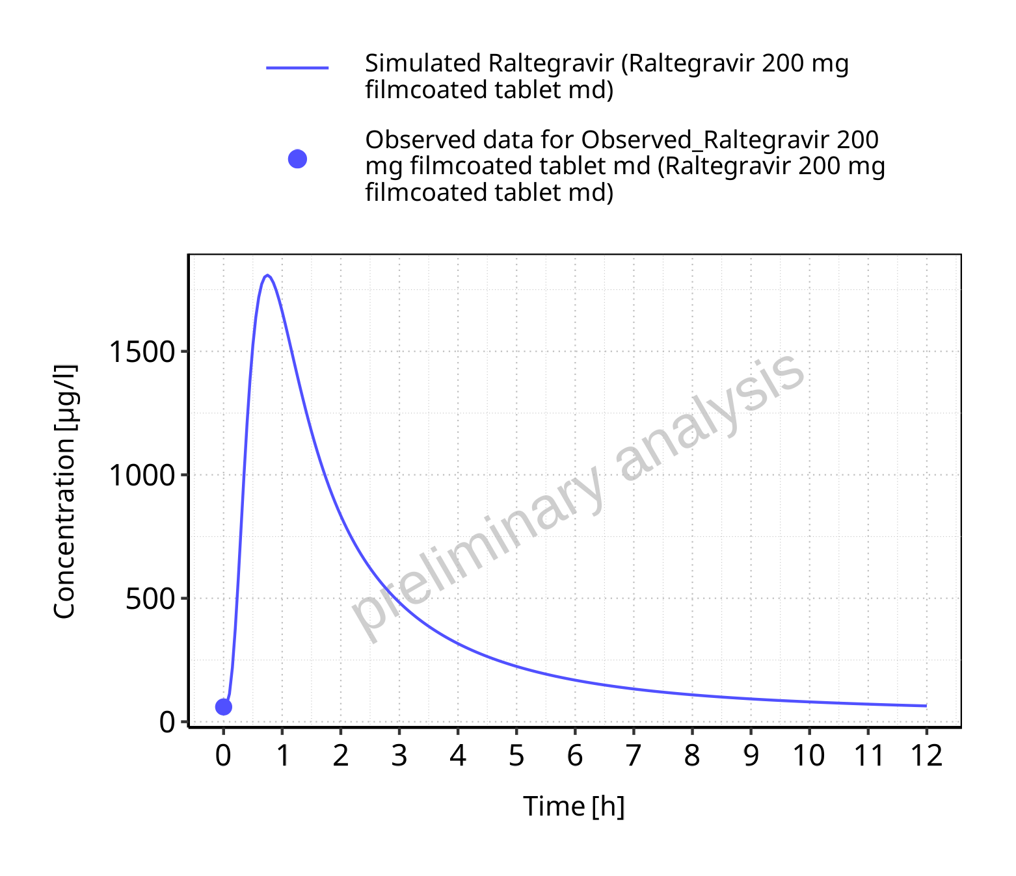

**Figure 5-37: Time profiles for Raltegravir 200 mg filmcoated tablet md. Data source: Data/Raltegravir_PK.txt. Time profiles are plotted in a linear scale.**

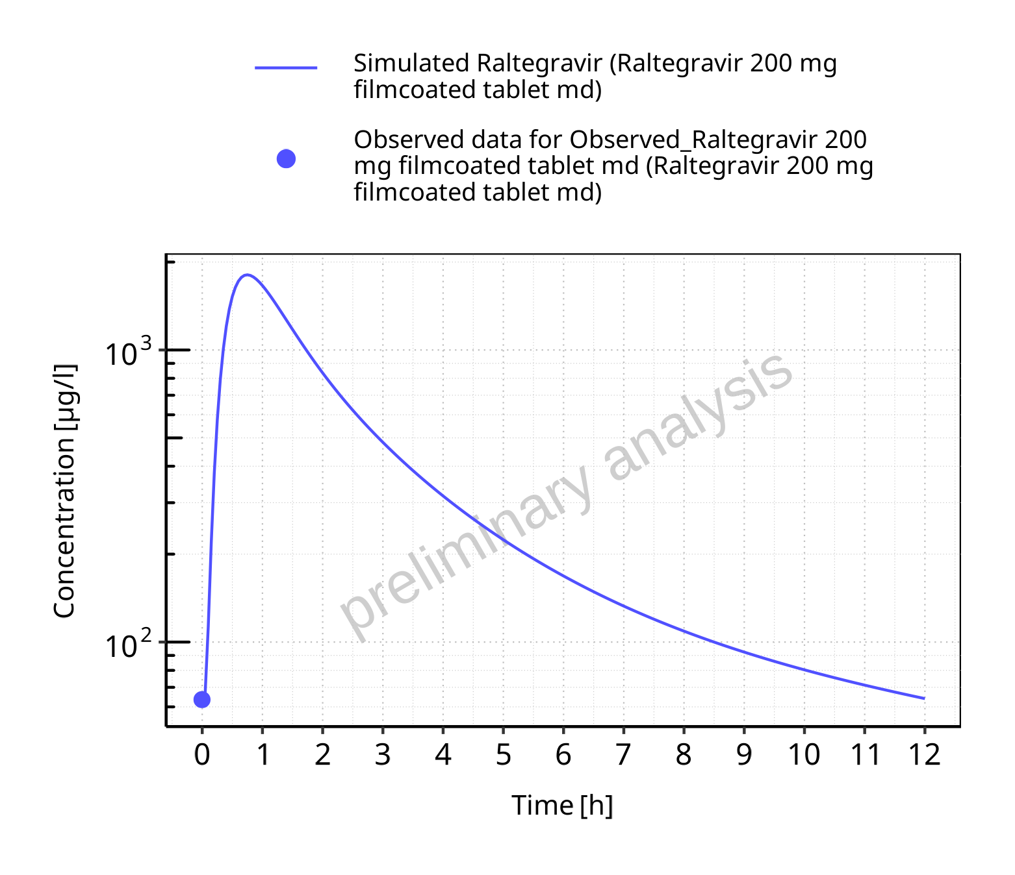

**Figure 5-38: Time profiles for Raltegravir 200 mg filmcoated tablet md. Data source: Data/Raltegravir_PK.txt. Time profiles are plotted in a logarithmic scale.**

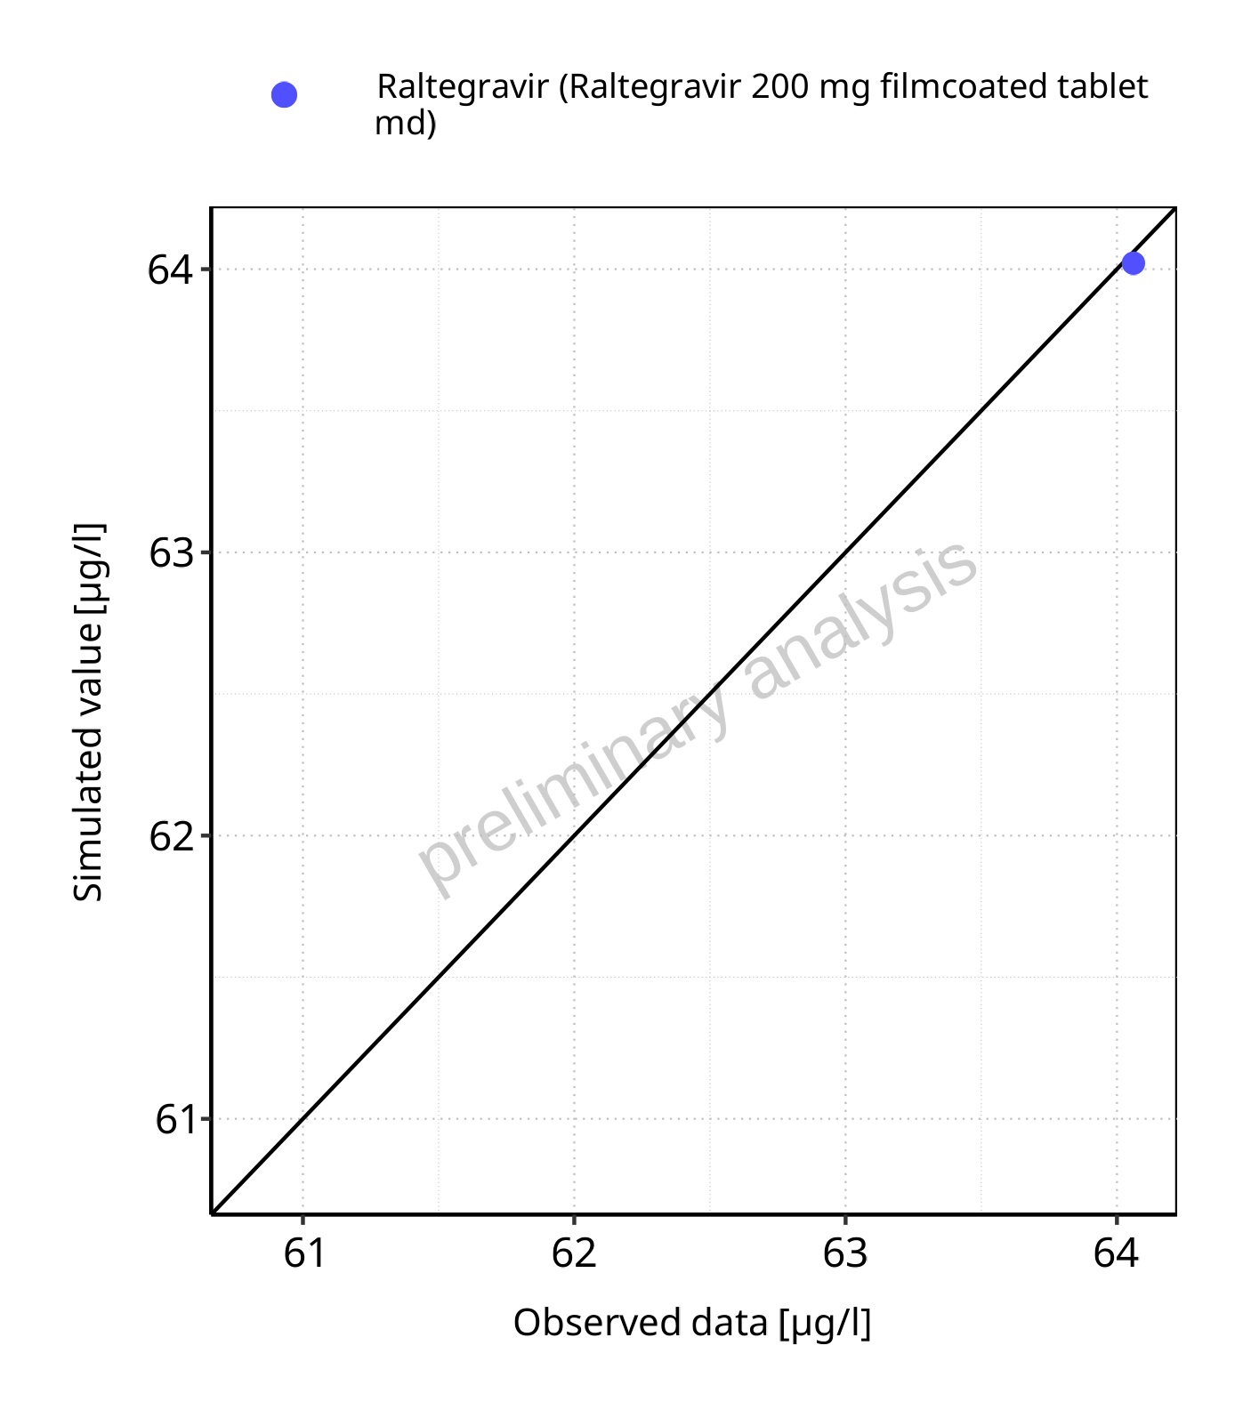

**Figure 5-39: Predicted vs observed for Raltegravir 200 mg filmcoated tablet md. Data source: Data/Raltegravir_PK.txt. Predictions and observations are plotted in a linear scale.**



**Figure 5-40: Predicted vs observed for Raltegravir 200 mg filmcoated tablet md. Data source: Data/Raltegravir_PK.txt. Predictions and observations are plotted in a logarithmic scale.**

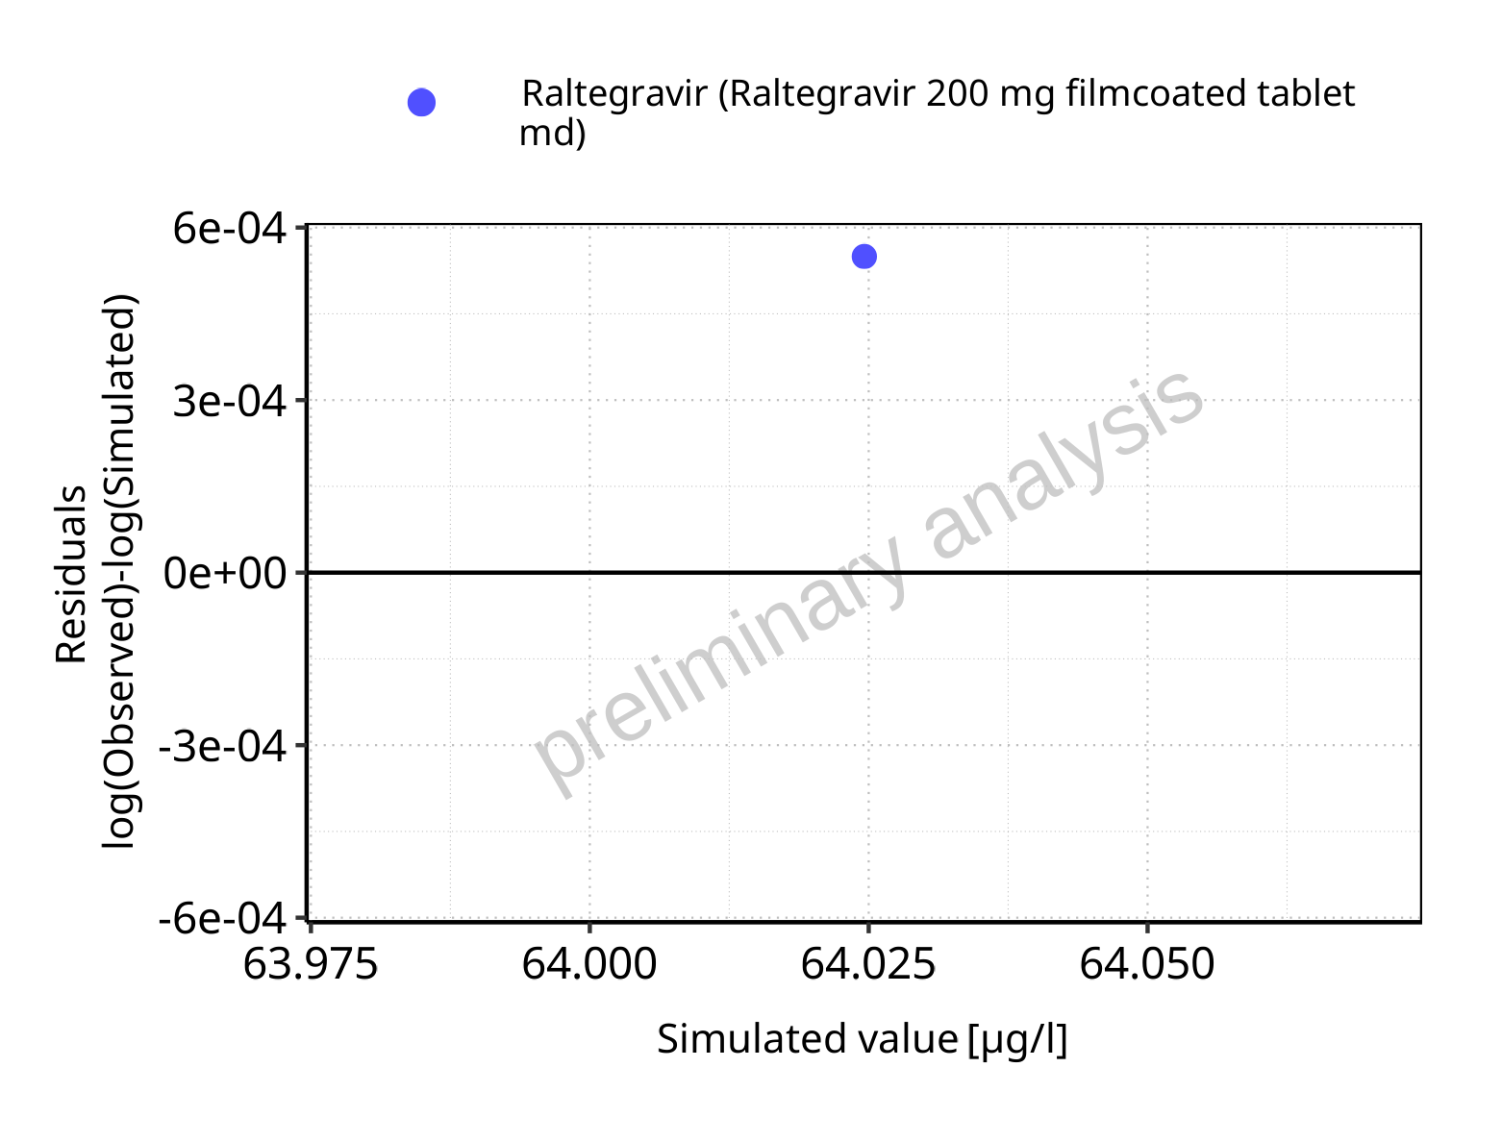

**Figure 5-41: Logarithmic residuals vs predicted values for Raltegravir 200 mg filmcoated tablet md. Data source: Data/Raltegravir_PK.txt.**

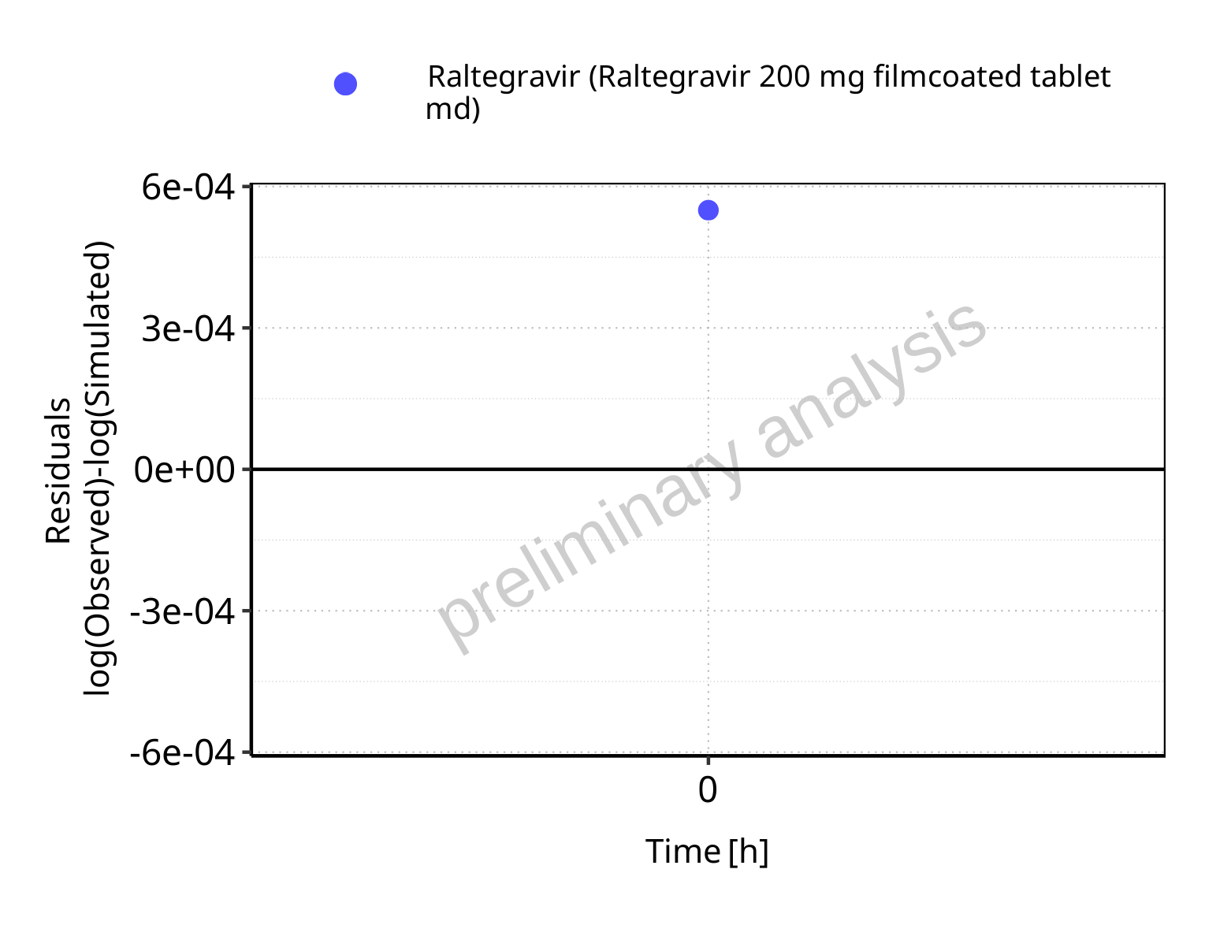

**Figure 5-42: Logarithmic residuals vs time values for Raltegravir 200 mg filmcoated tablet md. Data source: Data/Raltegravir_PK.txt.**

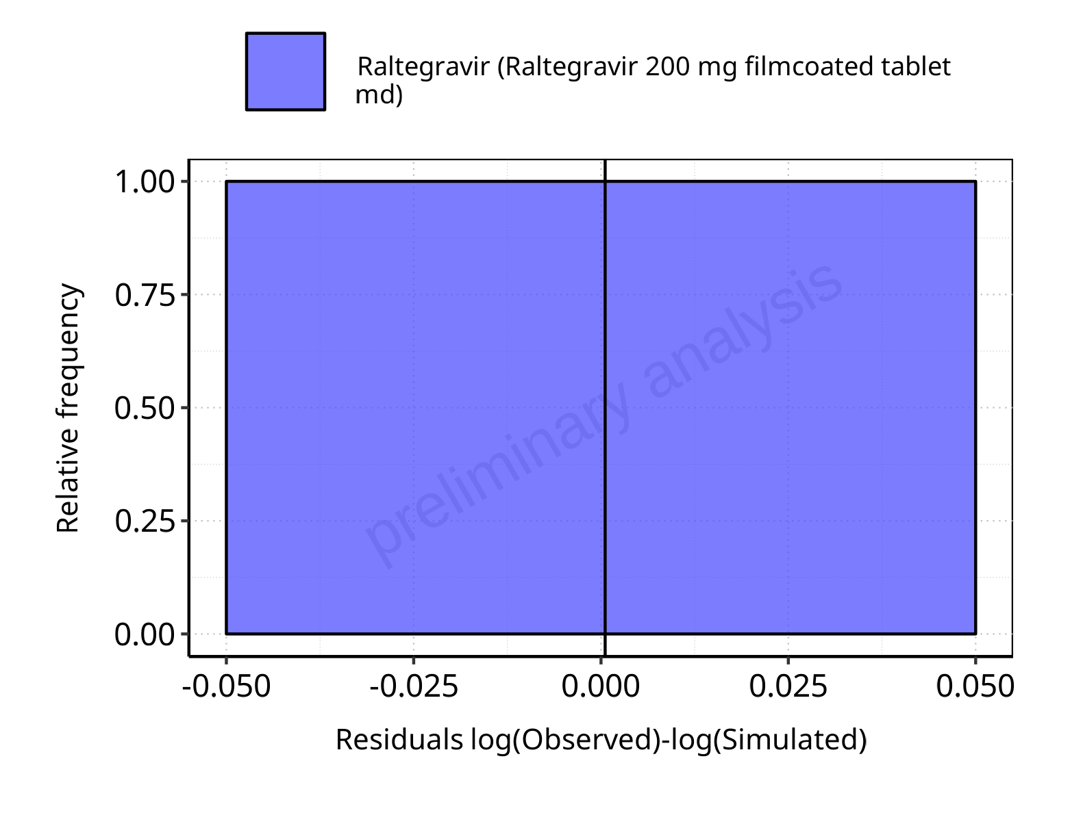

**Figure 5-43: Logarithmic residuals distribution (stacked) for Raltegravir 200 mg filmcoated tablet md. Data source: Data/Raltegravir_PK.txt.**

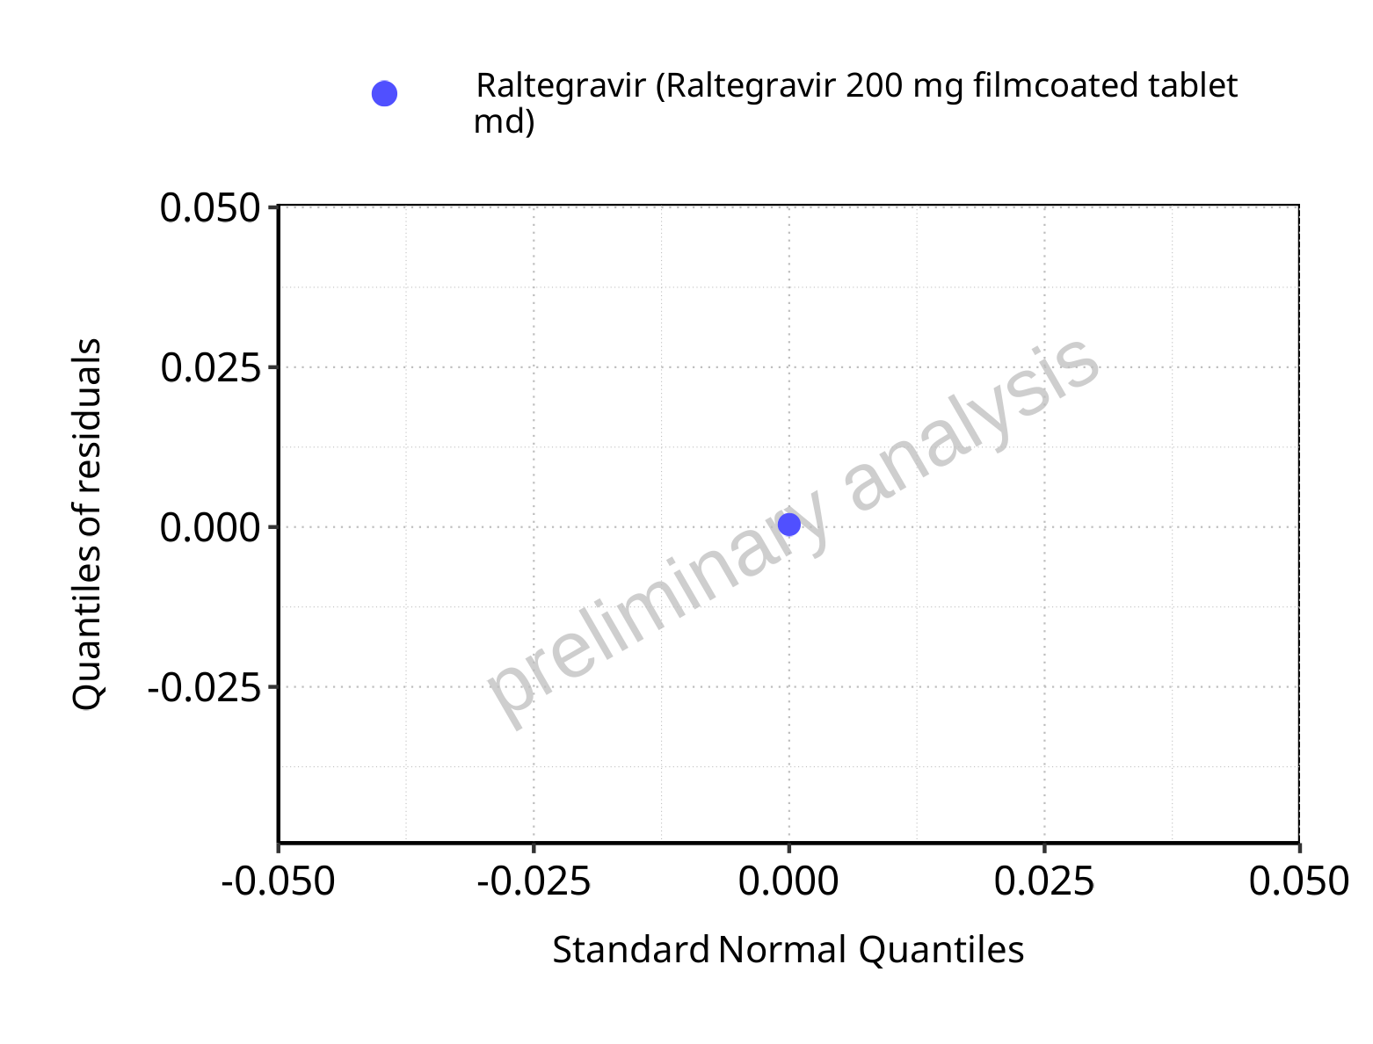

**Figure 5-44: Logarithmic residuals for Raltegravir 200 mg filmcoated tablet md as quantile-quantile plot. Data source: Data/Raltegravir_PK.txt.**

## Time profiles and residual plots for Filmcoated_tablet_400mg_sd

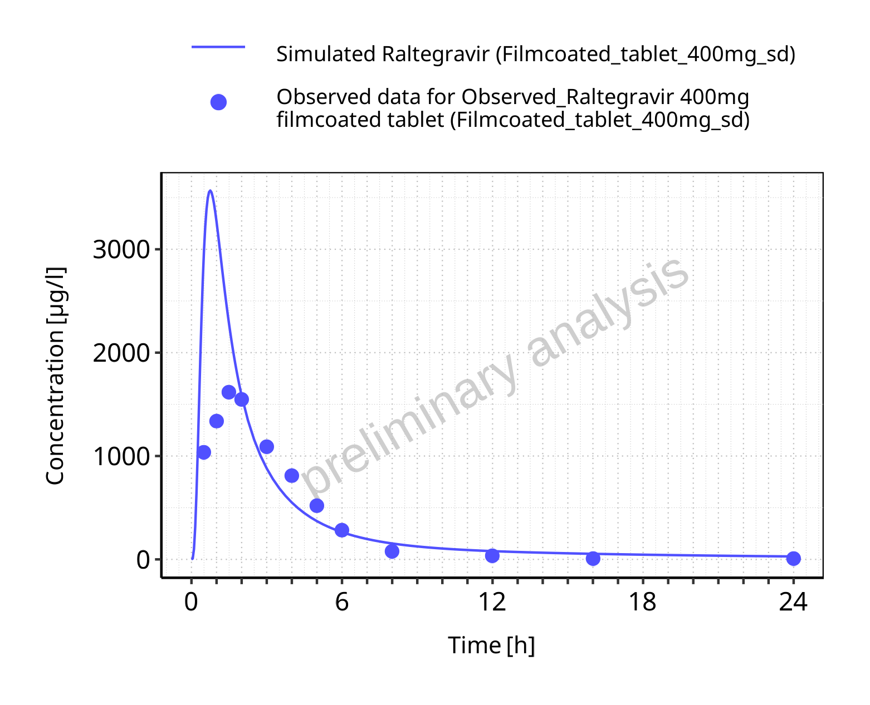

**Figure 5-45: Time profiles for Filmcoated_tablet_400mg_sd. Data source: Data/Raltegravir_PK.txt. Time profiles are plotted in a linear scale.**

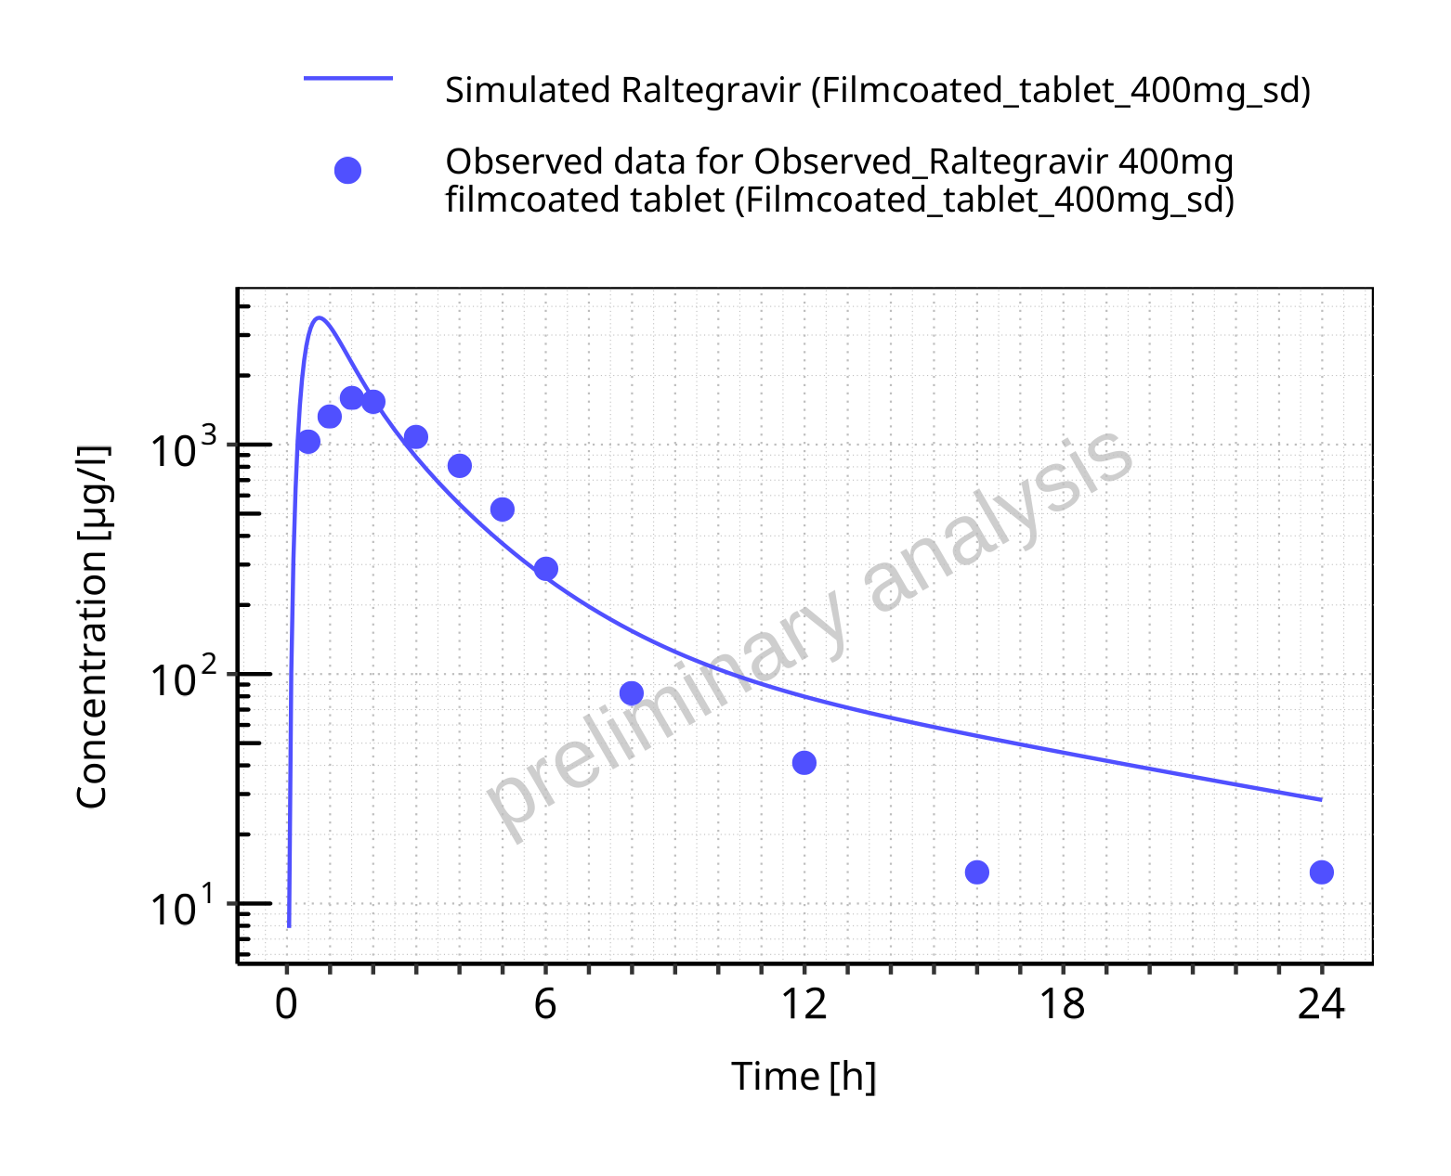

**Figure 5-46: Time profiles for Filmcoated_tablet_400mg_sd. Data source: Data/Raltegravir_PK.txt. Time profiles are plotted in a logarithmic scale.**

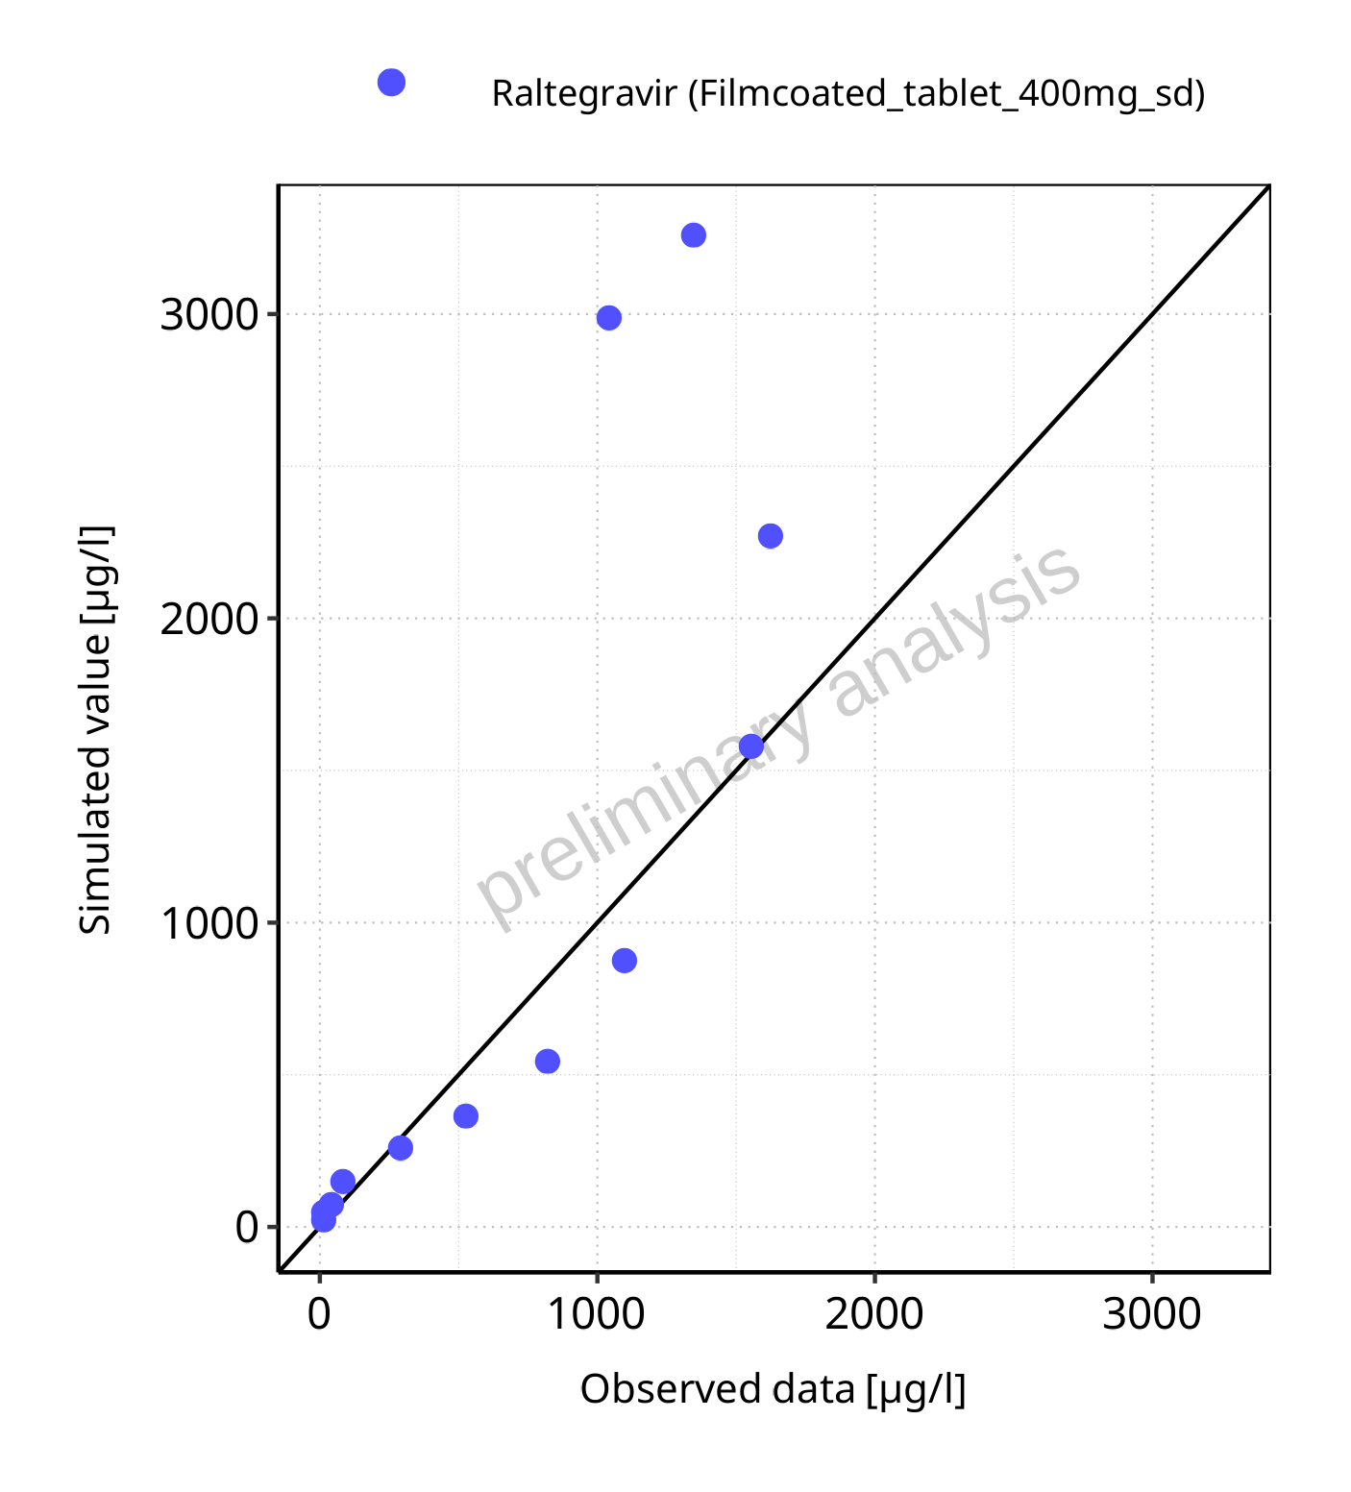

**Figure 5-47: Predicted vs observed for Filmcoated_tablet_400mg_sd. Data source: Data/Raltegravir_PK.txt. Predictions and observations are plotted in a linear scale.**



**Figure 5-48: Predicted vs observed for Filmcoated_tablet_400mg_sd. Data source: Data/Raltegravir_PK.txt. Predictions and observations are plotted in a logarithmic scale.**

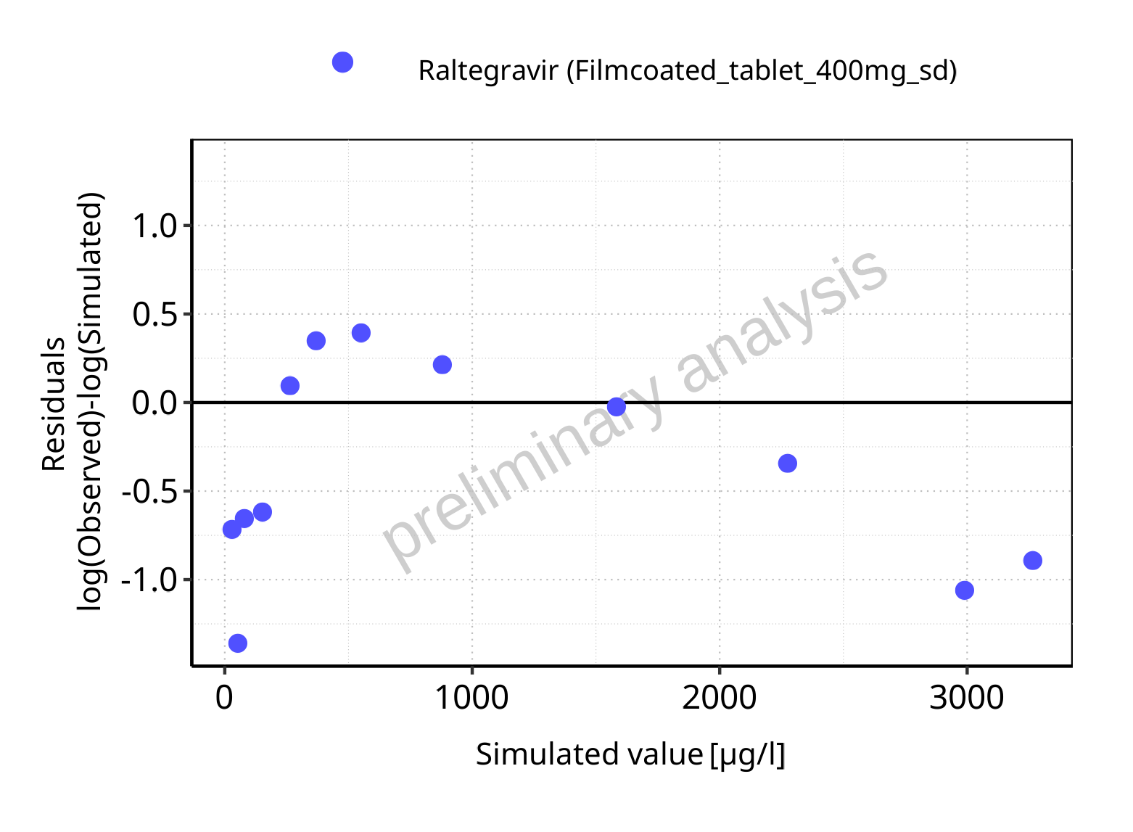

**Figure 5-49: Logarithmic residuals vs predicted values for Filmcoated_tablet_400mg_sd. Data source: Data/Raltegravir_PK.txt.**

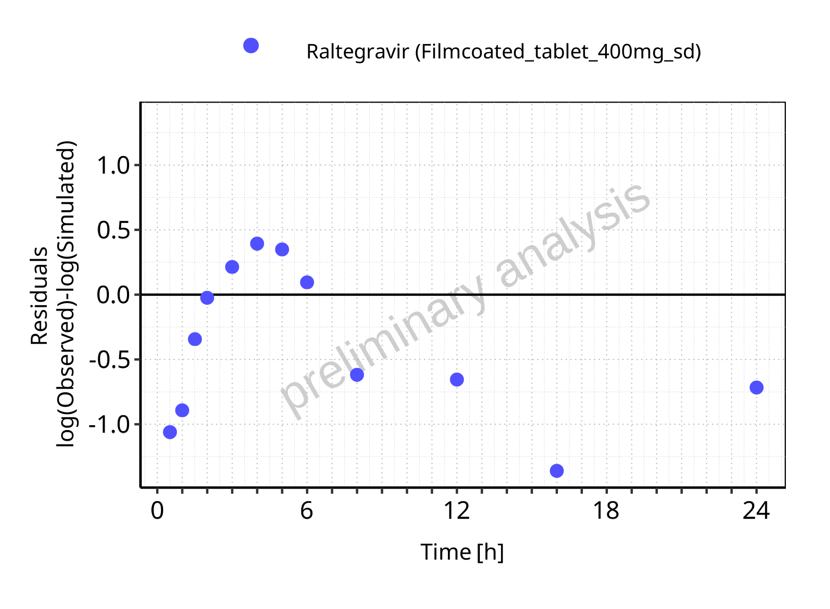

**Figure 5-50: Logarithmic residuals vs time values for Filmcoated_tablet_400mg_sd. Data source: Data/Raltegravir_PK.txt.**

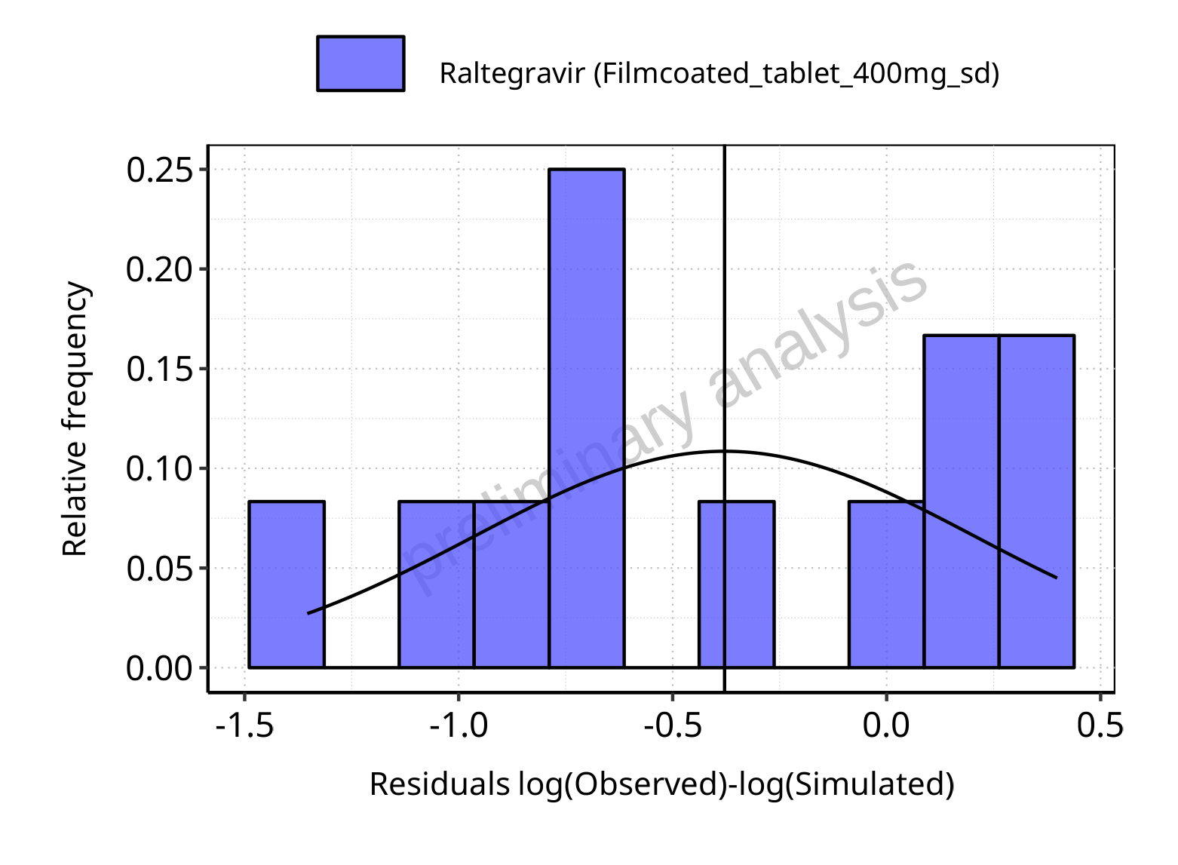

**Figure 5-51: Logarithmic residuals distribution (stacked) for Filmcoated_tablet_400mg_sd. Data source: Data/Raltegravir_PK.txt.**

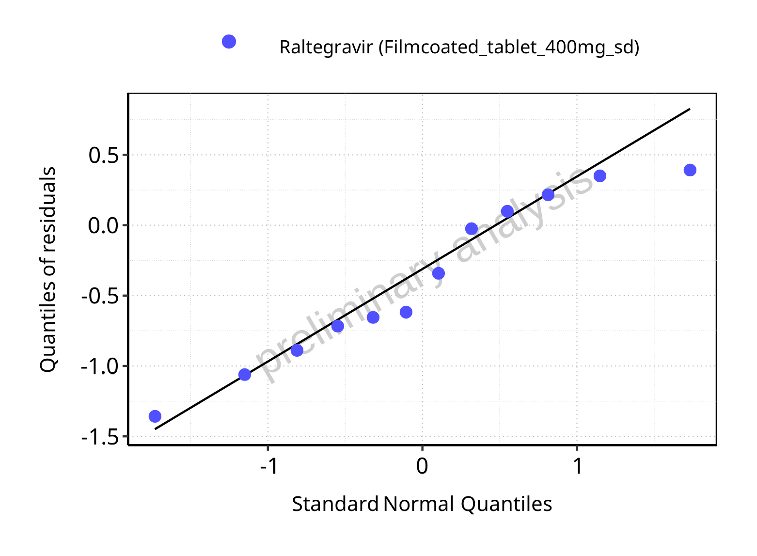

**Figure 5-52: Logarithmic residuals for Filmcoated_tablet_400mg_sd as quantile-quantile plot. Data source: Data/Raltegravir_PK.txt.**

## Time profiles and residual plots for Raltegravir 400 mg filmcoated tablet md

### For total simulation time range

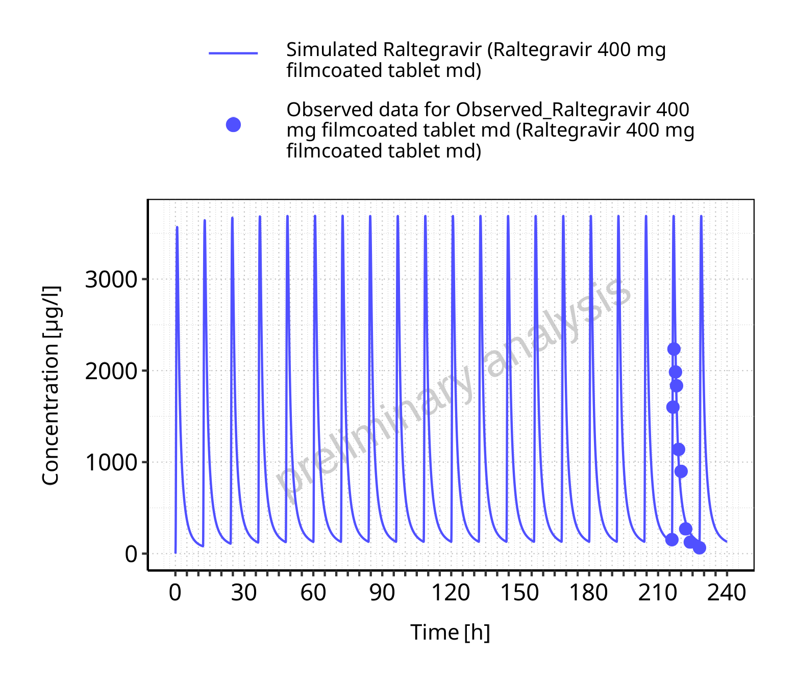

**Figure 5-53: Time profiles for Raltegravir 400 mg filmcoated tablet md. Data source: Data/Raltegravir_PK.txt. Time profiles are plotted in a linear scale.**

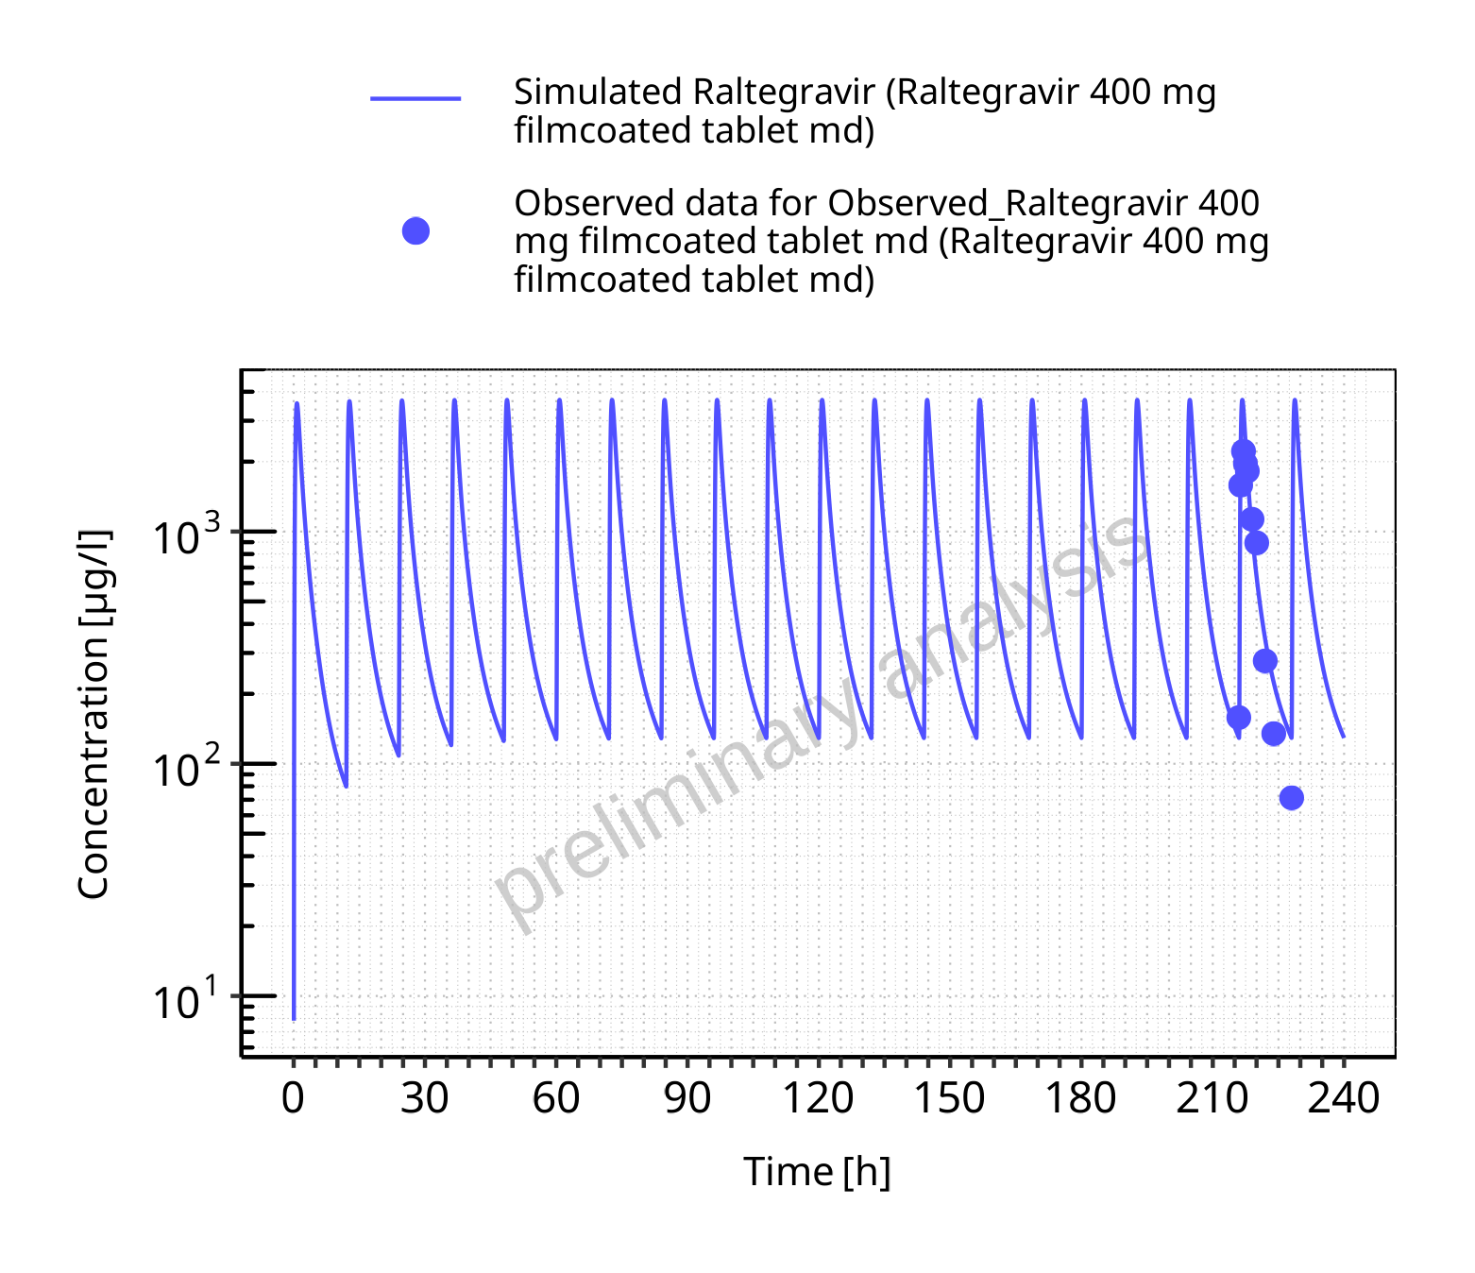

**Figure 5-54: Time profiles for Raltegravir 400 mg filmcoated tablet md. Data source: Data/Raltegravir_PK.txt. Time profiles are plotted in a logarithmic scale.**

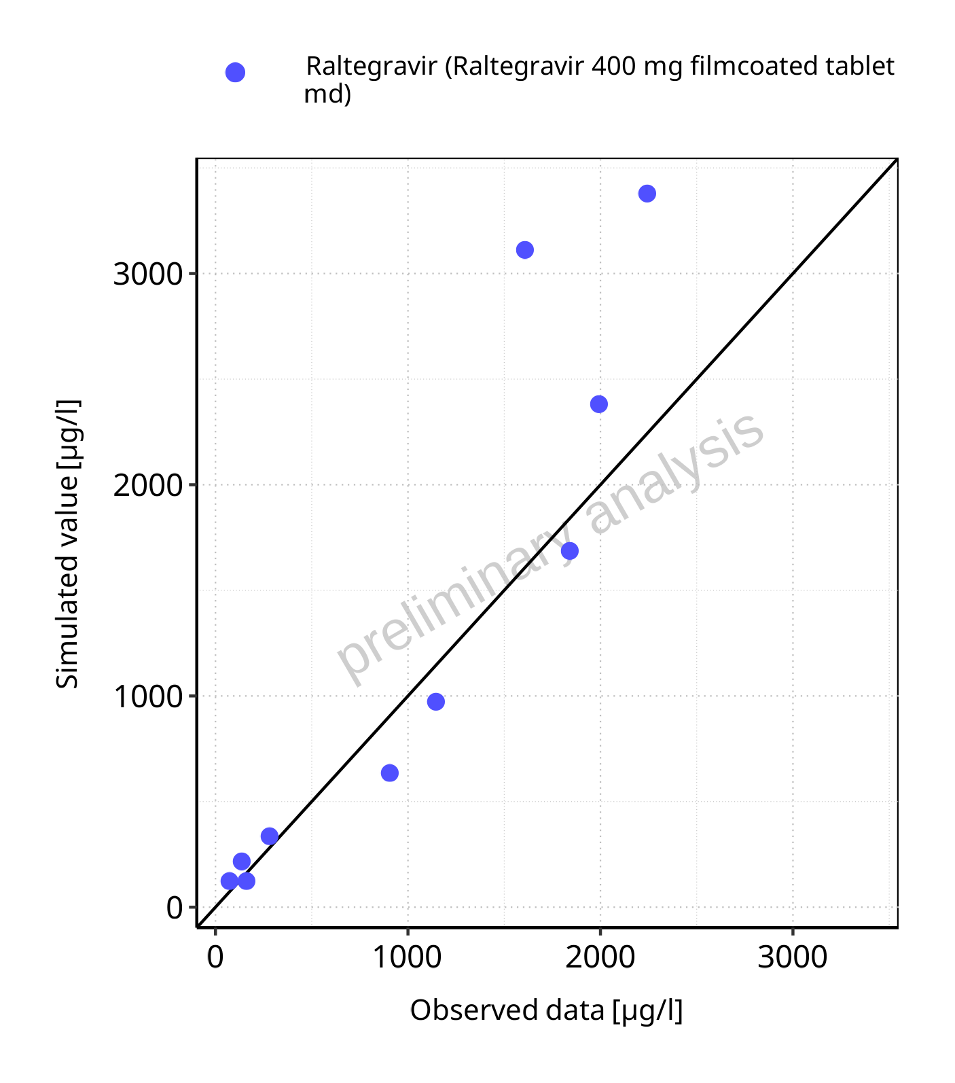

**Figure 5-55: Predicted vs observed for Raltegravir 400 mg filmcoated tablet md. Data source: Data/Raltegravir_PK.txt. Predictions and observations are plotted in a linear scale.**



**Figure 5-56: Predicted vs observed for Raltegravir 400 mg filmcoated tablet md. Data source: Data/Raltegravir_PK.txt. Predictions and observations are plotted in a logarithmic scale.**

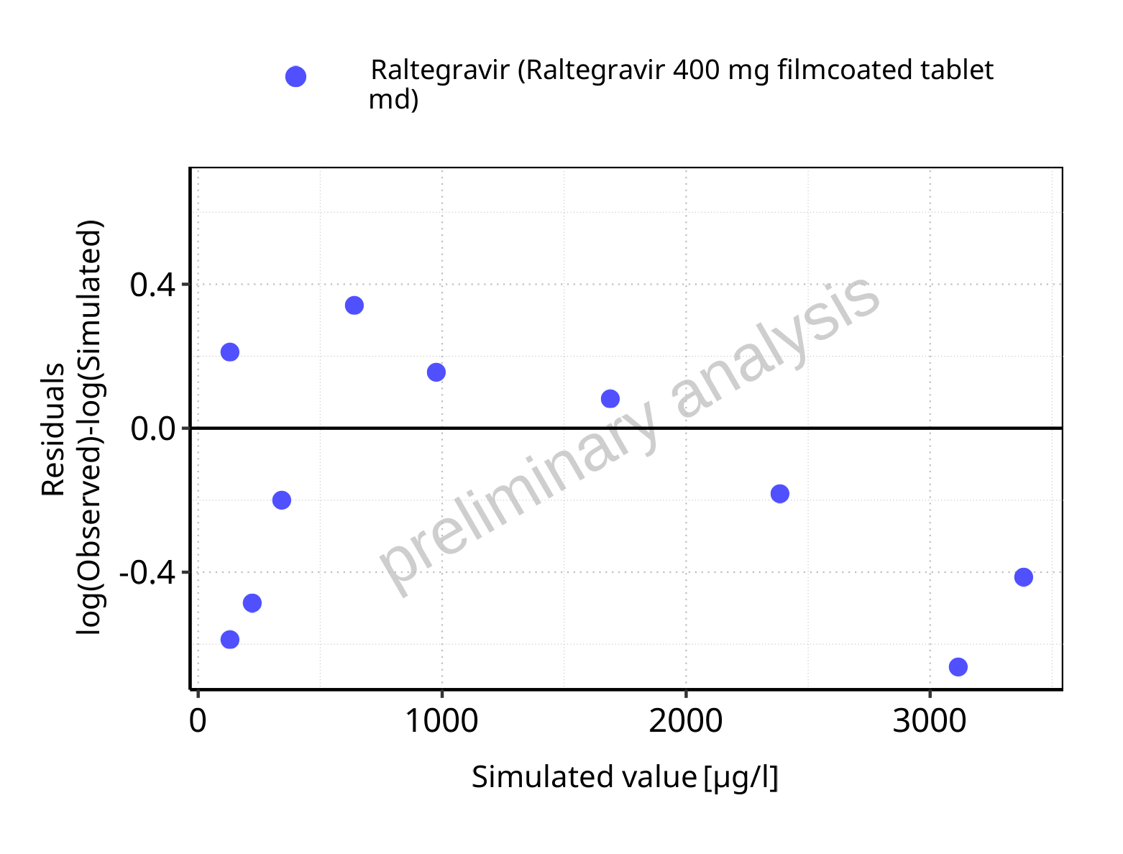

**Figure 5-57: Logarithmic residuals vs predicted values for Raltegravir 400 mg filmcoated tablet md. Data source: Data/Raltegravir_PK.txt.**

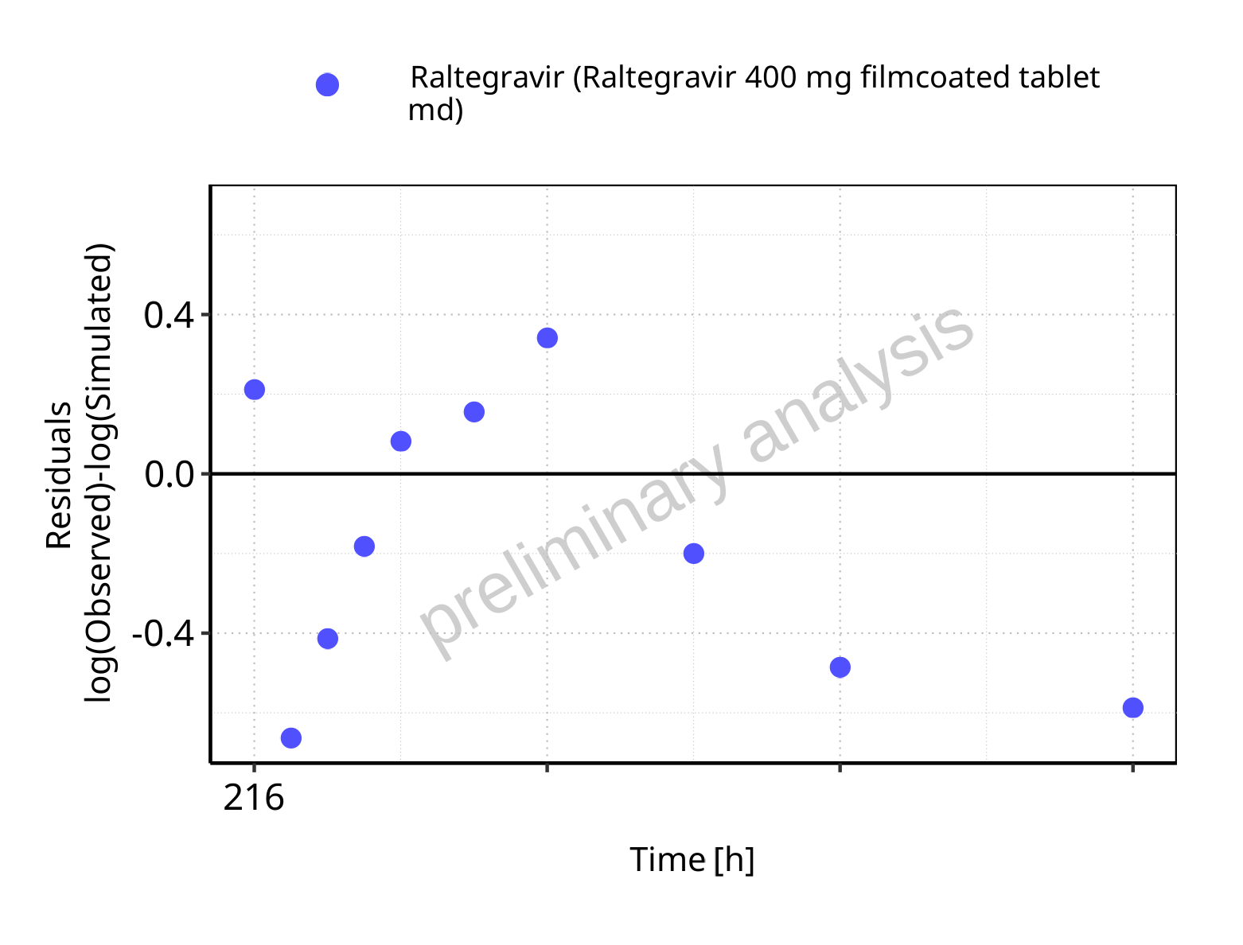

**Figure 5-58: Logarithmic residuals vs time values for Raltegravir 400 mg filmcoated tablet md. Data source: Data/Raltegravir_PK.txt.**

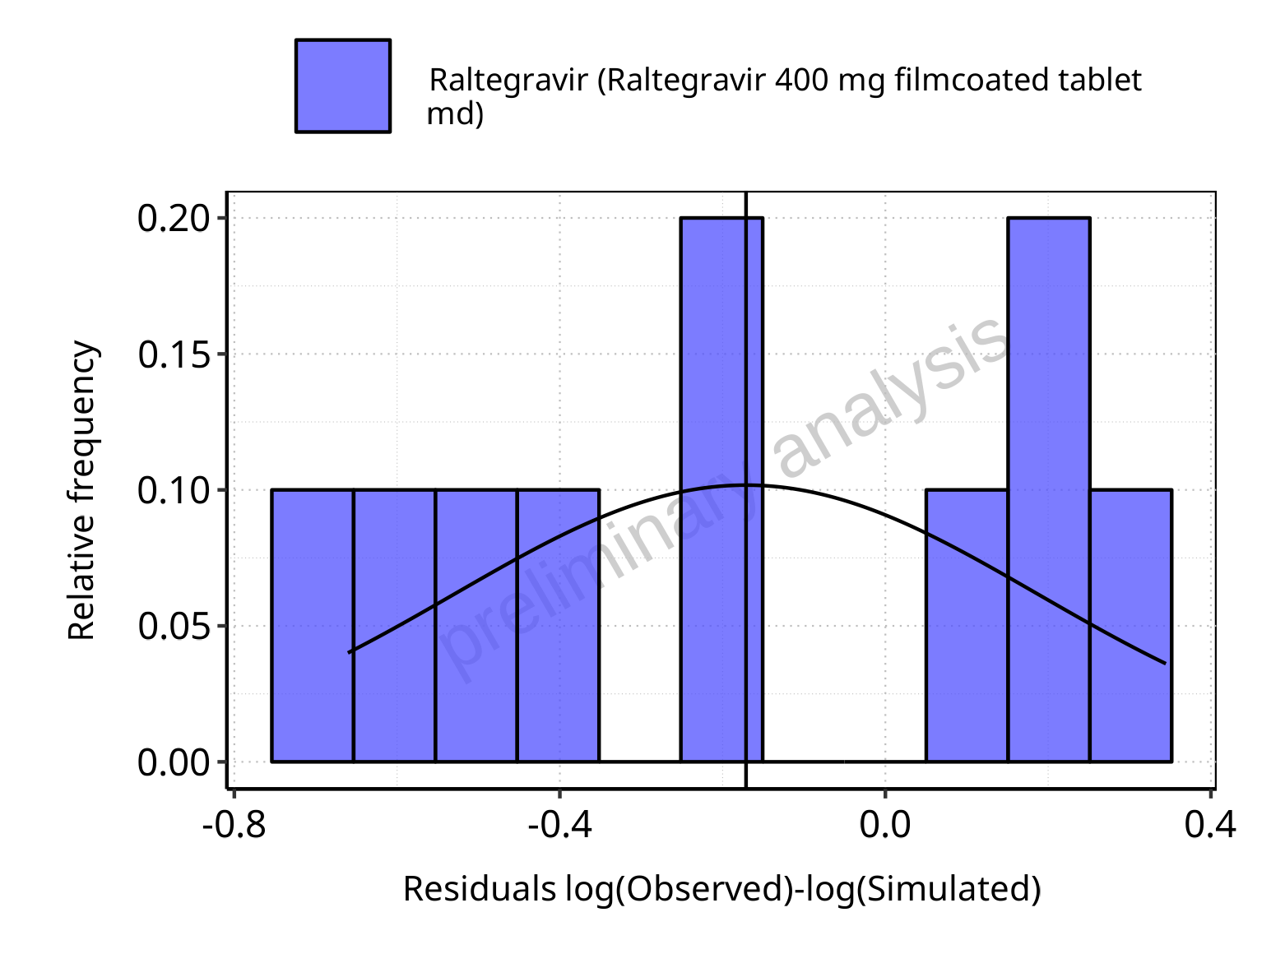

**Figure 5-59: Logarithmic residuals distribution (stacked) for Raltegravir 400 mg filmcoated tablet md. Data source: Data/Raltegravir_PK.txt.**

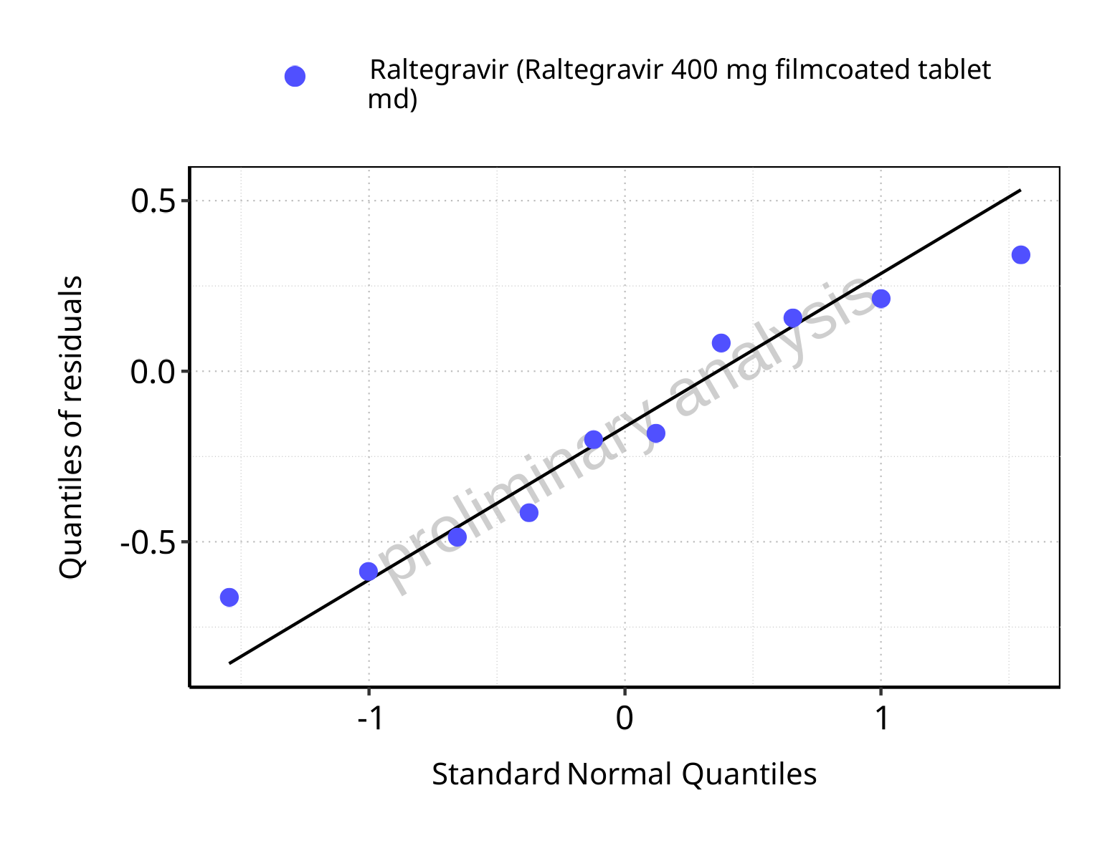

**Figure 5-60: Logarithmic residuals for Raltegravir 400 mg filmcoated tablet md as quantile-quantile plot. Data source: Data/Raltegravir_PK.txt.**

### For first application range

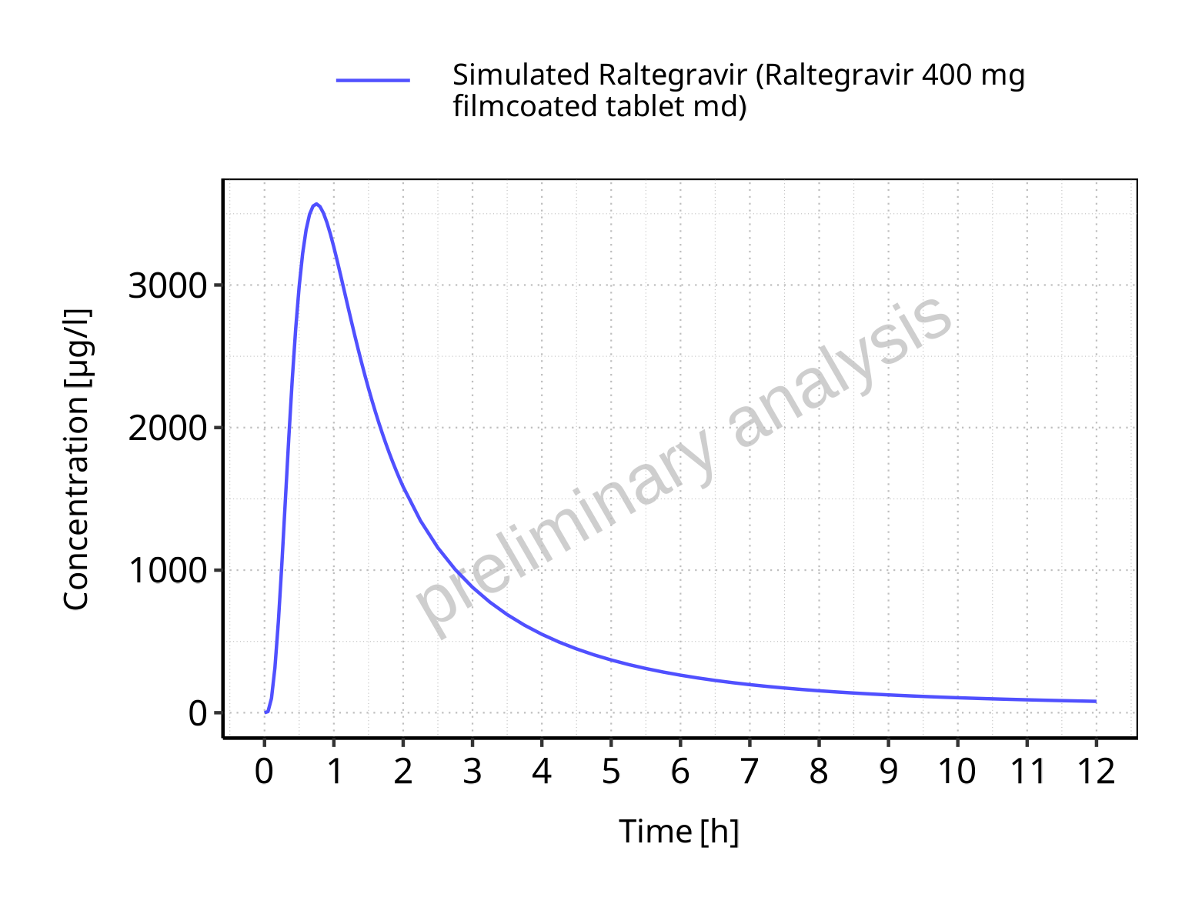

**Figure 5-61: Time profiles for Raltegravir 400 mg filmcoated tablet md. Data source: Data/Raltegravir_PK.txt. Time profiles are plotted in a linear scale.**

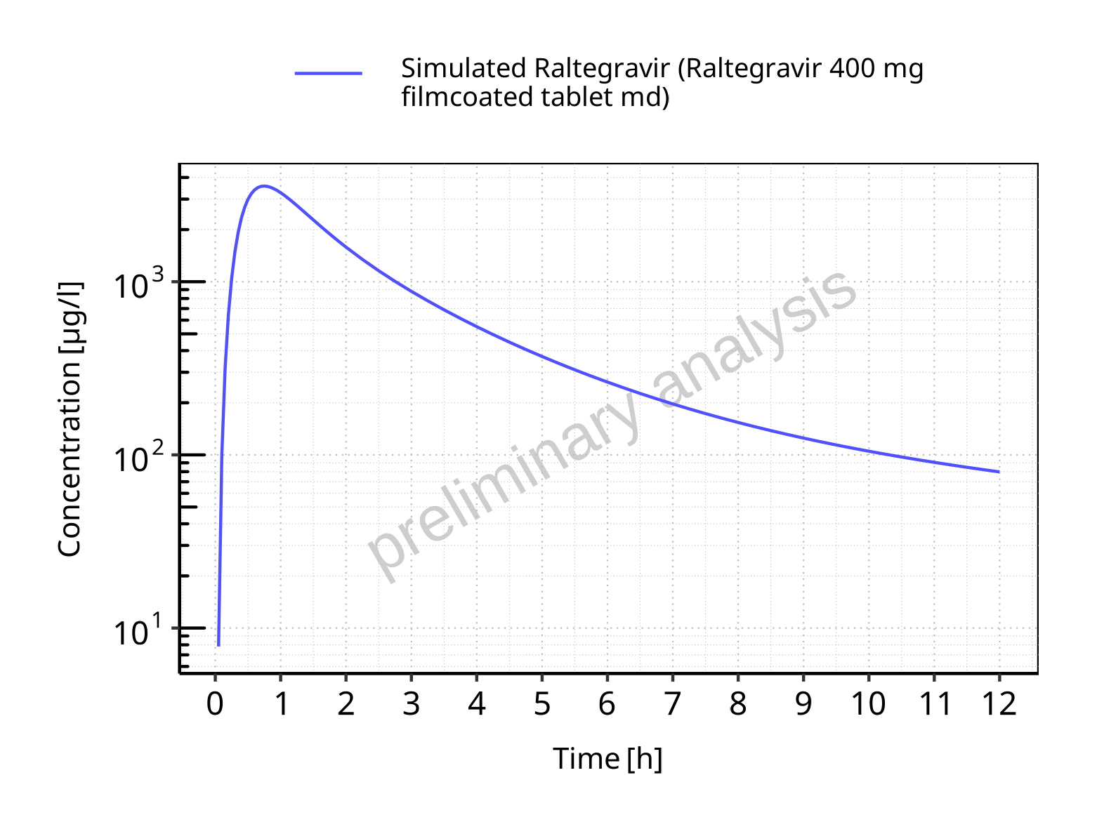

**Figure 5-62: Time profiles for Raltegravir 400 mg filmcoated tablet md. Data source: Data/Raltegravir_PK.txt. Time profiles are plotted in a logarithmic scale.**

### For last application range

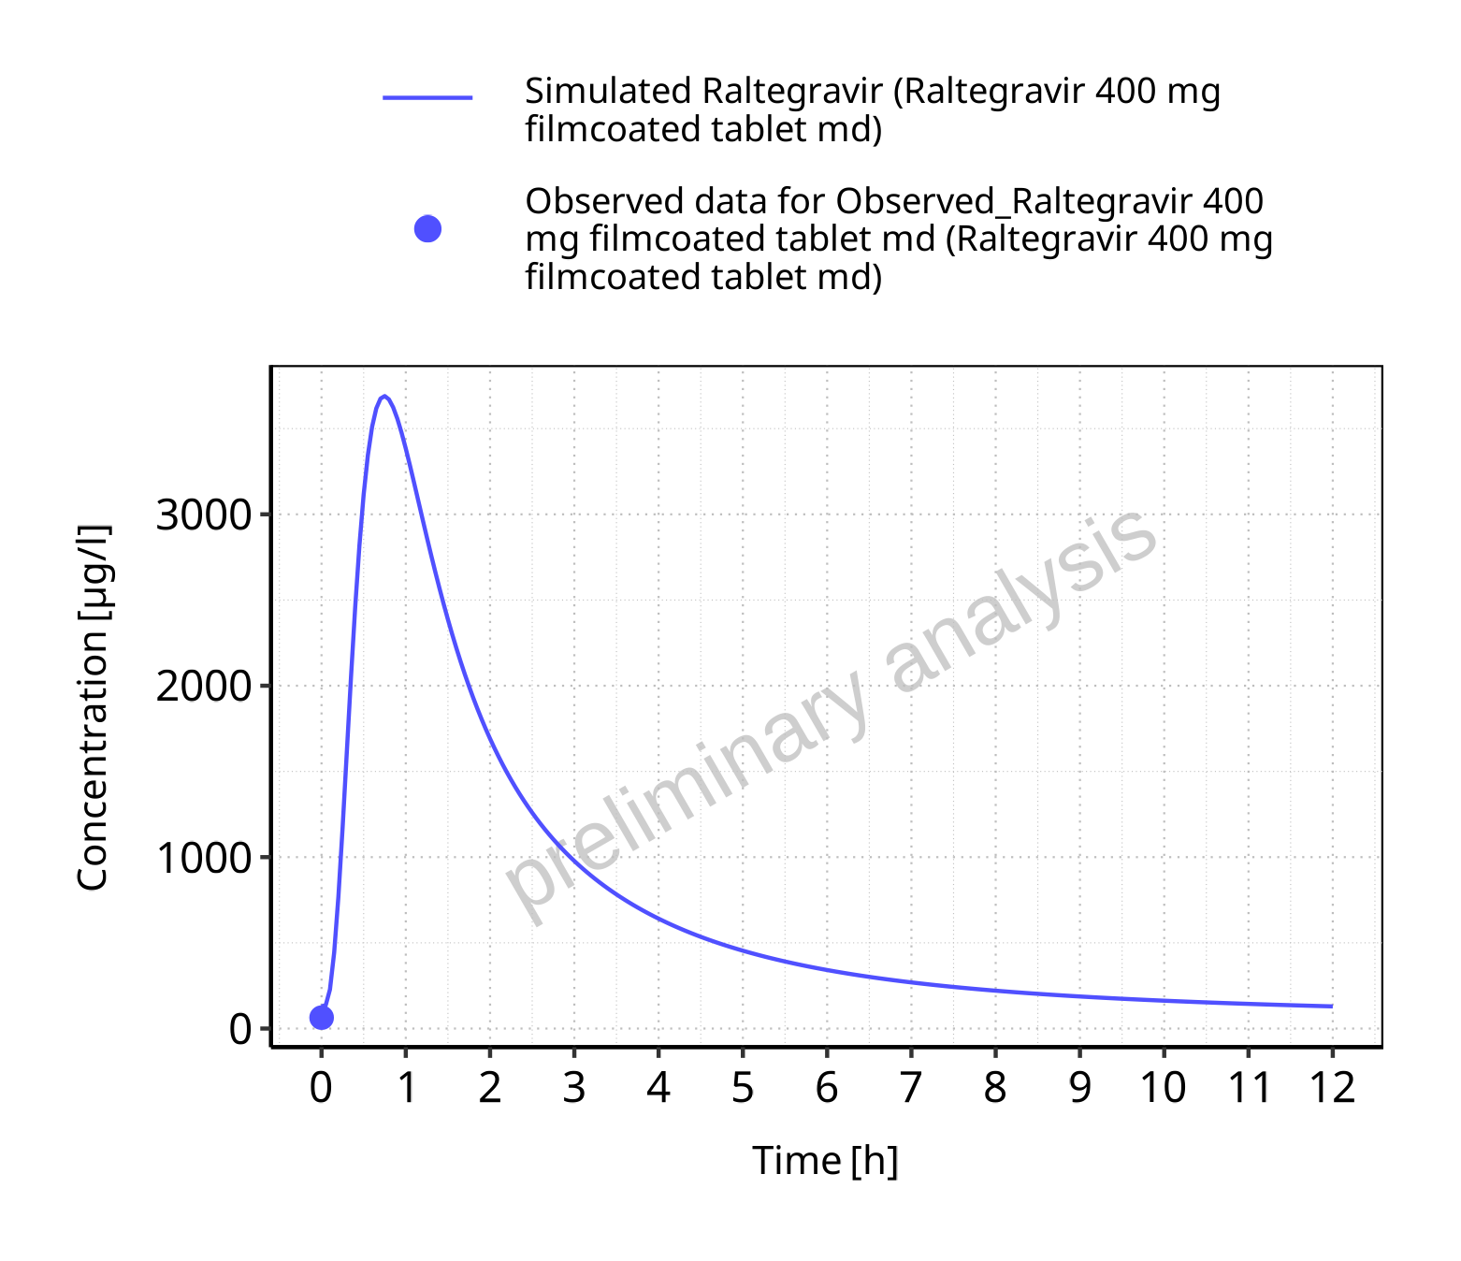

**Figure 5-63: Time profiles for Raltegravir 400 mg filmcoated tablet md. Data source: Data/Raltegravir_PK.txt. Time profiles are plotted in a linear scale.**

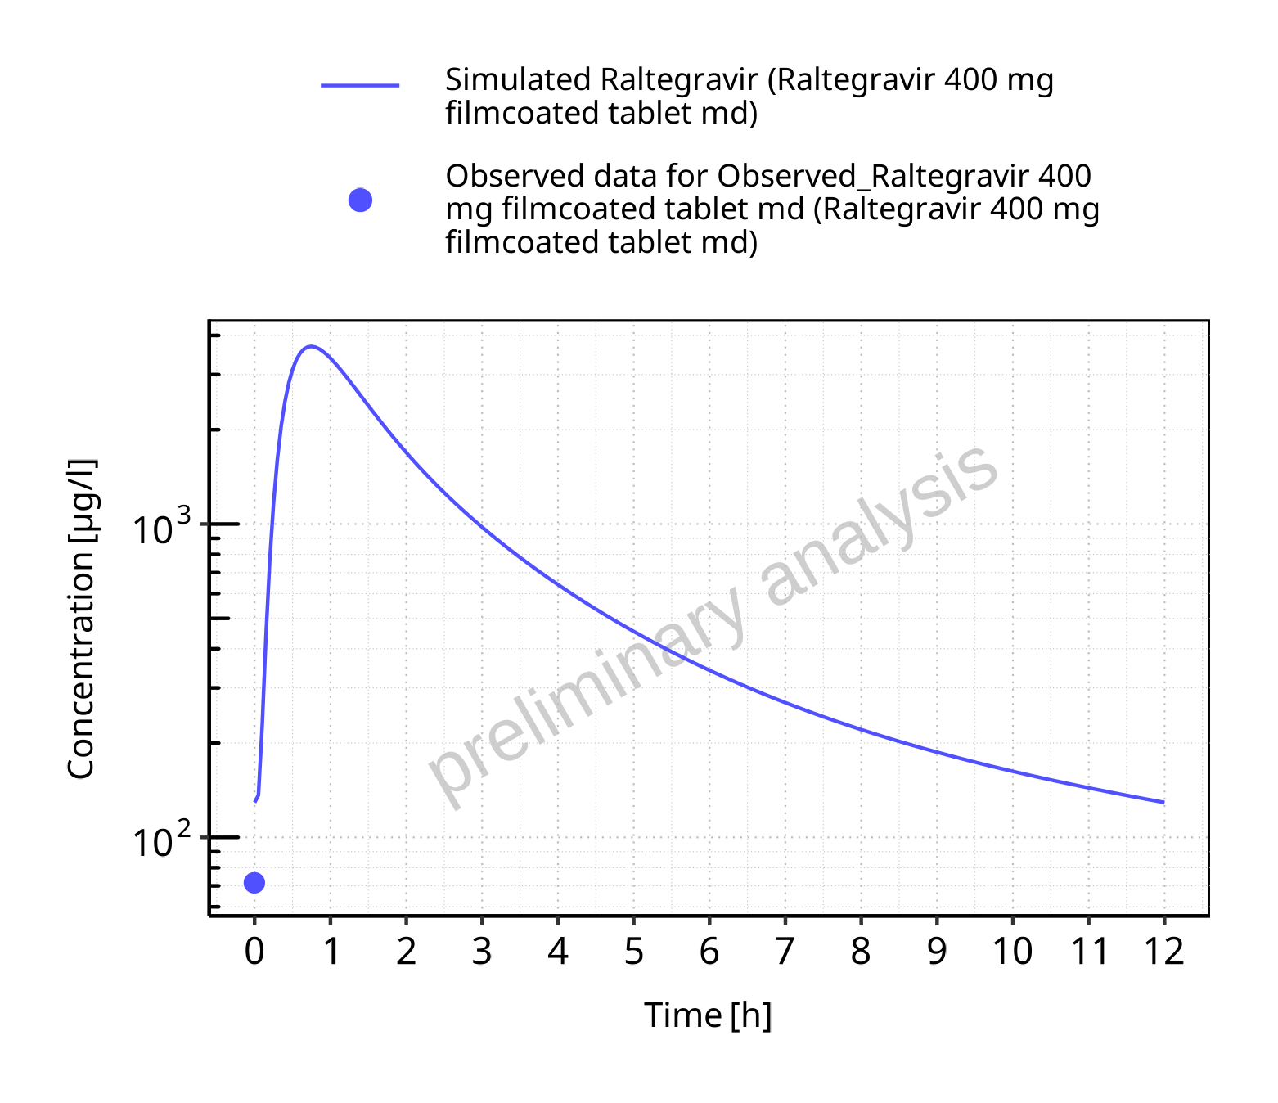

**Figure 5-64: Time profiles for Raltegravir 400 mg filmcoated tablet md. Data source: Data/Raltegravir_PK.txt. Time profiles are plotted in a logarithmic scale.**

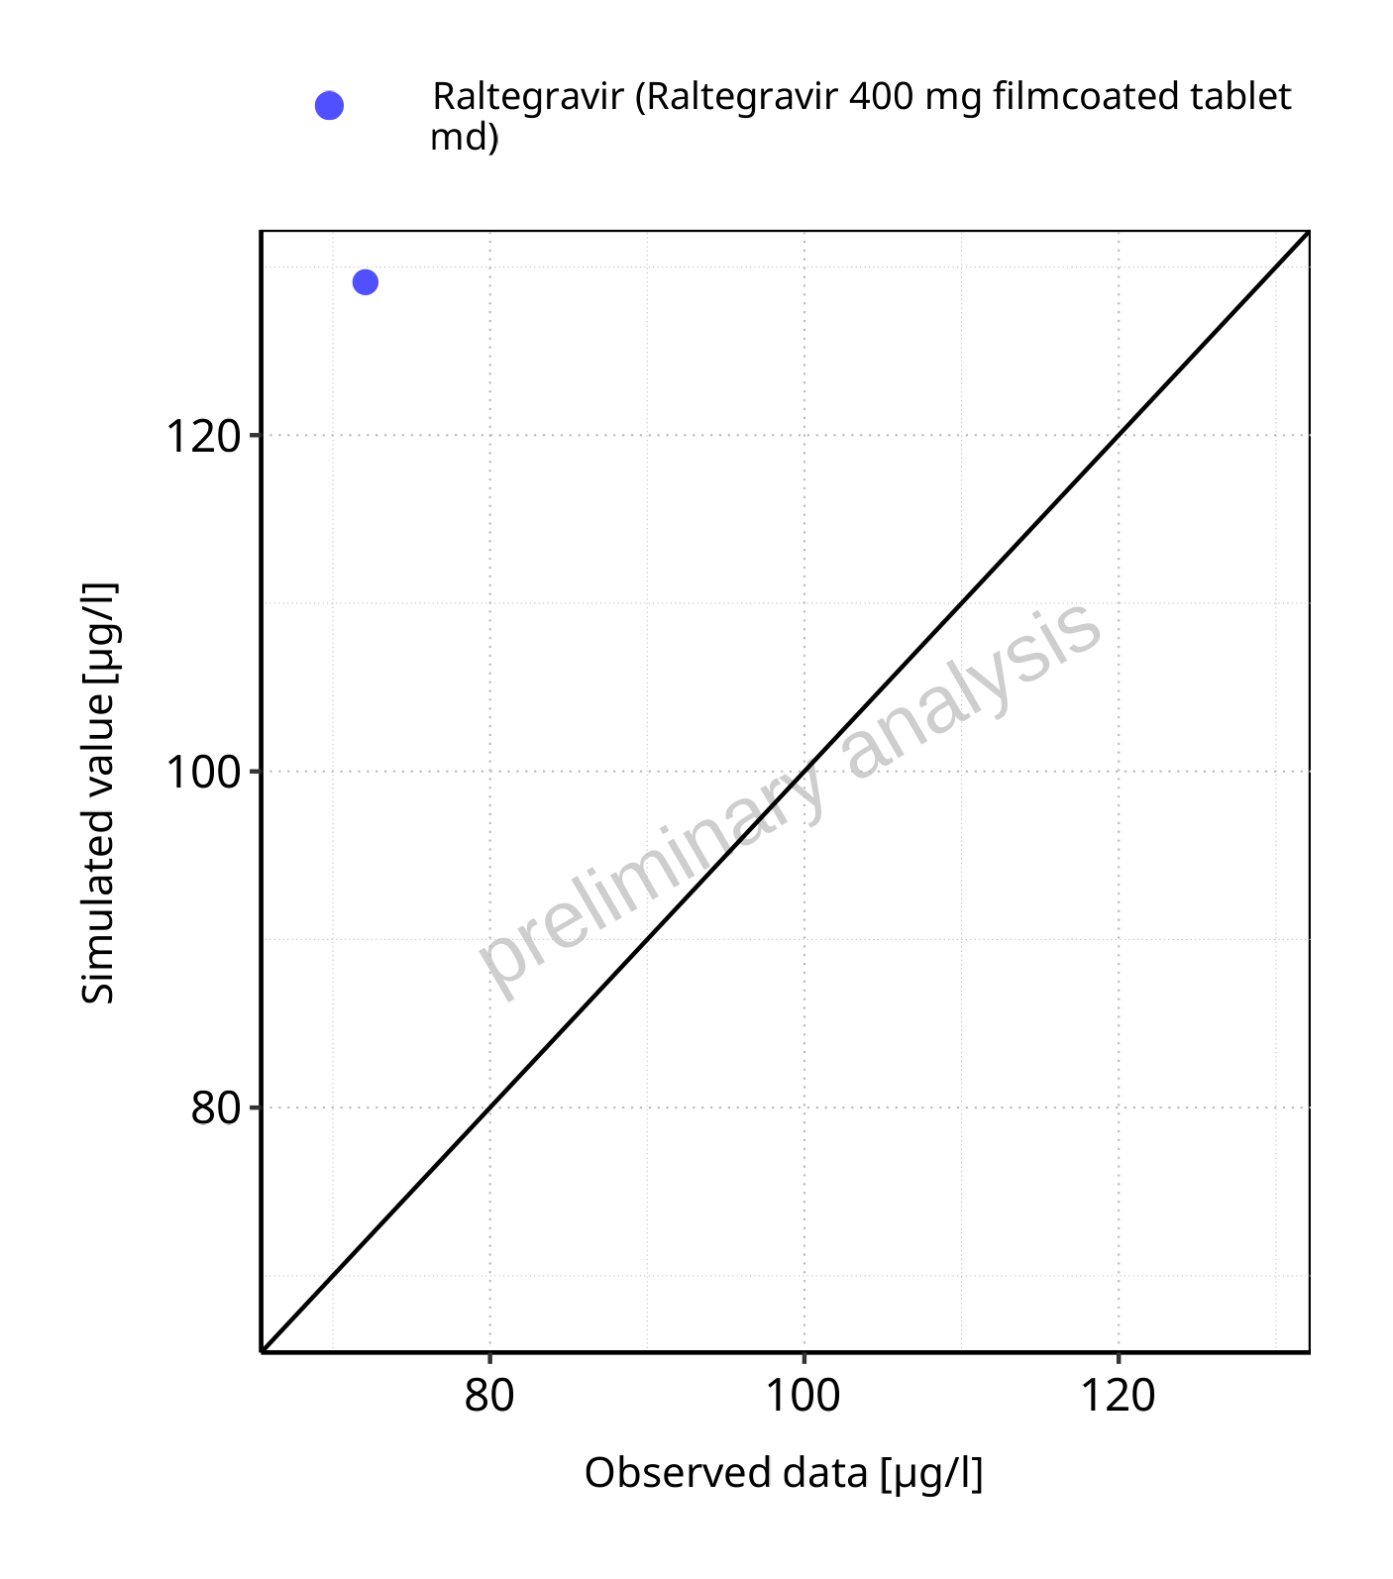

**Figure 5-65: Predicted vs observed for Raltegravir 400 mg filmcoated tablet md. Data source: Data/Raltegravir_PK.txt. Predictions and observations are plotted in a linear scale.**



**Figure 5-66: Predicted vs observed for Raltegravir 400 mg filmcoated tablet md. Data source: Data/Raltegravir_PK.txt. Predictions and observations are plotted in a logarithmic scale.**

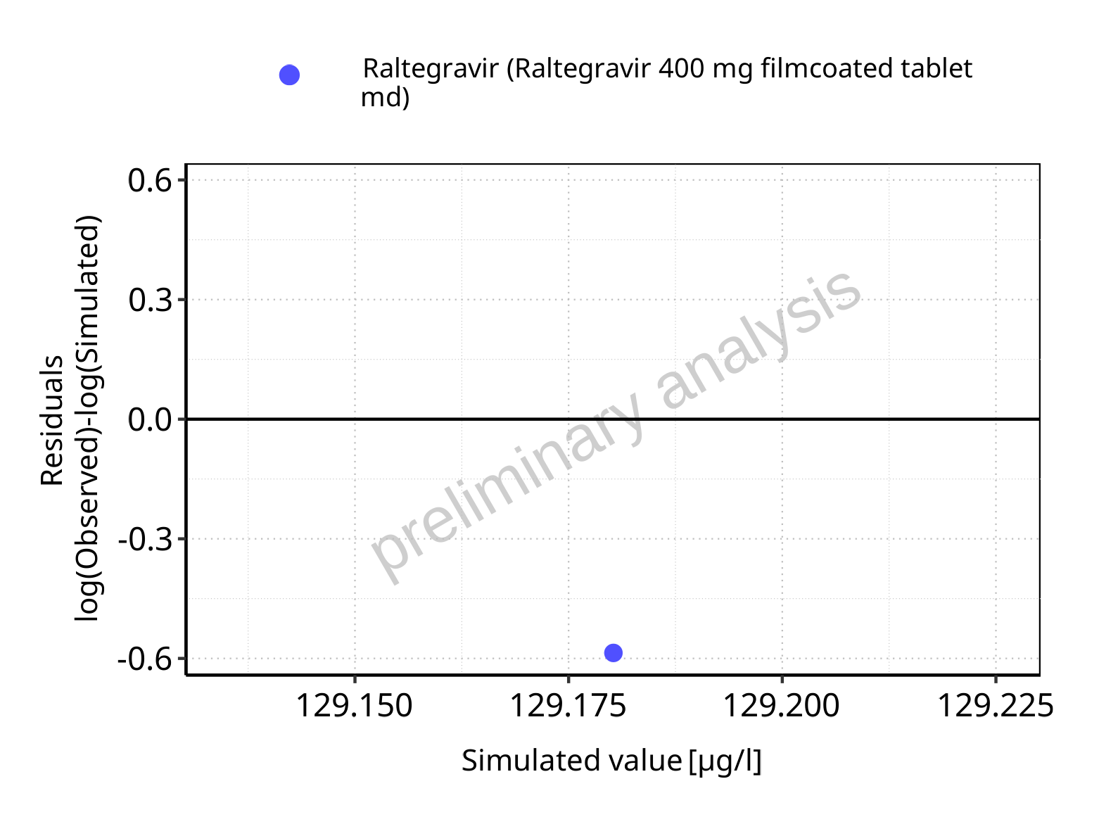

**Figure 5-67: Logarithmic residuals vs predicted values for Raltegravir 400 mg filmcoated tablet md. Data source: Data/Raltegravir_PK.txt.**

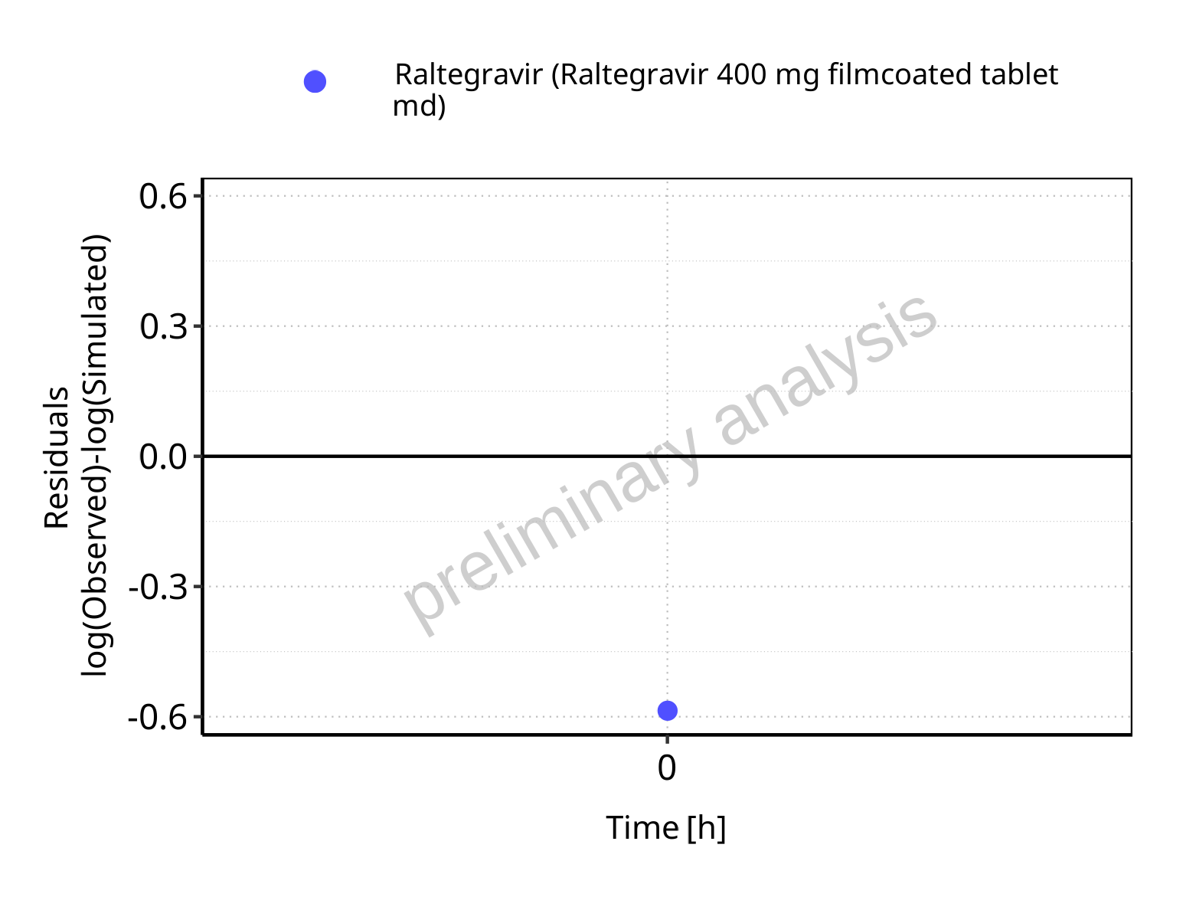

**Figure 5-68: Logarithmic residuals vs time values for Raltegravir 400 mg filmcoated tablet md. Data source: Data/Raltegravir_PK.txt.**

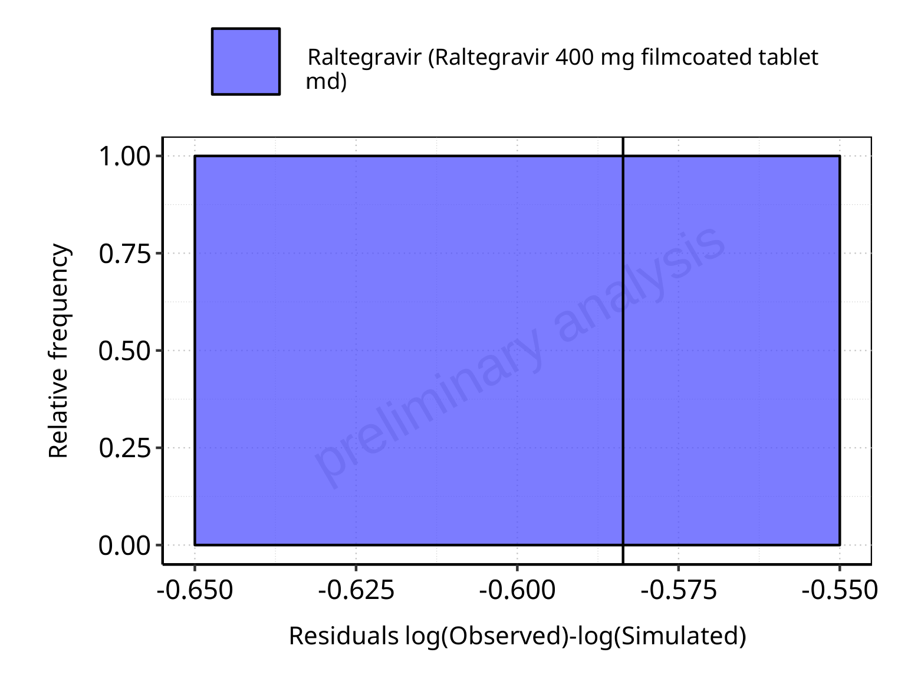

**Figure 5-69: Logarithmic residuals distribution (stacked) for Raltegravir 400 mg filmcoated tablet md. Data source: Data/Raltegravir_PK.txt.**

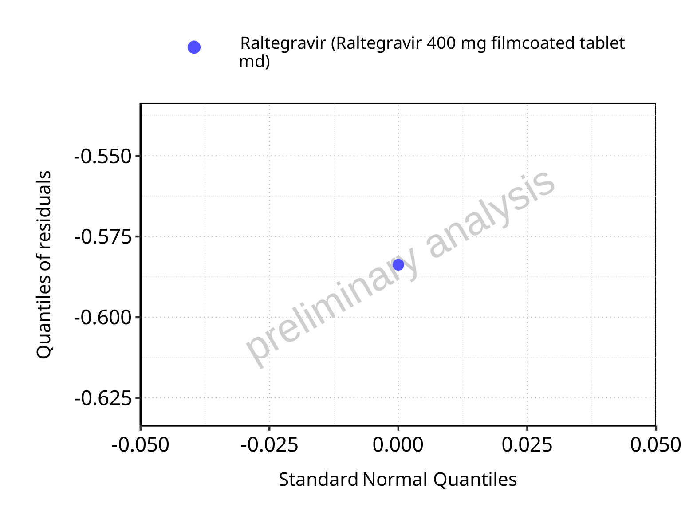

**Figure 5-70: Logarithmic residuals for Raltegravir 400 mg filmcoated tablet md as quantile-quantile plot. Data source: Data/Raltegravir_PK.txt.**

## Time profiles and residual plots for Raltegravir 400mg chewable fasted

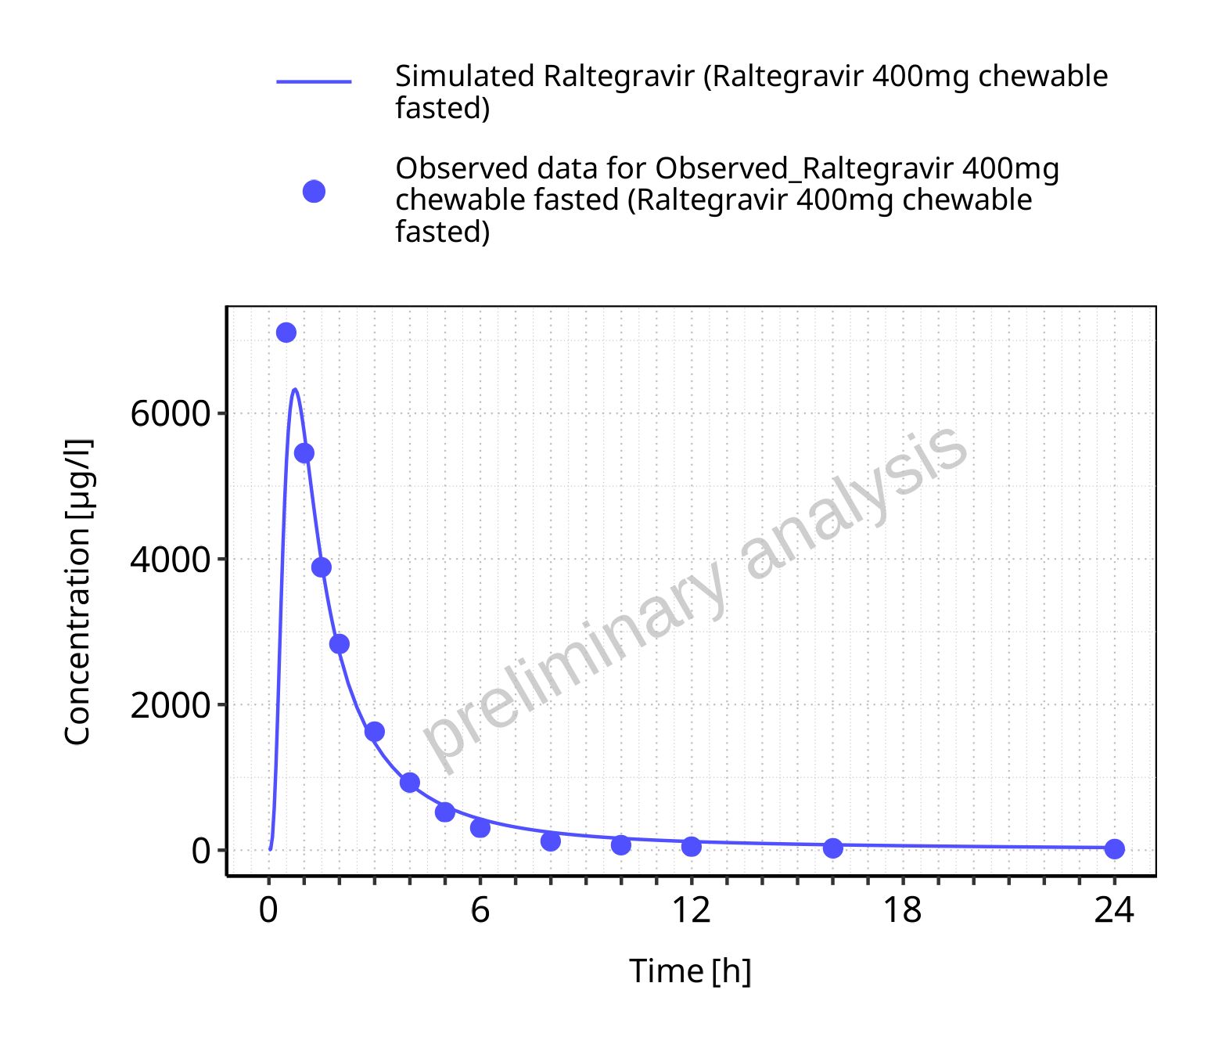

**Figure 5-71: Time profiles for Raltegravir 400mg chewable fasted. Data source: Data/Raltegravir_PK.txt. Time profiles are plotted in a linear scale.**

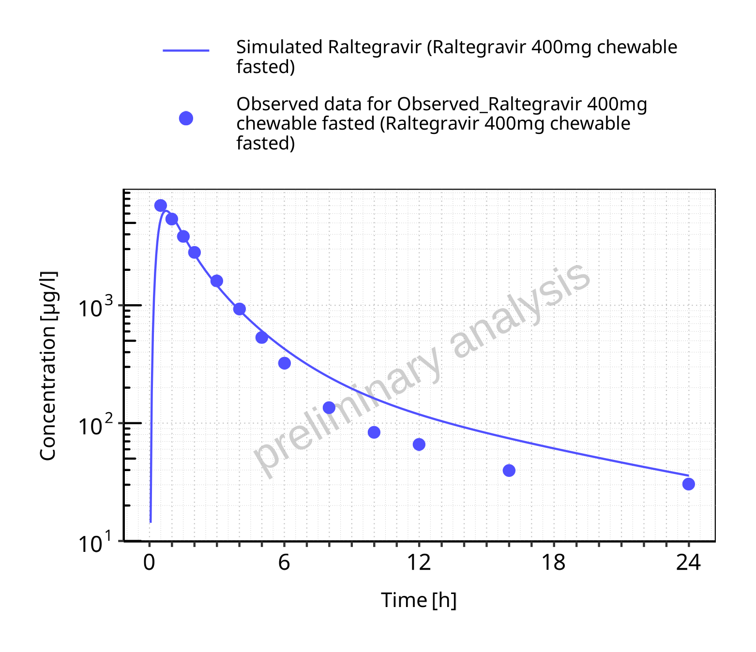

**Figure 5-72: Time profiles for Raltegravir 400mg chewable fasted. Data source: Data/Raltegravir_PK.txt. Time profiles are plotted in a logarithmic scale.**

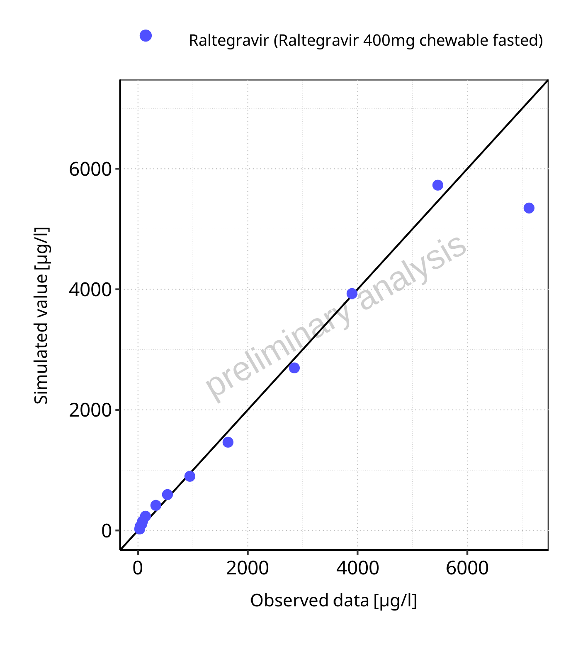

**Figure 5-73: Predicted vs observed for Raltegravir 400mg chewable fasted. Data source: Data/Raltegravir_PK.txt. Predictions and observations are plotted in a linear scale.**



**Figure 5-74: Predicted vs observed for Raltegravir 400mg chewable fasted. Data source: Data/Raltegravir_PK.txt. Predictions and observations are plotted in a logarithmic scale.**

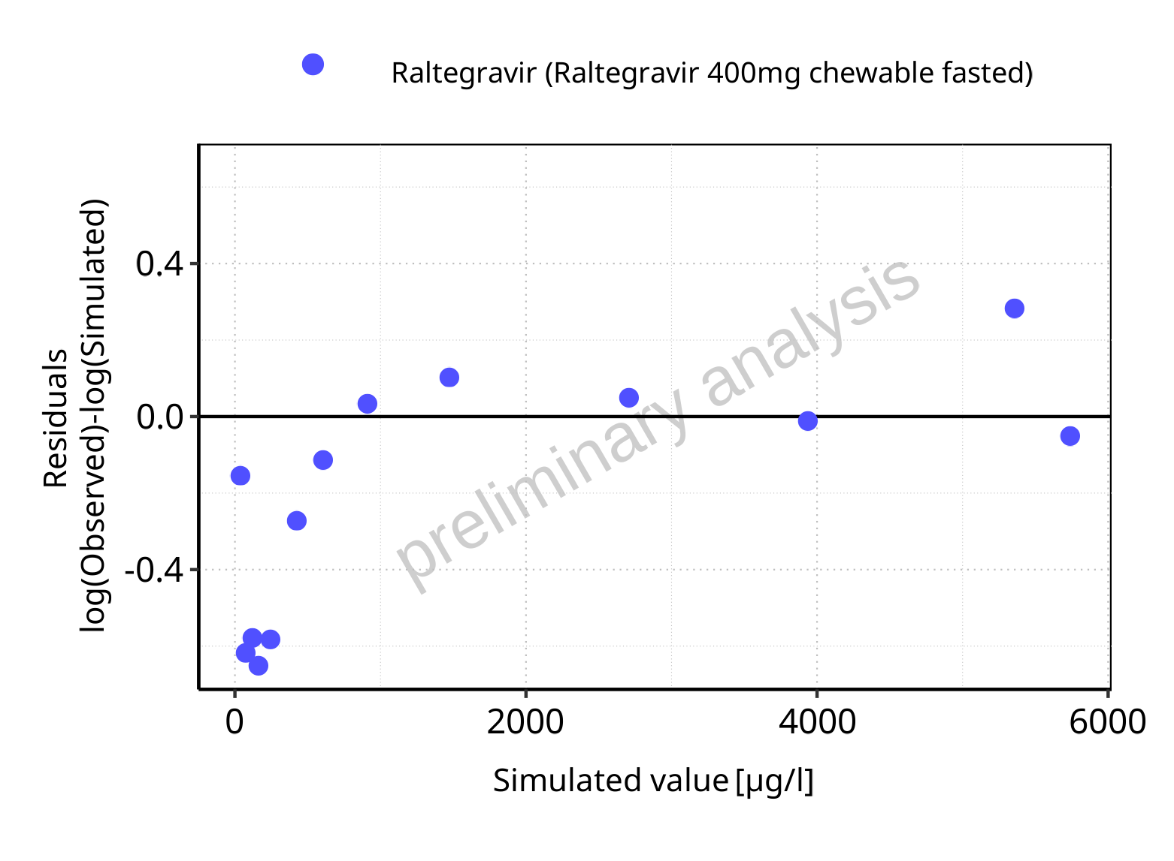

**Figure 5-75: Logarithmic residuals vs predicted values for Raltegravir 400mg chewable fasted. Data source: Data/Raltegravir_PK.txt.**

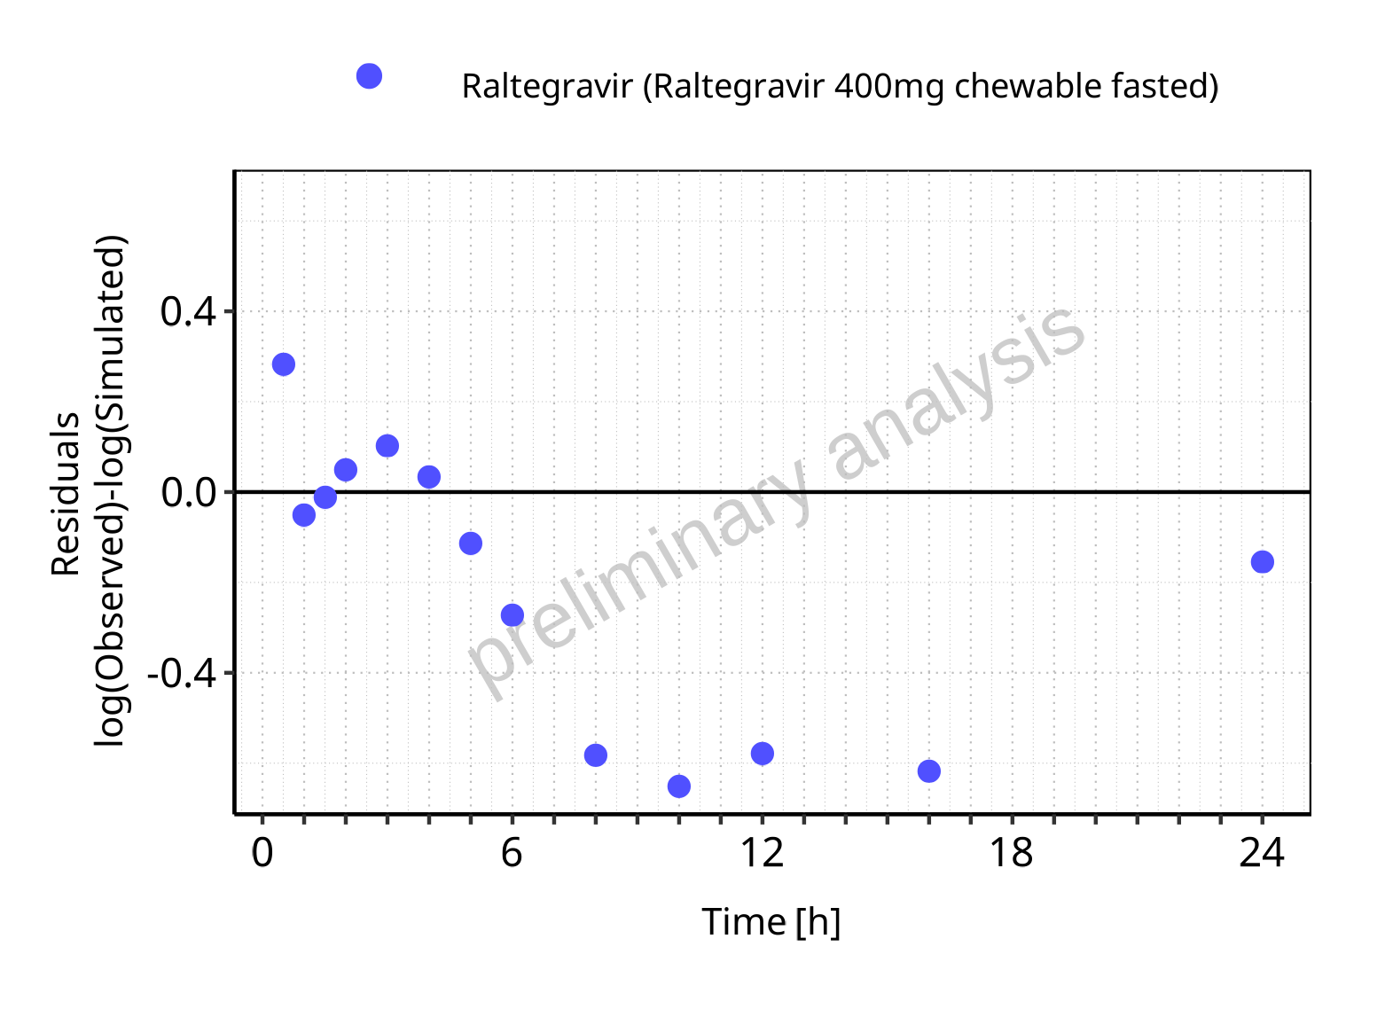

**Figure 5-76: Logarithmic residuals vs time values for Raltegravir 400mg chewable fasted. Data source: Data/Raltegravir_PK.txt.**

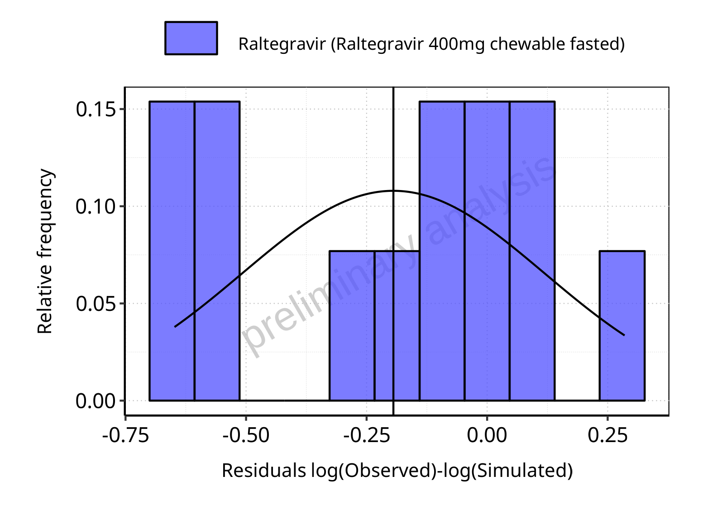

**Figure 5-77: Logarithmic residuals distribution (stacked) for Raltegravir 400mg chewable fasted. Data source: Data/Raltegravir_PK.txt.**

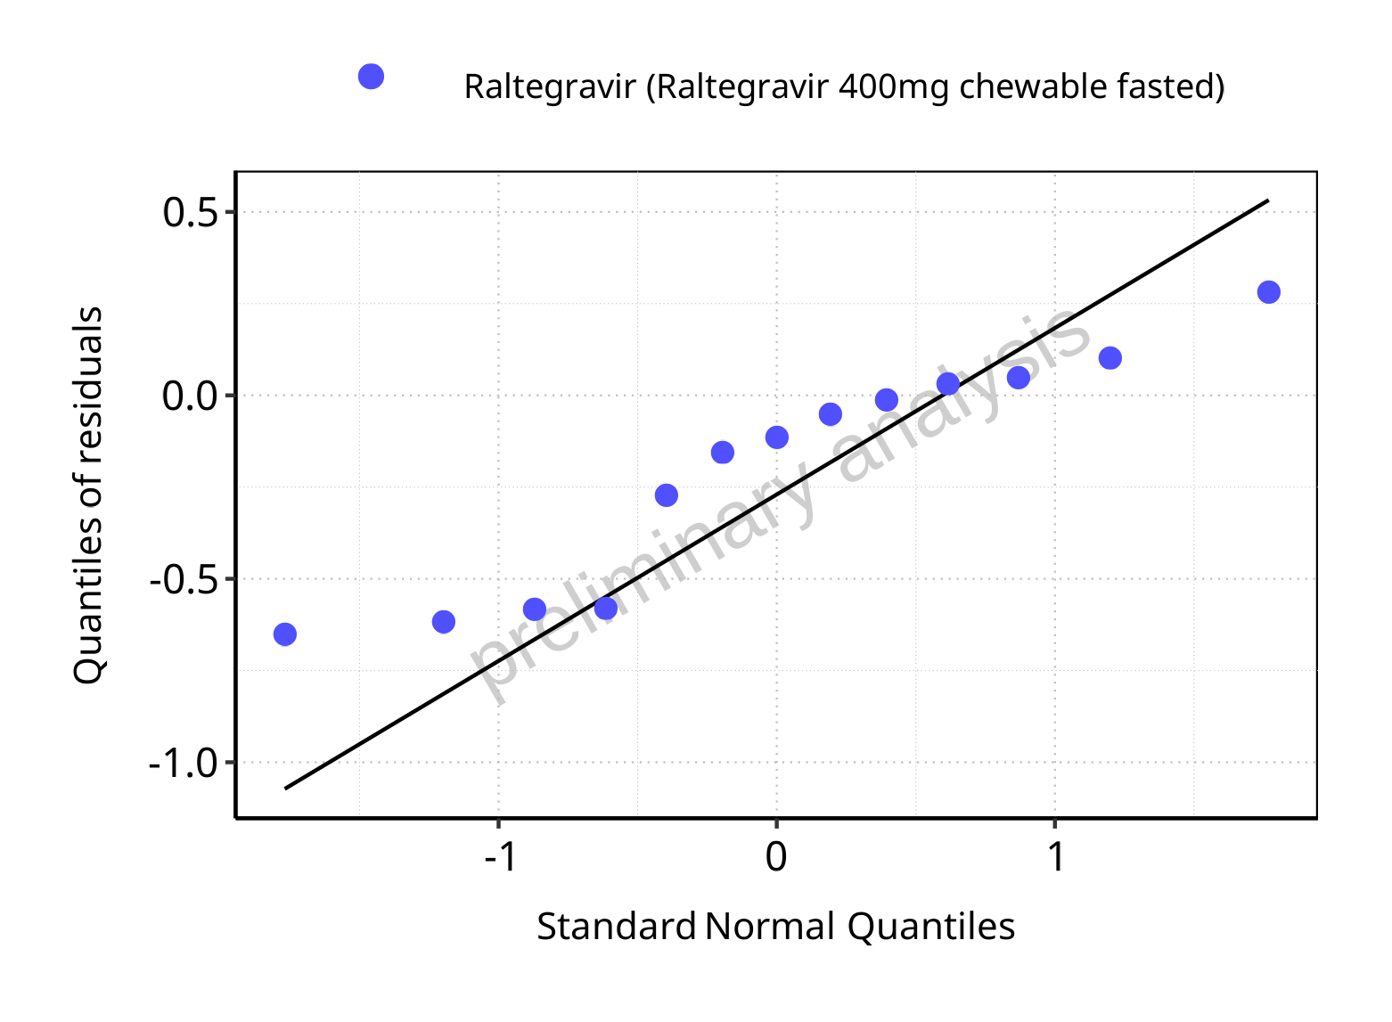

**Figure 5-78: Logarithmic residuals for Raltegravir 400mg chewable fasted as quantile-quantile plot. Data source: Data/Raltegravir_PK.txt.**

## Time profiles and residual plots for Raltegravir 400mg chewable fed

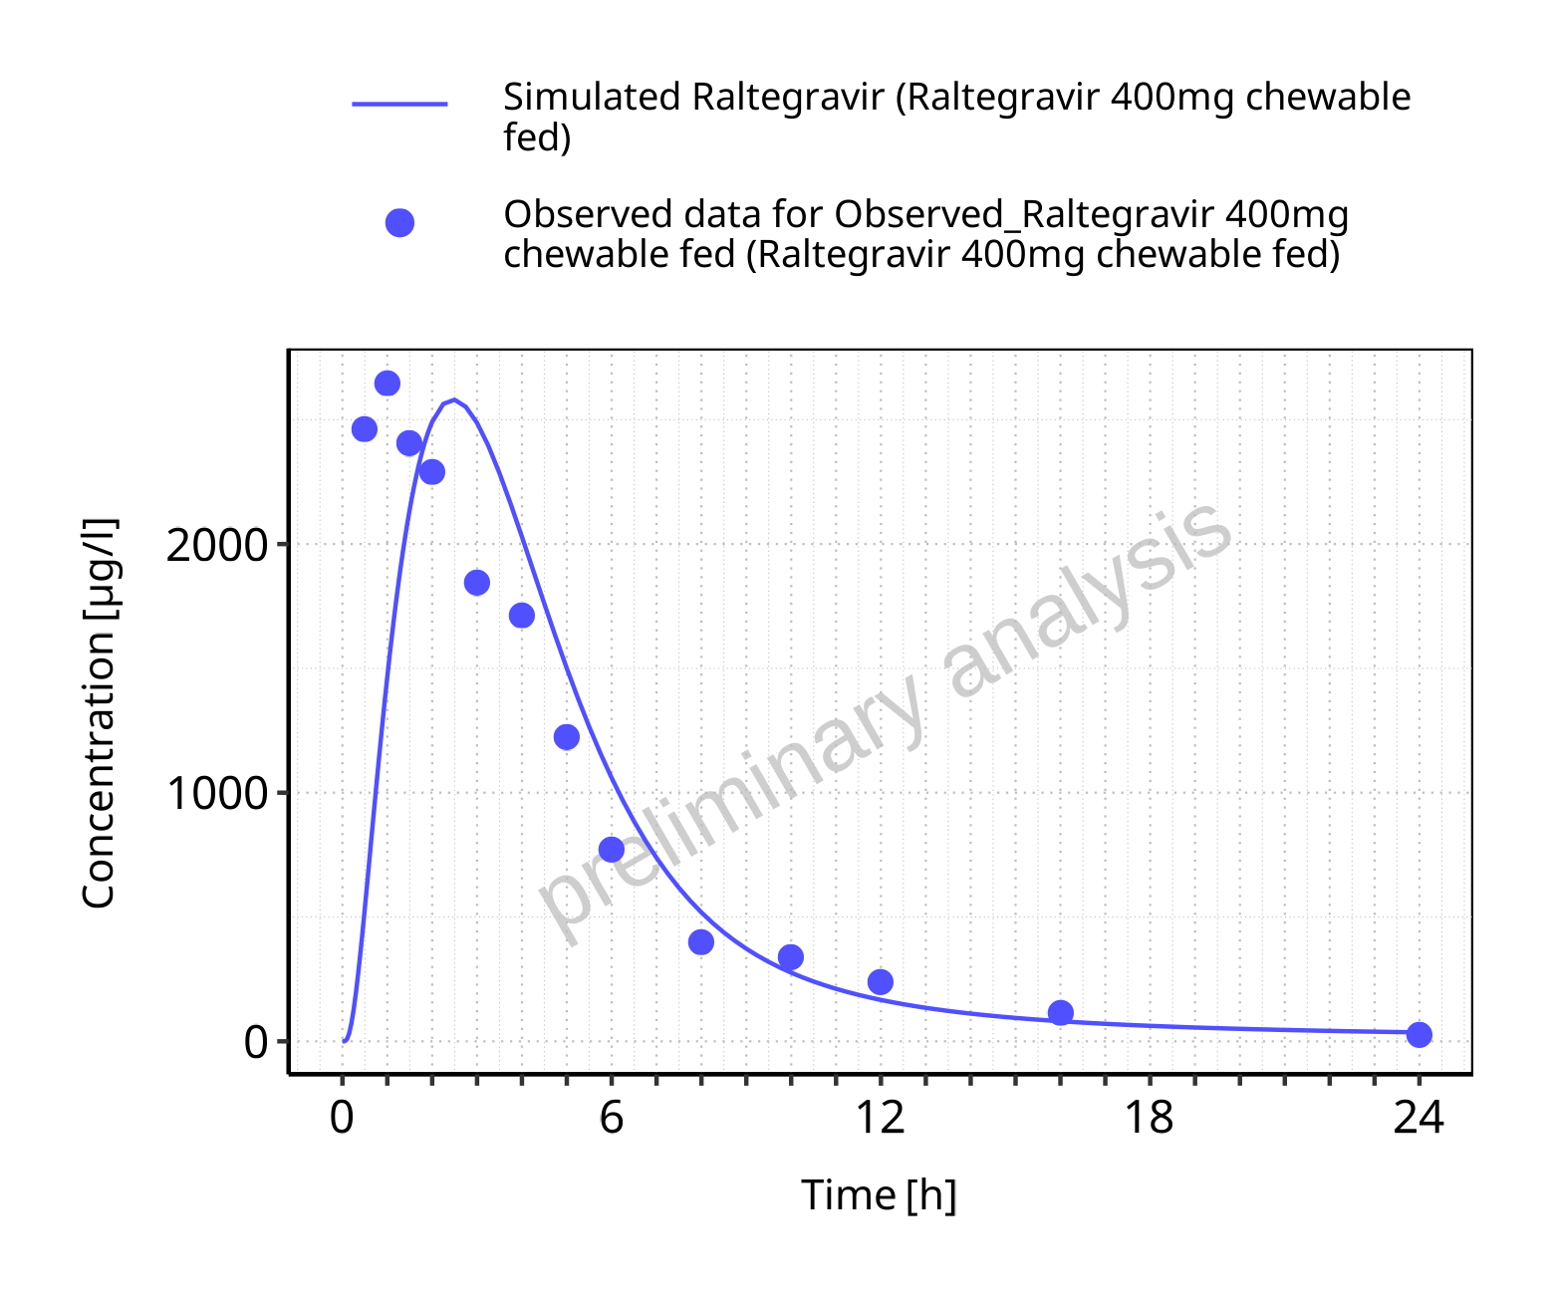

**Figure 5-79: Time profiles for Raltegravir 400mg chewable fed. Data source: Data/Raltegravir_PK.txt. Time profiles are plotted in a linear scale.**

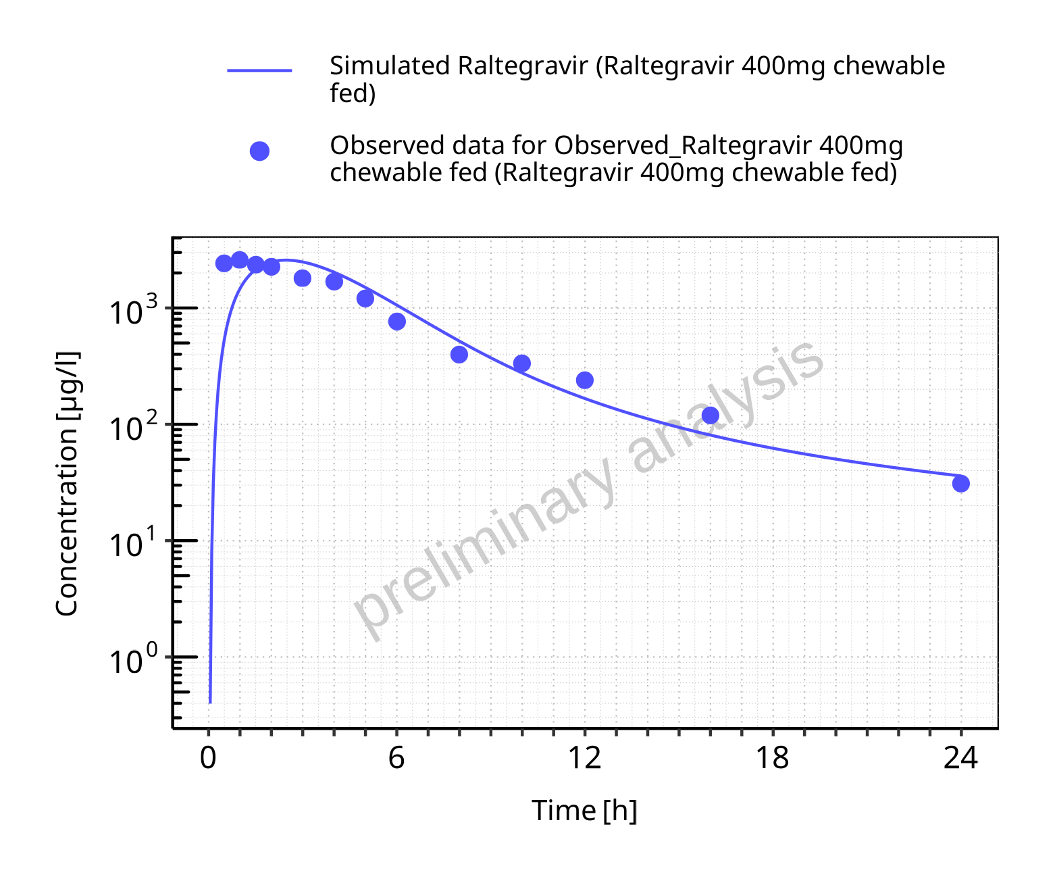

**Figure 5-80: Time profiles for Raltegravir 400mg chewable fed. Data source: Data/Raltegravir_PK.txt. Time profiles are plotted in a logarithmic scale.**

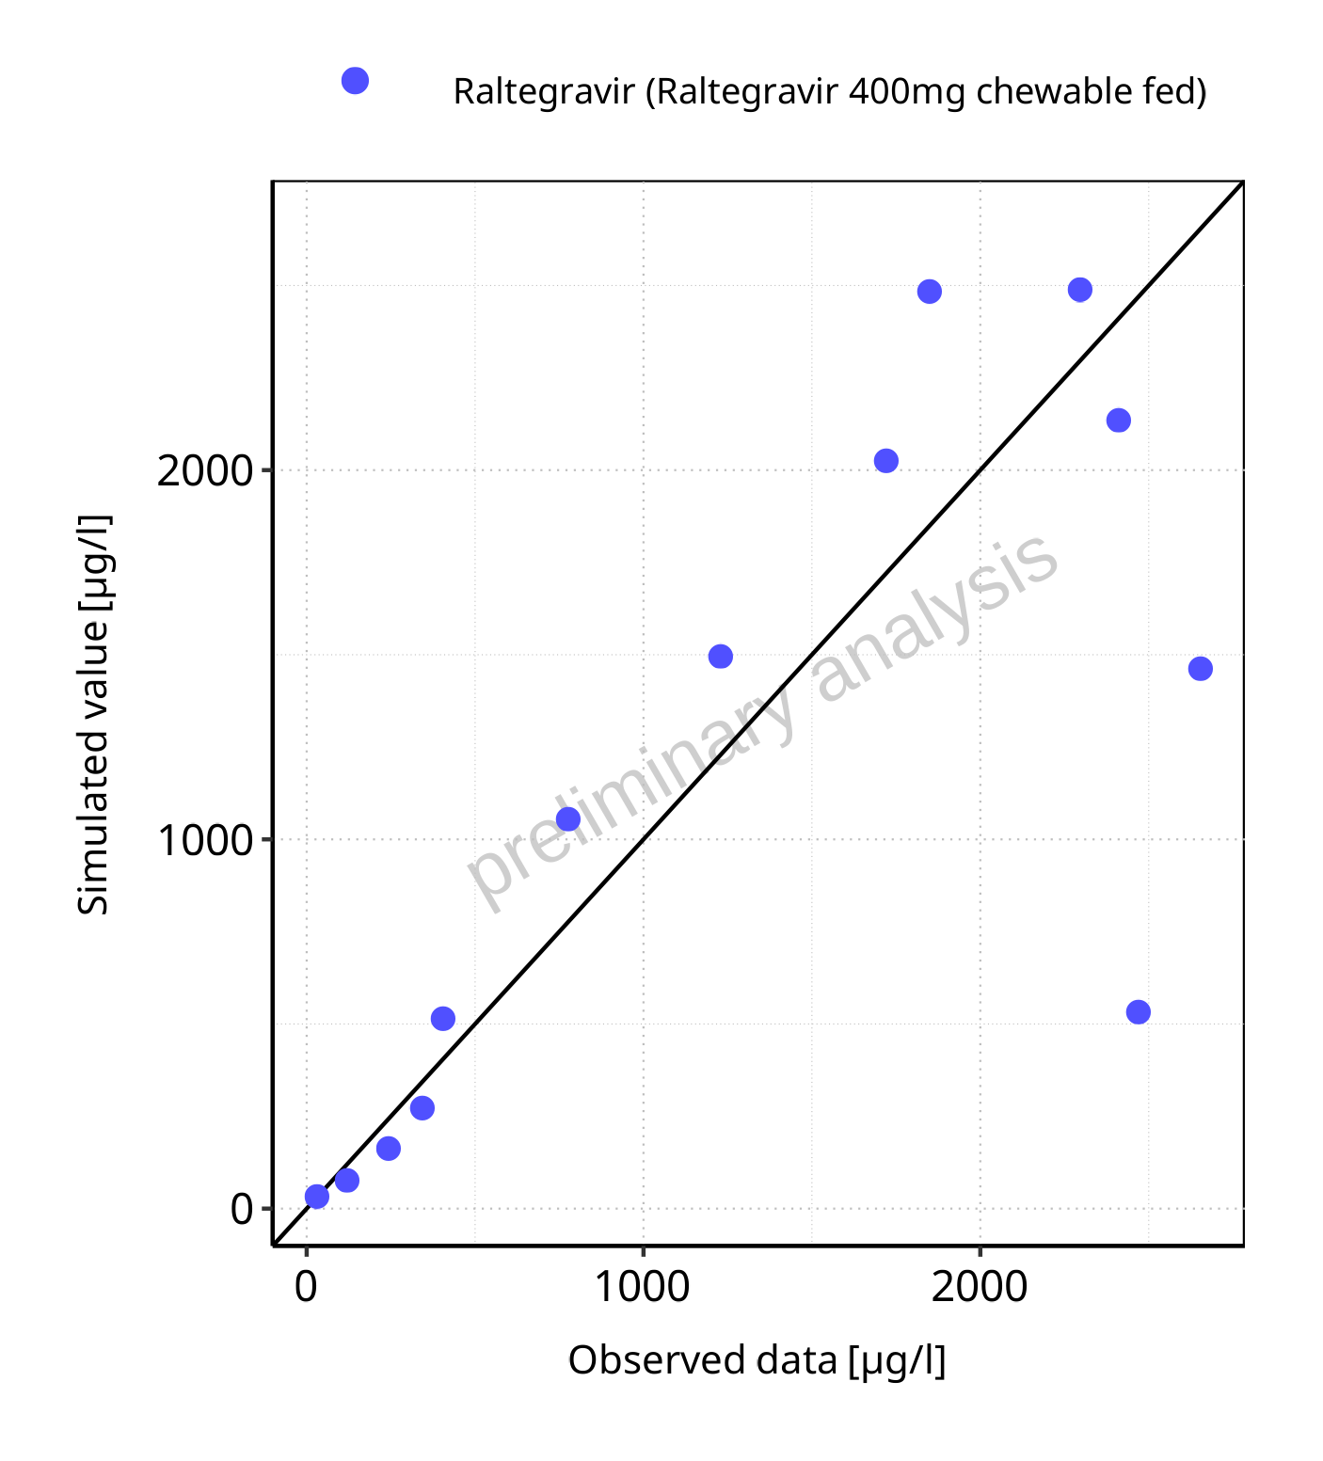

**Figure 5-81: Predicted vs observed for Raltegravir 400mg chewable fed. Data source: Data/Raltegravir_PK.txt. Predictions and observations are plotted in a linear scale.**



**Figure 5-82: Predicted vs observed for Raltegravir 400mg chewable fed. Data source: Data/Raltegravir_PK.txt. Predictions and observations are plotted in a logarithmic scale.**

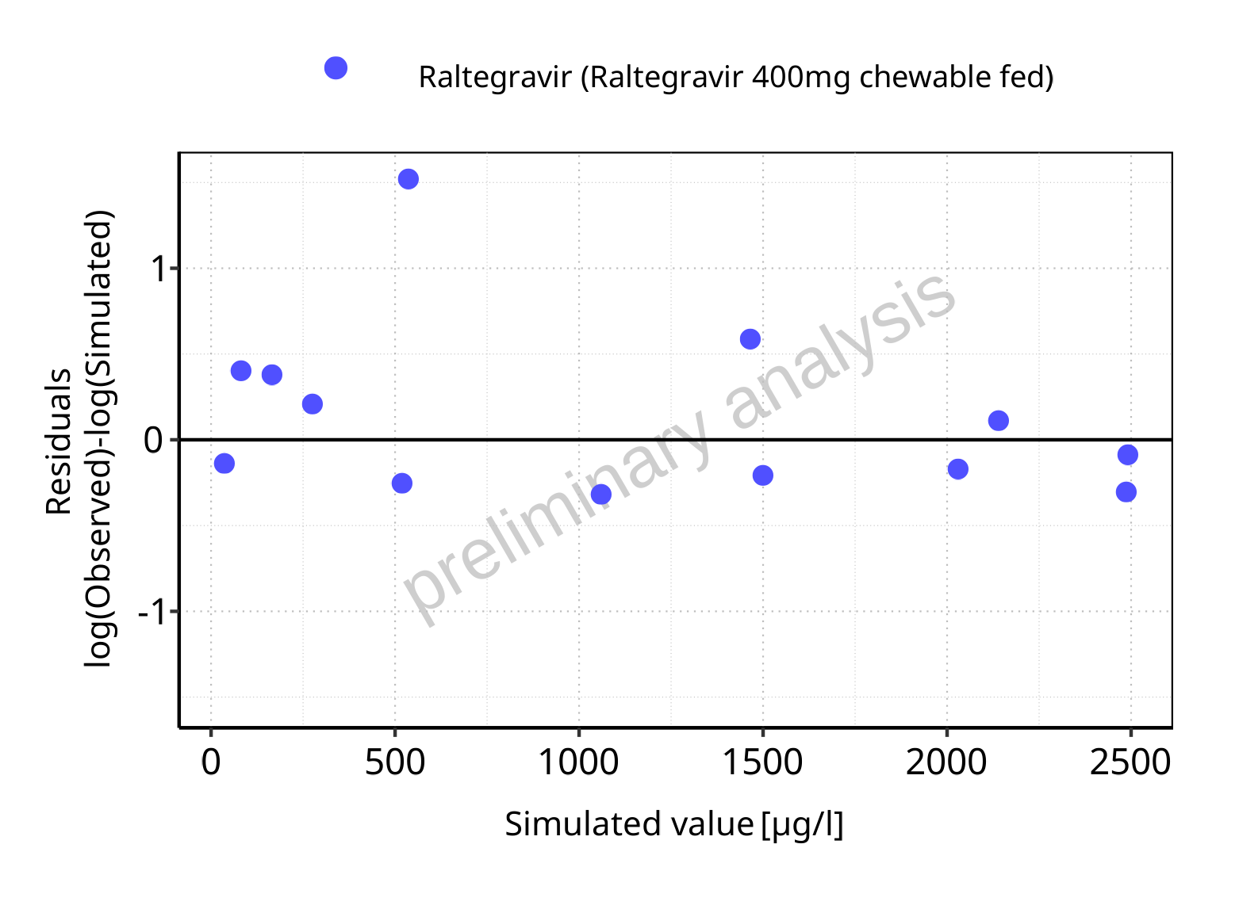

**Figure 5-83: Logarithmic residuals vs predicted values for Raltegravir 400mg chewable fed. Data source: Data/Raltegravir_PK.txt.**

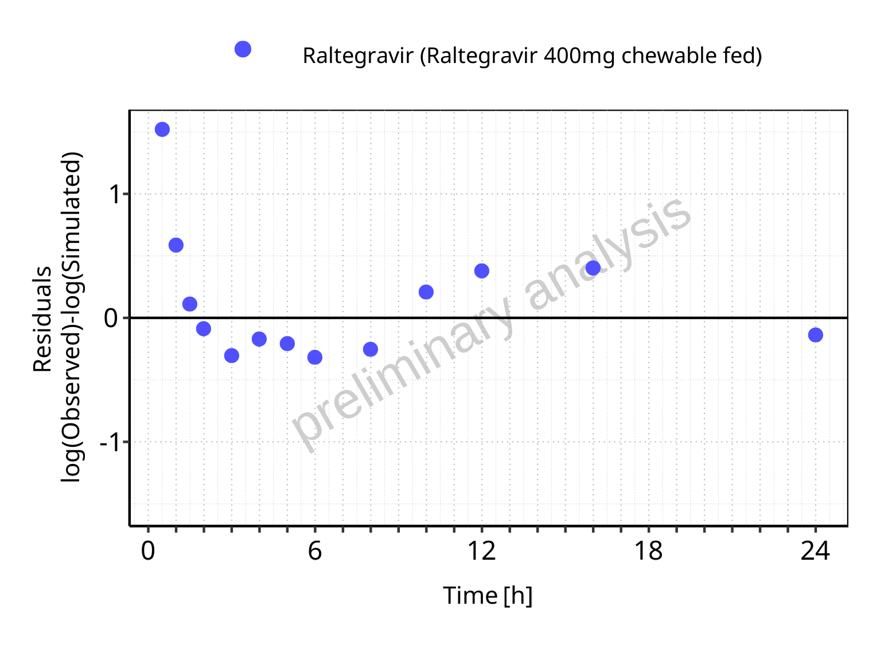

**Figure 5-84: Logarithmic residuals vs time values for Raltegravir 400mg chewable fed. Data source: Data/Raltegravir_PK.txt.**

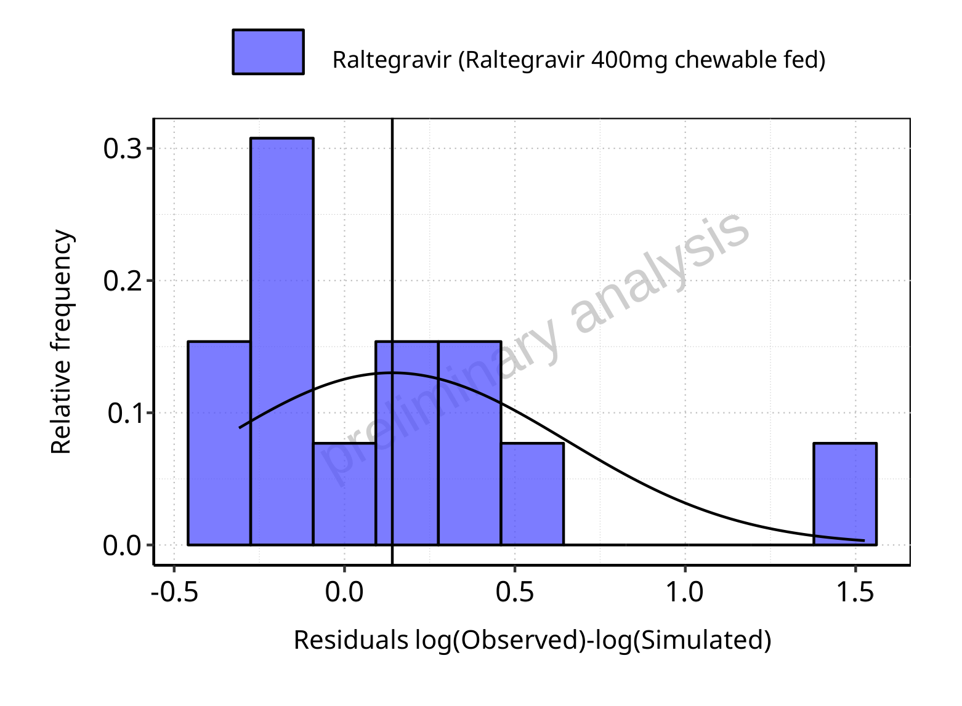

**Figure 5-85: Logarithmic residuals distribution (stacked) for Raltegravir 400mg chewable fed. Data source: Data/Raltegravir_PK.txt.**

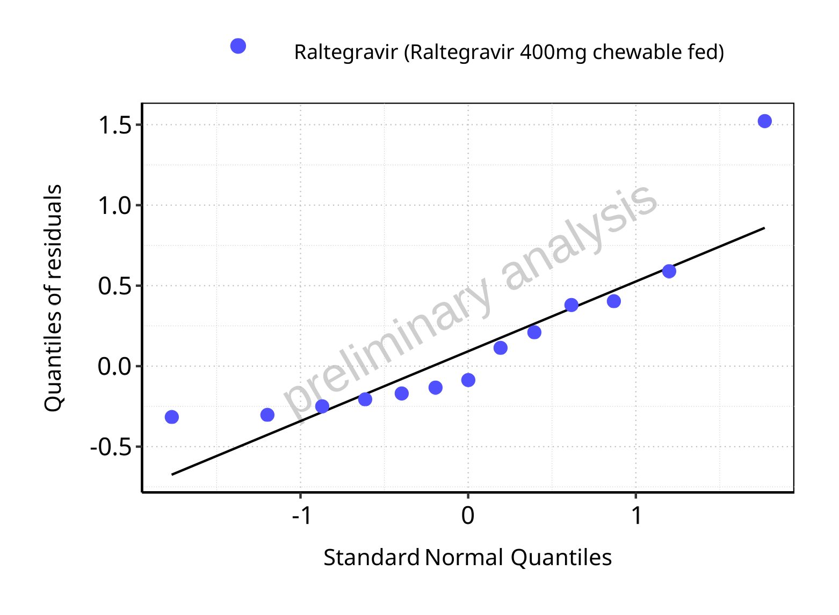

**Figure 5-86: Logarithmic residuals for Raltegravir 400mg chewable fed as quantile-quantile plot. Data source: Data/Raltegravir_PK.txt.**

## Time profiles and residual plots for Raltegravir 400mg (granules in suspension)

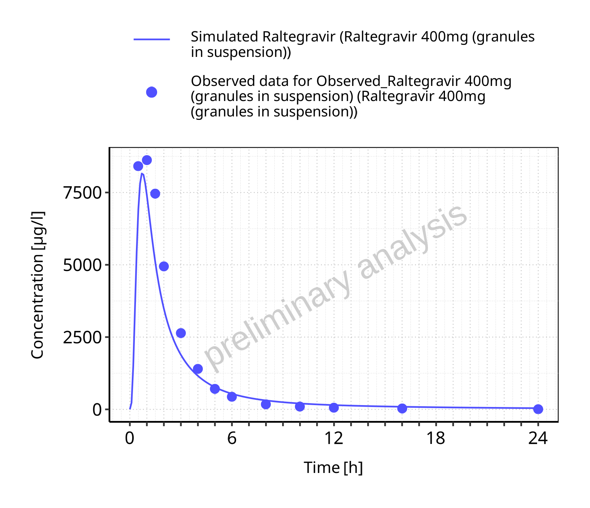

**Figure 5-87: Time profiles for Raltegravir 400mg (granules in suspension). Data source: Data/Raltegravir_PK.txt. Time profiles are plotted in a linear scale.**

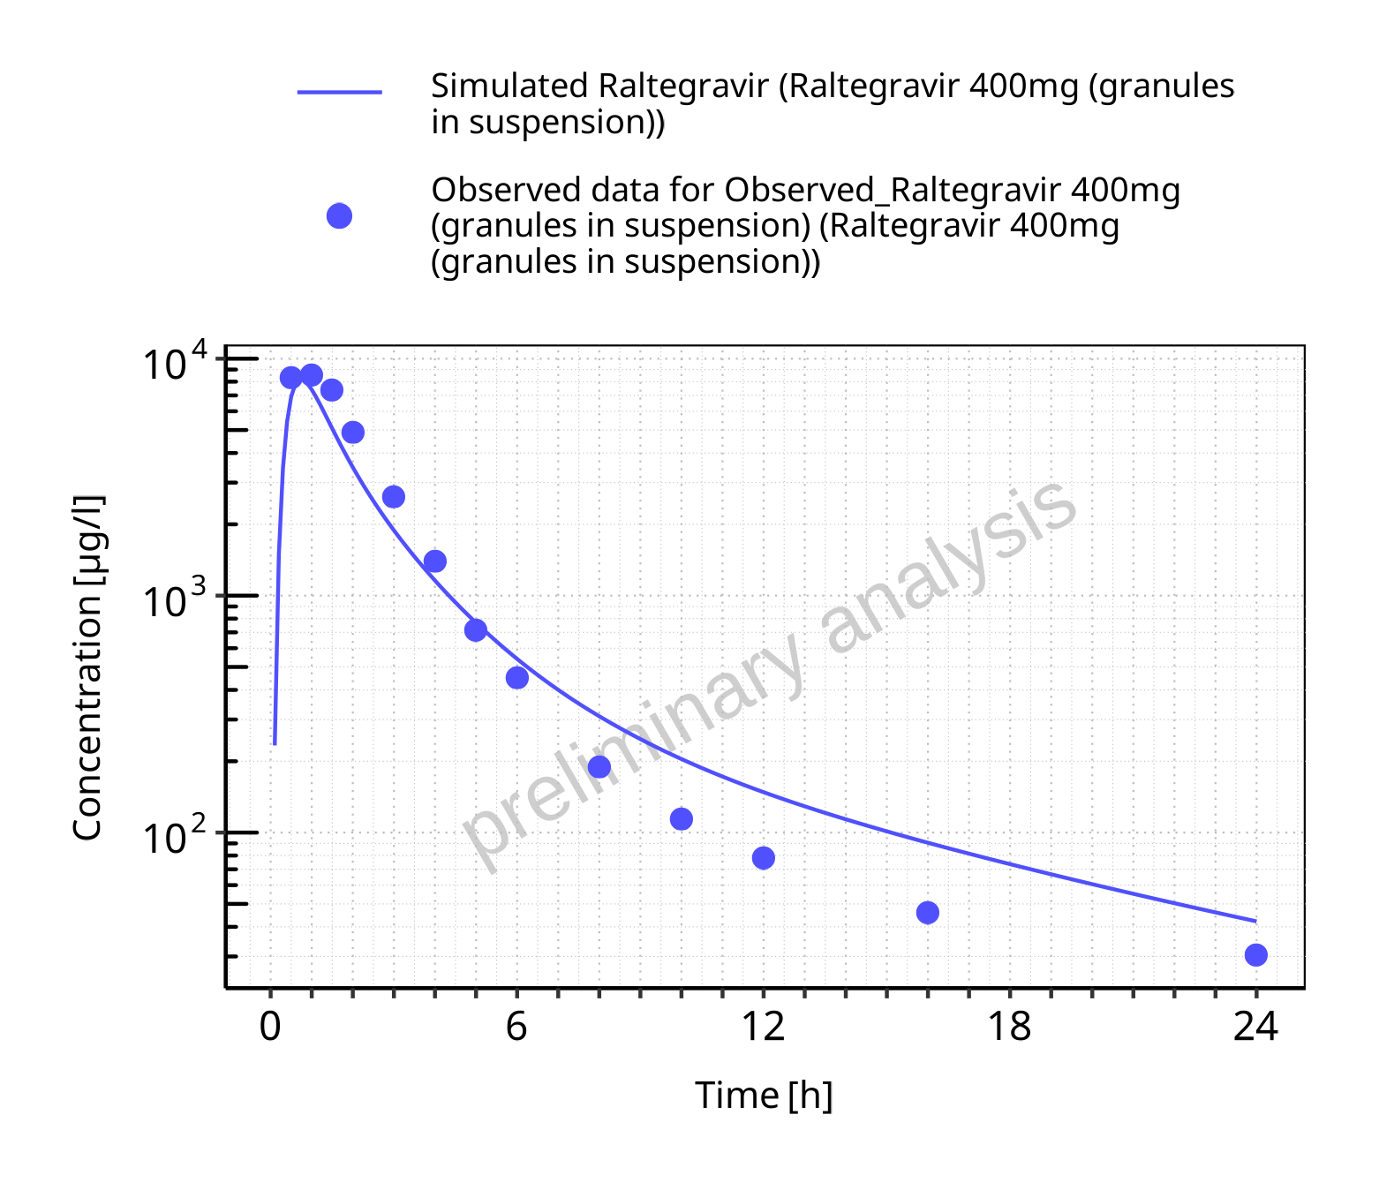

**Figure 5-88: Time profiles for Raltegravir 400mg (granules in suspension). Data source: Data/Raltegravir_PK.txt. Time profiles are plotted in a logarithmic scale.**

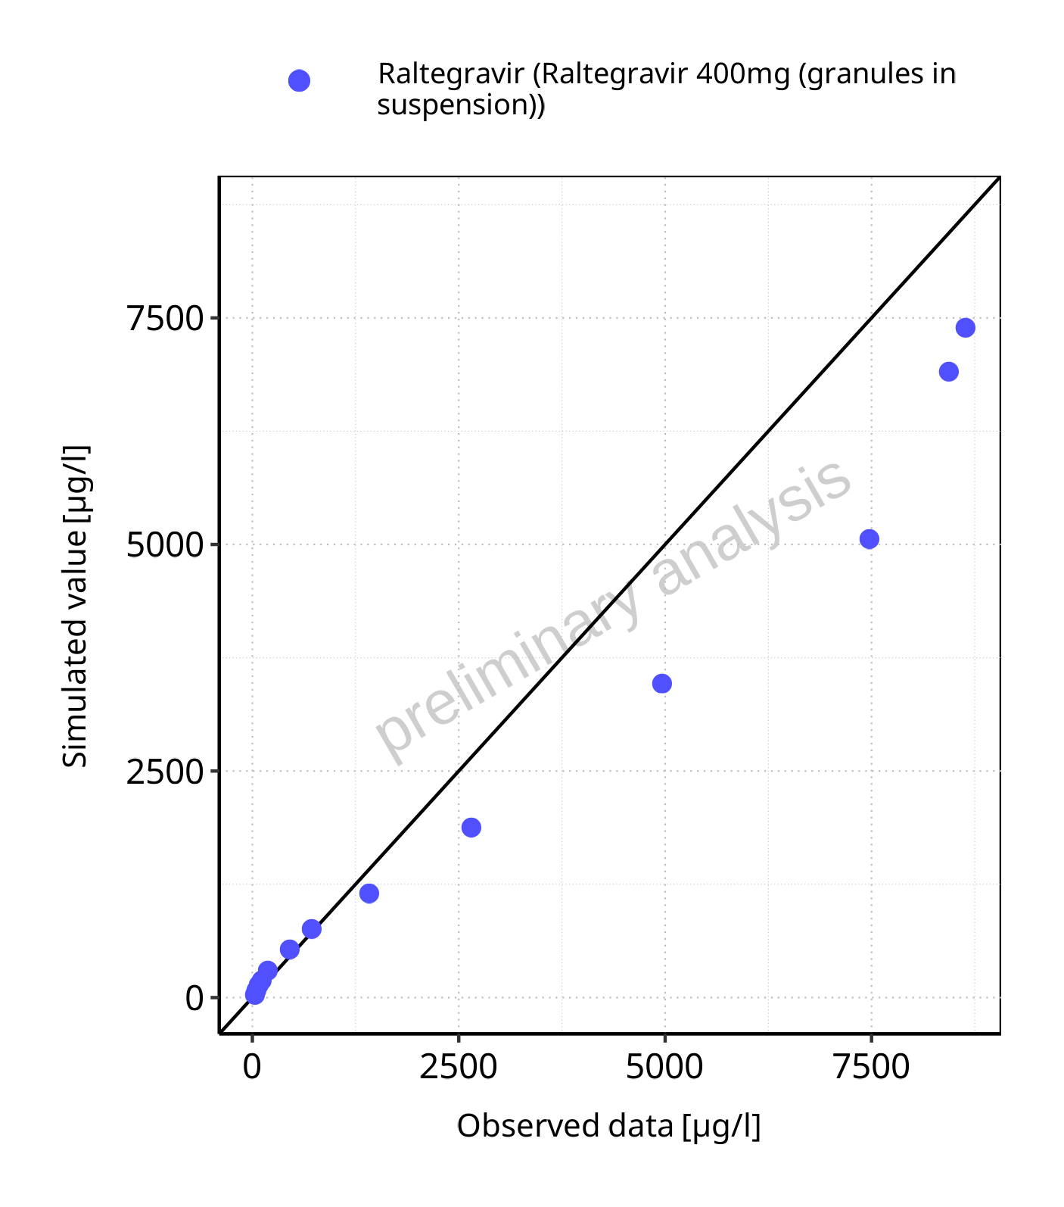

**Figure 5-89: Predicted vs observed for Raltegravir 400mg (granules in suspension). Data source: Data/Raltegravir_PK.txt. Predictions and observations are plotted in a linear scale.**



**Figure 5-90: Predicted vs observed for Raltegravir 400mg (granules in suspension). Data source: Data/Raltegravir_PK.txt. Predictions and observations are plotted in a logarithmic scale.**

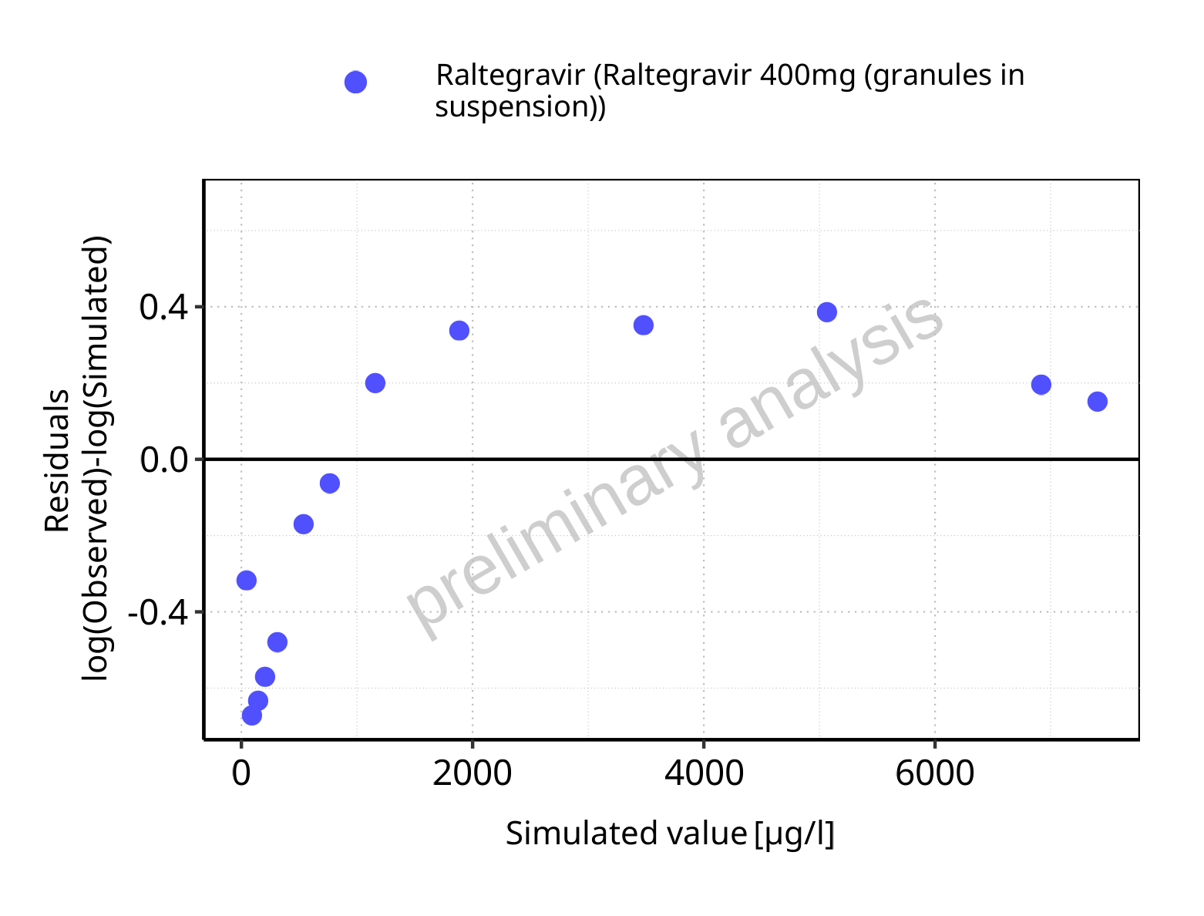

**Figure 5-91: Logarithmic residuals vs predicted values for Raltegravir 400mg (granules in suspension). Data source: Data/Raltegravir_PK.txt.**

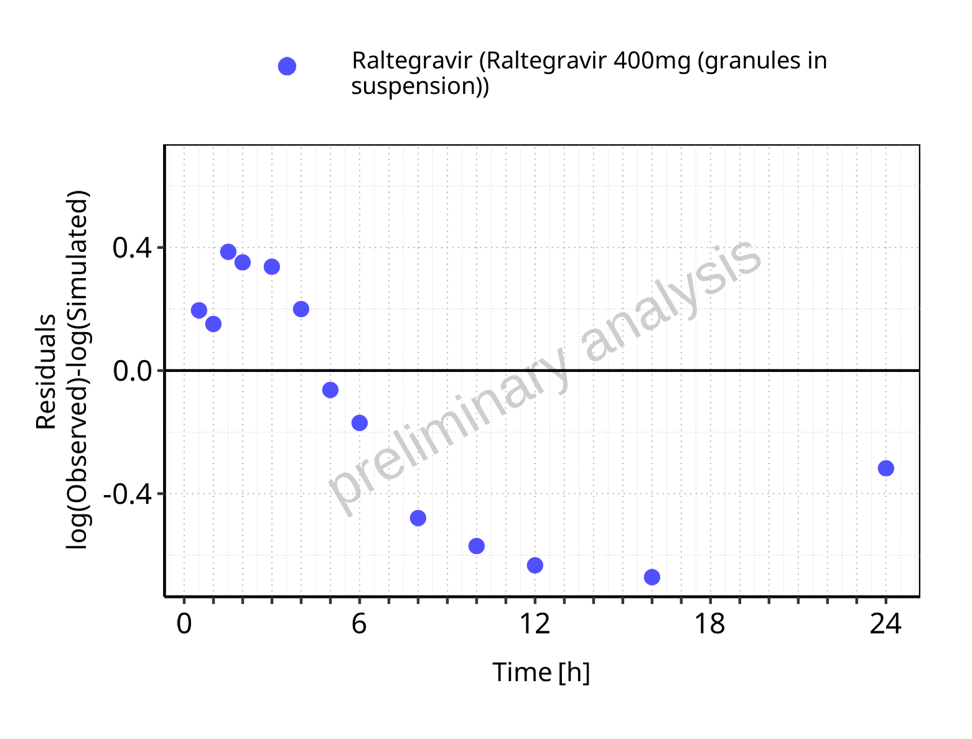

**Figure 5-92: Logarithmic residuals vs time values for Raltegravir 400mg (granules in suspension). Data source: Data/Raltegravir_PK.txt.**

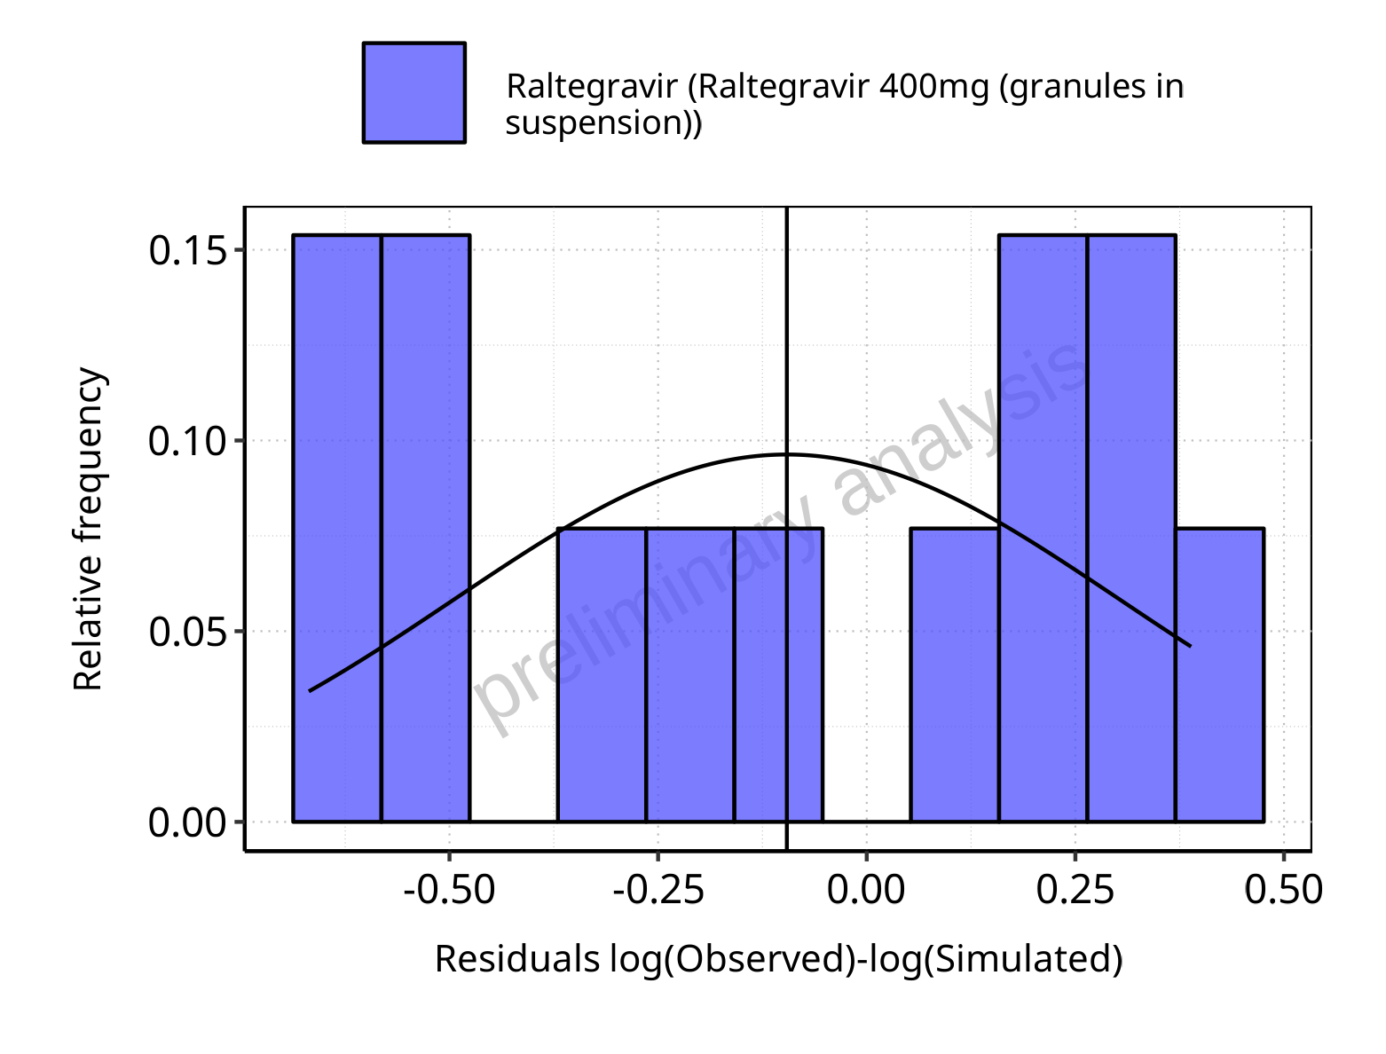

**Figure 5-93: Logarithmic residuals distribution (stacked) for Raltegravir 400mg (granules in suspension). Data source: Data/Raltegravir_PK.txt.**

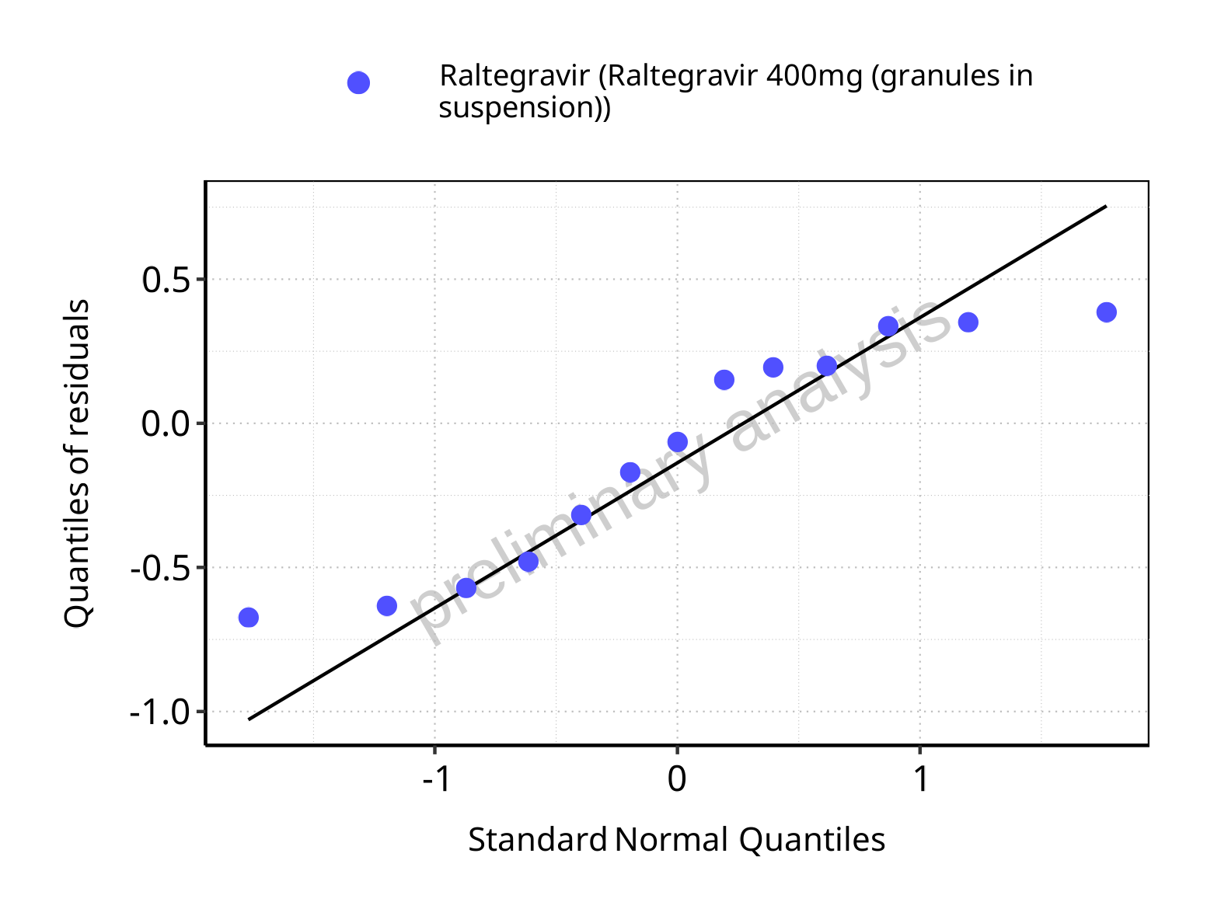

**Figure 5-94: Logarithmic residuals for Raltegravir 400mg (granules in suspension) as quantile-quantile plot. Data source: Data/Raltegravir_PK.txt.**

## Residuals across all simulations

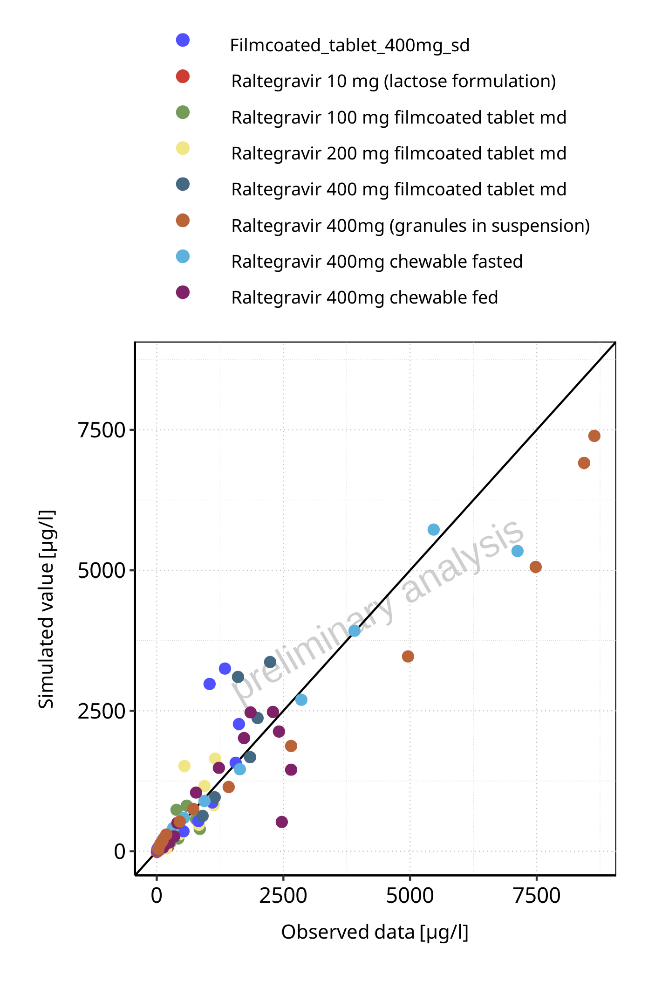

**Figure 5-95: Predicted vs observed for Raltegravir across Raltegravir 10 mg (lactose formulation), Raltegravir 100 mg filmcoated tablet md, Raltegravir 200 mg filmcoated tablet md, Filmcoated_tablet_400mg_sd, Raltegravir 400 mg filmcoated tablet md, Raltegravir 400mg chewable fasted, Raltegravir 400mg chewable fed, Raltegravir 400mg (granules in suspension). Predictions and observations are plotted in a linear scale.**

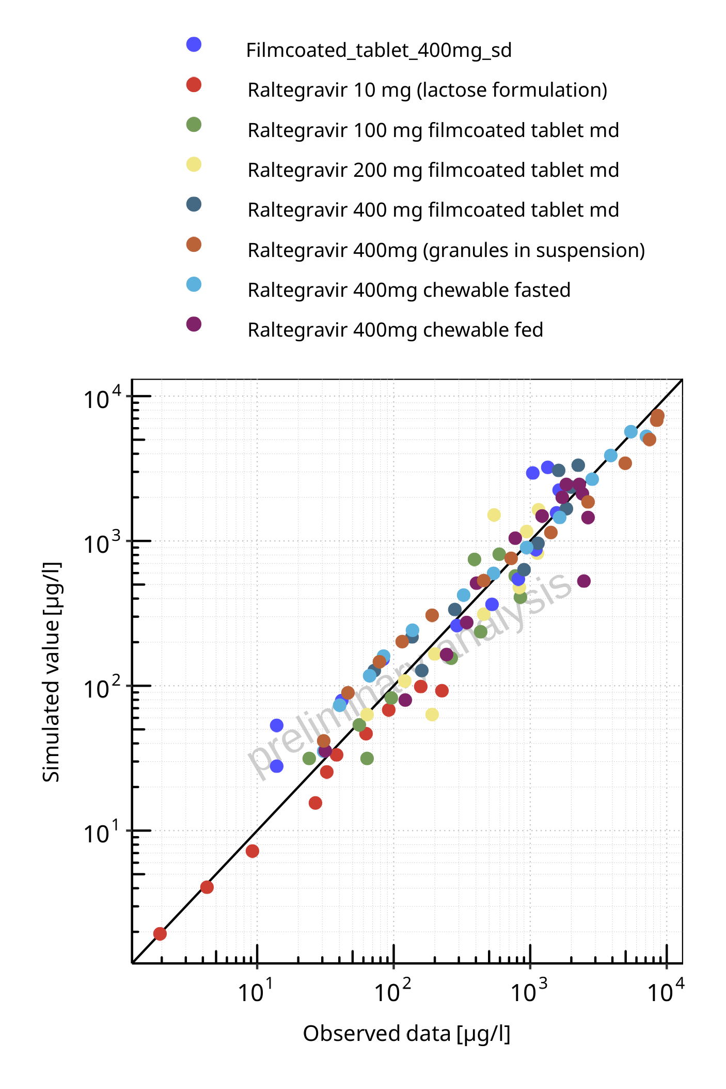

**Figure 5-96: Predicted vs observed for Raltegravir across Raltegravir 10 mg (lactose formulation), Raltegravir 100 mg filmcoated tablet md, Raltegravir 200 mg filmcoated tablet md, Filmcoated_tablet_400mg_sd, Raltegravir 400 mg filmcoated tablet md, Raltegravir 400mg chewable fasted, Raltegravir 400mg chewable fed, Raltegravir 400mg (granules in suspension). Predictions and observations are plotted in a logarithmic scale.**

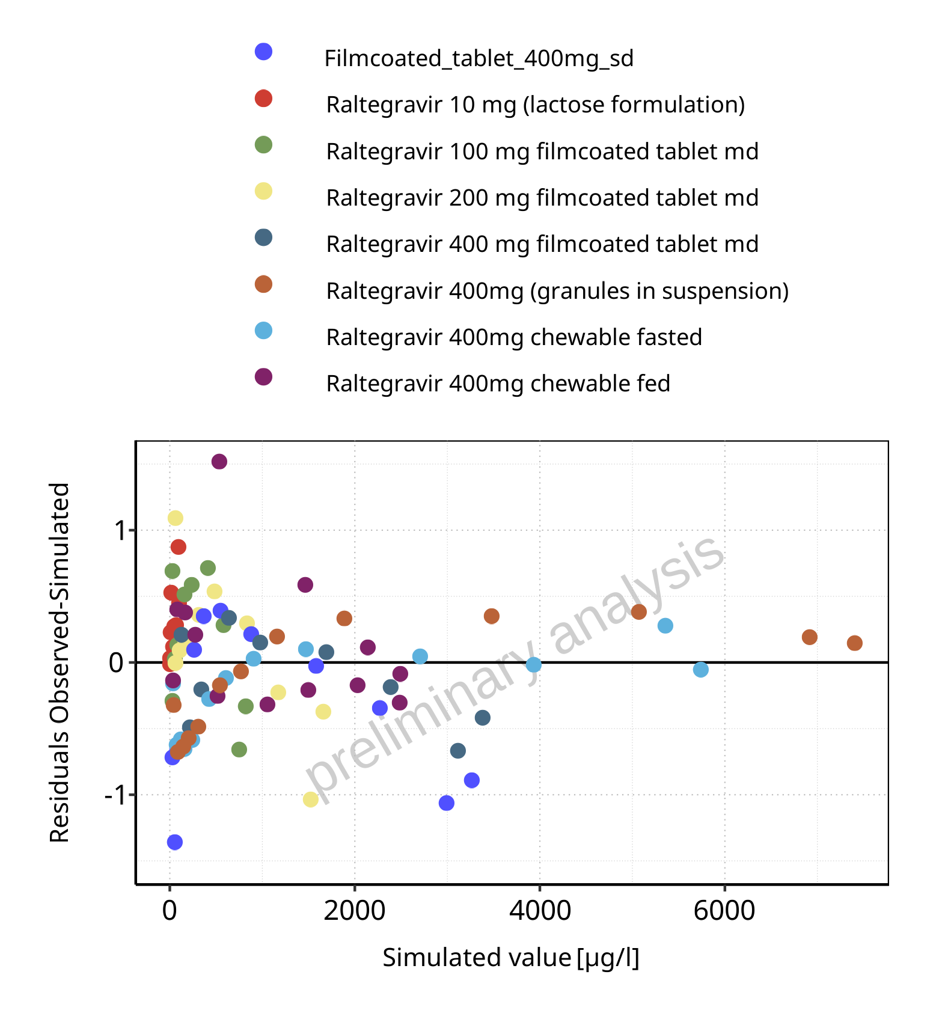

**Figure 5-97: Logarithmic residuals vs predicted values for Raltegravir across Raltegravir 10 mg (lactose formulation), Raltegravir 100 mg filmcoated tablet md, Raltegravir 200 mg filmcoated tablet md, Filmcoated_tablet_400mg_sd, Raltegravir 400 mg filmcoated tablet md, Raltegravir 400mg chewable fasted, Raltegravir 400mg chewable fed, Raltegravir 400mg (granules in suspension).**

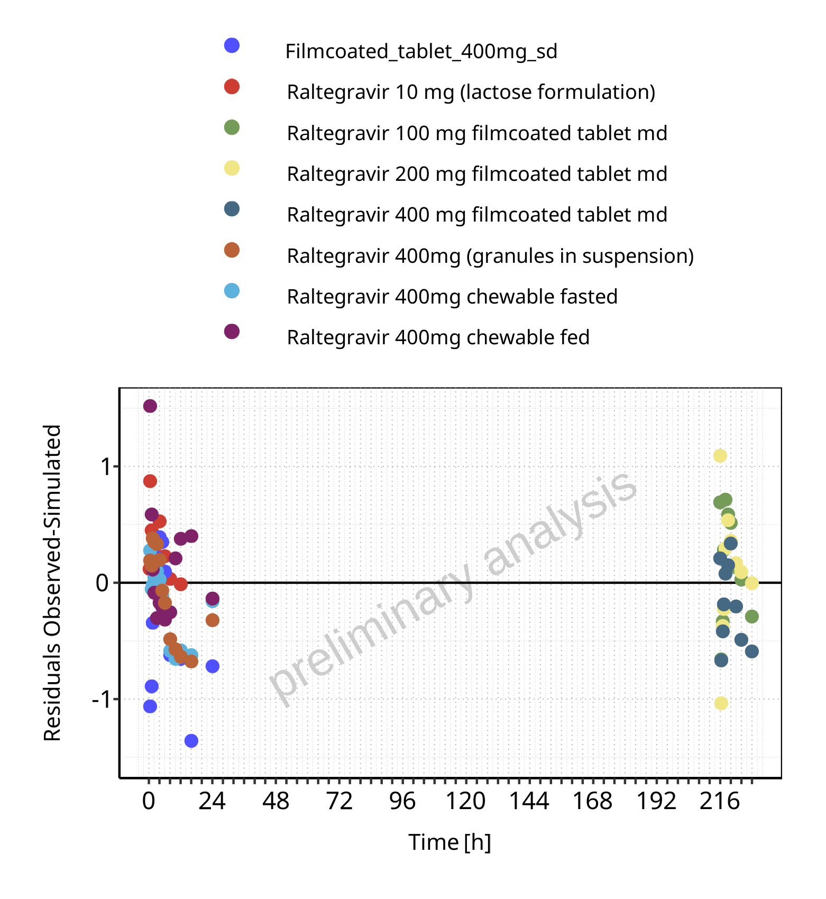

**Figure 5-98: Logarithmic residuals vs time values for Raltegravir across Raltegravir 10 mg (lactose formulation), Raltegravir 100 mg filmcoated tablet md, Raltegravir 200 mg filmcoated tablet md, Filmcoated_tablet_400mg_sd, Raltegravir 400 mg filmcoated tablet md, Raltegravir 400mg chewable fasted, Raltegravir 400mg chewable fed, Raltegravir 400mg (granules in suspension).**

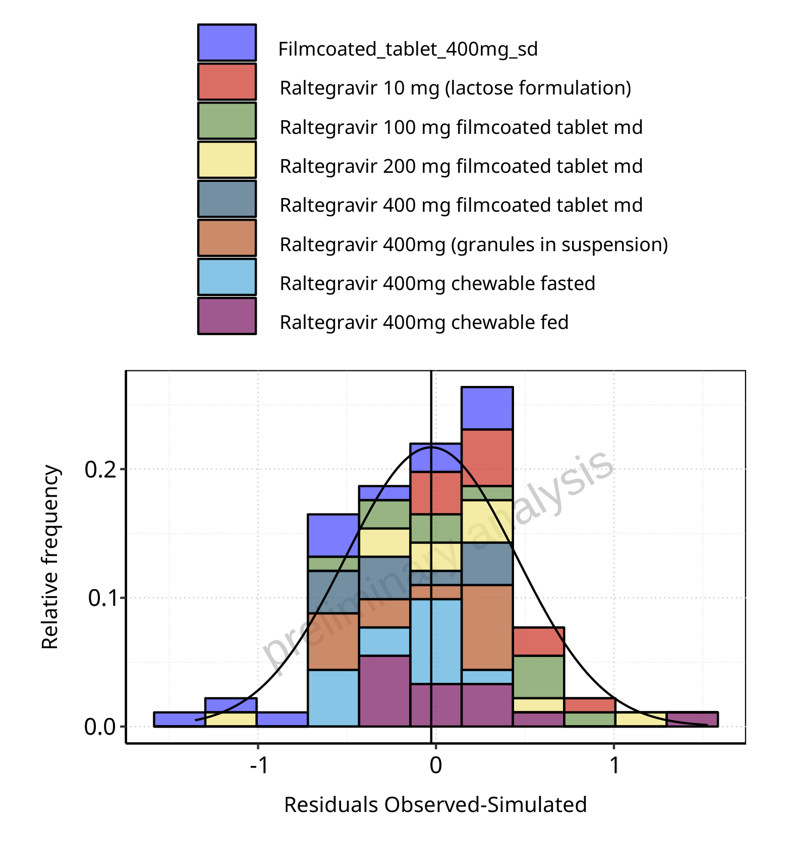

**Figure 5-99: Logarithmic residuals distribution (stacked) for Raltegravir across Raltegravir 10 mg (lactose formulation), Raltegravir 100 mg filmcoated tablet md, Raltegravir 200 mg filmcoated tablet md, Filmcoated_tablet_400mg_sd, Raltegravir 400 mg filmcoated tablet md, Raltegravir 400mg chewable fasted, Raltegravir 400mg chewable fed, Raltegravir 400mg (granules in suspension).**

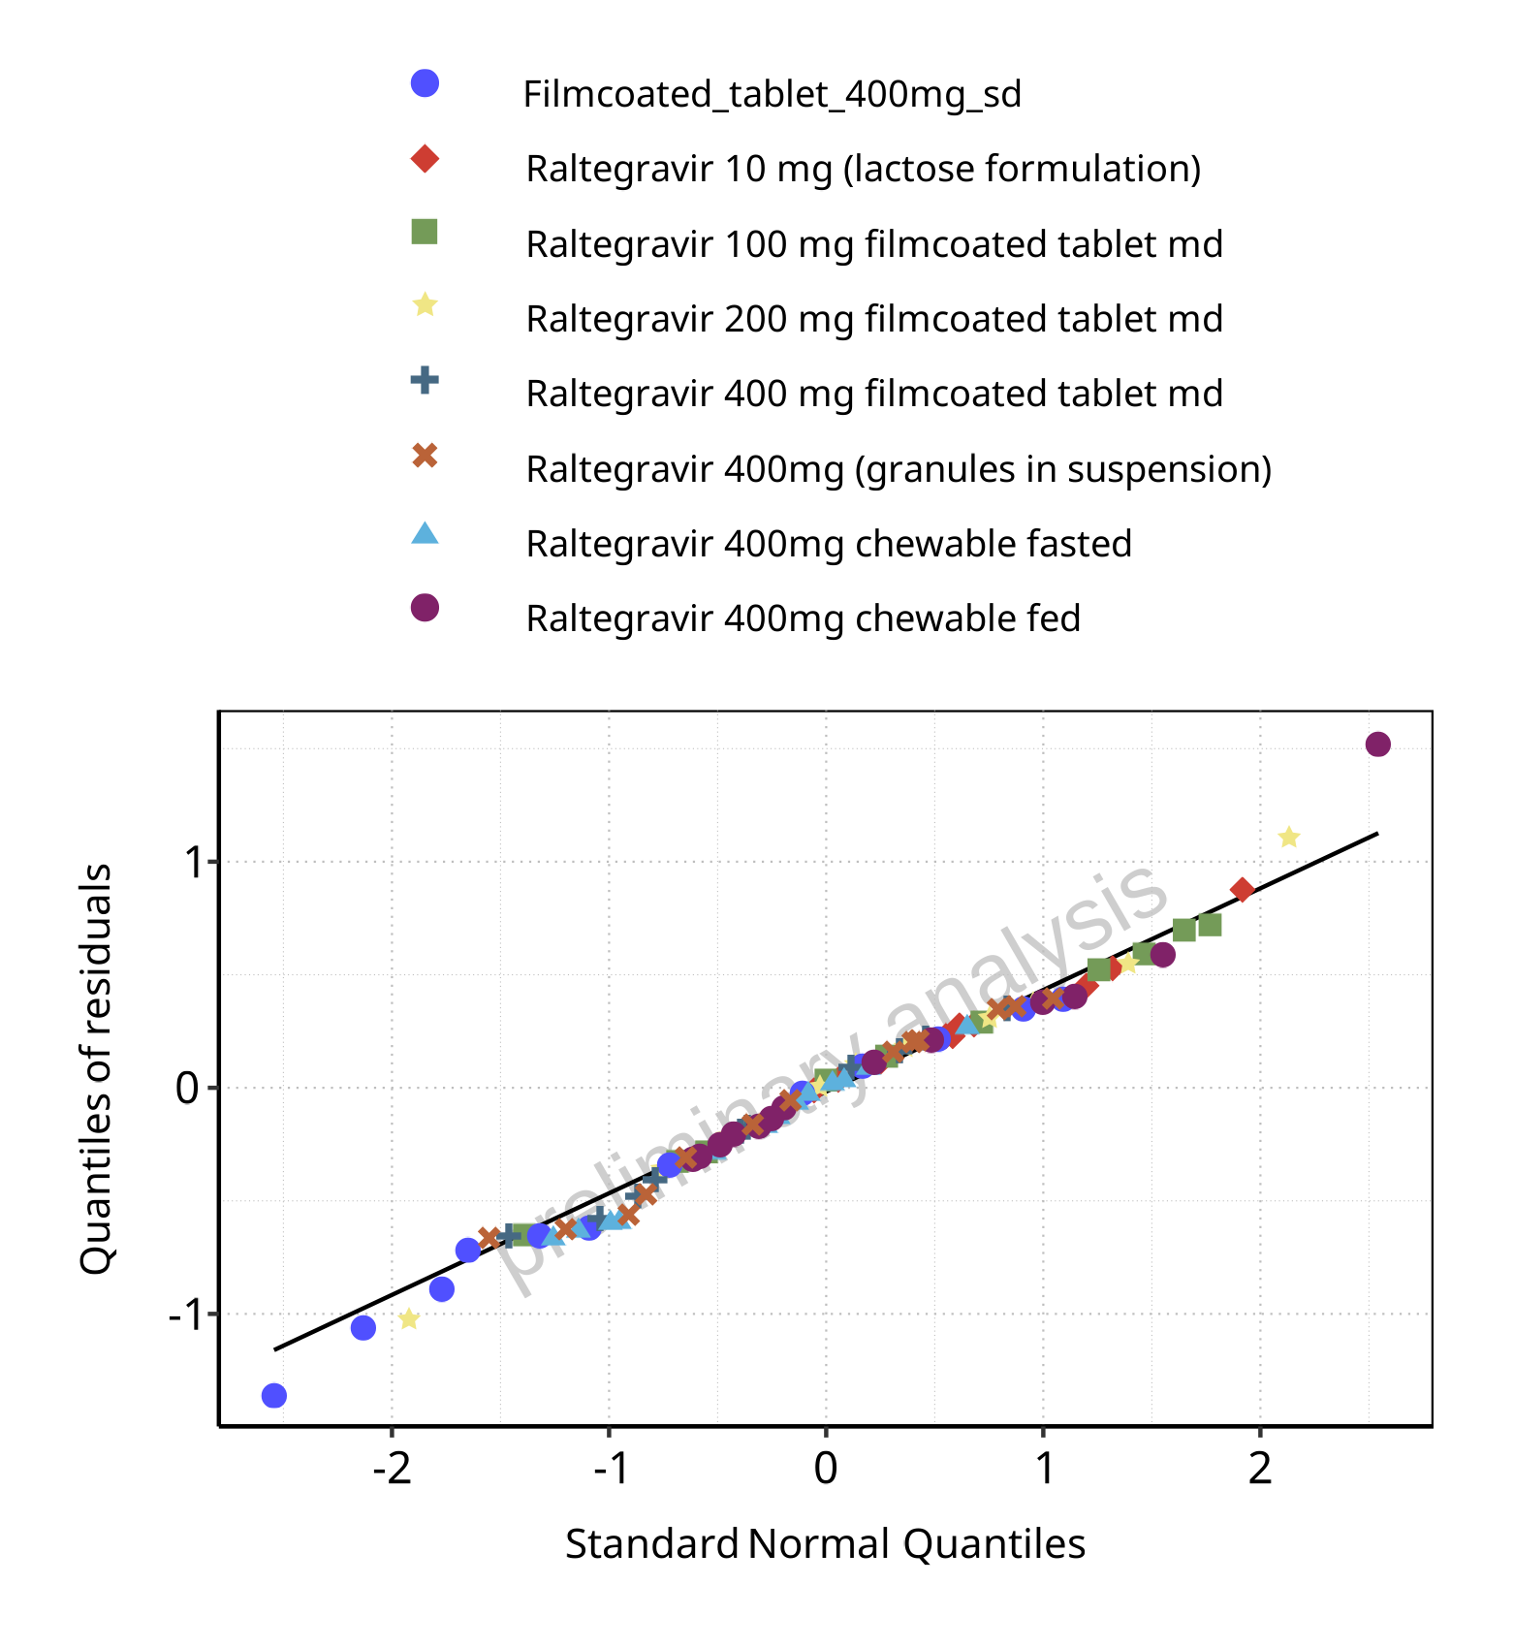

**Figure 5-100: Logarithmic residuals for Raltegravir across Raltegravir 10 mg (lactose formulation), Raltegravir 100 mg filmcoated tablet md, Raltegravir 200 mg filmcoated tablet md, Filmcoated_tablet_400mg_sd, Raltegravir 400 mg filmcoated tablet md, Raltegravir 400mg chewable fasted, Raltegravir 400mg chewable fed, Raltegravir 400mg (granules in suspension) as quantile-quantile plot.**